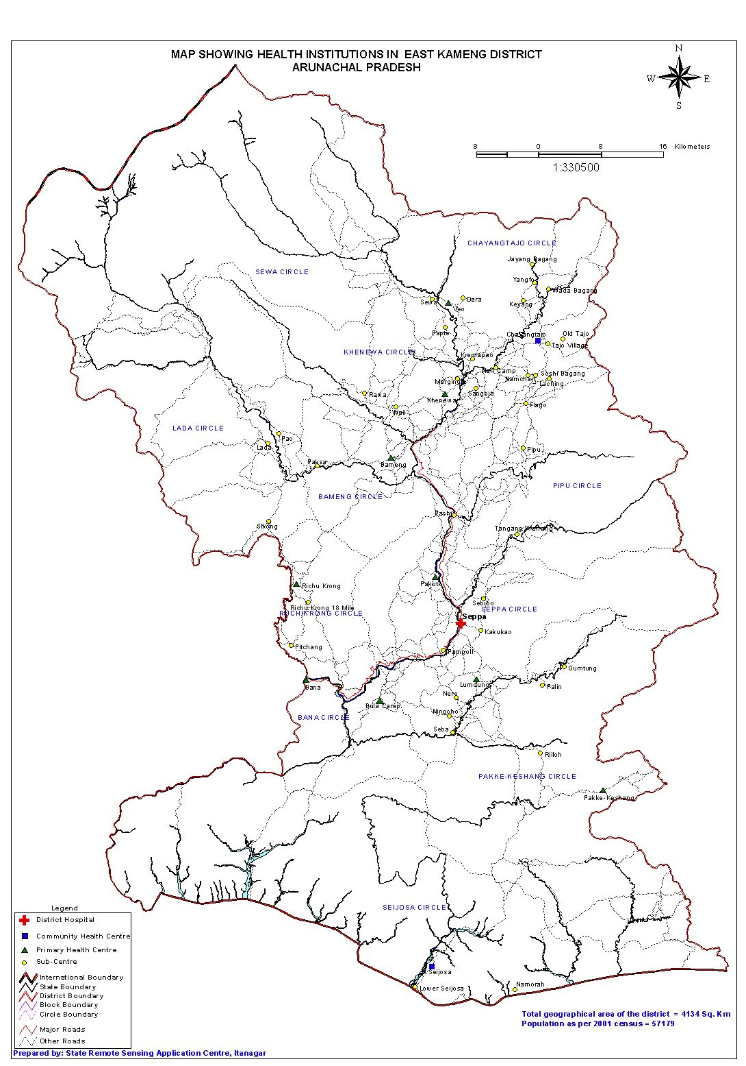

**PHC, CHC and DH as per classification (Level I, Level II & Level III)**

**PHC Bameng (PPP)**

**PHC Pakoti**

**PHC Bana**

**PHC Richu Krong**

**PHC Bula Camp**

DH, Seppa

**CHC, C/Tajo**

**PHC Khenewa**

**DH Seppa**

**PHC Veo**

INDEX

< 1

**PHC Lumdung**

**Level II**

**CHC Seijosa**



**Sub centres as per classification of categories (Type A, Type B & Type C)**

**SC Margingla (PPP)**

**SC Kakukao**

**SC Rilloh**

**SC Palin**

**SC Lower Seijosa**

**SC Lada (PPP)**

**SC Pompoli**

**SC Sebibo**

**SC Pachi**

INDEX

Type A- NIL

Type B- 9

Type C- NIL



**PHC, CHC and DH identified for Strengthening and Up-gradation**

**PHC Bameng**

**PHC Khenewa**

**CHC C/Tajo**

INDEX

<I to I

Strengthenn

II to III

**DH Seppa**

**PHC pakoti**

**PHC Bana**

**PHC Pakke Kessang**

**CHC Seijosa**



**Sub centres identified for Strengthening**

**Home delivery by SBA**

**Strengthen Outreach**

**Start Outreach**

**SC Nere**

**SC Paksa**

**SC Lower Seijusa**

**SC Mari camp**

**SC Pipu**

**SC Lada**

**SC Pachi**

**SC Rilloh**

**SC Palin**

**SC Pampoli**

