**THE BIOWAT: AN INNOVATION UNDER KAYAKLP**

**BIOMEDICAL WASTE WATER TREATMENT GENERATED AT NARTIANG PHC**

**WEST JAINTIA HILLS MEGHALAYA**

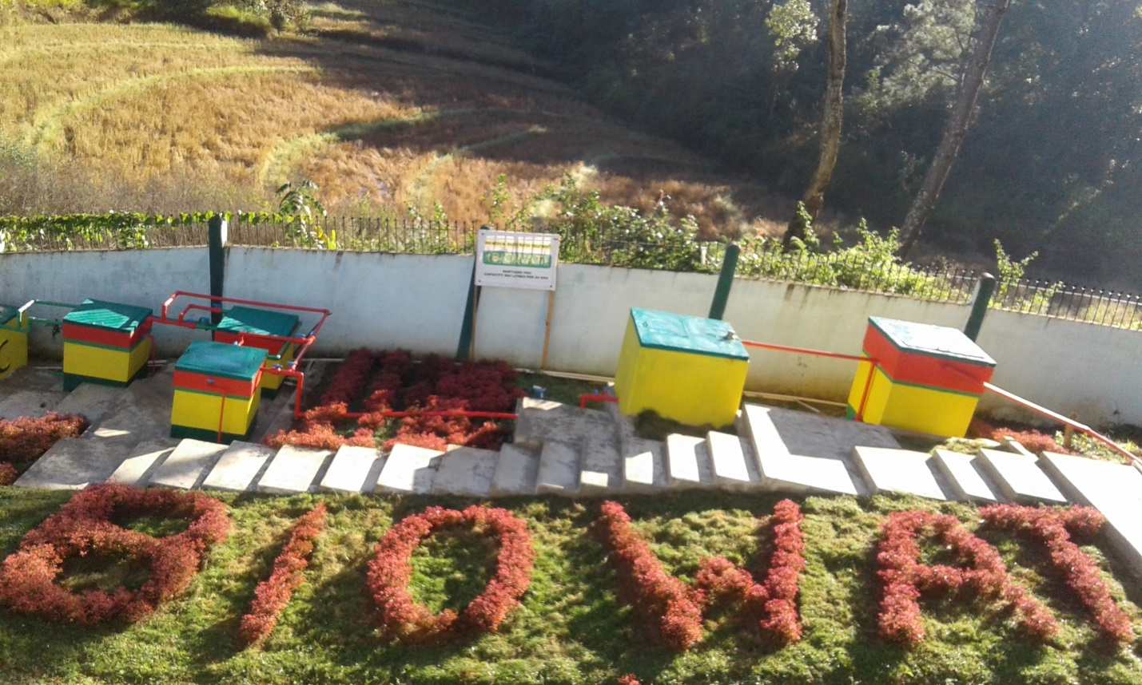

**IDEA BY:**

**DR.R.POHSNEM**

**SENIOR MEDICAL & HEALTH OFFICER**

**I/C. NARTIANG PHC**

**DEPARTMENT OF HEALTH & FAMILY WELFARE**

**GOVT. OF MEGHALAYA**

**(Email:** [**rpohsnem@gmail.com**](mailto:rpohsnem@gmail.com)**)**

**Phone: 8575737982**

Nature has so much to offer us, fresh food, clean air, crystal clear water. We take so much and we must give back what we owe to Mother Nature. That is the inspiration behind the conceptualization of the **BIOWAT**, which is short for Biomedical Waste Water Treatment. An improvised Liquid Waste Management facility developed at Nartiang PHC, for the treatment and disposal of Biomedical Waste Water - which is similar in meaning to disinfecting fluid, housekeeping fluid, laundry waste water, laboratory fluid generated at Nartiang PHC.

Evidences abound that direct discharge of liquid waste, and for that matter chlorinated water, into a water body does great harm to the aquatic life in the receiving stream. That, in essence, is tilting the balance of the local ecosystem that Mother Nature best shower upon us. Nartiang PHC is surrounded on three sides by natural streams which sustain a thriving aquatic ecosystem of local fishes. Local people use the streams for household needs, not to mention about the source of easy protein that the locals get from the fishes which thrive in the surrounding streams.

Imagine the fate of the aquatic ecosystem should 560 liters (daily output at Nartiang PHC) of pollutants-containing or oxygen depleting liquid waste or chlorinated waste water are directly discharged into the surrounding stream. All hell will break loose.

To neutralize the impending damage to mother nature, at BIOWAT we take the opportunity to drive home the message that simple & cost effective adaptation of current technology could be tapped for the treatment and safe disposal of biomedical waste water without compromising sound environmental considerations and local relevance of the practice.

At BIOWAT, liquid waste is passed through four stages of treatment. Intermittent or Demand Operated Slow Sand filtration is the first stage. Chlorine Disinfection is the Second stage of treatment. Carbon adsorption is the third stage of treatment. And to remove all traces of free chlorine from the waste water, dechlorination with vitamin-C is the fourth (final) stage of treatment. Some basic equipments, which were procured online from websites, were required at the initial stage. Aquarium grade activated carbon, Flowmeter, DPD test kit for free chlorine – to name a few.

Conservative estimate for the initial cost incurred towards the construction materials come to Rs.1,50,000/-( rupees one lac fifty thousand)only. Labor cost is approximately Rs.50000/- (rupees fifty thousand) only. So total approximate expenditure is Rs.200000/-(rupees two lacs) only. While the daily running cost is a meagre Rs.50 (rupees fifty) only. All the expenses are being born by the Health Engineering Wing of the Directorate of Health Services, Govt. of Meghalaya. Some materials are donated by local stakeholder and friends alike. RKS members contribute to the landscaping. I hope scaling up in other PHCs/CHCs will not be a financial hurdle.

Now BIOWAT is a new find among the local people and students alike as a spot worth visiting.

We must give back what Mother Nature owes us. I hope at BIOWAT we have taken a humble step- in that direction.