**Success in Adversity: Chokpot CHC**

Chokpot Community Health Centre is situated in the heart of Chokpot village in South Garo Hills district of Meghalaya. South Garo Hills is remotest corner of the country & most backward district of the state. Hospital is located 360 Km from the capital Shillong, 53 kms from Tura and 52 kms from Baghmara the headquarters.

Chokpot is blessed with lush greenery, perennial rivers, streams, many natural waterfalls and rain caves, etc. but also have very adverse weather, harsh working conditions, bad roads, connectivity through wooden bridges, irregular water & electricity supply & prone to insurgency.

Chokpot CHC is the major health provider for 158 villages under Chokpot Block. It caters to a population of 26435 and has 5 subcentres.

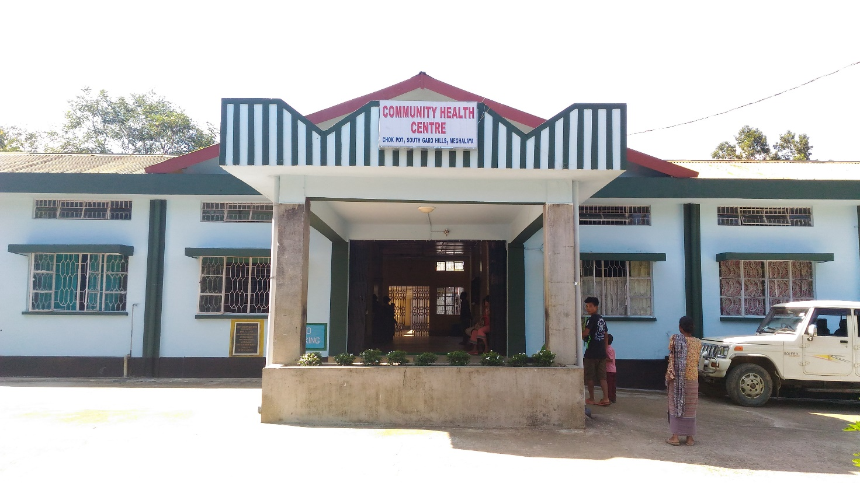

In 2016, Chokpot CHC has started working for Kayakalp, baseline score of facility was quite low due to poor infrastructure, insufficient funds & lack of support from certain section of society. MO I/C of facility motivated staff for Kayakalp activities & jointly they aimed for commendation award. In beginning of the programme cleanliness & hygiene was not improving much. Facility team thought to involve community to help them for Kayakalp. So on Sunday/ Holiday they start inviting people from adjacent villages, Schools, Church & BSF etc.

To sustain cleanliness in Hospital staff started mass cleaning of the facility on Holidays which includes cleaning of toilets, open area etc.

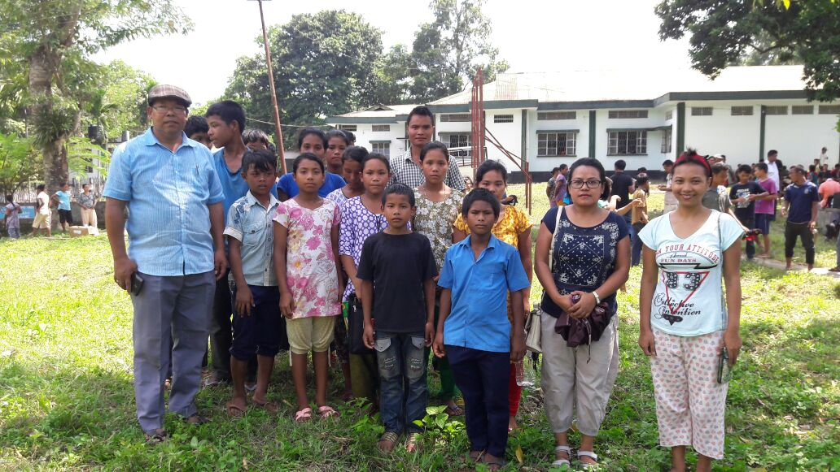

**Medical Officer with Rongmigre SSA School Students & Teachers**

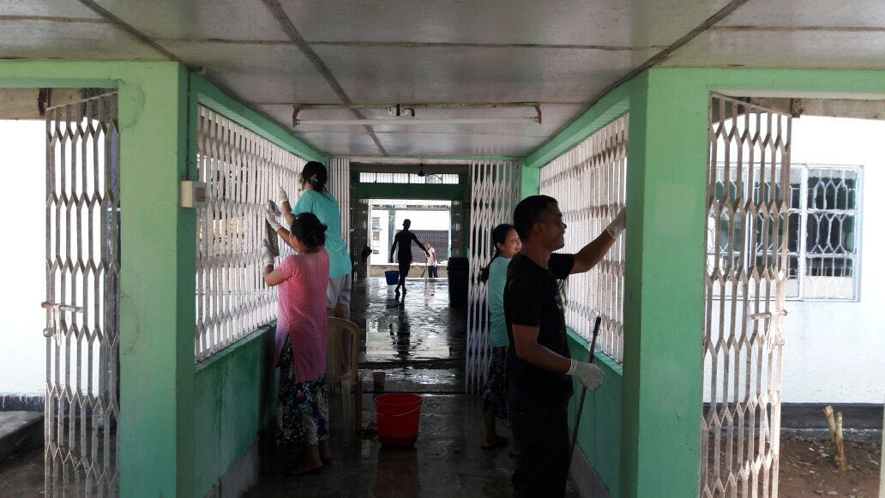

**Staff Cleaning Hospital Grills**

|  |  |  |
| --- | --- | --- |
| **Sr no.** | **Challenges** | **How facility overcome the challenges** |
| 1 | Dust Bin for General Waste | Staff along with community weaved local type baskets & paint them in green. |
| 2 | IEC material for Hygiene promotion | Staff has drawn IEC material in posters |
| 3 | Infection Control Practices | Training is given by Mo I/C & started monitoring on daily basis |
| 4 | Liquid waste Management | Locally design liquid waste management system as per Karnataka Model |
| 5 | Work place Management | All the areas like Pharmacy counters, stores & kitchen etc. are re-arranged & sustained by monitoring |
| 6 | Boundary Wall of the Hospital | Hospital Boundary was the biggest challenge for CHC, few sections of society did not want to construct boundary wall of the Hospital. Hospital & RKS members convinced them about importance of boundary wall & construct it. Later Hospital got notice from the court. |
| 7 | Infrastructure Maintenance | Infrastructure maintenance was also a challenge for facility as Handymen involved in repair work usually took holiday every alternate day. So MO I/C every day before OPD hrs go to their home to ensure they will come for repair work. |

**Achievements:**

In short span of time Chokpot CHC has seen drastic changes in hospital upkeep and cleanliness. Perceptive and positive changes were seen in the attitude and behaviour of the staff and among the general public.

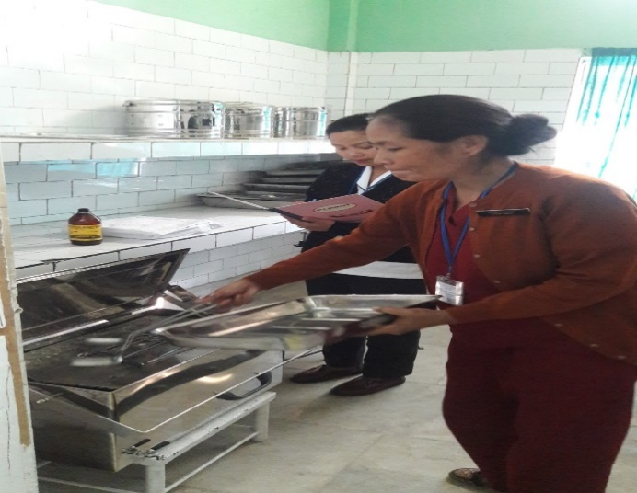

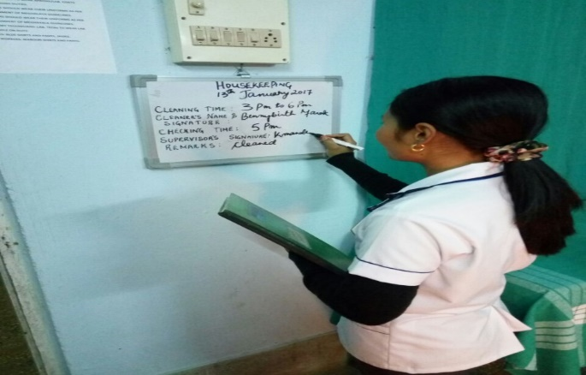

Infection Control Practise & its monitoring

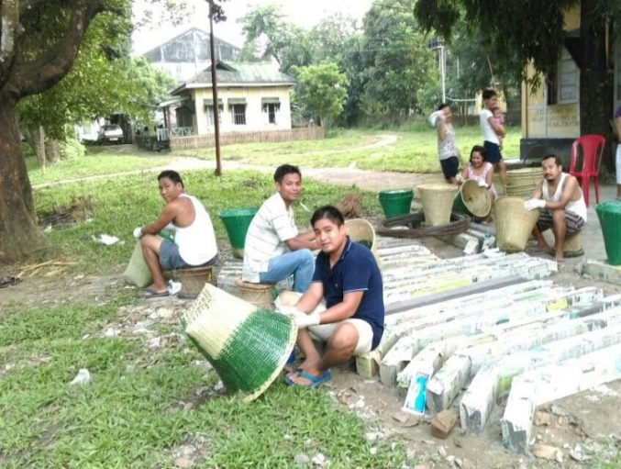 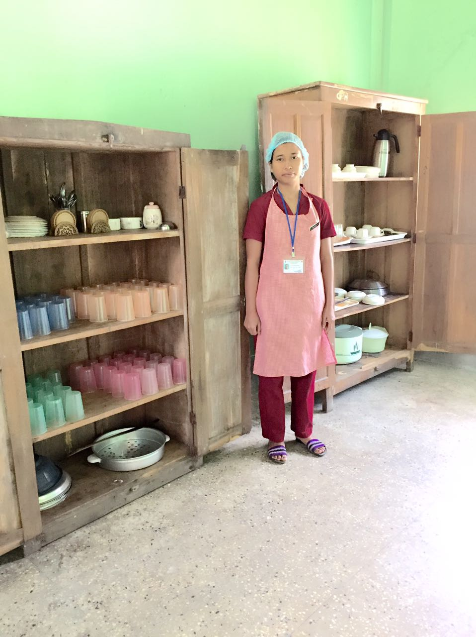

Weaving & Painting of Basket for General Waste Work place Management: Kitchen

**Road ahead:**

The Doctors and staff of Chokpot CHC aspire to keep up their dedication and work towards achieving the following-

* Plant more trees in and around the CHC compound
* Incorporate more herbal plants
* Visual IEC for patient waiting rooms
* Reinforce IEC programmes for public
* To make a pond where Gambusia fish will be introduced to control mosquitoes.

**Acknowledgement:**

* First and foremost, a heartfelt thanks to the staff of Chokpot CHC for their tireless dedication and participation in fulfilling the mammoth task of meeting the criteria listed in the guidelines.
* Special mention and gratitude to the Executive Engineer, Health Engineering Wing, Shillong and the SDO, Health Engineering wing , West Garo Hills for their timely intervention and taking up of the major constructions for the CHC.
* Special thanks to all the Officials who contributed to facility efforts.
* Special thanks to the community leaders, community members, students and security personnel’s who generously participated in the programme.

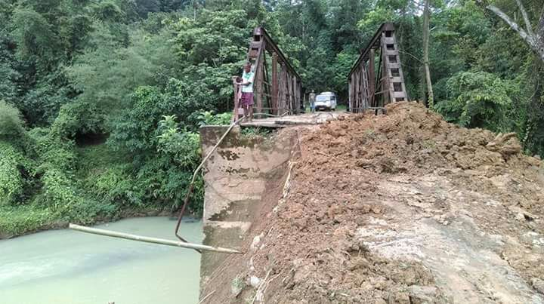

Glimpse of road Conditions to Chokpot