**Quality Improvement in Primary Health Centers in Haryana**

**Introduction**

Assuring quality in healthcare is a challenging endeavor. The inter-linkages and cross-functionalities of multiple stakeholders lead to complexity in deliverance of healthcare to the patients.

In public health facilities the provision of basic assured services like prompt treatment by a qualified doctor, laboratory investigations with the right result, basic medicines have become a high end commodity. The simplification of health systems is the need of the hour.

**Quality Improvement in Haryana**

In Haryana, Quality improvement of various public health facilities has been an ongoing initiative. A simultaneous conjugation of improvements in infrastructure, provision of adequate manpower and availability of essential equipments, medicines and consumables was taken up to improve the healthcare service delivery.

During the course, it has been experienced and realized that in preventive healthcare facilities like Primary Health Centers, process improvement and simple interventions lead to better patient and staff satisfaction levels and exalted service delivery. The public health sector has essentially faced problems in effective and efficient utilization of money. The above issues have led to thinking of out-of the box solutions in order to innovatively improve the present health care delivery system.

**Simple Quality improvement interventions-**

1. **Drug Dispensing Stickers-**

**Introduction-**

In the context of drug dispensing it had been highlighted that the patients were not being educated about the dosage and timings of medication to be taken at home. In order to remove the barrier of linguistics where medications are usually prescribed or written in English / local language, in a setting where majority of the population is illiterate a simple technique was implemented.

**Method of Intervention-**

At the time of drug dispensing a sticker having pictorial representations of -

1. “Morning”, “Evening”, “Night”
2. “Morning”, “Night”
3. “Morning”,
4. “Night”

As the local language in Haryana is Hindi, the pictorial representation also had text in Hindi for the above as:-

*1) "सुबह", "दोपहर", "रात"*

*2) "सुबह", "रात"*

*3) “सुबह”*

*4) "रात"*

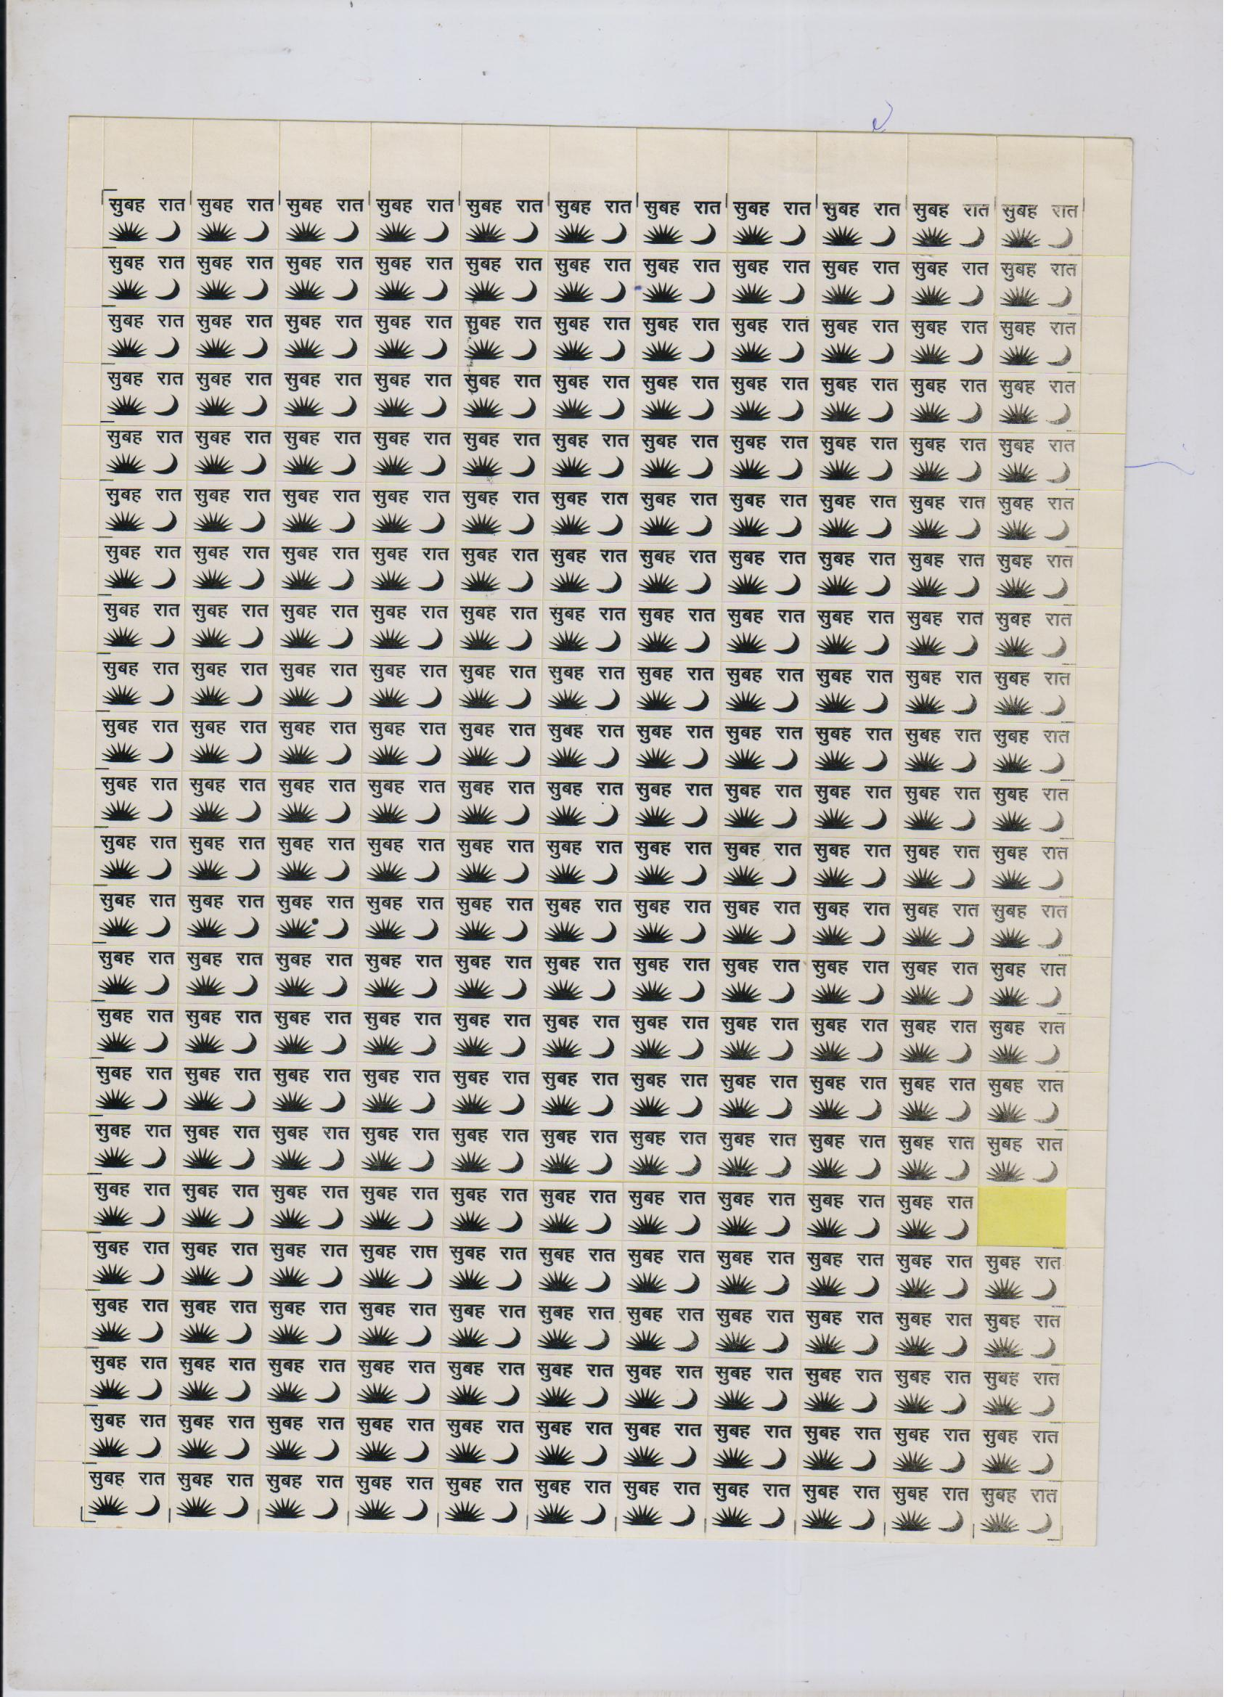

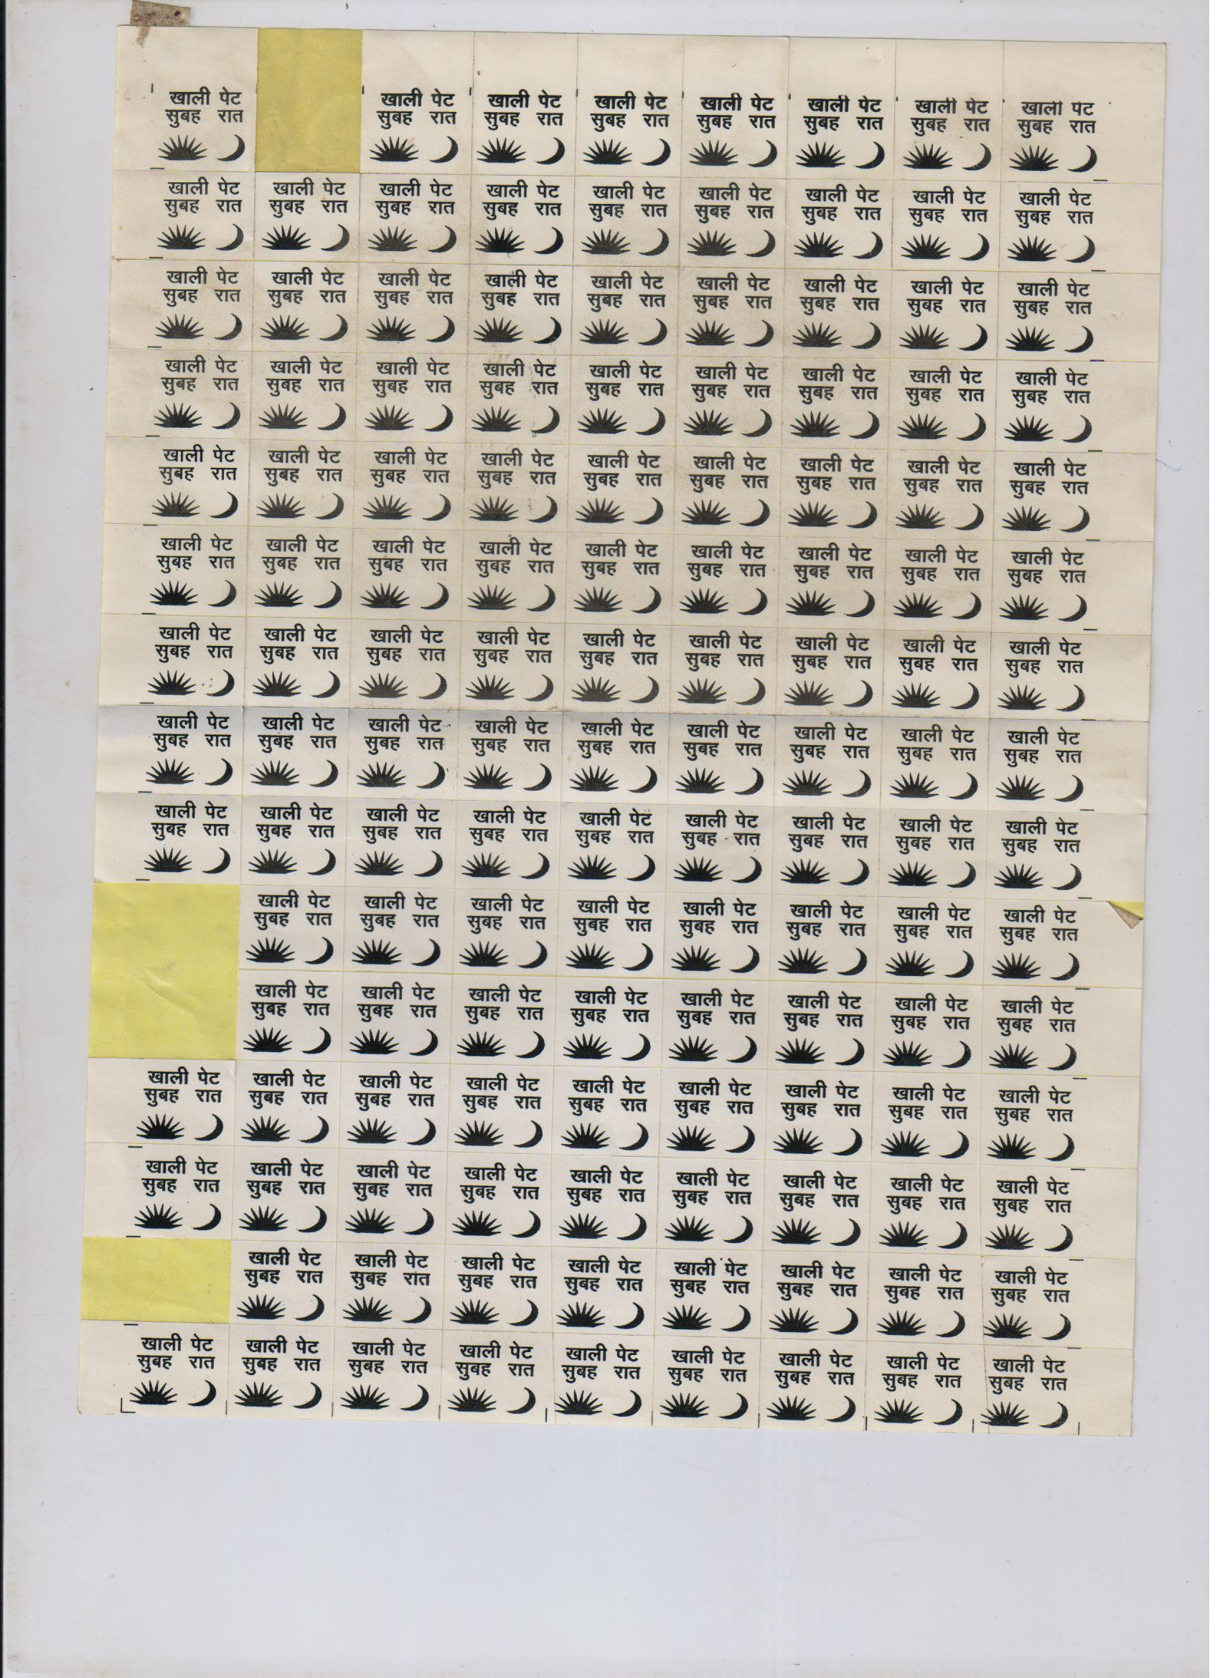

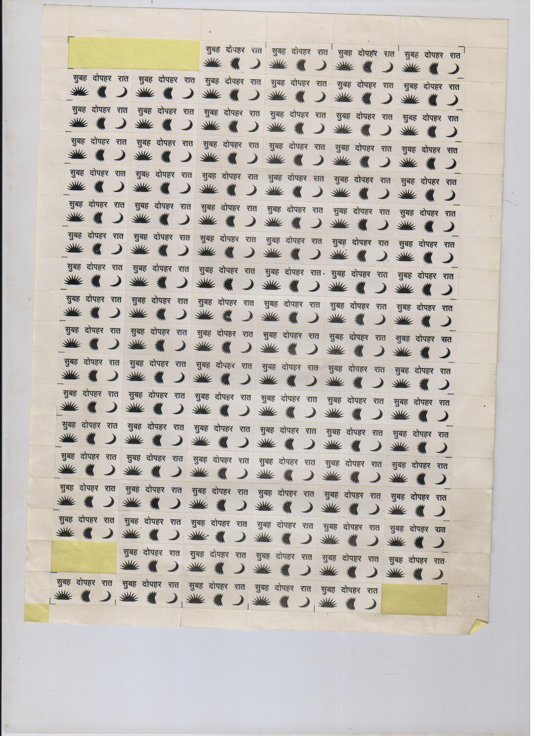

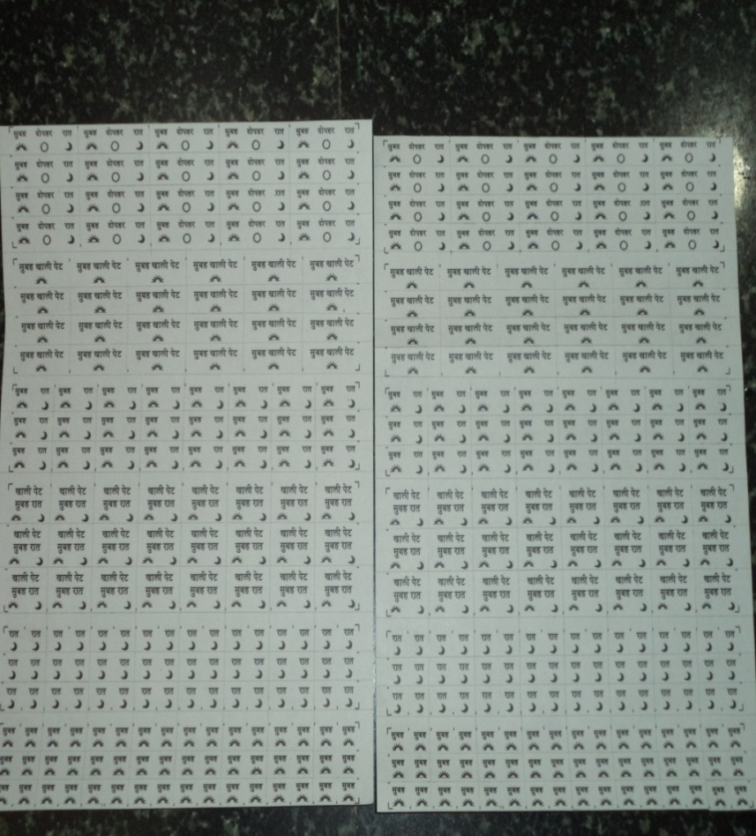

Also it removes the need for pharmacist dependency as majority of the healthcare facilities are facing manpower shortages. Even in case of an availability of a pharmacist/ drug dispenser in a Primary Health Centre approximately 120-150/ patients/day usually visit, making it difficult for the drug dispenser to educate about medication administration. The intervention of providing stickers removed the need for explanation.

**Cost Effectiveness-**

The intervention can be a model for cost effectiveness as:-

The cost of errors in self drug administration at home cannot be directly measured. The risk of self harm due to ignorance in drug administration can be estimated as opportunity cost.

The opportunity costs can be detailed into various forms- the cost borne by the patient in OPD/ IPD settings of a hospital including the cost of drugs/ stay (in case the patient visits any private/ public sector facility), the cost of man days when the patient is not being able to work for a living, travel cost of the patient, cost of hospitalizations borne by government in the healthcare setting including the operational cost of running a Primary Health care centre (the cost of fixed assets land, building and recurring cost including salaries of staff).

The importance of simple interventions like drug administration stickers can be highlighted from the fact that the out of pocket costs borne by the patients and the expenditure incurred by the government in curative treatments can simply be minimized.

1. **Septic tank for Liquid Waste Management –**

**Introduction**

The importance of Biomedical Waste management in a facility cannot be undermined, of which liquid waste component is usually under looked.

Biomedical Waste Management rules, 2016 state that pre-treatment of hospital generated liquid waste is mandatory prior to mixing in residential/ general effluent.

**Method of intervention-**

In a Primary Health care setting where feasibility of a high end Liquid Waste treatment plant is questionable, a low cost intervention has been implemented for pre-treatment of liquid waste.

The liquid waste generated in the high risk areas is pooled into the septic tank fixed at an area inside the Primary Health Centre, 10% Sodium Hypochlorite Solution is put in the tank for an adequate period of time to release free chlorine ion. The pre-treated waste is then discharged into the general effluent.

**Cost Effectiveness -**

The intervention can be a model for cost effectiveness as:-

The total cost of the tank and the connectors is below Rs. two thousand.

The interventions involving mechanized septic tanks have the same functioning are cost intensive where costs are in the range of Rs. One lakh to fifty lakhs depending upon the bed strength of the hospital and amount of waste generated. The model is replicable as it requires basic connectors and a capacitated tank.

Plastic tank is connected to sinks of high risk areas (Laboratory/ Labour Room

Connection with general effluent