**Minutes of First Meeting of Central Quality Supervisory Committee (CQSC)**

**Wednesday, 1st February’ 2017**

**Venue – NHSRC Theatre**

The Ministry of Health & Family Welfare has constituted Central Quality Supervisory Committee (CQSC) vide its office order no. 15015/27/2015-NRHM-1 dated 15th Dec 2015. TORs of the CQSC are attached as Annexure I.

First meeting of the CQSC was held on 1st of February’ 2017 at 4.00 pm at NHSRC Theatre under the chairmanship of Dr Arun K Panda, Additional Secretary & Mission Director, NHM, MoHFW. List of the Participants is attached as Annexure II.

Dr Sanjiv Kumar ED NHSRC welcomed the participants and provided a brief overview of the National Quality Assurance Standards (NQAS). Subsequently Dr J N Srivastava, Advisor – Quality NHSRC made a presentation on NQAS & process of development and arrangement of the Standards and current implementation status. Following broad topics were covered in the presentation -

* Overview of National Quality Assurance Standards
* QA Institutional Arrangement in the States
* Assessments of DHs, SDHs, CHCs, PHCs and U-PHCs
* Capacity Building - Trainings and Course modules
* Key findings of assessment in the States
* Quality Assurance under National Urban Heath Mission (NUHM)
* Status of QA Certification of Health Facilities
* Challenges & Critical issues
* Status of Kayakalp Scheme Implementation, and
* Mera Aspataal Initiative and key observations

1. **Agenda Point 1**
   1. **State specific Quality Scores:** While reviewing performance of the States against National Quality Assurance Standards, it was observed that the score of State of Rajasthan (78.2%) is significantly high as compared to other States in the same region. It could be genuine efforts of the State or it could be aberration. It was also felt that the state may have introduced few innovations, which resulted into good quality score of the Health Facilities in the State. Hence it was decided a sample of Health Facilities would be visited and score verified.
   2. **Strengthening States involvement for NQAS:** While acknowledging the work undergone into roll-out of the Quality Assurance Programme, AS & MD suggested that a letter from MoHFW should be sent to the States to highlight their performance in term of QA assessment and actions, required to be undertaken.
   3. **Inclusion of State specific QA status in PIP approval meeting:** It was felt that the States are expected to demonstrate commitment for improving Quality of Care at Public Health Facilities. Therefore status of QA programme would form a part of discussion in NPCC meeting and the States would be advised to make a presentation on proposed QA activities with a definite road-map.
   4. **Improving Quality of Laboratory Reports:** For improving credibility of the Public Hospital laboratories, the States may be advised to plan for strengthening of Internal Quality Control within the Hospital Laboratories and also the laboratories should be encouraged to join the External Quality Assurance Scheme, currently run by AIIMS New Delhi and CMC Vellore. In long run, the Public Hospital Laboratories should aspire for NABL accreditation. As intermediate goal, such laboratories should go for certification against National Quality Assurance Standards within 12 to 18 months.
   5. **Follow-up Action on Mera-Aspataal** – Currently there are 58 District Hospitals covered under the ‘Mera-Aspataal’. Need for ensuring follow-up actions on finding of Mera-Aspataal was emphasised.
2. **Agenda Point 2**
   1. **Audit Man-days:** Following audit Man-days for the External QA assessments were approved:

* **DH**- 3 Assessors for 3 working days
* **CHC**- 2 Assessors for 3 working days
* **PHC & U-PHC**- 2 Assessors for 2 working days
  1. Following criteria for Certification of Health facilities were approved –

1. **Certification of DH**
2. Criterion 1 - Aggregate score of the health facility ≥ 70%
3. Criterion 2 – Score of each department of the health facility ≥ 70%
4. Criterion 3 – Segregated score in each Area of Concern (Service Provision, Patient’s Right, Inputs, Support Services, Clinical Services, Infection Control, Quality Management, Outcome Indicator) ≥ 70%
5. Criterion 4 – Score of Standard A2, Standard B5 and Standard D10 is >70% in each applicable department.

* Standard A2 States “The *facility provides RMNCHA services*”.
* Standard B5 states that *“the facility ensures that there are no financial barriers to access, and that there is financial protection given from the cost of hospital services”*.
* Standard D10 states *“the facility is compliant with all statutory and regulatory requirement imposed by local, state or central government.”*

1. Criterion 5 - Individual Standard wise score ≥ 50%
2. Criterion 6 – Patient Satisfaction Score of 70% in the preceding Quarter or more (Satisfied & Highly Satisfied on Mera-Aspataal) or Score of 3.5 on Likert Scale

**Award of Certification –**

1. **Certification** – If health facility meets all of above-mentioned criteria.
2. Certification/recertification is valid for a period of three years, subject to validation of compliance to the QA Standards by the SQAC team every year for subsequent two years.
3. In the third year, the facility would undergo re-certification assessment by the National Assessors after successful completion of two surveillance audits by the SQAC.
4. **Certification with Conditionality** – If a Health Facility’s aggregate score is 70% or more (Criterion I), and also meets at least three criteria out of remaining five (Criterion II, III, IV, V & VI). Within agreed timeframe of six months, the facility is required to submit evidence of having addressed the reasons of conditionality, which may be verified by an external agency.

If the hospital does not meet the conditionality in stipulated time-frame, the QA certification may be revoked after giving one more chance for a period of six months.

1. **Deferred Certification –** The certificationmay be deferred until follow-up assessment if Hospital overall score is 70% in external assessment, but does not meet the criteria for conditional certification as mentioned in Para (b) above. The window for follow-up assessment will be from 6 months to one year from the date of declaration of external assessment result.
2. **Certification declined** - If hospital does not score 70% in external assessment the certification will be declined. The hospital may freshly apply for certification but not before one year of declaration of external assessment result.
3. **Proposed Criteria for Certification of CHC/U-CHC**

Criterion I - Aggregate score of the health facility ≥ 70%

Criterion II – Score of each department of the health facility ≥ 70%

Criterion III – Segregated score in each Area of Concern (Service Provision, Patient’s Right, Inputs, Support Services, Clinical Services, Infection Control, Quality Management, Outcome Indicator) ≥ 70%

Criterion IV – Score of Standard A2, Standard B5 and Standard D8 is >60% in each applicable department.

* Standard A2 States “The *facility provides RMNCHA services*”.
* Standard B5 states that *“the facility ensures that there are no financial barriers to access, and that there is financial protection given from the cost of hospital services”*.
* Standard D8 states *“the facility is compliant with all statutory and regulatory requirement imposed by local, state or central government.”*

Criterion V - Individual Standard wise score ≥ 50%

Criterion VI – Patient Satisfaction Score of 65% in the preceding Quarter or more (Satisfied & Highly Satisfied on Mera-Aspataal) or Score of 3.2 on Likert Scale

**Award of Certification –** As for DH

1. **Certification for PHC/U-PHC**

Criterion I - Aggregate score of the health facility ≥ 70%

Criterion II – Segregated score in each Area of Concern (Service Provision, Patient’s Right, Inputs, Support Services, Clinical Services, Infection Control, Quality Management, Outcome Indicator) ≥ 60%

Criterion III – Score of Standard A2, Standard B5 and Standard F6 (PHC)/F4 (U-PHC) is >60% in each applicable department.

Standard A2 (PHC/U-PHC) states “The *facility provides RMNCHA services*”.

Standard B4 (PHC) states that *“the facility ensures that there are no financial barriers to access, and that there is financial protection given from the cost of hospital services”*. OR B3 (U-PHC) states that “The Services provided are affordable”.

Standard F6 (PHC)/F4 (U-PHC) states *“the facility has defined and established procedures for segregation, collection, treatment and disposal of Biomedical & Hazardous Waste”.*

Criterion IV - Individual Standard wise score ≥ 50%

Criterion V – Patient Satisfaction Score of 60% in the preceding Quarter or more (Satisfied & Highly Satisfied on Mera-Aspataal) or Score of 3.0 on Likert Scale

**Award of Certification –**

1. **Certification** – If the health facility meets all of above-mentioned criteria.
2. **Certification with Conditionality** – If a Health Facility’s aggregate score is 70% or more (Criterion I), and also meets at least three criteria out of remaining four (Criterion II, III, IV & V).
3. **Deferred Certification –** The certificationmay be deferred until follow-up assessment if Health facility’s overall score is 70% in external assessment, but does not meet the criteria for conditional certification.

For State level certification score of above-criteria may be reduced by 5%.

* 1. **Disposal of Appeal** – To oversee the certification assessment process, complaint & representation disposal, NHSRC would empanel 5 senior experts, who are qualified assessors of NQAS. Tenure as members would for two years from the date of first meeting. A committee of at least two such experts and Advisor – QI NHSRC would meet at least quarterly (more often if required) and review the assessment process and take technical decisions on the certification related process.

1. **Agenda Point 3:**

**Accreditation of Quality Standards by ISQua** – International Society in Healthcare Society (ISQua) is an Ireland based apex body which accredits Hospital Quality Standards globally. Developed Quality Standards were put-up for ISQua Accreditation. ISQua had suggested to include separate Quality Standards on Medical Ethics, Risk Assessment and Competence & Performance. Hence four Standards encompassing these issues have been added. Post-facto approval of ISQua Accredited Standards was accorded.

1. **Agenda Point 4**

Approval for National Quality Convention in the year 2017 was accorded.

1. **Agenda Point 5**

Under the current system of QA Assessment, the health facilities are expected to be assessed at four levels – Facilities, Districts, States and National. Such assessment generates following scores:-

1. Overall score of Health Facility
2. Score against each area of concern – Service Provision, Patients’ Rights, Inputs, Support Services, Clinical Services, Infection control, Quality Management and Outcome
3. Departmental Check-list Score
4. Score against each Quality Standard.

In most of the states, at least one assessment of District Hospitals and also of other health facilities have been conducted. The MoHFW has accorded approval to create a website on National Quality Assurance Programme, linked to the NHM Existing Website.

Display of information on the Quality score of Health Facilities, Departmental Score, Score against Quality Standards, Monthly KPIs of the facilities, training resource, training reports, list of QA assessors, Certification Status of Health Facilities, etc. was approved.

1. **Agenda Point 6**

**Capacity building & Training:** NHSRC has launched following training programmes for creation of a pool of Quality professional in the country.

1. PG Diploma in Health Quality Management in collaboration with TISS Mumbai – Two semester course with contact programme of approx. 15 days in each semester, project work and on-line learning
2. Short term course on Quality in health care in collaboration with PHFI and AHPI – 6 days contact programme with project work to be completed in three months.

Post-facto approval to conduct above-mentioned training programmes was accorded.

The meeting ended with a vote of thanks to the chair.

**Annexure ‘I’**

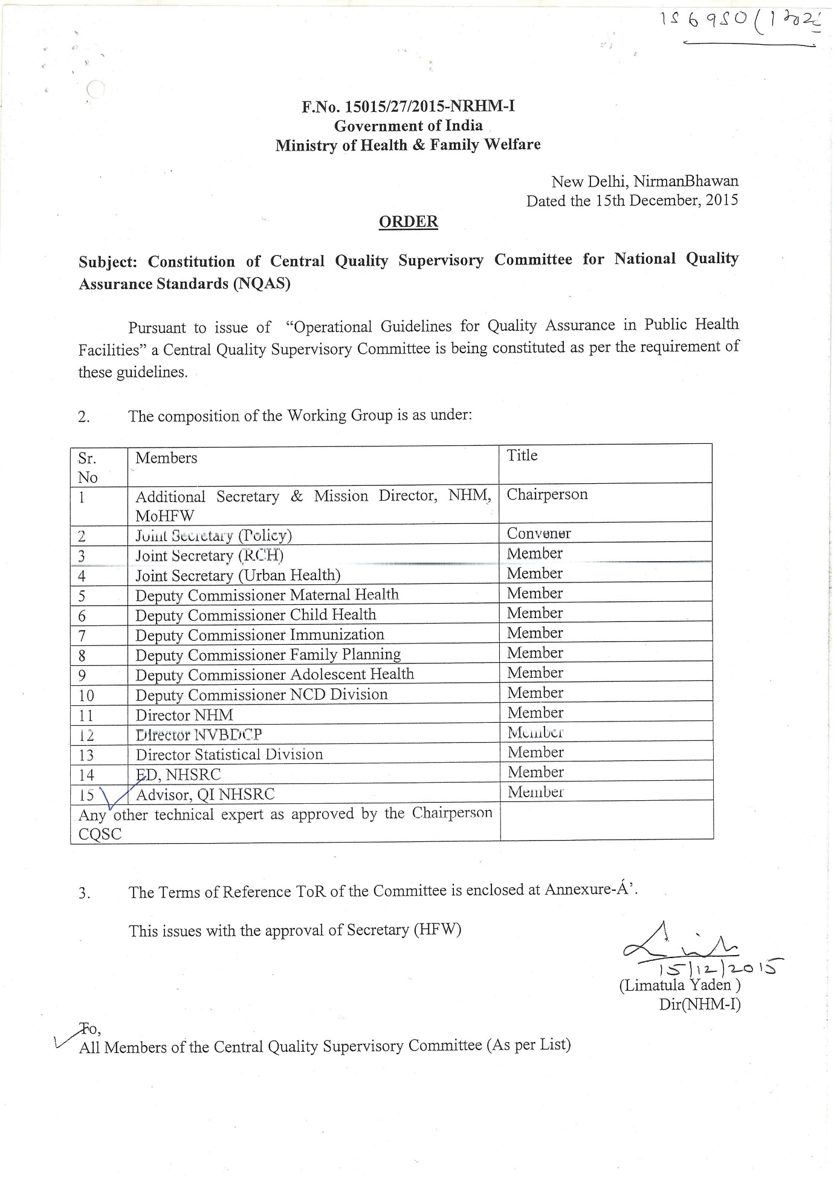

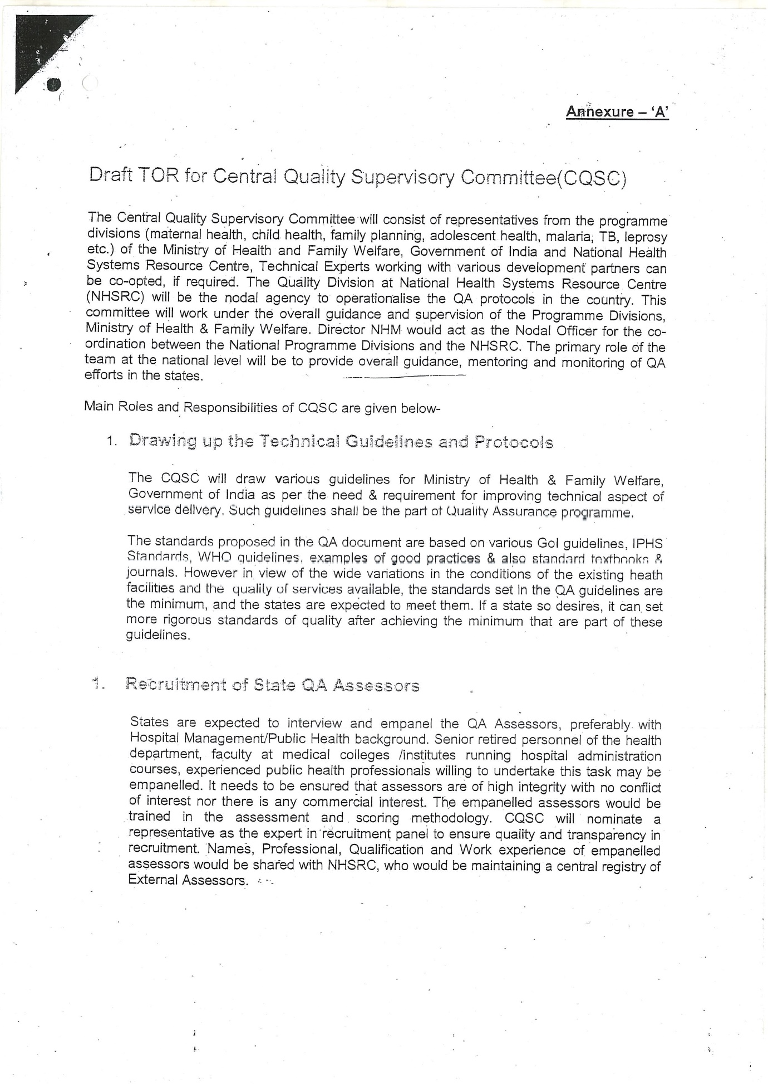

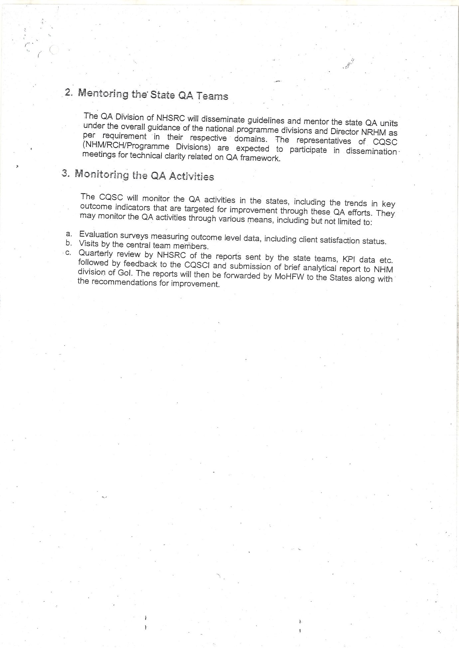

**Annexure II**

**List of Participants: Central Quality Supervisory Committee**

**List of CQSC members:**

|  |  |  |
| --- | --- | --- |
| **S.NO.** | **Name** | **Designation** |
| **1.** | Dr. A.K. Panda | AS & MD, NHM, MoHFW - Chairman |
| **2.** | Shri Manoj Jhalani | JS, Policy & Convenor |
| **3.** | Dr K. Rajeswara Rao | JS, Urban Health |
| **4.** | Dr. Sanjiv Kumar | ED, NHSRC |
| **5.** | Dr. S.K. Sikdar | DC, I/C FP |
| **6.** | Dr. Sushma Dureja | DC, Adolescent Health |
| **7.** | Dr. P.K. Prabhakar | DC, Child Health |
| **8.** | Dr. Sunita | DC, Maternal Health |
| **9.** | Ms. Navanita Gogoi | Director, Statistics, MoHFW |
| **10.** | Capt. Kapil Chaudhary | Director, NHM, MoHFW |
| **11.** | Dr. J.N. Srivastava | Advisor, QI, NHSRC |

**Others:**

|  |  |  |
| --- | --- | --- |
| **S.NO.** | **Name** | **Designation** |
| **1.** | Dr. Parminder Gautam | Senior Consultant, QI, NHSRC |
| **2.** | Dr. Nikhil Prakash | Senior Consultant, QI, NHSRC |
| **3.** | Dr. Sushant Agarwal | Consultant, QI, NHSRC |
| **4.** | Dr. Deepika Sharma | Consultant, QI, NHSRC |
| **5.** | Dr. Jagjeet Singh | Consultant, QI, NHSRC |
| **6.** | Mr. Rajesh Nallamothu | Consultant, QI, NHSRC |
| **7.** | Dr. Namit Singh Tomar | Consultant, QI, NHSRC |
| **8.** | Dr. Abhay Dahiya | Short-term Consultant, QI, NHSRC |
| **9.** | Mr. Gulam Rafey | Short-term Consultant, QI, NHSRC |
| **10.** | Dr. Shivali Sisodia | Fellow, QI, NHSRC |
| **11.** | Shri Shabeer P.K. | Consultant, NHM, MoHFW |
| **12.** | Dr. Disha Agarwal | Consultant, MoHFW |