UPHC INTERNAL ASSESSOR TRAINING ON NATIONAL QUALITY ASSURANCE STANDARDS

9th -11^{h} March, 2015 at Panchkula

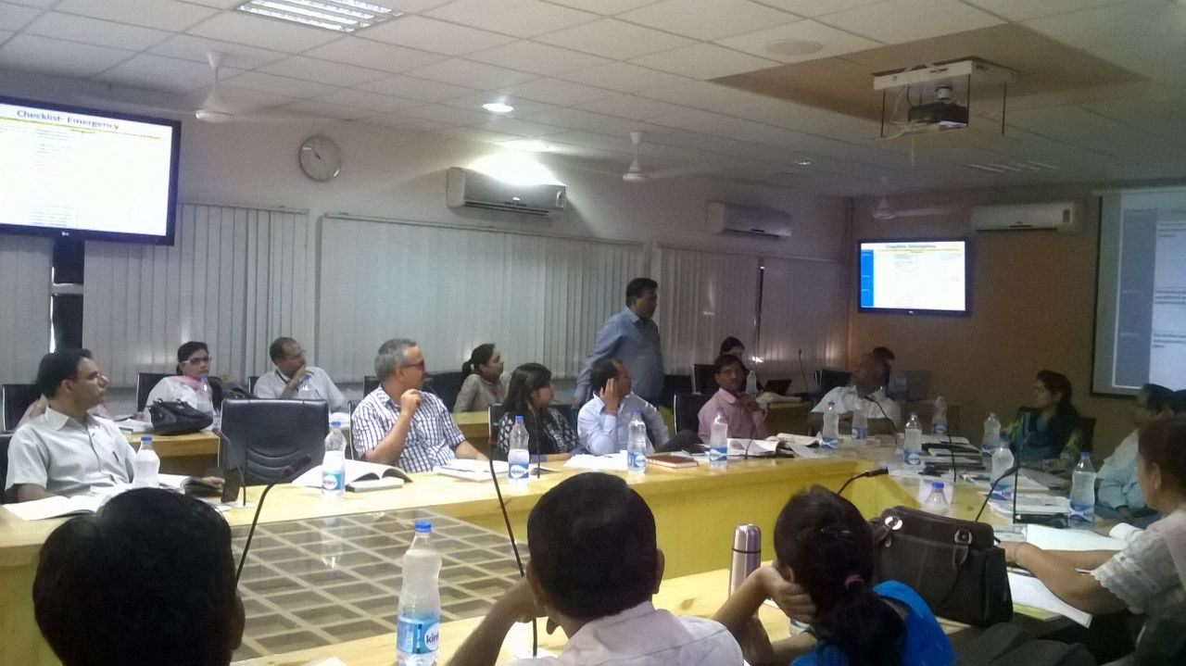

Conducted by:

National Health System Resource Centre in collaboration with
Haryana State Health Resource Centre and NUHM Haryana.

HARYANA

TRAINING REPORT: UPHC INTERNAL ASSESSOR’S TRAINING ON
NATIONAL QUALITY ASSURANCE STANDARDS

TRAINING COORDINATOR: Dr PARMINDER GAUTAM (Sr. Consultant, NHSRC, New Delhi)
Dr. RUCHI (State consultant QA HSHRC Haryana)

DATE OF TRAINING: 4th to 5th July 2016

PLACE OF TRAINING: SIHFW, Panchkula, Haryana.

PARTICIPANTS OF TRAINING: Total no. 44. (List attached in Annexure I)

OVERVIEW:
Two-days Internal Assessor training for UPHC was conducted in state of Haryana by National Health System Resource centre) in collaboration with HSHRC (Haryana Health State Health Resource Centre) and National Urban Health Mission (NUHM) Haryana from 4th to 5th July 2016.
Main objective of the training was to provide an overview of National Quality Assurance Standards as well as to develop state internal Assessor for the NQAS program. To fulfil the main objective state has nominated 44 participants for the training which include State and district Nodal Officers of Urban Health, State and district Urban Health Consultants, Medical Officers and Staff Nurses from UPHC, Deputy Civil surgeons, QA and PH consultants,.
Training started with inaugural Key note by Dr. Sonia Trikha, ED HSHRC who discuss about importance of the Quality in Healthcare system & assure participants about state support for Quality assurance in state. 2 day training was spread in to 10 Topics & 4 exercises for Hands on experience about various methodologies of the assessment.
Training was followed by Post training evaluation, which was attended by 44 participants. Post training evaluation was an open book exam with Question paper having 32 multiple-choice Questions. Maximum Marks for Question paper is 30. Passing marks for exam was 60%. all 44 participants who appeared in the exam sored 60% more and clear the exam.
Training program have inbuilt training course evaluation system, where training feedback form is provided to each participant. Feedback of participants has been analyzed on 5 point scale. Overall score for training program was 4.2 on a Five-point scale.

Training Agenda: Internal Assessor Training on Quality Assurance in Urban Health Facilities
4th -5th July 2016-Haryana
Time | Session | Speaker
Day 01 (4th July 2016)
9:00 am - 9:30 am | Registration
9:30 am – 10:00 am | Inaugural Address | SHSRC & NUHM Haryana
10:00am -11:00 am | Key concept of Quality, overview National Quality Assurance Program & National Urban Health Mission | Dr Parminder Gautam  Senior Consultant NHSRC
11:00 am -11:15 am | Tea
11:15 am –12:15 am | Measurement System, standards & Assessment Protocol | Dr Deepika Sharma  Consultant NHSRC
12:15 am – 1:00 pm | Area of Concern A&B (Service Provision & Patient Rights) | Mr Rajesh Nallamothu  Consultant NHSRC
1:00 pm – 2:00 pm | Lunch
2:00 pm – 3:00pm | Area of Concern C & D (Inputs & Support Services) | Mr Rajesh Nallamothu  Consultant NHSRC
3:00 pm -4:00 pm | Exercise on Area of concern A,B, C, & D
4:00pm -4:15 pm | Tea
4:15am-5:15 pm | Area of concern E (Clinical Services) | Dr Parminder Gautam  Senior Consultant NHSRC
 | Day 2 (5th July 2016)
9:00 am-9:30 am | Recap
9:30 am- 10:30 am | Infection Prevention & BMW rules 2016 (Area of concern F) | Dr. Neeraj  CH Panchkula
10.30 am – 11:00 am | Steps for implementation of QA program (Area of Concern G) | Dr Deepika Sharma  Consultant NHSRC
11:00 am- 11:15 am | Tea
11:15 am -12:15am | Gap analysis, action Planning & Patient satisfaction (Area of Concern G) | Dr Deepika Sharma  Consultant NHSRC
12:15 am -1:00 pm | Exercise on gap analysis & action planning
1:00pm- 2:00 pm | Lunch
2:00 pm -3:00 pm | Key Performance Indicators (Area of concern H) | Mr Rajesh Nallamathou  Consultant NHSRC
3:00 pm- 3:30 pm | Prescription Audit | Dr Parminder Gautam  Senior Consultant NHSRC
3:30 pm- 4:30 pm | Post Training Evaluation & working tea
4:30pm -5:00pm | Thanks & valedictory

Session Brief
Topic | Session Brief
Day -1 (4-07-2016)
Key concept of Quality, overview National Quality Assurance Program & National Urban Health Mission | Session covers concepts of Quality, discussion about various definitions of Quality, Dimensions of Quality (structure, process and outcomes), Improvement Cycle (PDCA), Development of National Quality Assurance Standards & their implementation framework at state & district level, challenges and opportunities in QA in UPHCs.
Measurement System for Quality Assurance & Assessment Protocol | Session covers understanding about Measurement system of National Quality Assurance standards. Elaboration of 8 Area of Concerns, Standards, Measurable Elements & checkpoints. It also cover overview about scoring & their methodology. A detailed discussion about 18 checklists of District Hospital Level
Standards for Area of Concern-A,B,C and D  Service Provision , Patient Rights , Inputs and Support services. | Session cover an elaborative discussion about first 4 area of concern i.e. Service Provision, Patient rights; Input and support services. It includes thorough understanding about availability of services & discussion on patient rights. It included availability of infrastructure, human resource and their training, competencies & also availability of consumables & drugs. Under support services, Maintenance of equipment, calibration, inventory management, dietary services, Laundry services, Security services, Community participation, financial management, contract management & Statutory requirement etc were discussed.
Exercise-Case study | A Case Study on ‘Outreach Services” was given to participants for better understanding of scoring system as well as hands on experience about assessment. Individually all participants had worked upon case study followed by formulation of score card for Area of Concern A, B & C. Followed by thorough discussion about all the checkpoints
Standards for ‘Area of Concern-E’  Clinical Services | Session include importance of clinical services as well as discussion on 9 standards of Clinical services which includes importance and methods of having established procedures for Registration and Consultation, Primary management and continuity of care, safe Drug Administration, and adherence to Standard Treatment Guidelines, Maternal Health care, New-born and child health care, Family planning, Adolescent health and National health program.
Day -2 (5-07-2016)
Standards for Infection Control  and Biomedical waste management | Session includes detailed discussion about standards precautions as well as infection control committee. It includes elaborative details on how to assess the infection control practices at public health care facilities. How to manage the biomedical waste generated by health facilities? What is new in the revised Biomedical waste management Rules 2016, their importance, relevance and implications were also discussed. Videos on infection control practices were also shown to participants.
Steps for implementation of QA program (Area of Concern G) | Session include discussion on how to establish a QMS at UPHC, Formation of multi-disciplinary Quality Team and regular meetings., Quality Policy, Quality Objectives, SOP, PSS, process mapping etc,.
Gap analysis, action Planning & Patient satisfaction (Area of Concern G) | Session include identification of gaps with the help of photographs as well as identification of standards & Area of concern related to gaps, prioritization of gaps, developing a time-bound Action Plan and its monitoring. A detailed discussion on how to conduct, analyse and improve patient satisfaction was carried out.  The discussions were followed by an exercise .
Key Performance Indicators | Session include description, importance and methods of calculating 16 Key Performance indicators of a UPHC. It also includes how to calculate & reporting mechanism of KPI at facility, district & state level.
Prescription Audit | The session included essential components of a good prescription, common errors made and methodology of conducting Prescription Audits.  The session was followed by an exercise wherein some random prescriptions from a nearby UPHC were audited using a simple tool.
Post Training Evaluation | At last Post training Evaluation of participants has been conducted. Post training evolution contain 40 Multiple choice Questions. Participants are allowed to use their notes & assessment guidebook for answering question paper.

TRAINING FEEDBACK EVALUATION (on 5-point Likart Scale)
S.No | UPHC INTERNAL ASSESSOR TRAINING FEEDBACK PANCHKULA, HARYANA.
 | TOPIC | AVERAGE SCORE
1 | KEY CONCEPTS OF QUALITY & OVERVIEW OF NQAP & NUHM (Dr. Parminder Gautam) | 4.63
2 | MEASUREMENT SYSTEM, STANDARDS & ASSESSMENT PROTOCOLS (Dr. Deepika Sharma) | 4.33
3 | AREA OF CONCERN A, B, C & D (Mr. Rajesh Nallamothu) | 3.83
4 | Exercise on Area of Concern A,B,C and D | 3.88
5 | AREA OF CONCERN-E (Dr. Parminder Gautam) | 4.21
6 | INFECTION PREVENTION & BMW RULES 2016 (Dr. Neeraj) | 4.08
7 | STEPS FOR IMPLEMENTATION OF QA PROGRAM (Dr. Deepiks Sharma) | 4.25
8 | Gap Analyisis, Action Planning & Patient Satisfacion (Dr. Deepika Sharma) | 4.25
9 | KEY PERFORMANCE INDICATORS (Mr. Rajesh Nallamothu) | 4.04
10 | PRESCRIPTION AUDIT (Dr. Parminder Gautam) | 4.63
OVER ALL SCORE |  | 4.21

DETAILS OF PARTICIPANTS APPEARED IN INTERNAL ASSESSOR EXAM WITH RESULT

Post Training Evaluation of UPCH INTERNAL ASSESSOR Training (4th to 5th July 2016)
S.No. | Name of Participant | Name of Facility | Designation | Contact number | Email ID | Marks/30
1 | DR. SUMAN VASHISHTH | UPHC RAJNAGAR PANIPAT | MO | 9896072922 |  | 26
2 | DR. PARVEEN KUMAR BOORA | POLYCLINIC SEC-8, JIND | DENTAL SURGEON | 9466847597 | parveenboora@gmail.com | 27
3 | DR. SATYA PRAKASH | REWARI | MO | 9416340602 | truelight84@gmail.com | 29
4 | DR. NEERAJ YADAV | DH SONEPAT | UH CONST. | 8816086128 | drneeraj73@gmail.com | 27
5 | DR. NITIN KUMARI | KKR | UH CONST. | 8572070809 | urbanhealthconsultantkkr@gmail.com | 26
6 | DR. TAMANNA SHARMA | PANCHKULA | DIST. QA CONST. | 9034490233 | tamannamehra@gmail.com | 18
7 | DR. GAGAN JAIN | JHAJJAR | UH CONST. | 9017269534 | urbanhealthconsultantjhajjar@gmail.com | 28
8 | DR. PREET VERMA | FARIDABAD | UH CONST. | 9818003879 | dr.preetverma@gmail.com | 29
9 | MS. RITIKA SHARMA | YMN NGR | DIST. QA CONST. | 8295266732 | 7.ritika@gmail.com | 26
10 | DR. VINEETA BHATTACHARJEE | UPHC FRDBD | MO | 9999623722 | uphcshivdurgaviharfba@gmail.com | 26
11 | MS. POOJA | YMN NGR | DPM | 7027823368 | dpmuyanunanagar@gmail.com | 26
12 | DR. NIDHI SHARMA | STATE HQ | PROG OFF NUHM | 8558897493 | pouhharyana@gmail.com | 25
13 | DR. ASHWANI BINDAL | UPHC BHIWANI | MO | 8685097960 | ashwani.bindal56@gmail.com | 23
14 | DR. GURNEETA KAUR BHALLA | UPHC FRDBD | MO | 9990740765 | uphchariviharfbd@gmail.com | 28
15 | DR. ANITA SHARMA | UPHC GURUGRAM | MO | 9868627980 | dranitasharma05@gmail.com | 20
16 | DR. SAROJ AGGARWAL | CH PANCHKULA | DY. C.S. | 9779903450 | saroj1756@yahoo.co.in | 29
17 | MS. ANU | PALWAL | UH CONST. | 9996087289 | uphcpalwal@gmail.com | 27
18 | MR. MEHBOOB | AMBALA | UH CONST. | 7027822092 | uhcambala@gmail.com | 21
19 | DR. YOGITA | UPHC AMBALA | MO | 9416037127 |  | 26
20 | DR. UMESH SHARMA | UPHC JHAJJAR | MO | 9811133623 |  | 28
21 | DR. SEEMA | SONIPAT | UH CONST. | 9466456801 | dpmurbansnp@gmail.com | 25
22 | DR. SUNITA MANGAL | HSHRC | MO (DENTAL) | 8813077321 | drsunitamangal@gmail.com | 26
23 | DR. NAVEEN TAXAK | UPHC GURUGRAM | MO | 7056909909 | ntaxak02@gmail.com | 26
24 | DR. SONIA JERATH | STATE HQ | STATE UH CONST. | 8558894069 | pouhharyana@gmail.com | 25
25 | MS. RAJBIR KAUR | PANIPAT | PH CONST. | 8571036641 | rajbirkpandey@gmail.com | 26
26 | DR. NAVNEET SINGH | PHC DARIYAWALA JIND | DENTAL SURGEON | 9991052039 | drnons2039@gmail.com | 28
27 | DR. MADHUBALA VASUDEVA | UPHC YAMUNA NAGAR | MO | 9813170066 | madhubalavasudeva@355.com | 27
28 | MR. HARI OM | PANIPAT | UH CONST. | 9813753812 | uhcpanipat@gmail.com | 27
29 | MS. PARMILA | UPHC SONEPAT | STAFF NURSE | 8950828390 |  | 26
30 | MS. SONIKA HOODA | FARIDABAD | UH CONST. | 9811790560 | uhcfaridabad@gmail.com | 26
31 | DR. DEEPAK CHOPRA | FARIDABAD | UH NODAL OFFICER | 9910189688 | drrajuchopra@gmail.com | 28
32 | DR. RAMESH SABHARWAL | KKR | MO | 9416990113 | ramesh.sabharwal@rediffmail.com | 26
33 | DR. NEHA GHAI | STATE HQ | JR. CONST. UH | 9558894049 | nehaghai@gmail.com | 26
34 | DR. MARTAND PRATAP SINGH | GURUGRAM | UH NODAL OFFICER | 9891716196 | dr_martand@yahoo.com | 25
35 | DR. VINAY KAUSHIK | UPHC BHIWANI | MO | 9466545471 | vinaykaushik68@gmail.com | 23
36 | MS. POONAM CHAUDHARY | HSHRC | TC QA | 9784868116 | poonam_chaudhary20@yahoo.com | 27
37 | DR. NAVEEN KUMAR KOKCHA | BHIWANI | DC QA | 9992298115 | naveenkokcha@gmail.com | 26
38 | DR. VIBHU MITTAL | SONIPAT | DC QA | 9729441525 | drvibhumittal@gmail.com | 29
39 | MR. MUMTAZ KHAN | GURUGRAM | UH CONST. | 9990328711 | mumtazkhan1615@gmail.com | 20
40 | DR. VISHAL GUPTA | AMBALA | DENTAL SURGEON | 9416192641 | vishal8398@gmail.com | 28
41 | DR. MONIKA | AMBALA | DC QA | 9416188691 | dr.monika25@gmail.com | 26
42 | DR. MANISH PASSI | PANIPAT | UH NODAL OFFICER | 9896203616 | drpassimanish@gmail.com | 28
43 | DR. U.P.S. DAHIYA | YMN NGR | DY. C.S. | 9354083575 | drvpsdahiya@gmail.com | 27
44 | DR. SHIVALI SISODIA | NHSRC | FELLOW | 9888973767 | shivali.sisodia3@gmail.com | 29

