‘’Swachh Bharat Abhiyan’’ Training on Kayakalp

4th to 5th July 2016, Uttarakhand

Conducted by

National Health System Resource Centre in collaboration with MHFW department Uttarakhand

TRAINING REPORT
‘’SWACHH BHARAT ABHIYAN’’ TRAINING ON KAYAKALP

TRAINING COORDINATOR
Dr Jitendra Negi (Assistant Director, QA, Uttarakhand)
Dr Abhay Kumar (Consultant, NHM Uttarakhand)
Dr Arvind Kumar (Consultant, NHM, Uttarakhand)
Dr Sushant Agarwal (Consultant, QI, NHSRC, New Delhi)

DATE OF TRAINING
4th to 5th July 2016.

PLACE OF TRAINING
Conference Hall, Health directorate, Dehradun, Uttarakhand

PARTICIPANTS OF TRAINING
Total no. 31 (List attached in Annexure I)
COURSE SCHEDULE
The course schedule (Attached in Annexure II) outlines the day to day contents.

Contents
OBJECTIVES OF TRAINING 3
BACKGROUND 4
EXECUTIVE SUMMARY 5
DAYWISE SUMMARY OF THE PRESENTATIONS 6
Day 1 6
Day 2 9
Annexure I 11
List of Participants 11
Annexure II 13
Agenda 13
13
Annexure III 16
Feedback Analysis 16
Annexure- IV 18
Road Map for Kayakalp 2016-17 18
Annexure- V 20
Photo Gallery 20

OBJECTIVES OF TRAINING

- To equip participants as a master trainers for providing ‘’Swachh Bharat training’’ at their respective districts and facilities.
- To roll out ‘’KAYAKALP’’ program in Uttarakhand for FY 2016-17.
- To develop skills and acumen to carry out internal and peer assessment of facilities under ‘’KAYAKALP’’ Program.
- To understand importance of quality assurance, Swachhata and infection control for the facilities.
- To prepare a road map for ‘’Kayakalp’’ 2016-17.

BACKGROUND

The Swachh Bharat Abhiyan launched by the Prime Minister on 2nd October 2014, Focuses on promoting cleanliness in public spaces. Public health care facilities are a major mechanism of social protection to meet the healthcare needs of large segments of the population.

Cleanliness and hygiene in hospitals are critical to preventing infections and also provide patients and visitors with a positive experience and encourage moulding behaviour related to clean environment. As the first principle of healthcare is ‘’to do no harm’’ it is essential to have our healthcare facilities clean and to ensure adherence to infection control practices.

To recognise such efforts of ensuring Quality Assurance at Public Health Facilities, the Ministry of Health & Family Welfare, and Government of India has launched a National Initiative to give Awards ‘KAYAKALP’ to those public health facilities that demonstrate high levels of cleanliness, hygiene and infection control. To supplement these Swachhta Guidelines for Public Health Facilities have also been issued.

For its effective roll out of this program in all States and UTs ‘’Swachh Bharat Abhiyan’’ has been introduced from FY 2016-17. One TOT on ‘’Swachh Bharat Abhiyan’’ were designed for two days training at State level. Participants were expected to provide same kind of training at their respective districts and facilities. One training schedule was prepared for this and it was extended up to period of two days. (Annexure-II)

EXECUTIVE SUMMARY

It was 1st ‘’Swachh Bharat Abhiyan’’ training conducted in the country by NHSRC. It was conducted in collaboration with Medical, health and family welfare department of Uttarakhand, from 4th July 2016 to 5th July 2016 at Conference hall, Health Directorate, Dehradun.

The aim of training was to strengthen participants with knowledge of overall importance of Swachhata, Sanitation and Hygiene and Infection control. It was also expected that participants would be equipped with knowledge and skills so that they can further organised these training at district and facilities level. Course curriculum for training was prepared by the NHSRC and was duly syndicated with state. 31 Participants of this training were from diverse background including Chief medical superintendents, Chief Medical officers, Medical Officers, Consultants, Hospital Manager and Staff nurses, from 13 districts and both regions of Uttarakhand.
The participants were given-
- A copy of KAYAKALP Guideline- Award to Public Health facilities.
- A copy of Swachhta Guidelines for Public Health facilities.
- A bag with writing pad, pen.
- Hard copy of exercises and material wherever required during training.
- Pen drive with all PowerPoints slides with all resource materials for the training.

The programme had 15 sessions, spread over a period of two days along with group exercises. (Annexure-II)

Feedback from the participants was taken and the report contains analysis and suggestions given by the participants. The overall rating of the programme in feedback has been very good with an overall score of 4.47 on a 5 point scale. (Annexure- III)

At last road map for kayakalp program 2016-17 was prepared for ‘’Uttarakhand’’. (Annexure- IV)

DAYWISE SUMMARY OF THE PRESENTATIONS

Day 1

Training was formally inaugurated by Dr Rajiv Pal, Joint Director Uttarakhand. He explained about the importance of Swachhta during his inaugural speech and welcome faculties from NHSRC and participants across the state.
Dr Jitendra Negi, Nodal officer QA, Uttarakhand presented their experience of implementation of ‘’KAYAKALP’’ in FY 2015-16. He explained about the whole ‘’Kayakalp’’ journey during last year and share their experience. He also had shown some photographs of the facilities like District female Hospital Haridwar and how they changed after implementation of this program.
Mr Girish Khandoori, Consultant QM, NHM welcome all participants from the State and ask for round of introductions from all participants.
After formal introduction from participants and faculties first presentation of the training was started by Dr J N Srivastava, Advisor QI, NHSRC with a topic on ‘’Overview of Kayakalp and Swachh Bharat Abhiyan’’ . He explained first about the Public Health system.
Which comprises of:-
- 7% of all hospitals, 20% of Resources, 20% of Doctors, and 36% of all beds
- 20% OPD Care, 37% IPD Care, 60% Terminal care and approx. 98% Immunisation services are provided by Public health facilities.
He also said after launch of National Health Mission 91% of OPD and 120% of IPD care has been increased from year 2009-10 to 2013-14.
He explained how Quality of services are utmost importance for the ministry and therefor Quality Standards for DH, CHC, PHC and Urban OHC has been released. He explained about 8 areas of concerns in ‘’National Quality Assurance Standards’’. He said ‘’KAYAKALP’’ program has been launched under Swachh Bharat mission of Prime Minister of India.
Dr Sirivastava then explained about the features of program like a system of internal assessment, Peer and External Assessment.
He said award scheme this year is extended up to CHCs and PHCs also. Number of awards depends upon the number of districts in the State. So for the large State (>50 districts) will have 3 award, Medium State (26-50 districts) will have two awards and for small states ( <10 Districts) will have only 1 award. All the facilities will be eligible for commendation award if scored more than 70% in external assessment.
Second session was taken by Dr Sushant Agrawal, Consultant, NHSRC on “Assessment Protocols”. He has explained that in Kayakalp tool there are 6 thematic areas 50 Components and 250 Checkpoints with a total score of 500 marks. He provided a brief overview of all thematic areas during his presentation. Dr Agrawal also explained about four assessment methods viz Observation, Staff Interview, Patient Interview and Record review also. Scoring method of ‘’Kayakalp’’ was also explained by him. He said for the simplicity of the assessor they have to score only 0,1 or 2. Zero can be scored if there is no compliance with the checkpoints, 1 for partial compliance and 2 for full compliance.
The next presentation was given by Dr Namit Singh Tomar , Consultant, NHSRC He has explained about “Facility Management”. He covered A4 Facility appearance, A1 Pest and Animal Control, A5 Infrastructure appearance; A7- Furniture and fixture maintenance, A8 Junk material and A10 work place management components of Kayakalp checklist. He explained about the importance of appearance of the facilities, condemnation policies to remove junks from the hospital. He also explained with an example about the Japanese management technique of Work place Management.
Next session was presented by Dr J N Srivastava and he presented on ‘’New dimension in Bio Medical waste Management Rule 2016’’. He explained how basic sanitation, Hygiene and infection control practices were followed in ancient times. He said even Charaka summarized all the attributes of a good hospital, including location in a breezy spot free of smoke and protected from the sun, smells, and objectionable noises. Details of equipment needed were described even to the extent of proper brushes and brooms in his book Charaksamhita.
Dr Srivastava shown how new BMW Management Rule 2016 is different from BMW Management Rule 1998. He emphasised these new highlights of BMW Rule 2016:-
- Scope – It also includes AYUSH Health Facilities, Vaccination Camps, First-Aid Rooms of Schools, Forensic Labs, etc.
- Constitution of a new committee at the state level
- Small facilities less than thirty beds may designate a qualified person to review and monitor the activities relating to bio-medical waste management
- Bar Code System for bags & containers (after 28th March 2017)
- Phase-out Chlorinated bags and no Non-chlorinated plastic bags after 28th March 2018
- On-site disinfection of laboratory waste, microbiological waste, blood samples & blood bags
- Treatment & disposal of Liquid waste in accordance with the water (Prevention & control of Pollution) 1974
- ‘On-site’ Waste Management can be established if nearest CTF is 75 kms away
- Segregated collection – Four Categories
- Prior Approval for ‘Deep Burial’
Post lunch Dr Sushant Agarwal, had taken session on “Group Activity- Key Words”. He distributed few small chits to all participants with one key word. All participants were expected to find thematic area, components and check points as per the Key word written on the chit. They had to form six broad group based upon thematic areas. After group formation they were expected to explain about the importance of particular key word and checkpoints for Swachhta in hospitals. All participants enthusiastically did this exercise and it acts as a breather for them.
Next session was taken by Dr J N Srivastava on ‘’Waste Management- Special Consideration’’. In this session Dr Srivastava defined waste and explained about the importance of proper waste management in the facilities. He explained Solid, liquid and hazardous waste during this session also. Classification of waste into Bio Degradable, Non-Biodegradable and Domestic Hazardous waste was also explained to participants. Management of Bio Degradable waste through Sanitary land fill, Composting, Vermicomposting, EM (Effective Microorganisms) Technology, Bio-gas plant, Incineration and Salvaging was also explained.
Next session ‘’Green and Energy Efficient Hospital’’ was taken by Dr Sushant. He covered A2- Landscaping and Gardening, A3-Maintenance of Open area, A6-Illumination, E2- Water Sanitation, A9 Water Conservation and B10- Drainage and sewage Management components of Kayakalp. He shown so many photographs during this session and given examples of how hospitals have improved in these criteria during last year kayakalp program. He covered these topics in two subtopics for each component- like what is the problem of the facilities and what are easy solutions.
Last session for the day was taken by Dr Namit Singh Tomar on ‘’Clean Hospital’’. In this session he covered B 1-6 Why clean hospital, B7-8 Standard material and equipment for cleaning,B-9 Overview of Cleanliness and Cleanliness in High risk areas of Hospital. He discussed about 5S approach of work place management i.e. Sort, Straightening, shine, standardise and sustain. Than he explained about procedure of cleaning in various areas of hospital like wards, kitchen, laundry and high risk areas like ICU and OT.

Day 2
Day 2 was initiated with a brief recap of all the sessions of day one by Dr Sushant Agarwal. After that he handed over Dias to Dr Namit to take topic on “Infection Control Practices- Module-1”. He has explained mode of infection, difference between Antiseptic and disinfectant solution, hand hygiene, personal protective equipment, sharp instrument and its safe practice for prevention. During his session he shown two videos of ‘’Proper Hand Washing’’ and ‘’Proper method of wearing gloves’’
2nd session was taken by Dr Sushant Agrawal and took topic on “Infection control Practices Module-2”. In this session Dr Sushant covered processing of equipment i.e. Disinfection, cleaning and Sterilization. He shown NHM video, in this video correct method of instrument processing was shown. Dr Sushant also cleared confusion about preparation of Chlorine and Hypochlorite solution.
Next session was taken by Dr Namit on “Infection Control Program”. During this session Dr Namit covered D-8 and D-9 i.e. about Infection control program and Hospital acquired infection surveillance. He gave emphasis on constitution of infection control committee in all facilities. He also explained how to calculate hospital acquired infection in the facilities.
Next session was taken by Dr Sushant on ‘’Management of Support services’’. During this session management of hospital linen, kitchen and security services was discussed. Dr Sushant also discussed in details about management of all outsource services in the Hospital.
Post lunch session was started with an exercise called ‘’Gap Assessment’’ by Dr Sushant. During this session photographs from the facilities were shown and participants were expected to find out gaps and relevant checkpoint point from ‘’kayakalp’’ book.
Next session was on “Promoting Kayakalp and Swachh Bharat Abhiyan” by Dr Namit. In this session Dr Namit covered F-1 Community monitoring and patient participations, F-2 Information, Education and Communication, and F-5 Staff Hygiene and Dress code. Dr Namit explained about importance of community participation for Swachhta in public health facilities. He also give importance about ‘’Swachhta sapath’’ and various IEC for Swachhta. He also explained about importance of dress code and I-card for staff.
Next session was taken by Dr Sushant on “Managing and sustaining transformation’’. In this session Dr Sushant explained about various strategies for transforming organisation culture for a change. He said for a change there should be a leader who could have Power, Pain, Vision and do scarifies for a change in an organisation.
Last session of the training was taken by QI team from the State of Uttarakhand for ‘’Road map for KAYAKALP 2016-17’’ They took inputs from all participants and prepared a road map for ‘’KAYAKALP’’ 2016-17. (Annexure-IV)

After completion of all session of last day feedback were collected from all participants. (Annexure III).
At last Dr Jitendra Negi, Assistant Director and Nodal Officer Quality had given vote of thanks to faculties from NHSRC and all participants for overwhelming participation and sincerity towards the training.

Annexure I

List of Participants

TOT ON SWACHH BHARAT ABHIYAN-2016-17
DATE-4th & 5th JULY-2016
VENUE- HEALTH DIRECTORATE-DEHRADUN,UTTARAKHAND
S.NO. | NAME OF PARTICIPANT | DESIGNATION
1 | DR.RAJEEV PAL | JD-NHM
2 | DR.J.S.NEGI | ASST DIR-NHM
3 | SANTOSH BHASKAR | REGIONAL CONSULTANT -QM-GARHWAL
4 | DR. V.S. CHAUHAN | CMS-RUDRAPRAYAG
5 | DR.B.S. BISHT | SR.PATHOLOGIST-RUDRAPRAYAG
6 | DR. RAM BIHARI VERMA | PATHOLOGIST -DH -BAGESHWAR
7 | DR. AJAI VEER SINGH | QUALITY MANAGER-DH-RUDRAPUR
8 | TARUN BHARDWAJ | QUALITY MANAGER-HARIDWAR
9 | RANJANA WALIA | SISTER INCHARGE-BASE HOSPITAL -HALDWANI
10 | MEENA KOHLI | SISTER INCHARGE-DH-BAGESHWAR
11 | ROSY | ASST NURSING SUPRINTENDENT-NAINITAL
12 | MITHLESH BISHT | QUALITY MANAGER-HALDWANI
13 | RUPESH MUMGAIN | REGIONAL CONSULTANT -QM-KUMAON
14 | DR.H.S.PANDEY | ADD CMO -UDHAM SINGH NAGAR
15 | KANISHK KALA | QUALITY MANAGER-UTTARKASHI
16 | DR.V.C.KALA | MS-DH-BAURARI-TEHRI
17 | REETA BAMOLA | GYNAECOLOGIST-BAURARI-TEHRI
18 | DR.AMIT KUMAR | REGIONAL CONSULTANT-QA-GARHWAL
19 | DR.V.S.KADWAL | CMS PAURI
20 | DR.KALPANA GUPTA | CMS-FEMALE HOSPITAL PAURI
21 | DR. A.S. SAGAR | CMO-TEHRI
22 | DR.S.D.SURI | CMS
23 | BALBEER SINGH RAWAT | QUALITY MANAGER-PAURI
24 | DR.MEETU SRIVASTAVA | PAEDIATRICIAN-FEMAL HOSP-HARIDWAR
25 | ALYAMIN THOMUS | STAFF NURSE -FEMALE HOSPITAL-HARIDWAR
26 | DR. SANJAY | DH-UTTARKASHI
27 | DR.S.BORA | ORTHO SURGEON-DH-MALE HOSPITAL HARIDWAR
28 | DR.ABHAY KUMAR | STATE CONSULTANT-PH
29 | DR.ARVIND SRIVASTAVA | STATE CONSULTANT-QA
30 | GIRISH KHANDURI | STATE CONSULTANT-QM
31 | DIGPAL KANDARI | STATE PROGRAMME ASST-QA

Annexure II

Agenda
Master Training on “Swachh Bharat Abhiyan”, Uttarakhand
4th to 5th July, 2016
Day- 01
09:00 – 09:30 | Registration
09:30 – 10:00 | Inaugural address
10:00 – 10:30 | Experiences on Implementation of Kayakalp in 2015-16.  State Nodal Officer ( Quality Assurance), Uttarakhand
10:30 – 11:15 | Overview of Kayakalp and Swachh Bharat Abhiyan  Dr J.N.Srivastava, Advisor-Quality Improvement Division,  National Health Systems Resource Centre- New-Delhi.
11:15 – 11:30 | Tea
11:30 – 12:00 | Assessment Protocol  Dr. Sushant Agrawal, Consultant- Quality Improvement,  National Health Systems Resource Centre- New-Delhi
12:00 – 12:45 | Facility Management  Dr. Namit Singh Tomar, Consultant- Quality Improvement,  National Health Systems Resource Centre- New-Delhi
12:45 – 13:30 | New Dimensions in Bio- Medical Waste management  (Bio-Medical Waste Management rules 2016).  Dr.J.N.Srivastava.
13:30- 14:00 | Lunch
14:00 – 15:00 | Exercise- Group work
15:00 – 15:45 | Waste Management- Special Consideration  Dr.J.N.Srivastava
15:45 – 16:00 | Tea
16:00 – 16:45 | Green & Energy efficient Hospital  Dr. Sushant Kumar Agrawal
16:45 – 17:30 | Clean Hospital  Dr. Namit Singh Tomar
Day- 02
09:00 – 09:30 | Recap
09:30 – 10:15 | Infection Control Practices-1  Dr. Namit Singh Tomar
10:15 – 11:00 | Infection Control Practices-11  Dr. Sushant Kumar Agrawal
11:00 – 11:15 | Tea
11:15 – 12:00 | Infection Control Program  Dr. Namit Singh Tomar
12:00 – 12:45 | Management of support services  Dr. Sushant Agrawal
12:45 – 13:30 | Promoting “Kayakalp” & “Swachh Bharat Abhiyan”  Dr. Namit Singh Tomar
13:30 – 14:15 | Lunch
14:15- 15:00 | Exercise- Gap finding
15:00 – 15:45 | Managing & sustaining transformation  Dr. Sushant Kumar Agrawal
15:45 – 16:00 | Tea
16:00- 16:30 | Road Map on implementation of Kayakalp  Dr. Abhay and Dr.Arvind  State Quality Assurance Unit, Uttarakhand

Annexure III

Feedback Analysis
First TOT ''Swachh Bharat Training'' , Uttarakhand (Feedback Evaluation)
S.No | SESSION |  | FACULTY | Scores
1 | OVERVIEW OF KAYAKALP & SWACHH BHARAT ABHIYAN |  | Dr J.N Srivastava | 4.4
2 | ASSESSMENT PROTOCOLS |  | Dr.Sushant Agrawal | 4.36
3 | FACILITY MANAGEMENT |  | Dr Namit Singh Tomar | 4.28
4 | NEW DIMENSIONS IN BIO MEDICAL WASTE MANAGEMENT |  | Dr J.N Srivastava | 4.56
5 | GROUP ACTIVITY- KEY WORDS |  | Dr.Sushant Agrawal | 4.52
6 | WASTE MANAGEMENT SPECIAL CONSIDERATION |  | Dr J.N Srivastava | 4.52
7 | GREEN AND ENERGY EFFICIENT HOSPITAL |  | Dr.Sushant Agrawal | 4.4
8 | CLEAN HOSPITAL |  | Dr.Namit Singh Tomar | 4.32
9 | INFECTION CONTROL MODULE-1 |  | Dr.Namit Singh Tomar | 4.52
10 | INFECTION CONTROL MODULE-2 |  | Dr.Sushant Agrawal | 4.52
11 | INFECTION CONTROL PROGRAM |  | Dr Namit Singh Tomar | 4.48
12 | MANAGEMENT OF SUPPORT SERVICES |  | Dr.Sushant Agrawal | 4.44
13 | PROMOTING ''KAYAKALP'' & ''SWACHH BHARAT ABHIYAN'' |  | Dr.Namit Singh Tomar | 4.48
14 | EXERCISE- GAP ASSESSMENT |  | Dr.Sushant Agrawal | 4.63
15 | MANAGING AND SUSTAINING TRANSFORMATION |  | Dr Sushant Agrawal | 4.64
 |  |  | AVERAGE | 4.47
SESSIONS MOST APPRECIATED BY PARTICIPANTS
SESSION |  | NO. OF PARTICIPANTS APPRECIATED THE SESSION
INFECTION CONTROL PRACTICES- MODULE 1  Dr.Namit Singh Tomar |  | 13
INFECTION CONTROL PRACTICES- MODULE 2  Dr Sushant Agrawal |  | 13
BIO MEDICAL WASTE MANAGEMENT  Dr J N Srivastava |  | 7
EXERCISE- GAP ASSESSMENT |  | 5

SUGGESTIONS OF PARTICIPANTS
1. More exercises and Group activities should be included.
2. More video films can be shown during training.
3. Training days should be at least three days.
4. Duration of each presentation should not be too large.
5. Training should be organised for two region of ''Uttarakhand'' i.e. Garhwal and Kumaun.
6. One session on team work can be included.

Annexure- IV

Road Map for Kayakalp 2016-17

ROAD MAP ON IMPLEMENTATION OF KAYAKALP PHASE-2 -UTTARAKHAND (2016-17)
S.NO | ACTIVITIES | TIME LINE
1 | Constitution of State Award Nomination Committee(Member of SQAC) & District Award Nomination Committee (Member of DQAC) | 19th October-2015
2 | State Level Awareness Training on KAYAKALP in FY 2015-16 | 28th October-2015
3 | State Level Master Training on ‘’Swachh Bharat Abhiyan’’ | 4th & 5th July-2016
4 | Awareness cum Internal Assessors Workshop at District Level | 20th July-2016
5 | Facility Level Training on’’ Swachh Bharat Abhiyan’’ at District Hospital  (1 Per DH) | 30th July-2016
6 | Facility Level Training on ‘’Swachh Bharat Abhiyan’’ at SDH/CHC of District  (1 Per SDH) | 30th July-2016
7 | Facility Level Training on ‘’Swachh Bharat Abhiyan’’ at PHC of Districts  (1 Per PHC) | 30th July-2016
8 | KAYAKALP External Assessors Training at State Level | 30th August-2016
9 | Constitution of Infection control committee/Quality team at CHCs & PHCs | 30th July-2016
10 | Baseline internal Assessment at facility level | 5th August-2016
11 | Gap analysis & action plan for Gap Closure phase -1 (Minor Gaps) | 14th August-2016
12 | Gap analysis & action plan for Gap Closure phase -2 (Moderate Gaps) | 25th August-2016
13 | Gap analysis & action plan for Gap Closure phase -3 (Major Gaps) | 5th September-2016
14 | 2nd Internal assessment at facility level | 10th September-2016
15 | Peer Assessment by the other districts for that facilities who will secure  70 % or more than 70 % score in internal Assessment | 20th September-2016
16 | External Assessment by the state team | 30th September-2016
17 | Final Award Declaration of DH/CHC/PHC | 2nd October-2016

Annexure- V

Photo Gallery

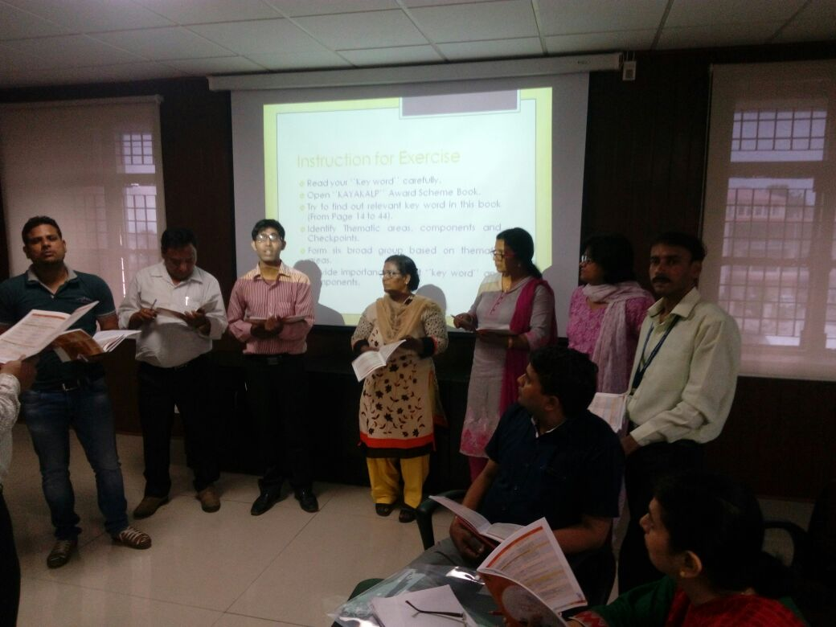
Enthusiastic participation during Group activity Exercise- Key Words

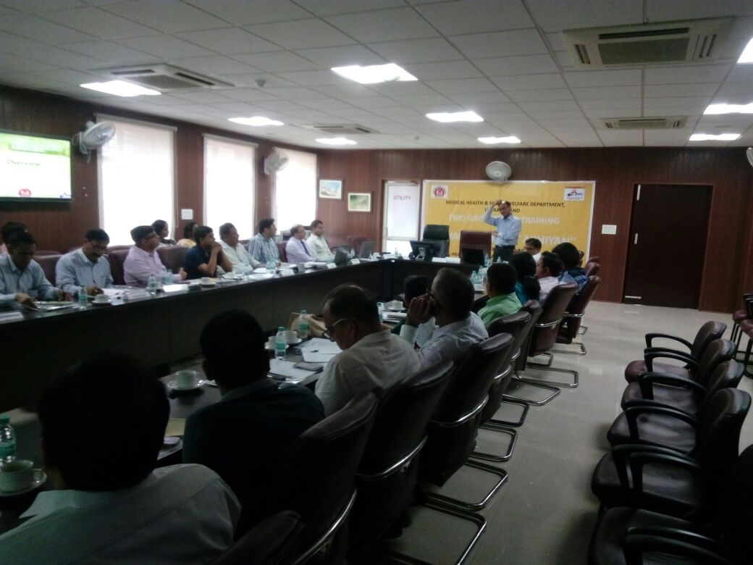
Dr J N Srivastava describing Kayakalp Overview
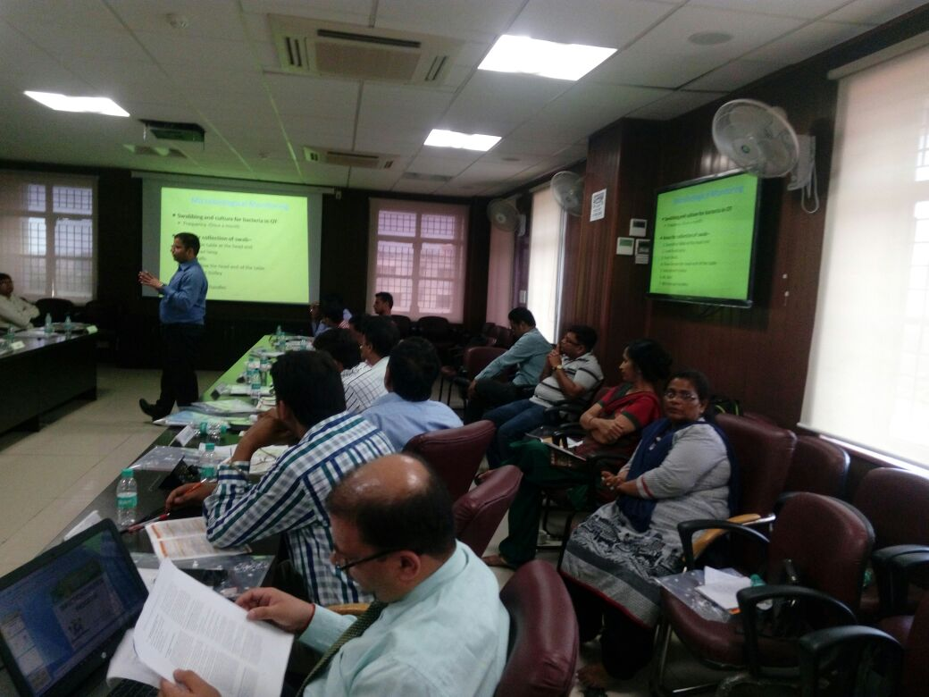
Dr Sushant explaining ‘’Green and Energy Efficient Hospital’’

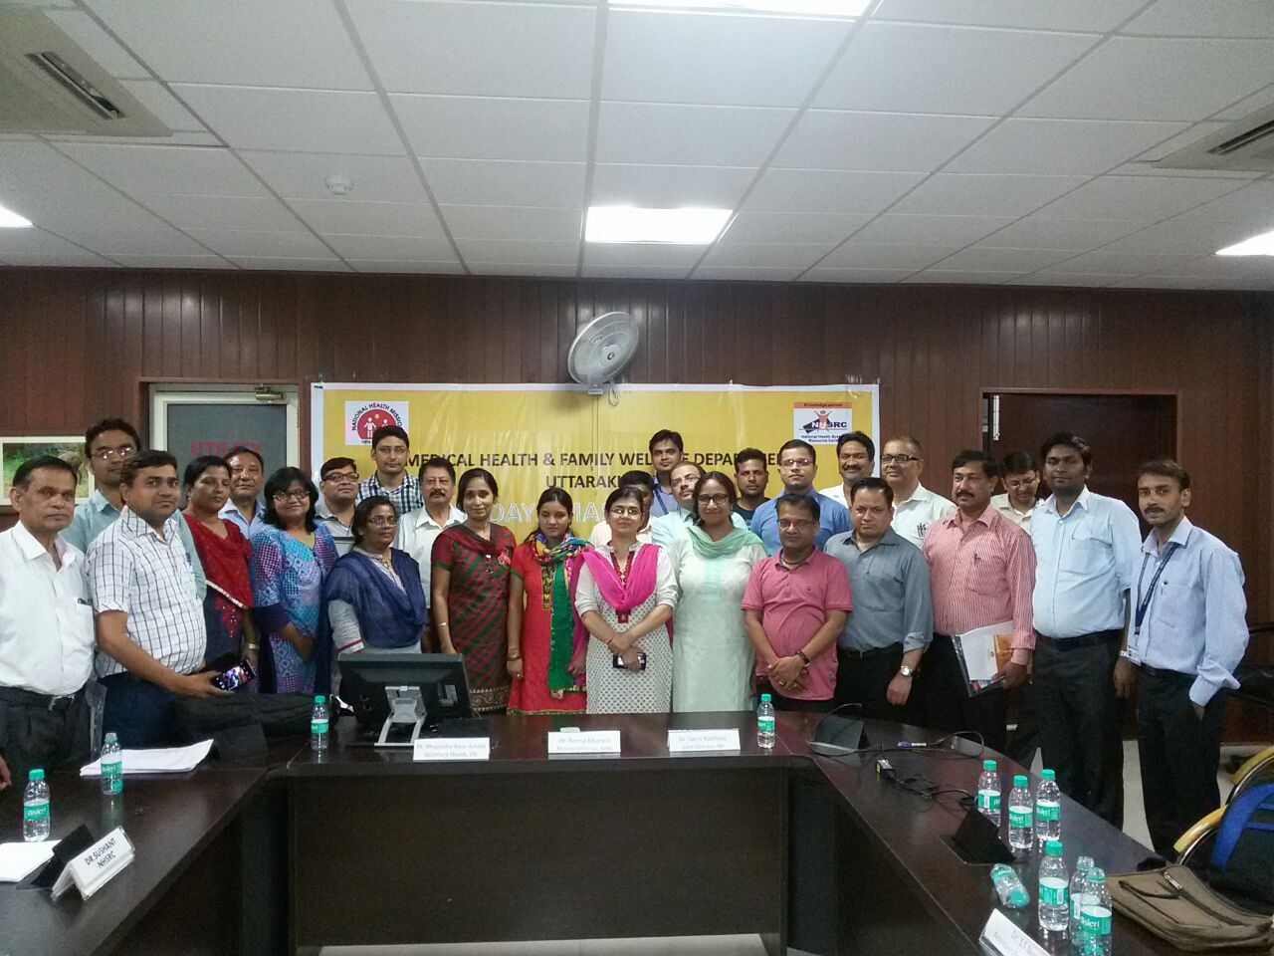
Group Photographs after Training

Dr. Shushant explaining about Plan-Do-Check-Act

