Service Provider Training on National Quality Assurance Standards

25th May to 27th May 2016, Nagpur, Maharashtra

Conducted by

National Health System Resource Centre in collaboration with National Health Mission Maharashtra

TRAINING REPORT
SERVICE PROVIDER TRAINING ON NATIONAL QUALITY ASSURANCE STANDARDS

TRAINING COORDINATOR
Ms. Vinny Arora (Consultant, QI, NHSRC, New Delhi)
Dr. Mayuri Sankhe (State Programme Officer)
Ms. Anamika Nigwal (State Program Officer)
Dr. Mayur L. Munne(State QA Consultant)

DATE OF TRAINING
25th May 2016 to 27th May 2016

PLACE OF TRAINING
Conference Hall, Public Health Institute, Nagpur

PARTICIPANTS OF TRAINING
Total no. 73 (List attached in Annexure I)
COURSE SCHEDULE
The course schedule (Attached in Annexure II) outlines the day to day contents and learning methods.

Contents

OBJECTIVES OF TRAINING 3
BACKGROUND 4
EXECUTIVE SUMMARY 4
DAYWISE SUMMARY OF THE PRESENTATIONS 5
Day 1 5
Day 2 6
DAY 3 7
PARTICIPANT FEEDBACK 8
Most liked sessions were 8
Most useful topics 8
Suggestion to improve the training 8
Annexure I 9
List of Participants 9
Annexure II 12
Agenda 12
Annexure III 14
Teams for Exercise 14
Annexure IV 15
Photo Gallery 16

OBJECTIVES OF TRAINING

- To equip service provider’s with knowledge of key concepts, tools and methodologies of National Quality Assurance Standards.
- To understand basic concepts of quality assurance, standards and how to implement them in their facilities
- Provide skill to service provider to independently assess all departments of the health care facility based on departmental checklist.
- To develop skills and acumen to carry out assessment of hospitals.

BACKGROUND

Under National Health Mission, to improve the quality of Health care services at public hospitals, Ministry of Health & Family welfare, Government of India, has launched National Quality Assurance Standards. To comply with these standards, Government of India has launched operational Guidelines as well as Assessor’s Guidebook for District hospitals, CHC (FRU) and PHC (24X7). For implementation and certification under National Quality Assurance Standards (NQAS), 4 types of trainings courses were designed i.e. one day awareness training, two days internal assessor training, three days service provider training and five days external assessor training. Three day service provider training is for service providers who are working in hospitals and by implementing good practices or process part will helps in to the internal assessor to conduct certification audit for facilities applying for NQAS certification/National level certification. National level certification process is organized by MOHFW or technical resource institution. Main aim of training is to understand basic concepts of quality assurance, standards and how to implement them in their facilities to aspiring Service Provider. There is fixed curriculum for the training extended up to period of three days.

EXECUTIVE SUMMARY
The 1st Service Provider training is conducted by NHSRC in collaboration with NHM, Maharashtra from 25th May 2016 to 27th May 2016 at Conference hall, PHI Nagpur.
The aim of training was to strengthen service provider’s knowledge of key concepts, tools, and methodologies for assessment of National Quality Assurance Standards. Course curriculum for training was prepared by the NHSRC and was duly syndicated with state requirements. Participants were from diverse background including Medical Officers, District Program Managers, District Quality Assurance Coordinators, Matrons, Sister Incharges & Staff Nurse’s.
The participants were given-
- A copy of Operational Guidelines.
- A copy of Assessor’s guidebook for District Hospital(Volume1 & Volume 2)
- A bag with writing pad & pen.
- Hard copy of guidelines, exercises and material wherever required during training.

The programme had 15 sessions & 4 exercises, spread over a period of three days. Feedback from the participants was taken and the report contains analysis and suggestions given by the participants. The overall rating of the programme in feedback has been average with an overall score of 3.93 on a 5 point scale.

DAYWISE SUMMARY OF THE PRESENTATIONS

Day 1
In the first presentation of the training Ms. Vinny Arora, Consultant, NHSRC explained “Key Concepts and Principles of Quality Assurance in Public Health Facilities”. She had explained following things in his session
- Definition of Quality
- Perspectives of the Quality
- Key Concept of Quality
- Principles of Quality Management
- National Quality Assurance Standard for Healthcare Facilities

Second session was taken by Ms. Richa Sharma, Consultant, NHSRC on “Overview of National Quality Assurance Program and standards”. She has explained National Quality Assurance Programme, checklist information, key features of the programme, snapshot of all eight areas of concerns and the standards concerning them. This helped the participants to acquaint themselves with the newly introduced National Quality Assurance Programme.
After the presentation Ms. Vinny Arora, Consultant, NHSRC imparted session on “Quality Team Formulation”. She explained about definition of team, importance of team, characteristic of team, subcommittees. In this session all participant were distributed into 4 groups for exercise as a Quality Pur, Quality Bad, Quality Nagar, and Quality Ganj on Quality Team Formation. Each group came on the stage and presented the group exercise followed by questions answers by each group.
Next session was imparted by Ms. Richa Sharma, Consultant, NHSRC. In this session she has explained about “Internal assessment and Gap analysis”. She further explained about PDCA Cycle, Planning of assessment and implementation of quality assurance at facility level.
Session on “Quality Assurance in Laboratory” has been imparted by Dr. Swati Patil, Pathologist, Civil Hospital Wardha. She explained what all requires for quality in Lab, internal quality control, external quality assurance, error classification, human resource management, equipment management, record maintenance & SOP.
Last session of the day i.e. “Process Mapping and Exercise” was imparted by Ms. Vinny Arora, Consultant, NHSRC. She explained what is process & process mapping, importance of process mapping, symbols used in process mapping, process bottleneck, functional bottleneck, value/non value adding steps, MUDAS, value stream map etc. After that she gave exercise to all groups on process mapping.

Day 2
Day 2 was initiated with presentation of each group on process mapping exercise & brief recap of all the sessions of day one by Ms Vinny Arora.

The topic of “Prioritization and Action Planning” was imparted by her. She explained quality assurance cycle, gap analysis, why-why analysis, fish bone diagram, root cause analysis, action planning methodology and prioritization. After the session exercise was given to all 4 groups on action planning and prioritization. Each group presented very well.

Next session was taken by Dr. Padmaja Jogewar, Principal PHI, Nagpur on “Prescription & Clinical Audit”. She explained what is audit, purpose of it, audit cycle, stages in clinical audit, medical audit, prescription audit, maternal death review.

Next session was on “Group Exercise on Clinical Audits” by Ms. Richa Sharma. For every group 4 prescription paper were provided for group exercise. After 15 minutes every group performed presentation in front of all.
4th session of the day was imparted by Ms. Vinny Arora. Topic was “Hospital Infection control”. She has explained Mode of infection, difference between Antiseptic and disinfectant solution, hand hygiene, personal protective equipment, process of sterilization/ disinfectant of instrument, sharp instrument and its safe practice for prevention.
Next session of the day was taken by Ms. Richa Sharma, Consultant, NHSRC. She has discussed the topic “Patient Safety”. In this session she has shown the photographs and explained through pictures about medical errors, types of medical errors, adverse events, Sentinel events, , high alert medicine, high risk medication.
Last session of the day was taken by Dr. Madhuri Thorat, Addl Civil Surgeon , Daga Hospital Nagpur, on “Quality Assurance in Labor room & OT”. She explained pull and push factors for institutional delivery, present scenario of labor room in Maharashtra State, Quality of care in labour room, quality in labour room, ideal labour room, zoning of OT and OT specifications.

DAY 3
Day 3 was started with brief recap of all the sessions of day one and day two by Ms. Vinny Arora.
Topic on “Key Performance Indicators and tools for improvements” was taken by Ms. Richa Sharma in which she explained about all 30 KPIs, data required for KPI, how to calculate it. Even he explained quality tools like brainstorming, cause and effect diagram, fish bone diagram, check sheets, pareto analysis, control chart, run chart, root cause analysis, 5S etc.
The next session was given by Dr. Ravi Mannadiyar, General Manager, Hospital Administration, Care Hospital, Nagpur . He has explained about “Quality Assurance in Accident & Emergency”. Speaker gives idea about ideal view of department, process in the department, key feature & Triage.
Next session was taken by Ms. Vinny Arora on “Patient Rights & Satisfaction” in which she explained about pillars of patient rights (availability, accessibility, acceptability and outcome) and standards of patient rights as explained in area of concern B in quality assurance guideline. She also explained about patient satisfaction survey and how to analyze the patient satisfaction survey.
“Standard Operating Procedure” session was taken by Ms Richa Sharma. She briefed about what is SOP, how to write SOP and implementation of SOP at facility level. Then each group worked on exercise and then presented.
The last session of the entire 3 day training i.e. “ Documentation for NQAS” was imparted by Ms. Vinny Arora. She has given a useful insight of all the documents and policies required to be prepared, committees to be formed and action plan to be followed for state & national level certification.
After completion of all session of last day, NHSRC Team declared the result of each exercise performed by 4 groups and finally announced winner.
At last Dr. Jadav (Joint Director NHM Maharashtra) awarded winner group with a gift and thanked all the participants for the overwhelming participation and sincerity towards the training.

Photo shows that Dr. Sangeeta was presenting a topic on “Inventory and drug store management”.

PARTICIPANT FEEDBACK
Following examination feedback was taken from participants. Evaluation of participant feedback is taken on 5 point scale. Analysis of Participant feedback is attached in Annexure IV. Overall Average scoring was of 3.93 out of 5.

Most liked sessions were
Name of Topic & Presenter | Score
Group Exercise on Clinical Audits | 4.29
Ms. Richa Sharma
Prioritization & Action Planning | 4.14
Ms. Vinny Arora
Overview of National Quality Assurance Program & Standards | 4.14
Ms. Richa Sharma
Internal Assessment & Gap Analysis | 4.14
Ms. Richa Sharma
Hospital Infection Control | 4.10
Ms. Vinny Arora

Most useful topics
- Infection Control
- SOP Formulation
- Key Performance Indicators
- Medical Audits
- Patient Rights & Satisfaction

Suggestion to improve the training
- Duration of training should be increased from 3 days to 5 days.
- Training could be done at district level rather than at State level.
- How to improve Quality of Partograph session should be included.
- Require more training periodically and evaluation of service provider as per need.
- More demonstration of procedure in the service provider training.
- Legal Aspects of BMWM to be shared.
- Job description of all cadre of staff to be shared.

Annexure I

List of Participants
Service Provider Training
25th - 27th May 2016
S.No. | Name of Participant | Designation | District
1 | Ms. Thorat Saraswati Maruti | Matron | Beed
2 | Dr. Satish Lingaram Haridas | RMO | Beed
3 | Dr. Ranjit Sambhajirao | MS | Georai
4 | Ms. Pallavi Kulkarni | IPHS Coordinator | Osmanabad
5 | Smt. Shital Subhash Naikare | I/S | Kolhapur
6 | Dr. Padmavati ramesh Bhokre | MS | Kolhapur
7 | Dr. Sunil Shamlal Bansi | MO | Jalgaon
8 | Dr. Kirti Tushar Patil | MS | Selu
9 | Mr. Yogesh Shalikram Arbat | IPHS Coordinator | Bhandara
10 | Dr. Laxman Vithalrao Deshmukh | MS | Higanghat
11 | Smt. Gayatri Vilas Bhosale | Ass. Matron | Satara
12 | Dr. Vinit B. Zalke | Epideriologist | Wardha
13 | Dr. Prashant Shantaram Putthawar | DQAC | Hingoli
14 | Ms. Sunita Jagannath Sid | Staff Nurse | Kolhapur
15 | Mrs. Swati Vinayak Tapasvi | Staff Nurse | Pune
16 | Dr. Seema Deshmukh | MS | Pune
17 | Ms. Sujata Anand Dhoble | Staff Nurse | Pune
18 | Mrs. Lata Nandkishore Satao | Sister I/C | Nagpur
19 | Dr. Rajeshwar Dhondibarao Debawad | DQAC | Nagpur
20 | Dr. Pallavi Annarao Reddy | DQAC | Latur
21 | Dr. Snehal Shirbhate | DQAC | Thane
22 | Dr. Parag Krishna Jiwatode | DQAC | Chandrapur
23 | Ms. Sangeeta Hari Wagh | Staff Nurse | Buldhana
24 | Ms. Rohini H. Gholave | IPHS Coordinator | Buldhana
25 | Dr. Geeta D. Kulkarni | MS | Pune
26 | Dr. Vilas Vasantrao Jadhav | MO | Amravati
27 | Dr. Santosh Ramrao Nandurkar | DPM | Beed
28 | Dr. Bhayekar Sachin Bhagwanrao | MO | Parbhani
29 | Mrs. Mangala Suresh Khadse | Matron | Thane
30 | Mrs. Alka Sanjay Arya | Ass. Matron | Parbhani
31 | Mr. Rajesh G. Bure | DPM | Parbhani
32 | Ms. Kalpana Ramesh Ratnakar | Staff Nurse | Kolhapur
33 | Dr. Priyanka P. Ubhad | DQAC | Yavatmal
34 | Mrs. Gadhane Manda Prakash | Matron | Amravati
35 | Dr. Sanghmitra Kashinathrao Phule | MO | Ratnagiri
36 | Dr. Abhijit H. Dhamale | DQAC | Jalna
37 | Dr. Rahul Ramchandra Shinde | DQAC | Ahmednagar
38 | Dr. Pankajkumar .P. Patle | DQAC | Gadchiroli
39 | Mr. Mahendra Laxmanrao Bhonde | PA (QA) | Washim
40 | Ms. Rathod Ranjana Manohar | Staff Nurse | Beed
41 | Ms. Alka Bhaskar Jawale | Matron | Jalgaon
42 | Ms. Joice Suresh Shinde | Staff Nurse | Kolhapur
43 | Dr. Satyendra Shukla | DQAC | Gondia
44 | Mr. Kamble Anil Prabhurao | RBSK Coordinator | Nanded
45 | Mr. Ingle Arun Balikramji | Matron | Jalna
46 | Dr. Shital Ravindra Patil | MO | Kolhapur
47 | Smt. Leelabai Sakhram Lashkare | Sister I/C | Nashik
48 | Dr. Nishigandha Diliprao Kute | DQAC | Nashik
49 | Ms. Gandhile Manisha Ghanshyam | Staff Nurse | Pune
50 | Ms. Karande Mangala Umeshchandra | Staff Nurse | Pune
51 | Dr. Supriya V. Vetkoli | MO | Nashik
52 | Dr. Wasef Iqbal Siddhiqui | DQAC | Aurangabad
53 | Dr. Swapnil Fakira More | DQAC | Ratnagiri
54 | Mr. Shivshankar B. Latpate | Staff Nurse | Satara
55 | Dr. Balachandra Omana Pradhan | DQAC | Satara
56 | Dr. Mangesh Nareshrao Raut | DQAC | Amravati
57 | Dr. Mujahid Mansur Alsakar | DQAC | Sindudurg
58 | Ms. Sindhutai Kishore Lavate | Sister I/C | Kolhapur
59 | Dr. Utpala Udaram Deshbharatar | DQAC | Akola
60 | Mrs. Sheetal Rajan Khanolkar | Matron | Ratnagiri
61 | Dr. Suwarne Kowe | MO | Thane
62 | Ms. Rajshri Vilas Jadhav | Staff Nurse | Thane
63 | Dr. Sunita S. Badhe | ACS | Ramtek
64 | Ms. Rajendra Vasant Butte | M&E | Palghar
65 | Mr. Shinde Saraoj rajesh | Staff Nurse | Kolhapur
66 | Dr. Bhushan Dashrath Chavan | DQAC | Raigad
67 | Mrs. Rekha Milind Kale | Ass. Matron | Hingaghat
68 | Mr. Mayur L. Munne | State Consultant (QA) | Mumbai
69 | Ms. Animaka Nigwal | State Programme Officer | Mumbai
70 | Dr. Mayuri Vilas Sankhe | State Programme Officer | Mumbai
71 | Dr. S K Jadhav | Joint Director | Mumbai
72 | Mr. Sajjad Ahmad Lodhi | PA (QA) | Nagpur
73 | Dr Hirakani Madnaik | DQAC | Sangli

Annexure II

Agenda

Service Provider Training on National Quality Assurance Standards
25th - 27th May 2016
Maharashtra
Agenda

Day-1
Time | Topic | Resource Person
09:00AM- 09:30AM | Registration
09:30AM -10.00AM | Inaugural Address MD NHM/State representative | MD NHM
10.00AM - 11.15AM | Key Concepts and Principles of Quality Assurance in Public Health Facilities | Ms. Vinny Arora
11:15AM - 11:30AM | TEA
11:30AM - 12:30PM | Overview of National Quality Assurance Program and standards | Ms. Richa Sharma
12:30PM - 01:30PM | Quality Team Formulation and Role Play | Ms. Vinny Arora
01:30PM – 02:15PM | LUNCH
02:15PM – 03:15PM | Internal Assessment and Gap Analysis  (Tea during the session) | Ms. Richa Sharma
03:15PM - 04:30PM | Quality Assurance in Laboratory | Dr. Swati Patil
04:30PM - 05:30PM | Process mapping & exercise | Ms. Vinny Arora

Day-2
09:00AM -09:30AM | Recap | NHSRC team
09:30AM- 10:45AM | Prioritization and Action Planning | Ms. Vinny Arora
10:45AM - 11:15AM | Prescription and Clinical Audit  (Tea during the session) | Dr. Padmaja Jogewar
11:15AM- 11: 45 PM | Group Exercise on Clinical Audits | Ms. Richa Sharma
11:45 PM - 01:15 PM | Hospital Infection Control | Ms. Vinny Arora
01:15 PM - 02:15PM | LUNCH
02:15PM- 03: 15 PM | Patient Safety | Ms. Richa Sharma
03: 15 PM - 03: 30PM | TEA
03: 30PM – 04:30PM | Quality Assurance in OT & Labour Room | Dr. Madhuri Thorat

Day-3
Time | Topic | Resource Person
09:00AM - 09:30AM | Recap | NHSRC team
09:30AM - 10:15AM | Key Performance Indicators and tools for improvements | Ms. Richa Sharma
10:15AM - 11:00 AM | Quality Assurance in Accident & Emergency | Dr. Ravi Mannadiyar
11:00AM - 11:15AM | TEA
11:15AM - 12:15PM | Patient Rights and Satisfaction | Ms. Vinny Arora
12:15PM - 1:45PM | Standard Operating Procedures | Ms. Richa Sharma
01:45PM - 02. 30PM | LUNCH
02: 30PM - 03:15PM | Documentation for NQAS | Ms. Vinny Arora
03:15 PM- 04:00PM | Post Training Evaluation | NHSRC team
04:00PM- 04:15PM | Valedictory and Feedback  (Tea)

Annexure III

Teams for Exercise
Groups were divided by slip distribution randomly between Service Providers

QUALITY GANJ
QUALITY PUR

QUALITY NAGAR
QUALITY BAD

Annexure IV
SERVICE PROVIDER TRAINING , MAHARASHTRA
(FEEDBACK EVALUATION)
25th to 27th May 2016, Nagpur, Maharashtra
SESSION | FACULTY | AVERAGE
Key concepts and Principles of Quality Assurance in Public Health Facilities | Ms. Vinny Arora | 3.95
Overview of National Quality Assurance Program & Standards | Ms. Richa Sharma | 4.14
Quality Team Formulation & Role Play | Ms. Vinny Arora | 3.98
Internal Assessment & Gap Analysis | Ms. Richa Sharma | 4.12
Quality Assurance in Laboratory | Dr. Swati Patil | 3.48
Process Mapping & Exercise | Ms. Vinny Arora | 3.81
Prioritization & Action Planning | Ms. Vinny Arora | 4.14
Prescription & Clinical Audit | Dr. Padmaja Jogewar | 3.98
Group Exercise on Clinical Audit | Ms. Richa Sharma | 4.29
Hospital Infection Control | Ms. Vinny Arora | 4.10
Patient Safety | Ms. Richa Sharma | 3.95
Quality Assurance in OT & Labour Room | Dr. Madhuri Thorat | 3.81
Key Performance Indicators & Tool for improvements | Ms. Richa Sharma | 3.69
Quality assurance in Accident & Emergency | Dr. Ravi Mannadiyar | 3.81
Patient Rights & satisfaction | Ms. Vinny Arora | 3.88
Standard Operating Procedures | Ms. Richa Sharma | 3.86
Documentation for NQAS | Ms. Vinny Arora | 3.78
 | AVERAGE | 3.93

Photo Gallery

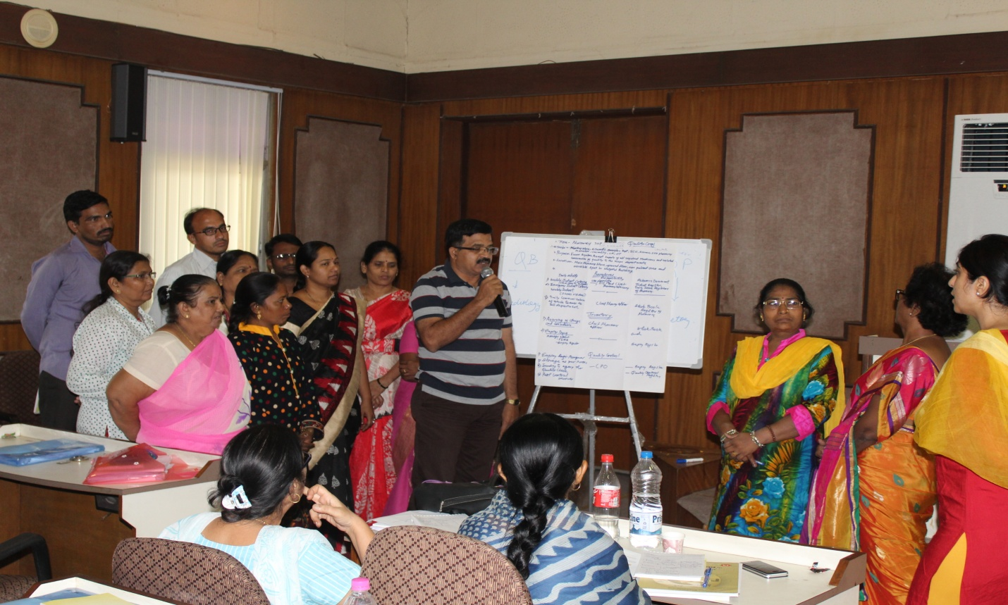
Group Exercise on SOP Preparation by Quality Ganj Group

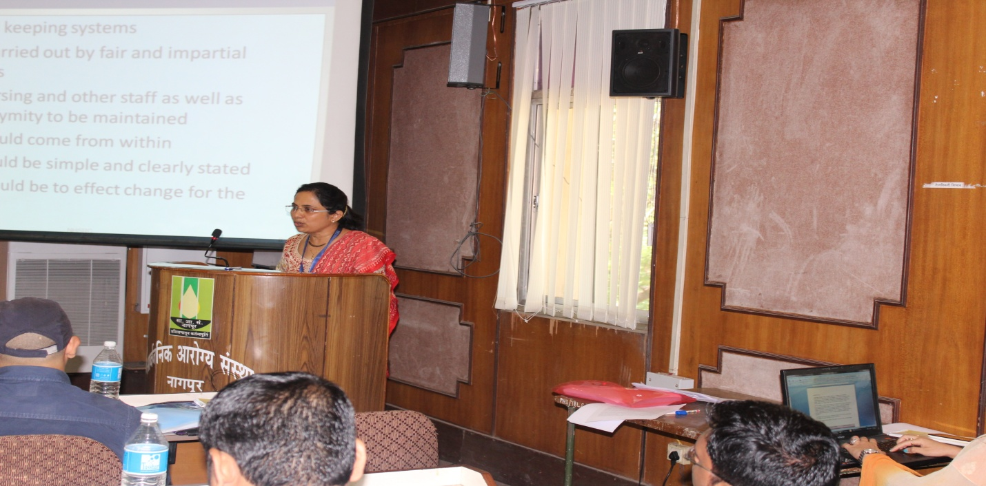
Dr. Padmaja Jogewar describing about Clinical Audits

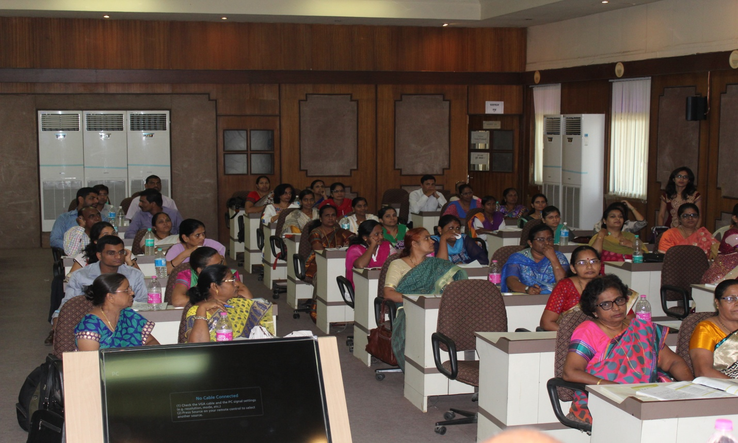
Participants in the training
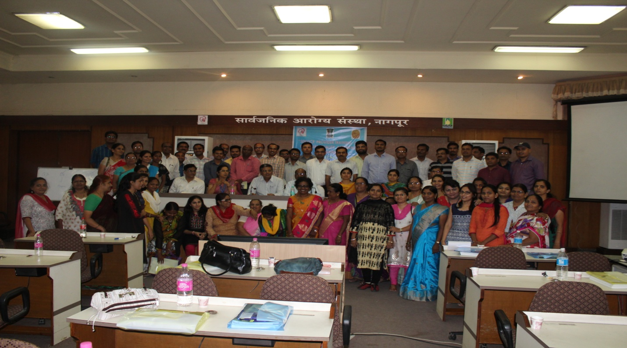
Group Photo

