Internal Assessor cum Service Provider Training on National Quality Assurance Standards

2nd August to 4th August 2016, Daman

Conducted by

National Health System Resource Centre in collaboration with National Health Mission Daman

TRAINING REPORT
DAMAN INTERNAL ASSESSOR CUM SERVICE PROVIDER TRAINING ON NATIONAL QUALITY ASSURANCE STANDARDS

TRAINING COORDINATOR
Dr. Trushar Parmar (SPM, Quality Assurance, UT of Daman & Diu)
Ms. Vinny Arora (Consultant, QI, NHSRC, New Delhi)

DATE OF TRAINING
2nd August 2016 to 4th August 2016.

PLACE OF TRAINING
Conference Hall, CHC Moti Daman, Daman.

PARTICIPANTS OF TRAINING
Total no. 25 (List attached in Annexure I)
COURSE SCHEDULE
The course schedule (Attached in Annexure II)
outlines the day to day contents and learning
methods.

Contents
OBJECTIVES OF TRAINING 3
BACKGROUND 4
EXECUTIVE SUMMARY 4
DAY WISE SUMMARY OF THE PRESENTATIONS 5
Day 1 5
Day 2 7
DAY 3 8
PARTICIPANT FEEDBACK 9
Most liked sessions were 9
Most useful topics 9
Suggestion for inclusion of topics 9
Suggestion to improve the training 10
Annexure I 11
List of Participants 11
Annexure II 13
Agenda 13
Annexure III 15
Teams for Exercise 15
Annexure IV 16
Service Provider Training Feedback Evaluation- Bihar 16
Photo Gallery 18

OBJECTIVES OF TRAINING

- To understand basic concepts of quality assurance, standards and how to implement them in their facilities.
- To acquaint the trainees with National Quality Assurance standards, measurable elements, departmental checklists and scoring system along with scoring methodology.
- To develop skills and acumen to carry out assessments, gap analysis and gap closure activities in the hospital.
- Provide skill to service provider to independently assess different area of concern, measurable elements & checklist

BACKGROUND

Under National Health Mission, to improve the quality of Health care services at public hospitals, Ministry of Health & Family welfare, Government of India, has launched National Quality Assurance Standards. To comply with these standards, Government of India has launched operational Guidelines as well as Assessor’s Guidebook for District hospitals, CHC (FRU) and PHC (24X7) & UPHC. For implementation and certification under National Quality Assurance Standards (NQAS), 4 types of trainings courses were designed i.e. one day awareness training, two days internal assessor training, three days service provider training and five days external assessor training. Three day service provider training is for service providers who are working in hospitals and by implementing good practices or process part will helps in to the internal assessor to conduct certification audit for facilities applying for NQAS certification/National level certification. National level certification process is organized by MOHFW or technical resource institution. Main aim of training is to understand basic concepts of quality assurance, standards and how to implement them in their facilities to aspiring Service Provider.

EXECUTIVE SUMMARY
This was 1st Internal Assessor cum Service Provider training that was conducted by NHSRC in collaboration with NHM, Daman & Diu from 2nd to 4th August 2016 at Conference hall, CHC Moti Daman, Daman.
The aim of training was to strengthen service provider’s knowledge of key concepts, tools, and methodologies for assessment of National Quality Assurance Standards. Course curriculum for training was prepared by the NHSRC and was duly syndicated with UT requirement. Participants were from diverse background including Medical Officers, Sister Incharges, Staff nurse, OT Technician, Medical Record Technician from 8 Health Care facilities (2DH, 2 CHC & 4 PHC) from UT of Daman & Diu.
The participants were given-
- A copy of Operational Guideline for National Quality Assurance in Public Health Care to all service providers
- A copy of Assessor’s guidebook for District Hospital.(Volume1 & Volume 2) to all service providers
- A bag with writing pad, pen.
- Hard copy of guideline, exercises and material wherever required during training.

The programme had 13 sessions along with 3 exercises and a field visit to DH Daman, spread over a period of three days.

Feedback from the participants was taken and the report contains analysis and suggestions given by the participants. The overall rating of the programme in feedback has been average with an overall score of 3.97 on a 5 point scale.

DAYWISE SUMMARY OF THE PRESENTATIONS

Day 1
Topic | Session Brief
Day -1 (02-08-2016)
Overview of National Quality Assurance Program  Dr. Parminder Gautam | This session covers the concepts, dimensions and approaches towards Quality, it outlines about development of National Quality Assurance Program and also brief about its 8 areas of concern along with its Key features. Session also describes about the proposed organization structure required at state and district level for effective implementation of program.
Measurement System for Quality Assurance, Standards and Assessment Protocol  Dr. Deepika Sharma | This session elaborate the measurement system and scoring methodology. It also gives an overview of 8 Area of Concerns and its Standards. A detailed discussion about 18 checklists of District Hospital Level is done during the session.
Standards for Service Provision , Patient Rights & Inputs  Ms. Vinny Arora | Session cover an elaborative discussion about first 3 area of concern i.e. Service Provision, Patient rights & Input. It includes thorough understanding about availability of services & discussion on patient rights. Inputs includes availability of infrastructure, human resource and their training, competencies & also availability of consumables & drugs were also discussed.
Case study Labour Room  Ms. Vinny Arora | Case Study of Labour room is given to participants for better understanding of scoring system as well as hands on experience about assessment. Individually all participants had worked upon case study followed by formulation of score card for Area of Concern A, B & C. Followed by thorough detailed discussion about all the checkpoints.
Standards for Support Services  Dr. Deepika Sharma | Session Include importance of support services in public healthcare facilities as well as detailed discussion on 12 standards of Support services. It also include detailed discussion on Maintenance of equipments, calibration, inventory management, dietary services, Laundry services, Security services, Community participation, financial management, contract management & Statutory requirement etc.
Standards for General & Specific Clinical services  Dr. Parminder Gautam | Session include importance of clinical services as well as discussion on standards of Clinical services which includes assessment of Quality of registration, admission, consultation services, assessment & reassessment of in patients, their care during transfer & referral. It also include discussion about nursing care, drug administration, patient record maintenance and discharge process etc. Specific Clinical Standards were also discussed that comprises of Assessment of quality of specific clinical services like Emergency, ICU/SNCU, OT, Anaesthesia services, Diagnostic services, Blood bank as well as end of life care.
Day -2 (03-08-2016)
Standards for RMNCH+A Services  Dr. Deepika Sharma | It also include discussion on RMNCHA services which include Antenatal, intra-natal & Postnatal care as well as family planning & ARSH services along with standards for Quality of National Health Programs.
Standards for Infection Control  Ms. Vinny Arora | Session includes detailed discussion about 6 standards. It includes elaborative details on how to assess the infection control practices at public health care facilities. Discussion of New Bio Medical Waste Management rules forms the part of the session. Methods of Donning and removing PPE, Sterilization and Decontamination Protocols were also discussed in the session.
Key Performance Indicators & Patient Satisfaction Survey  Dr. Parminder Gautam | Session include discussion on 30 KPIs. It also include how to calculate & reporting mechanism of KPI. How to calculate Patient Satisfaction Score was also briefed during the session.
Standards for Quality Management & Road Map  Ms. Vinny Arora | Session include discussion on 8 standards of Quality Management system. Approaches to quality, (Control, Assurance, Improvement, Accreditation) were discussed along with formulation of Quality Teams, their responsibilities. How to prepare Quality policy and Quality objectives, established mechanism for Patient Satisfaction Survey, Preparation of SOP and how to conduct an assessment and prepare a time bound action plan was also shared during the session. Road map session include compilation of all standards & step need to take for assessment as well as guideline for implementation after gap finding. It also include guidance about activities that can be started at facility along with assessment process.
Field Visit to District Hospital Daman.
Participants were divided into 4 groups and were allotted with department checklist for assessment in the District Hospital Daman and format for report preparation was shared with them. This is done to provide hands on training to the participants on conducting assessment.
Presentation of Field visit | All the 4 group prepared the reports and presented well in front of all the participants.
Preparation of NQAS  Dr. Deepika Sharma | The documents required for certification i.e. list of Policies & SOPs , Manual, Checklist , Score cards required were shared. Discussion about how to apply for State & national level certification was also discussed in the session.
Tools & Methods of Quality Improvement  Dr. Parminder Gautam | Dr. Gautam briefed about various tools of Quality with a focused approach towards Why- Why tool for RCA. Fish Bone Diagram, Run Charts & other tools were briefly shared with a detailed discussion on Pick chart for prioritization.
National Quality Assurance Standards for Primary Health Care  Dr. Deepika Sharma | The requirement for developing QA urban Standards were discussed along with that a detailed discussion about 12 checklist was done. The different components in UPHC checklist were briefed during the session.
Overview of Kayakalp  Ms. Vinny Arora | Session include a brief on Kayakalp Program along with detailed discussion about its scoring methodology to be applied in the tool. Scaling up of the program to PHC & CHC level in current FY was also shared. A brief discussion on 6 thematic areas of Kayakalp tool forms the part of session.
Post Training Evaluation  NHSRC team | At last Post training Evaluation of participants has been conducted. Post training evaluation contain 42 Multiple choice Questions. Participants are allowed to use their notes & assessment guidebook for answering question paper.

PARTICIPANT FEEDBACK
Overall Average scoring was of 3.97 out of 5. Evaluation of participant feedback is taken on 5 point scale.
Analysis of Participant feedback is attached in Annexure IV.

Most scored maximum
Name of Topic & Presenter | Score
Tools & Method of Quality Improvement | 4.43
Dr. Parminder Gautam
Key Performance Indicators | 4.17
Dr. Parminder Gautam
Standards of RMNCH+A services | 4.22
Dr. Deepika Sharma
Overview of Quality & National Quality Assurance Program | 4.17
Dr. Parminder Gautam
Measurement System for Quality Assurance its assessment protocol & Standards | 4.13
Dr. Deepika Sharma
Hospital Infection Control | 4.09
Ms. Vinny Arora

Suggestion to improve the training
- Duration of training should be increased
- SWOT analysis should be explained
- Doctor Patient ratio should be described
- How to conduct Employee Satisfaction Analysis
- Training could be done at district level

Annexure I

List of Participants
Internal Assessor cum Service Provider Training , Daman
2nd - 4th August 2016
S.No. | Name of Participant | Designation | Contact Number
1 | MS. ANEETHA ABRAHAM | PHN, DAMAN | 7574829817
2 | DR. ANUJA VAGHELA | MO, GOVT. HOSPITAL DIU | 8140455939
3 | DR. MRUNAL OZA | DISTRICT PROGRAM MANAGER, DIU | 8758318040
4 | DR. TAPAN DESAI | MO, CHC MOTI DAMAN | 8238399100
5 | DR. PRITI HALPATI | MO, GOVT. HOSPITAL DAMAN | 7567509260
6 | MS. ARUNA DARJI | I/C WARD SISTER, GOVT. HOSPITAL DAMAN | 9927801346
7 | DR. HINAL PATEL | DISTRICT EPIDEMIOLOGIST, DAMAN | 9033492982
8 | MR. RAJESH GOSWAMI | MRT,GOVT. HOSPITAL DAMAN | 9725200145
9 | MS. GARIMA GUPTA | MICROBIOLOGIST, CHC MOTI DAMAN | 9904855771
10 | MS. ARTI PANDYA | OT TECHNICIAN, CHC MOTI DAMAN | 9537333624
11 | MS. ROSHNI D'COSTA | SN, PHC DABHEL, DAMAN | 8000920066
12 | MS. VIJAL PATEL | SN, PHC BHIMPORE, DAMAN | 8238726293
13 | DR. RICHA JOG | DISTRICT PROGRAM MANAGER, DAMAN | 7574829802
14 | DR. TRUSHAR PARMAR | STATE PROGRAM MANAGER, UT OF DAMAN & DIU | 7574888408
15 | MR. BHAVYESH VAJA | WARD SISTER, GOVT. HOSPITAL DAMAN | 9898458985
16 | MS. ELSEMMA K.C. MATHEW | LHV, DAMAN | 9978930850
17 | MS. SINI MATHEW | SN, GOVT. HOSPITAL DAMAN | 9429530879
18 | MS. SAVITA PATEL | WARD SISTER, GOVT. HOSPITAL DAMAN | 995572648
19 | MR. SALIM VADAVIYA | SN CHC GHOGHLA, DIU | 9429549141
20 | MR. TEJAS PATEL | EXTENSION EDUCATOR, DAMAN | 9998963063
21 | MS. CORINA M.F. NORONHA | SN CHC MOTI DAMAN | 9879479194
22 | MS. JASMINE JOHN | SN, CHC MOTI DAMAN | 9979085524
23 | MS. MELBA LOPES | WARD SISTER, CHC MOTI DAMAN | 9898792858
24 | MS. ALENA ALMEIDA | WARD SISTER, GOVT. HOSPITAL DIU | 9727321850
25 | DR. SANGEETA JOSHI | DISTRICT PROGRAM OFFICER, DAMAN | 9978930863

Annexure II

Agenda

Internal Assessor cum Service Provider Training on National Quality Assurance Standards
Daman & Diu
2nd – 4th August 2016
Agenda
Time | Topic | Resource Person
Day-01
09:00 - 09:30 | Registration
09:30 - 10.00 | Inaugural Address by MD NHM
10:00 - 10:45 | Overview of Quality & National Quality Assurance Program | Dr Parminder Gautam
10:45 - 11:00 | Tea
11:00 - 12:00 | Measurement System for Quality Assurance its assessment protocol & standards | Dr Deepika Sharma
12:00 - 13:00 | Standards for Service Provision, Patient Rights & Inputs | Ms. Vinny Arora
13:00 - 14:00 | Lunch
14:00- 14:45 | Exercise on Area of Concern-A, B, C (Case study-01) | Ms. Vinny Arora
14:45 - 15:45 | Standards for Support Services | Dr Deepika Sharma
15:45 - 16:00 | Tea
16.00 – 17:00 | Standard for Specific Clinical Services | Dr Parminder Gautam
17:00 -18:00 | Identification of Standards Exercise | Ms. Vinny Arora
Day-02
09:00 - 09:30 | Recap
09:30 - 10:30 | Standards of General Clinical & RMNCH+A Services | Dr. Deepika Sharma
10:30 - 11:15 | Standard for Infection Control | Ms. Vinny Arora
11:15 – 11:30 | Tea
11:30 – 12:30 | Key Performance Indicators & Patient Satisfaction Survey | Dr. Parminder Gautam
12:30 – 01:30 | Standards for Quality Management | Ms. Vinny Arora
13:30 - 14:30 | Lunch
14:30 - 17:30 | Field Visit to District Hospital Daman | State
Day-03

09:00 - 11:00 | Presentation of field visit
11:00 - 11:15 | Tea
11:15 – 01:30 | Preparation of NQAS | Dr. Deepika Sharma
01:30 – 02:15 | Lunch
02:15 – 04:00 | Tools & Method of Quality Improvement | Dr. Parminder Gautam
04:00 – 04:45 | National Quality Assurance Standards for Primary Health Care | Dr. Deepika Sharma
04:45 – 05:30 | Overview of Kayakalp | Ms. Vinny Arora
05:30 | Post Training Evaluation

Annexure III

SERVICE PROVIDER TRAINING , Daman & Diu (FEEDBACK EVALUATION)
02nd to 04th August 2016, Daman
SESSION | FACULTY | AVERAGE
Overview of Quality & National Quality Assurance Program | Dr Parminder Gautam | 4.17
Measurement System for Quality Assurance its assessment protocol & Standards | Dr Deepika Sharma | 4.13
Standards for Service Provision, Patient Rights & Inputs | Ms. Vinny Arora | 3.74
Exercise on Area of Concern-A, B, C (Case study-01) | Ms. Vinny Arora | 3.48
Standards for Support Services | Dr Deepika Sharma | 3.91
Standard for Specific & General Clinical Services | Dr Parminder Gautam | 3.87
Standards of RMNCH+A Services | Dr. Deepika Sharma | 4.22
Standard for Infection Control | Ms. Vinny Arora | 4.09
Key Performance Indicators & Patient Satisfaction Survey | Dr. Parminder Gautam | 4.17
Standards for Quality Management | Ms. Vinny Arora | 3.83
Preparation of NQAS | Dr. Deepika Sharma | 3.83
Tools & Method of Quality Improvement | Dr. Parminder Gautam | 4.43
National Quality Assurance Standards for Primary Health Care | Dr. Deepika Sharma | 4.09
Overview of Kayakalp | Ms. Vinny Arora | 3.61
 | AVERAGE | 3.97

Photo Gallery
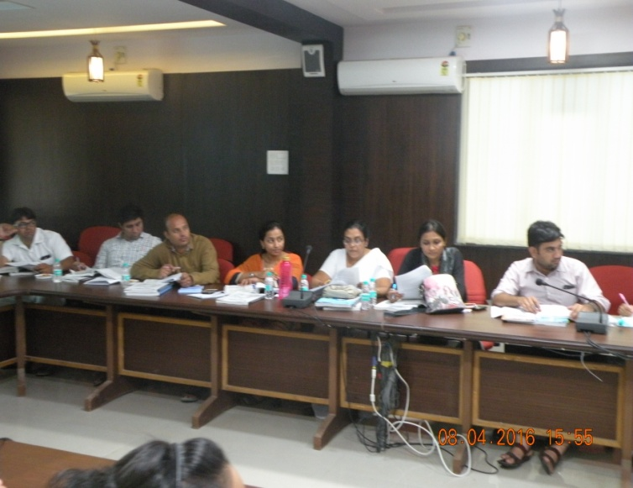 | 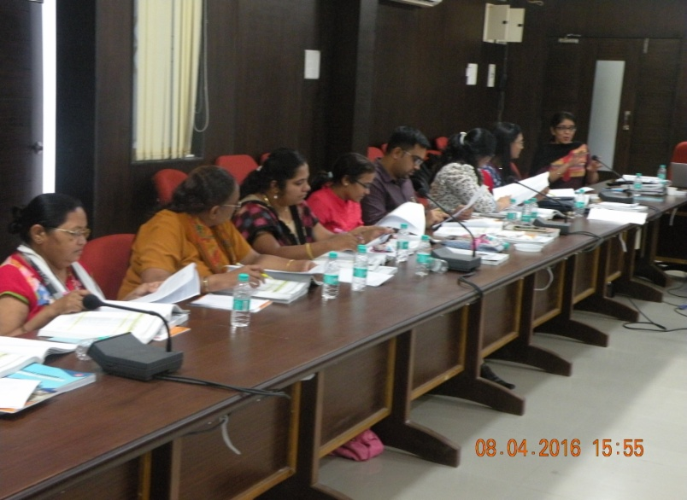

Participants of the training
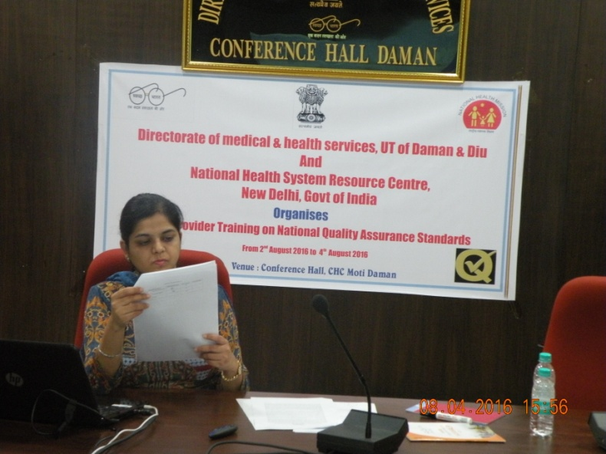 | 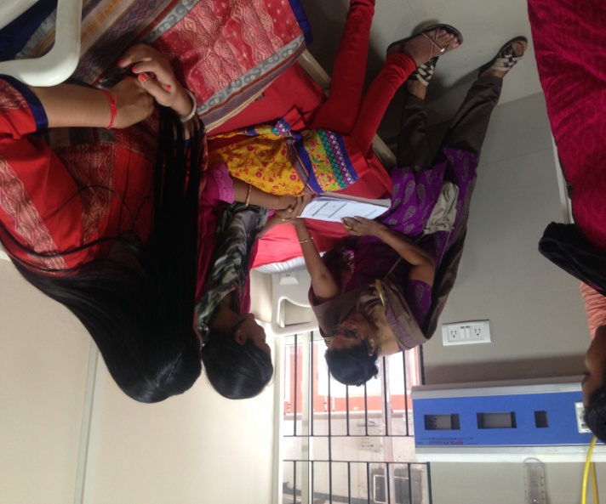
Discussion on Labour Room Case Study | Field Visit in DH Daman
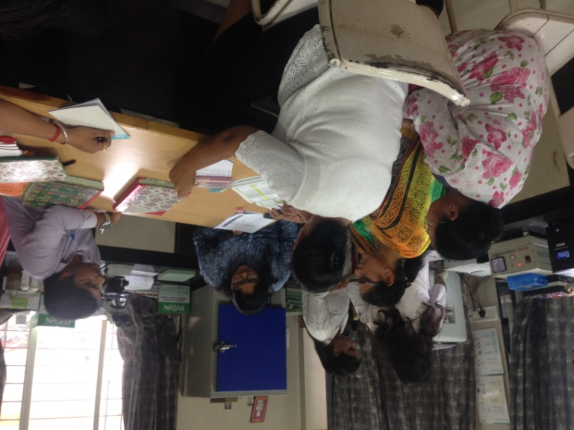  Photo Gallery | 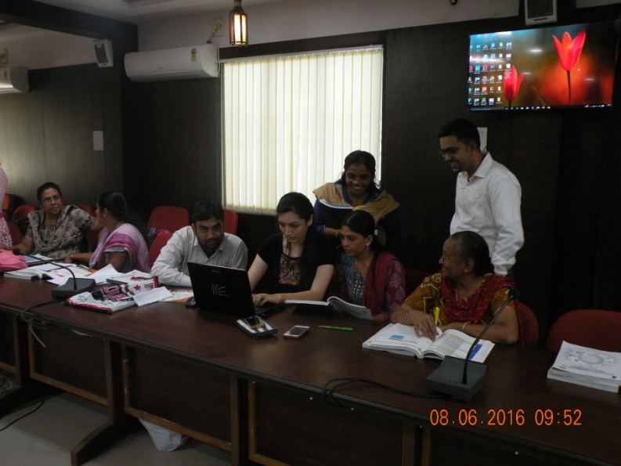
Laboratory Visit and filling of Checklist | Preparation of Presentation
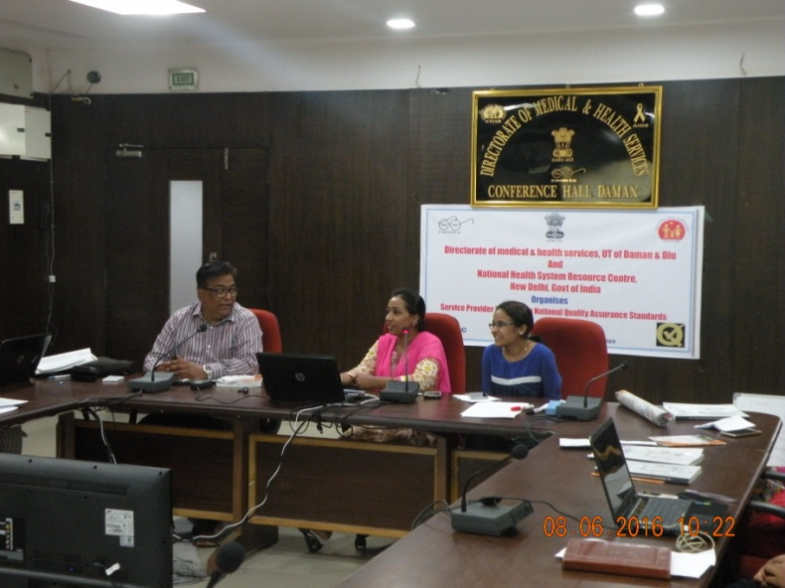 | 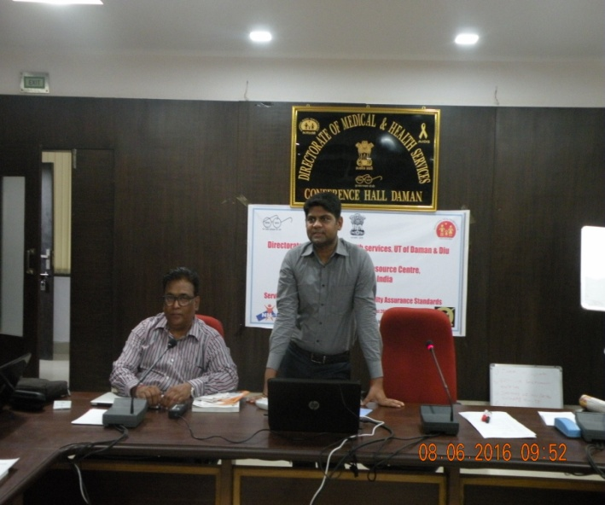
Team giving a presentation of Field visit | Dr. Tushar briefing about available infrastructure in UT
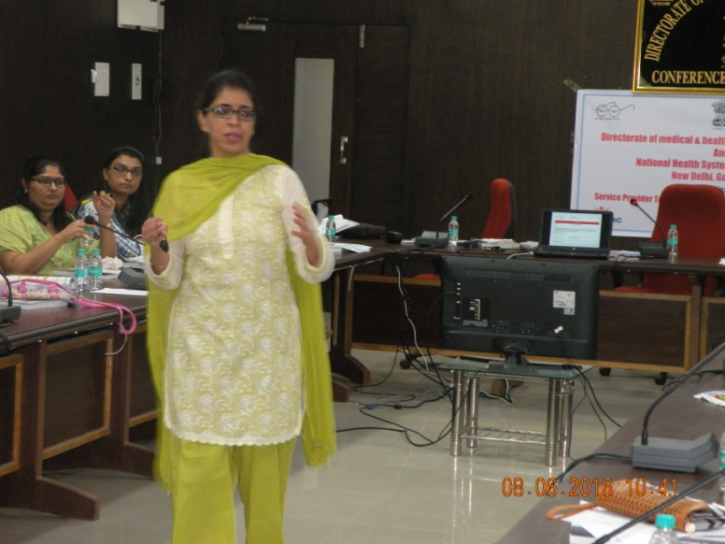  Photo Gallery | 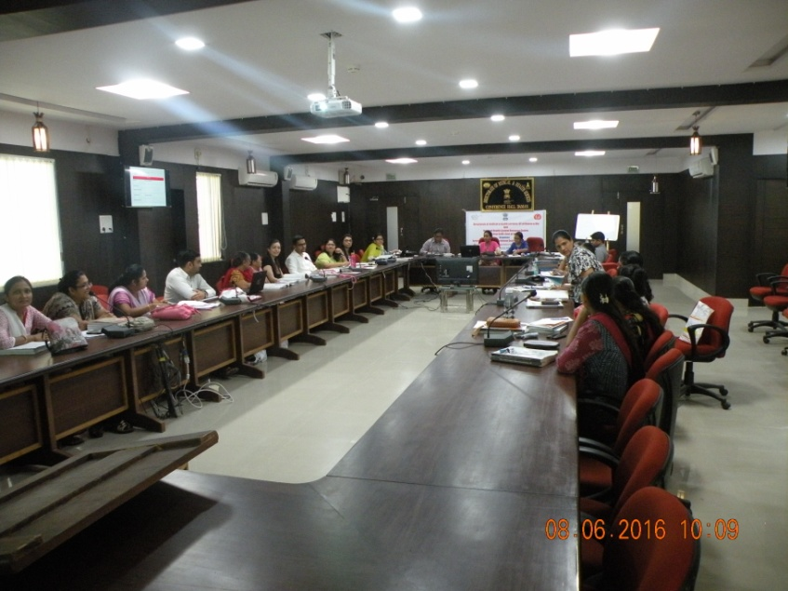
Dr. Deepika briefing about preparation of NQAS | Valedictory

