Punjab Service Provider Training on National Quality Assurance Standards

9th to 11th February 2016, Mohali, Punjab

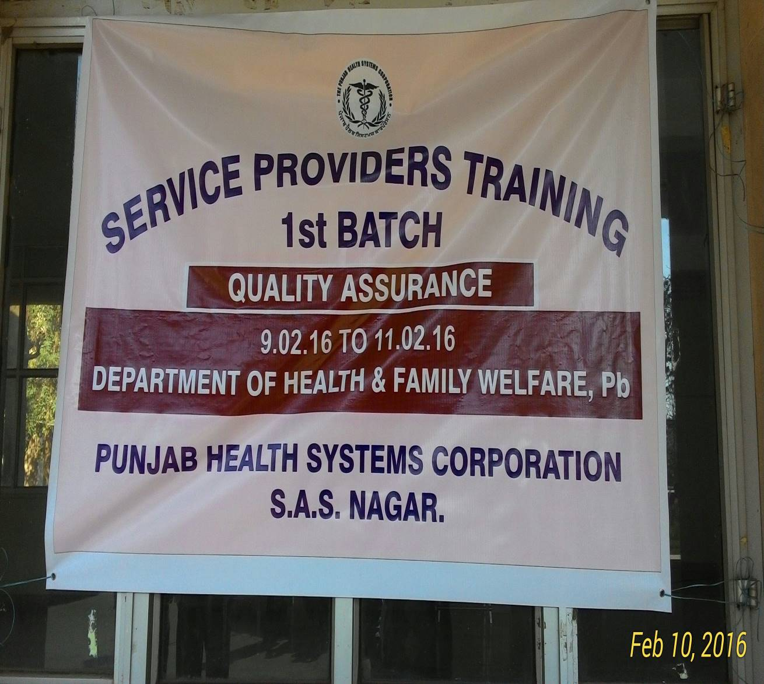

Conducted by:
National Health Systems Resource Centre in collaboration with Punjab Health Systems Corporation

BACKGROUND

Under National Health Mission, to improve the quality of Health care services at public hospitals, Ministry of Health & Family welfare, Govt. of India, has launched National Quality Assurance Standards. To comply these standards, Govt. has launched operational Guidelines as well as Assessor’s Guidebook for District hospitals, CHC (FRU) and PHC (24X7).
For implementation and certification under National Quality Assurance Standards (NQAS), 4 types of trainings courses were designed i.e. One day Awareness training, two days Internal Assessor Training, three day Service provider training and five day External Assessor training.
Three day Service Provider training is mandated for the facility levels service providers who can understand the requirements of NQAS and successfully implements standards and improved their health facilities as per the mandate of NQAS.
There is fixed curriculum for the training extended up to period of three days.

Executive Summary
1st Service Provider training was conducted by NHSRC in collaboration with Punjab Health Systems Corporation from 9th February, 2016 to 11th February, 2016 at Mohali, Punjab.
Course curriculum for training was prepared by the NHSRC and was duly syndicated with state. Participants were from diverse background including Nodal Officer Quality, SMO’s, Assistant Hospital Superintendent, Pathologist, Gynaecologist, Paediatrician, Medical Officers, Matron and Staff Nurse from selected nine district hospital for Certification under NQAP by the state.

TRAINING COORDINATOR: Dr Sushant Kumar Agrawal (Consultant, NHSRC, New Delhi)
Dr. Parvinder Pal Kaur (AD,QA PHSC)

DATE OF TRAINING: 9th to 11th February 2016
PLACE OF TRAINING: Auditorium, SIHFW, Mohali, Punjab
PARTICIPANTS OF TRAINING: Total no. 48–. (List attached in Annexure ii)
COURSE OVERVIEW: The course schedule (Attached in Annexure iii)
OBJECTIVES OF TRAINING:
The specific objectives of the Training programme were: -
- To understand basic concept of Quality in Public health facilities.
- To equip with knowledge of key concepts, tools and methodologies of National quality assurance standards.
- Provide skill to identify gaps and fulfils these gaps.
- To develop skills and acumen to implement Quality services in their health facilities.

The participants were given-
- A copy of Operational Guideline for National Quality Assurance in public health care.
- A copy of Assessor’s guidebook for District Hospital.(Volume1 & Volume 2)
- Writing pad and pen.
- Pen drive with all presentations of three days training.
- Hard copy of Exercises and material wherever required during training.
- Dynamic Training tools like Group discussions; Interactions, group work, individual work etc. has been used to facilitate focused learning and keep the interest of the audience alive.
The programme had 18 Sessions, spread over a period of three days.
Feedback from the participants was taken and the report contains analysis and suggestions given by the participants at annexure-i.

3. Training Brief:-
3.1 Inauguration:-
Training was inaugurated by Dr.Gurinder Kaur Barar, Director of Punjab Health Systems Corporation, Punjab. In his opening remarks she gave an overview about the importance of Quality in Public health facilities. She said that about the role of service provider training for successful implantation of National Quality Assurance Program.
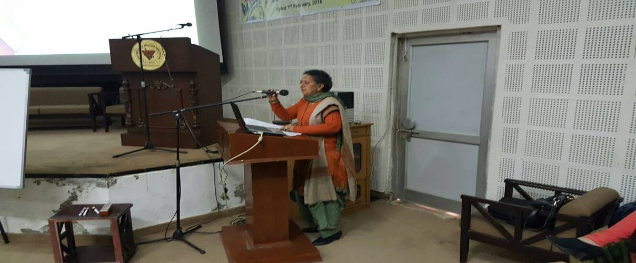

Followed by this, technical session of the training started.
3.2 Technical Session Day-1 (9th February 2016)
Dr Sushant Agrawal, Consultant QI NHSRC first introduced himself to the participants followed by introduction of all participants. He discussed about the ‘’Key Concepts and Principles of Quality Assurance in Public Health Facilities’’ in this session. Dr.Agrawal defined Quality in many terms like Quality is minimising variation, Meeting and surpassing costumer expectations. Then he also explained why Quality required in public health facilities. He also discussed about the Donabedian model of Quality i.e. Structure, Process and Outcome. Participants were also involved in their own way to define Quality. He discussed various approach of Quality like Certification, Quality Management system, Quality Improvement, Quality Assurance and Quality Control. He also explained about the objective of service provider training and role of participants in implementing QA program in their health facilities.

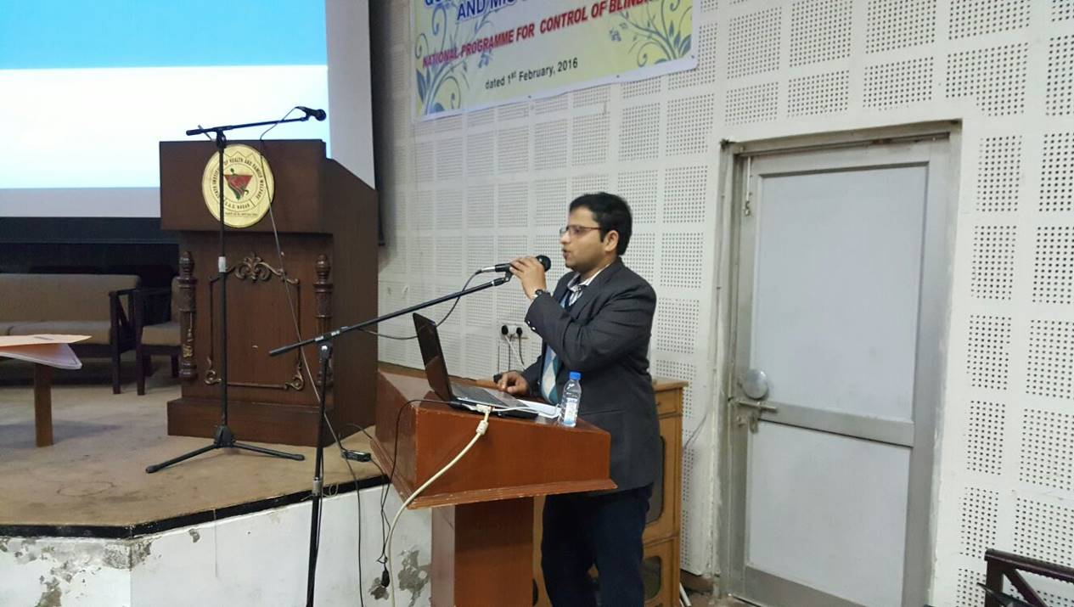
Followed with this Ms. Richa Sharma, Consultant QI NHSRC given brief about the ‘’Overview of National Quality Assurance Program and standards’’. She first introduced national quality assurance program and briefly explained eight key features of QA program namely, unified organizational framework, Quality assurance standards, continual assessment and scoring, Assessment Methodology, Training and Capacity building, inbuilt quality improvement model, Certification at state and national level, Incentives and sustenance. She discussed about the Organizational framework of Quality and role of SQAU, SQAC, DQAU and DQAC. Then she explained about the measurement system of Quality, Customization of standards. She also explained about the 4 training under NQAP. She covered scoring rules and incentive mechanism under this program in details.
Next presentation made by Dr. Pardeep Sharma, Dental Surgeon Ludhiana, he explained about the ‘’Quality Assurance in Operation Theatre and Labour Room’’ in Public health facilities. Dr Sharma said prime objective of OT is to create an area of asepsis and provide comfort to patient, staff and operating doctor. He discussed about the 4 zoning required in operating room i.e. protective, clean, aseptic and disposal zone. He described specifications required for an OT. He gave emphasis on Positive pressure, temperature and humidity control required in OT. He also discussed about the process requirement of OT and gave due weightage on monitoring of its outcome. He continued his presentation and discussed about the Quality requirement in Labour room also. He discussed about the Push and Pull factor for institutional delivery in this session. He shown few photographs of labour room to the participants and discussed about the quality of care in labour room.
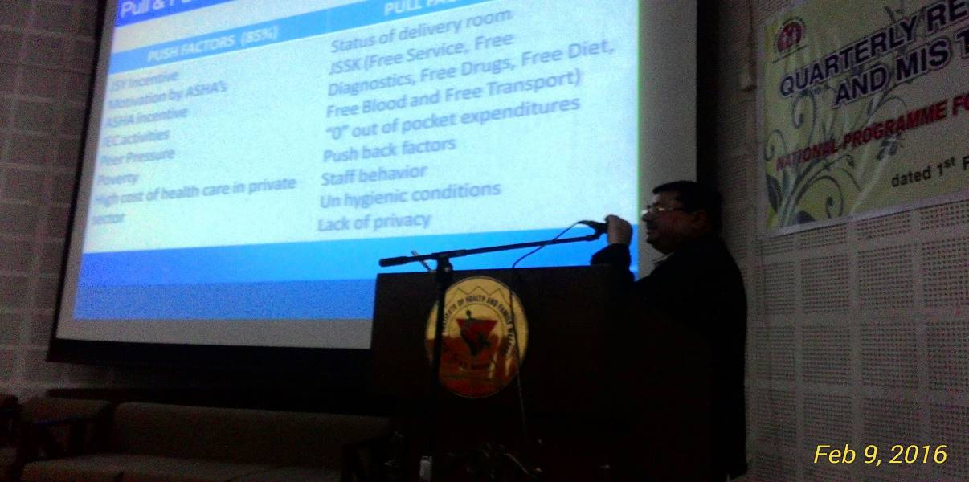

It was followed by lunch.
After lunch session started by Dr.Sushant, he discussed about the ‘’Quality Team Formulation’’ and given importance of team work and formation of Quality improvement team and various subcommittees. Dr.Sushant distributed chits to all participants and they were supposed to make 4 different group based upon that chit. All participants than divided in to 4 group namely Quality pur, Quality ganj, Quality Nagar and Quality Bad.
This was followed by a group exercise called “Make Quality Team “which acted as a breather for all the participants. Participants were distributed texts for different committee in the Hospital, and were instructed to compose one committee in their group. Then the participants were supposed to present the role and responsibility of their committee, and discuss issue pertaining to their committee given by Dr.Sushant.
Ms. Richa Sharma presented next session for the day and explained about the ‘’Internal Assessment and Gap Analysis’’. She discussed various steps of conducting assessment. Participants were explained about the scoring system and the method to obtain the cumulative hospital score card, department wise score and also areas of concern wise score.
It was followed by a group exercise, where participants were shown some photographs of gaps found in a district Hospital. They were instructed to write gap statement and find about the standard and measurable elements of the gap. All groups did this exercise very enthusiastically.

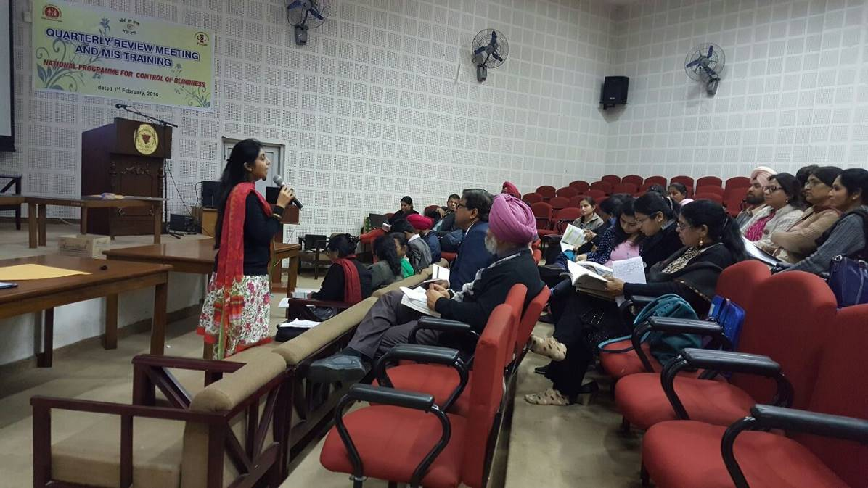
Last presentation for the day was about the ‘’Hospital infection control’’ practices and taken by Ms. Surbhi Sharma, Consultant QI, NHSRC. She defined hospital acquired infection and its importance for patient and staff of the hospital. She discussed about the myths about antiseptic and disinfectant during this session. She showed a video also which described about the disinfection, sterilization and equipment processing. She also explained about the Standard precautions required for a Hospital to control hospital acquired infections. Participants were instructed to demonstrate six steps of hand washing also during this session.
3.3 Day-2(10th February 2016):-
Session started after brief recap by Dr.Sushant Agrawal.
After this Ms. Surbhi Sharma had taken session on ‘’Process mapping’’. She first discussed about the process followed by steps for mapping the process. She gave importance in process mapping to Increase efficiency, eliminate non-value-added activities, reduce cycle time, expand service capabilities, simplify work flow, and minimize dependencies. She explained about the 7 MUDAS in a hospital which are confusion, motion/conveyance, waiting, over processing, inventory, defects and over production. Followed by this Ms. Richa Sharma had undertaken group exercise on process mapping. She distributed one case study to all 4 groups and they were instructed to map and streamline the process to reduce time. All 4 groups made presentations after that.
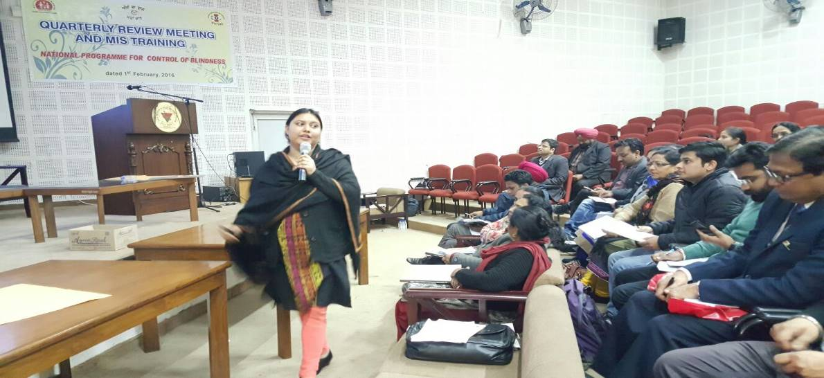
After this Dr Sushant Agrawal took session on ‘’action planning and Prioritization’’. He explained about the steps for action planning and, how to prioritize these gaps based upon their severity, ease of implementation and level of intervention required for closing these gaps. All 4 groups were instructed to prioritize the gaps identified during exercise on gap analysis and action planning. Then all 4 groups presented one by one their prioritization.
Dr Surinder Singh, SMO Kharar from Punjab took last session before lunch and described about the ‘’Prescription and clinical audit’’. He covered Medical, death, prescription and infection control audits. He described about the general rule for conducting audits and said it is fact finding exercise and not fault finding, focus of audit should always be on improving the quality of current process based upon the findings.
It was followed by lunch and then Ms. Richa Sharma distributed two OPD prescription and two case sheet selected from Amritsar district hospital to each four group. She also distributed format for conducting prescription and clinical audit to each group. Ms. Richa had given an exercise to all four group for conducting prescription and clinical audit. Then all groups made presentation one by one. Each group shared their audit findings and Ms. Richa Sharma explained them to conclude the audit process after the audit.
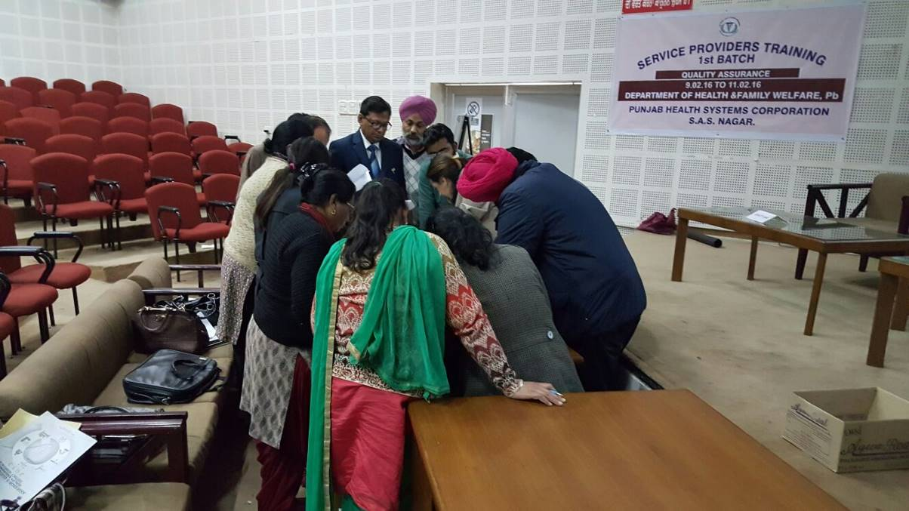
Followed by this Dr Parvider Pal Kaur had taken sessions on ‘’Quality Assurance in Lab Services’’. She made session very interactive and asked participants about their own requirements of Quality in lab services. She explained about the pre-testing, testing and post-testing activities about the lab services. She also explained about the importance of Internal Quality Assurance program including running control in lab and External Quality Assurance program. She explained about bio safety in lab services in this session.
Last session for the day was taken by Ms. Richa Sharma and she discussed about ‘’Patient Safety’’ .She said about the various factors affecting the safety of patients, vulnerable group of patients, general rules on protection of patients and common safety measures. She also discussed about the Patient safety solutions like Look alike sound alike medicines, Patient identifications, Hand over practice etc. She also covered medication safety issue in brief.
3.4 Day-3(11th February 2016)
Day started with recap from Dr.Sushant Agrawal for all two days sessions. All participants were requested to share one or two things which they would like to implements in their facilities soon after learning from this training.
Followed by this, first session of the day was started by Dr.Sushant and he took sessions on measuring ‘’Key performance indicator and tools for Quality Improvement’’. He discussed one by one all 30 KPI’s applicable for district hospital. He had few exercises to calculate some of important KPI like BOR, ALOS etc. He also discussed some of the Quality toll like brain storming, Fish Bone Diagram, Run Chart and control chart and PICK Chart very briefly. Dr Agrawal did one brain storming session alive with participants for detecting cause of ‘’Stray animals in health care facilities’’.
Follow with this Dr.Parvinder Pal Kaur took session on ‘’Quality Assurance in Accident and Emergency department’’ of the hospital. She briefly described about thing which should take into consideration before planning of A&E department. She also explained about the triage protocol and management of Disaster in this session.
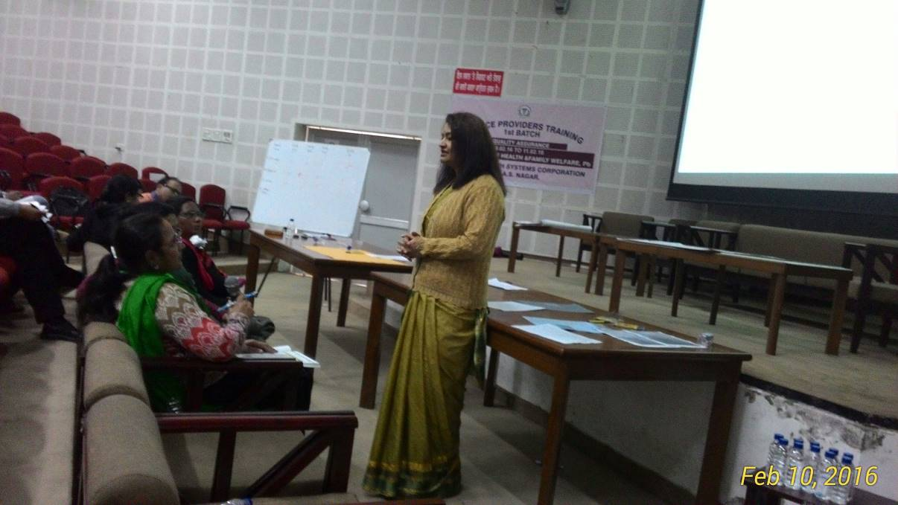
Followed by this Ms. Surbhi Sharma took session on ‘’Patient Rights and satisfactions’’ and explained the importance of rights of patients in terms of availability, accessibility, acceptability and Quality, She covered importance of Patient satisfaction survey in the hospital, and explained various steps for conducting patient satisfaction survey in the hospital.
Next session for the day with ‘’Standard Operating Procedures’’ taken by Ms. Richa Sharma. She described importance of SOP’s for Health care industry and emphasized importance of service provider to make SOP of their department. Then she also explained how to make SOP and described each component of SOP’’s. She had given task to each group to make one SOP for Laundry, Pharmacy, Radiology and Dietary, followed by lunch.
Post lunch started with presentation from all groups one by one and Ms. Richa Sharma cleared their queries to make SOP in effective way.
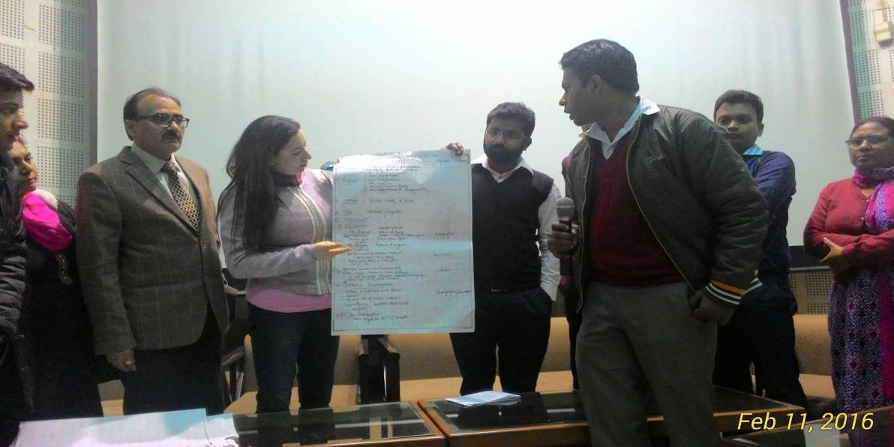
Last sessions for this service Provider training was taken by Dr.Sushant Agrawal and he discussed about the ‘’Documentation requirements for NQAS’’. Dr Agrawal explained about the requirements for customization of standards and required documents before final submission of application for National certification to the ministry.
Feedback was taken at the end of the training.
Facilitation and vote of thanks: - Facilitation was done to ‘’Qualityganj’’ team for their best performance on all exercises among all 4 groups by Shri Hussan Lal Mission Director (NHM) followed by this vote of thanks to all participants and trainers of NHSRC done by MD NHM.

.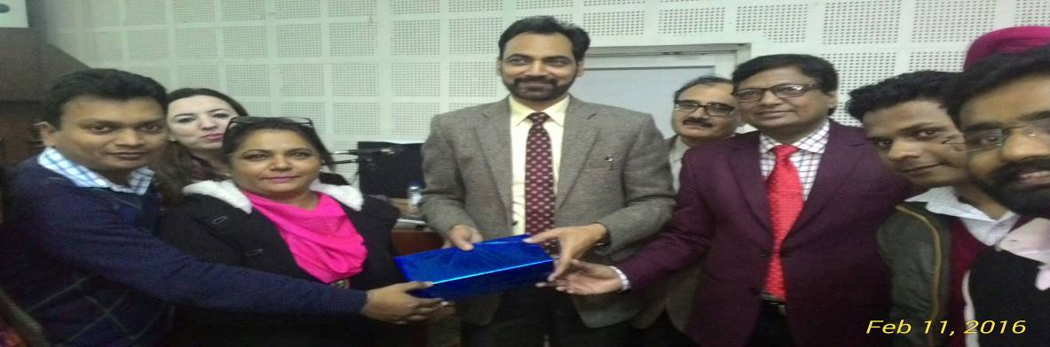
4.1 Training Feedback Evaluation:-
Participants found this training very relevant to their current work. Feedback on Quality of facilitators was positive. Feedback on all sessions was evaluated at level of fair or above in 1-5 point of scale. No sessions was found unsatisfactory.
Annexure-i
SERVICE PROVIDER TRAINING ,1st Batch PUNJAB (FEEDBACK EVALUATION)
9th to 11th February 2016
S.No | SESSION | FACULTY | AVERAGE
1 | Key concepts and Principle of Quality Assurance in Public Health | Dr.Sushant Agrawal | 4.27
2 | Overview of National QA Program & Standards | Ms. Richa Sharma | 4.57
3 | Group Exercise (Formation of Quality Improvement Team) | Dr.Sushant Agrawal | 4.27
4 | Quality Assurance in OT & Labour Room | Dr.Pradeep Sharma | 3.7
5 | Internal Assessment & Gap Analysis | Ms. Richa Sharma | 4.59
6 | Hospital Infection Control | Ms. Surbhi Sharma | 4.1
7 | Process mapping & Exercise | Ms. Surbhi Sharma | 4.13
8 | Prioritization and Action Planning | Dr.Sushant Agrawal | 4.41
9 | Prescription and Clinical Audit | Dr.Surinder Singh | 3.41
10 | Exercise on Clinical Audit | Ms. Richa Sharma | 4.47
11 | Organizing A & E Department | Dr.Parvinder Pal Kaur | 4.24
12 | Patient Safety | Ms. Richa Sharma | 4.47
13 | Key Performance indicator & tool for QI | Dr.Sushant Agrawal | 4.13
14 | Patient Rights & Satisfaction | Ms. Surbhi Sharma | 4.37
15 | Quality Assurance in Lab Services | Dr.Parvinder Pal Kaur | 3.97
16 | Standard Operating Procedure | Ms. Richa Sharma | 4.76
17 | Documentation for NQAP | Dr.Sushant Agrawal | 4.39
 |  | AVERAGE | 4.25

Most liked sessions | Trainer | Number of participants liked
Infection Control | Ms. Surbhi Sharma | 11
KPI and Tool for QI | Dr.Sushant Agrawal | 10
Patient Safety | Ms. Richa Sharma | 10
Gap Analysis & Prioritization | Dr.Sushant Agrawal | 11
Exercise of Clinical audit | Ms. Richa Sharma | 17
SUGGESTIONS TO IMPROVE TRAINING
Sitting time was too long
Inclusion of session for MLC cases
Time limit for a particular session
Small training venue
Documentation of NQAP should have more time
Online training
Videography of training
Last day of training should be till lunch time only

5.0 List of Participants: - Annexure-ii
List of Participants SERVICE PROVIDER TRAINING ON 09.02.2016 to 11.02.16
S.No. | Name | District | Designation | Mobile No. | E-mail ID
1 | Dr. Krishan Singh | Patiala | SMO | 9872040159 | smoapjchrajpura@gmail.com
2 | Dr. Surinder Singh | Kharar | SMO | 9417272277 | smokharar@yahoo.com
3 | Dr. Rajesh Kumar | SDH Dasuya(HSP) | SMO | 9814694249 | chdasuya2@gamial.com
4 | Dr. Davinder Bhukal | Fazilka | SMO | 9872840537 | smochfazilka@gmail.com
5 | Dr. Rajinder Arora | Amritsar | SMO | 9872891364 | rajinderrortho@yahoo.com
6 | Dr. Maninder Singh | Tarn Taran | SMO | 9779212479 | manindersingh@gamil.com
7 | Dr. Kundan Kumar | Bathinda | SMO | 9855421495
8 | Dr. P.S.Sidhu | Ludhiana | SMO | 9814032324 | smoludhiana@gamil.com
9 | Dr. Namrata | CH Dasuya | M.O. | 9855026891 | drnamratapuri@gamil.com
10 | Dr. naresh Sharin | CHPathankot | M.O. | 9914639620
11 | Dr. Salish Juro | Ch Bathinda | Paed. | 9988485101 | drsalishj@yahoo.com
12 | Dr. Renu Beri | CH Ludhiana | Gaynae | 9465855520 | renuberi@gamil.com
13 | Dr. Sunny Verma | CH Rajpura | Paed. | 8194908565
14 | Dr. Parkash | CH Amritsar | Paed. | 98554488304
15 | Dr. Paraminder Kaur | SDH Kharar | Gaynae
16 | Dr.Kiranjot | Patiala |  | 9815936858 | apjchrajpura@gmail.com
17 | Dr. Mandeep Singh | Fazilka |  | 9464094288
18 | Dr.Pardeep | Ludhiana |  | 9888456296 | pardeepjey3123@yahoo.com
19 | Dr.Pawan Preet Kaur | Mohali | M.O.(Dental) | 9814091413
20 | Dr. Parminder Kaur | Mohali | M.O.(Gynae) | 9216151325 | parminderskaur@gmail.com
21 | Dr. Sarabdeeps riar | Amritsar |  | 9814000765 | ssriar2@gmail.com
22 | Dr. Neeraj Sehgal | Taran Tarn |  | 987613265 | neerajsehgal1970@yahoo.com
23 | Dr.H.S.Hayer | CH Bathinda | SMO(NO) | 9417115500
24 | Dr. Ravi Kant | Ch Pathankot |  | 9780413452
25 | Dr. Vishal Bajaj | Ferozepur | MO(Anaethisaia) | 9914055500
26 | Smt. Neelam Rani | Fazilka | Nurse/Mat | 9878075455
27 | Smt Pomela Sahi | Rajpura | Nurse/Mat | 9814617522
28 | Smt Manjeet Kaur | Rajpura | Nurse/Mat | 9876630164
29 | Smt Paramjeet Kaur | Kharar | Nurse/Mat | 9781445410
30 | Smt Jaswant Kaur | Dasuya | Nurse/Mat | 9811356316
31 | Smt Ramesh Kumari | Amritsar | Nurse/Mat | 9501761705
32 | Smt Surinder PAL Kaur | Ludhiana | Nurse/Mat | 9779078607
33 | Smt Sukhvinder Kaur | Amritsar | Nurse/Mat | 9815125337
34 | Smt Reeta Sood | Ludhiana | Nurse/Mat | 8146274072
35 | Smt Indu Bala | Bathinda | Nurse/Mat | 9646017741
36 | Smt. Rajinder PAL | Bathinda | Nurse/Mat | 9256473104
37 | Smt. AMRIT Pal Kaur | Tran Taran | Nurse/Mat | 9888346200
38 | Smt. Raj Kaur | Tran Taran | Nurse/Mat | 9878724445
39 | Smt. Neelam Bedi | pathankot | Nurse/Mat | 9780906691
40 | Smt Anita Rani | Firozpur | Nurse/Mat | 9417043304
41 | Smt. Asha | Firozpur | Nurse/Mat | 9914059300
42 | Dr. Neha | Mohali | AHA | 9888636006 | neha.vashith85@gmail.com
43 | Dr. Sheenu Goyal | Bathinda | AHA | 9876698457 | sheenugoyal11@gmail.com
44 | Dr. Babandeep Kaur | Mohali | AHA | 9915206027 | drbabandeep@yahoo.com
45 | Dr. Shifa Arora | Ferozpur | AHA | 8290015009 | shifaarora89@gmail.com
46 | Dr. Varun Joshi | Amritsar | AHA | 94173555379 | drvarunjosh@gmail.com
47 | Dr. Atul Gautam | Kharar | AHA | 9780673844 | atulgautam3863@gmail.com
48 | Dr. Rashmi Wadhwa | Ludhiana | AHA | 8528005591 | wadhwa.rashmi86@gmail.com
6.0 Program Schedule- Annexure-iii
Service Provider Training on National Quality Assurance Standards
9th - 11th Feb 2016
Day-1
Time | Topic | Resource Person
09:00AM- 09:30AM | Registration
09:30AM -10.00AM | Inaugural Address MD NHM/State representative | MD NHM
10.00AM - 11.15AM | Key Concepts and Principles of Quality Assurance in Public Health Facilities | Dr. Sushant Agrawal
11:15AM - 11:30AM | TEA
11:30AM - 12:30PM | Overview of National Quality Assurance Program and standards | Ms. Richa Sharma
12:30PM -1:30PM | Quality Assurance in Operation Theatre and Labour Room | Dr. Pardeep Sharma
01:30PM – 02:15PM | LUNCH
02:15PM – 03:15PM | Quality Team Formulation | Dr. Sushant Agrawal
03:15PM - 03:30PM | TEA
03:30PM - 04:30PM | Internal Assessment and Gap Analysis | Ms. Richa Sharma
04:30PM - 05:30PM | Hospital Infection Control | Ms.Surbhi Sharma
Day-2
09:00AM -09:45AM | Process mapping | Ms.Surbhi Shama
09.45AM- 10:30AM | Process making Exercise | Ms.Richa Sharma
10:30AM- 10:45AM | TEA
10:45AM - 11:45AM | Prioritization and action planning | Dr.Sushant Agrawal
11:45AM- 12:30PM | Prescription and Clinical Audit | Dr. Surinder Singh
12:30 PM - 01:30PM | Group Exercise on Clinical Audits | Ms. Richa Sharma
01:30PM - 02:15PM | LUNCH
02:15PM- 03:15PM | Quality Assurance in Lab services | Dr. Parvinder Pal Kaur
03:00PM - 03:15PM | TEA
03:15PM - 04:30PM | Patient Safety | Ms. Richa Sharma
Day-3
Time | Topic | Resource Person
09:00AM - 09:30AM | Recap
09:30AM - 10:15AM | Key Performance Indicators and tools for improvements | Dr. Sushant Aggarwal
10:15AM - 11:00 AM | Quality Assurance in Accident & Emergency | Dr. Parvinder Pal Kaur
11:00AM - 11:15AM | TEA
11:15AM - 12:15PM | Patient Rights and Satisfaction | Ms. Surbhi Sharma
12:15PM - 1:15PM | Standard Operating Procedures | Ms. Richa Sharma
01:15PM - 02.00PM | LUNCH
02:00PM - 03:00PM | Quality Team Role Play Exercise | Dr. Sushant Agrawal / Ms. Richa Sharma / Ms. Surbhi Sharma
03:00 PM- 03:45 | Documentation for NQAS | Dr.Sushant Agrawal
03:45PM - 04:00PM | TEA
04:00PM- 04:15PM | Valedictory and Feedback

