INTERNAL ASSESSORS TRAINING REPORT ON NATIONAL QUALITY ASSURANCE STANDARDS In PRIMARY HEALTH CENTRES
^{13th – 14th August 2015}
Vinny Arora

Conducted by:

National Health System Resource Centre
in collaboration with National Health Mission, Maharashtra.

INTERNAL ASSESSOR’S TRAINING ON NATIONAL QUALITY ASSURANCE STANDARDS

TRAINING COORDINATOR: Ms. Vinny Arora (Consultant, NHSRC, New Delhi)
Dr. Vijay Bhawiskar (Nodal officer for QA Maharashtra)

DATE OF TRAINING: 13TH To 14TH August 2015

PLACE OF TRAINING: PHI, Nagpur, Maharashtra.

PARTICIPANTS OF TRAINING: Total no. 40

Overview
2-days Internal Assessor training of PHC standards was conducted in state of Maharashtra by National Health System Resource centre in collaboration with National Health Mission (NHM) Maharashtra from 13th to 14th August, 2015.
Main objective of the training was to provide an overview of National Quality Assurance Standards of PHC as well as to prepare the state participants as internal assessors for the implementation of National quality assurance program. The state has nominated 56 participants for the training which include District Program Officers, Principal HFWTC .
Training started with lamp lighting ceremony and an inaugural key note by Principal HFWTC, he discussed about importance of the Quality in Healthcare system. 2 day training was spread in to 09 Topics & 2 exercises for hands on experience about various methodologies of the assessment and identifying standards.
Training was followed by Post training evaluation, which is attempted by 37 participants. Post training evaluation contain open book exam with Question paper having 42 multiple-choice Questions. Maximum Marks for Question paper is 40. Passing marks for exam was 60%. Out of 37 participants 20 has passed the exam successfully.
Training program have inbuilt training course evaluation system, where training feedback form is provided to each participant in the beginning of the session. Feedback of participants has been analyzed on 5 point scale. Overall score for training program was 4.1 on a Five-point scale.

Training Agenda

Time | Topic | Resource Person
Day-01 ( 13th August 2015)
09:00 am - 09:30 am | Registration
09:30 am - 10.00 am | Inaugural Address MD NHM
10.00 am - 12:00 Noon | Overview of National Quality Assurance Programme & Measurement System | Dr. Parminder Gautam
12:00 pm – 1:30 pm | Standards for Service Provision , Patient Rights & Inputs | Dr. Sushant Aggarwal
1:30 pm – 2:15 pm | Lunch
2:15 pm- 3:00 pm | Exercise – Case Study Labour Room | Ms. Vinny Arora
3:00pm – 3:45 pm. | Standards for Clinical Services | Dr. Parminder Gautam
3:45 p.m. – 5:00 p.m. | Standards for Support Services, Quality Management & Outcome. | Ms. Vinny Arora
5:00 p.m. – 5.30 p.m. | Group activity – Identifying Standards | Ms. Vinny Arora
Day-02 ( 14th August 2015)
09:00 a.m. - 09:15 a.m. | Recap
09:15 a.m. - 10:30 a.m. | Improvement Cycle-I Quality Team, Baseline assessment and Gap Analysis. | Dr. Sushant Aggarwal.
10:30 a.m. – 11:15 a.m. | Improvement Cycle-II, Prioritization and Action Planning, | Dr. Parminder Gautam
11:15 a.m. – 12:30 p.m. | Improvement Cycle III Periodic Reviews (Prescription and Clinical Audit) | Dr. Parminder Gautam
12:30 a.m. – 1:15 pm. | Measuring and Improving Patient Satisfaction and PHC performance. | Ms. Vinny Arora
01:15 p.m. – 02:00 p.m. | Lunch
02:00 p.m. – 03:15 p.m. | Infection Control & Patient Safety | Ms. Vinny Arora.
3:15 p.m. – 4:30 p.m. | Post Training Evaluation & Feedback  (Tea during the session) | NHSRC team
4:30 p.m. – 5:15 p.m. | Valedictory and Feedback.

Session Brief
Topic | Session Brief
Day -1 ( 13-08-2015)
Overview of National Quality Assurance Program & Measurement System  Dr. Parminder Gautam | This session covers the concepts, dimensions and approaches towards Quality, it outlines about development of National Quality Assurance Program and also brief about its 8 areas of concern along with its Key features. The measurement system along with scoring & methodology and the differentiation of the system at PHC level is also briefed. Discussion about 6 checklists and its implementation in the system. Session describes about the proposed organization structure required at state and district level for effective implementation of program.
Standards for Service Provision, Patient Rights & Inputs  Dr. Sushant Aggarwal | This session elaborate the first 3 area of concern i.e. Service Provision, Patient rights & Input. It includes thorough understanding about availability of services & discussion on patient rights. It includes availability of infrastructure, human resource and their training, competencies & also availability of consumables & drugs.
Case Study Labour Room  Ms. Vinny Arora | Case Study of Labour room is given to participants for better understanding of scoring system as well as hands on experience about assessment. Individually all participants had worked upon case study followed by formulation of score card for Area of Concern A, B & C. Followed by thorough detailed discussion about all the checkpoints.
Standards for Clinical Services  Dr. Parminder Gautam | Session include standards pertaining to clinical services which includes assessment of Quality of registration, admission, consultation services, assessment & reassessment of in patients, their care during transfer & referral. It also include discussion about nursing care, drug administration, patient record maintenance and discharge process, antenatal, Intranatal and postnatal care along with emphasis on 14 National Health Programs implementation.
Standards for Support Services, Quality Management & Outcome  Ms. Vinny Arora | Session describes about the importance of support services in public healthcare facilities and detailed discussion on 8 standards of Support services. It encompasses detailed discussion on monitoring of National Health Programs, Maintenance & calibration of equipments, inventory management, dietary services, financial management, contract management & Statutory requirement etc. Discussion on Quality Management system that include preparation & assessment of Quality policy, objective, SOP etc. KPI was also enlisted that need to captured in PHC which was later on discussed in detail in other session.
Group Activity – Identifying Standards  Ms. Vinny Arora | Group activity is about identification of Standards & their area of concern. During Exercise one key word is given to each participant & they have to identify in which area of concern & standard it falls.
Day -2 (14-08-2015)
Improvement Cycle – I  (Quality Team , Baseline assessment and Gap analysis)  Dr. Sushant Aggarwal | Session describes about formation of quality teams & PDCA cycle and. Steps in Quality improvement is shared along with setting of Quality policies and objectives. How to conduct an initial assessment was discussed and elaborated in the entire session. Gap analysis after the baseline assessment was also described.
Improvement Cycle – II  (Prioritization & Action Planning)  Dr. Parminder Gautam | The entire session briefs about the prioritization and action planning to be done in the entire Quality Cycle. About the steps for action planning and, how to prioritize these gaps based upon their severity, ease of implementation and level of intervention required for closing these gaps. This session also describes about NHSRC prioritization tool which simplifies the quantum of work of quality team.
Measuring and Improving Patient satisfaction and PHC performance  Ms. Vinny Arora | Session includes discussion on Key performance indicators, formulae for calculating it along with significance was discussed, that needs to be monitored at the facility level. It also briefs about the Patient Satisfaction survey methodology and protocol to be followed.
Infection Control & Patient Safety  Ms. Vinny Arora | Session includes detailed discussion about standards precautions as well as infection control committee. It includes elaborative details on how to assess the infection control practices at public health care facilities. Patient safety parameters were also discussed in this session that incorporates medication, physical, chemical, electrical safety etc.
Post Training Evaluation  NHSRC team | At last Post training Evaluation of participants has been conducted. Post training evolution contain 40 Multiple choice Questions. Participants are allowed to use their notes & assessment guidebook for answering question paper.

Training Feedback Evaluation

SESSION | FACULTY | AVERAGE
OVERVIEW OF NATIONAL QA PROGRAM & MEASUREMENT SYSTEM | Dr. Parminder Gautam | 4.33
STANDARD FOR SERVICE PROVISION, PATIENT RIGHTS AND INPUTS | Dr. Sushant Aggarwal | 3.82
CASE STUDY - LABOUR ROOM | Ms. Vinny Arora | 4.06
STANDARDS FOR CLINICAL SERVICES | Dr. Parminder Gautam | 3.97
STANDARD FOR SUPPORT SERVICE, QUALITY MANAGEMENT & OUTCOME | Ms. Vinny Arora | 4.24
GROUP ACTIVITY FOR IDENTIFYING STANDARDS | Ms. Vinny Arora | 4.03
IMPROVEMENT CYCLE -1 (QUALITY TEAM, BASE LINE ASSESSMENT & GAP ANALYSIS) | Dr. Sushant Aggarwal | 3.97
IMPROVEMENT CYCLE - 2 (PRIORITIZATION & ACTION PLANNING) | Dr. Parminder Gautam | 4.24
MEASURING & IMPROVING PATIENT SATISFACTION & PHC PERFORMANCE | Ms.Vinny Arora | 4.12
INFECTION CONTROL & PATIENT SAFETY | Ms.Vinny Arora | 4.21
 | AVERAGE | 4.1

DETAILS OF PARTICIPANTS APPEARED IN INTERNAL ASSESSOR EXAM WITH RESULT

Post Training Evaluation of INTERNAL ASSESSOR PHC Training-First Batch (13th to 14th August 2015) Nagpur, Maharashtra
S.No. | Name of Participant | Name of Facility | Designation | Contact number | Email ID | Marks/40 | Percentage(%)
1 | Dr. A.K. Dhawle | Wardha | Add DHO | 9823405675 | dhowardha@rediffmail.com | 32 | 80%
2 | Dr. V. D. Karanjekar | Amravati | Mo, HFWTC | 9372337076 | hfwtcamt2015@gmail.com | 31 | 78%
3 | Dr. Y. R. Sawai | Nagpur | DHO | 9421908087 | dhonagpur2015@gmail.com | 31 | 78%
4 | Dr. Shashikant Shambharkar | Gadchiroli | DRCHO | 9422141016 | shashishambharkar@gmail.com | 31 | 78%
5 | Dr. R.P. Galhot | Gondia | ADHO | 9420683658 | dr.rajgahlot@gmail.com | 30 | 75%
6 | Dr. Kiran Bakre | Nashik | Principal HFWTC | 9623450820 | hfwtcnsk@gmail.com | 30 | 75%
7 | Dr. C. J. Shinde | Kolhapur | Principal HFWTC | 9421382566 | cjshinde777@gmail.com | 29 | 73%
8 | Dr. Nitin Ambedkar | Akola | DHO | 9423125197 | nambadekar@yahoo.com | 29 | 73%
9 | Dr. S.D. Nimgade | Jalgaon | DHO | 9623438530 | sdnimgade@gmail.com | 28 | 70%
10 | Dr. S.Y. Asole | Amravati | Principal HFWTC | 8007959629 | hfwtcamt2015@gmail.com | 27 | 68%
11 | Dr. Sagar P.Patil | Palghar | DRCHO ZP | 9167986665 | dhopalghar@gmail.com | 27 | 68%
12 | Dr. Sandeep Sangle | Beed | DHO | 7588539502 | drsandip2002@yahoo.co.in | 26 | 65%
13 | Dr. P.S. Kapse | Latur | HQ ADHO ZP | 9422472107 | dr.prashantkapse@gmail.com | 25 | 63%
14 | Dr. P. D. Gandal | Ahamadnagar | DHO | 9822606249 | drpuna.gandal24@gmail.com | 25 | 63%
15 | Dr. A.K. Videkar | Kannad, Aurangabad | THO | 9420080445 | thokannad@rediffmail.com | 25 | 63%
16 | Dr. V.C. Wankhede | Gondia | MODTT | 9823890123 | drvjy1960@rediffmail.com | 25 | 63%
17 | Dr. Irfan Ahmad | Nagpur | DRCHO | 7588421505 | drirfanahmad98111@gmail.com | 24 | 60%
18 | Dr. Vijay Doifode | Bhandara | DHO | 9975493100 | drvijaydoifode@gmail.com | 24 | 60%
19 | Dr.Nitin Bhalero | Amravati | DHO | 9423034199 | drbhaleraonitin@gmail.com | 24 | 60%
20 | Dr. D. G. Chavan | Wardha | DHO | 7722032221 | dhowardha@rediffmail.com | 23 | 58%
21 | Dr.Satish R. Runwal | Hingoli | DRCHO | 9423141806 | dhohingoli@gmail.com | 23 | 58%
22 | Dr. Dilip K. Mane | Satara | DHO | 9423054929 | yash12397@rediffmail.com | 23 | 58%
23 | Dr. Sudhir K. Meshram | Chandrapur | ADHO | 9422838430 | sudhir.meshram85@gmail.com | 23 | 58%
24 | Dr. G. M. Kudlikar | Jalna | ADHO | 9420703008 | dr.gopalk@gmail.com | 23 | 58%
25 | Dr. S. M. Holey | Amravati | District Ayush Officer | 9604351223 | drsunilholey@gmail.com | 20 | 50%
26 | Dr. S.N. Baradkar | Jalna | EMO ZP | 9423453399 | dr.snbaradkar@gmail.com | 22 | 55%
27 | Dr. Subhitash P. Pawar | Parbhani | DRCHO | 9422472107 | subhashpawar555@mail.com | 21 | 53%
28 | Dr. Phulari Shivaji S. | Osmanabad | ADHO | 9423444645 | shivajiophulari@gmail.com | 21 | 53%
29 | Dr. Ajay K Vivchurkar | Nandurbar | DRCHO | 9423905448 | drchondb@gmail.com | 21 | 53%
30 | Dr. S.V. Kale | Sindhudurg | MODTT/DRCHO | 9423766118 | rchsindhudurg@yahoo.in | 21 | 53%
31 | Dr. H.V. Wadgave | Beed | DRCHO | 9405844323 | drwadgave@gmail.com | 21 | 53%
32 | Dr. R.N. Marathe | Palghar | ADHO | 9702712539 | dr.mrnarayanrao@gmail.com | 19 | 48%
33 | Mr. Sunil S. Nule | Pune | Health Edu Officer, HFWTC | 8087459854 | sunil.nule@yahoo.com | 17 | 43%
34 | Dr. D.T. Ranmale | Yavatmal | ADHO | 9420025986 | drdilipranmale@gmail.com | 16 | 40%
35 | Dr. B. S. Sonwane | Thane | DHO | 9920101945 | dhozpthane@rediffmail.com | 13 | 33%
36 | Pravin Kumar S Kilkarne | Gadchiroli | HTT Medical Officer | 9422154115 | drpravinskilnake@gmail.com | 13 | 33%
37 | Kamlesh R Bhandari | Gadchiroli | DHO | 9096734987 | drkbhandari25@gmail.com | 28 | 70%
38 | Dr. A.V. Deshapande | Nagpur | Principal HFWTC | 9850219448 | Not appeared
39 | Dr. R.B. Waghmare | Nagpur | Jr. Lecturer, PHI | 9975629676 | Not appeared
40 | Dr. G.P. Chaudhari | Aurangabad | Principal HFWTC | 8275861555 | Not appeared

Note:- Results of 2 candidates namely Mr. Pravin Kumar SKilkarne & Mr. Kamlesh R Bhandari has been withhold as they had not attended only 2nd day training.
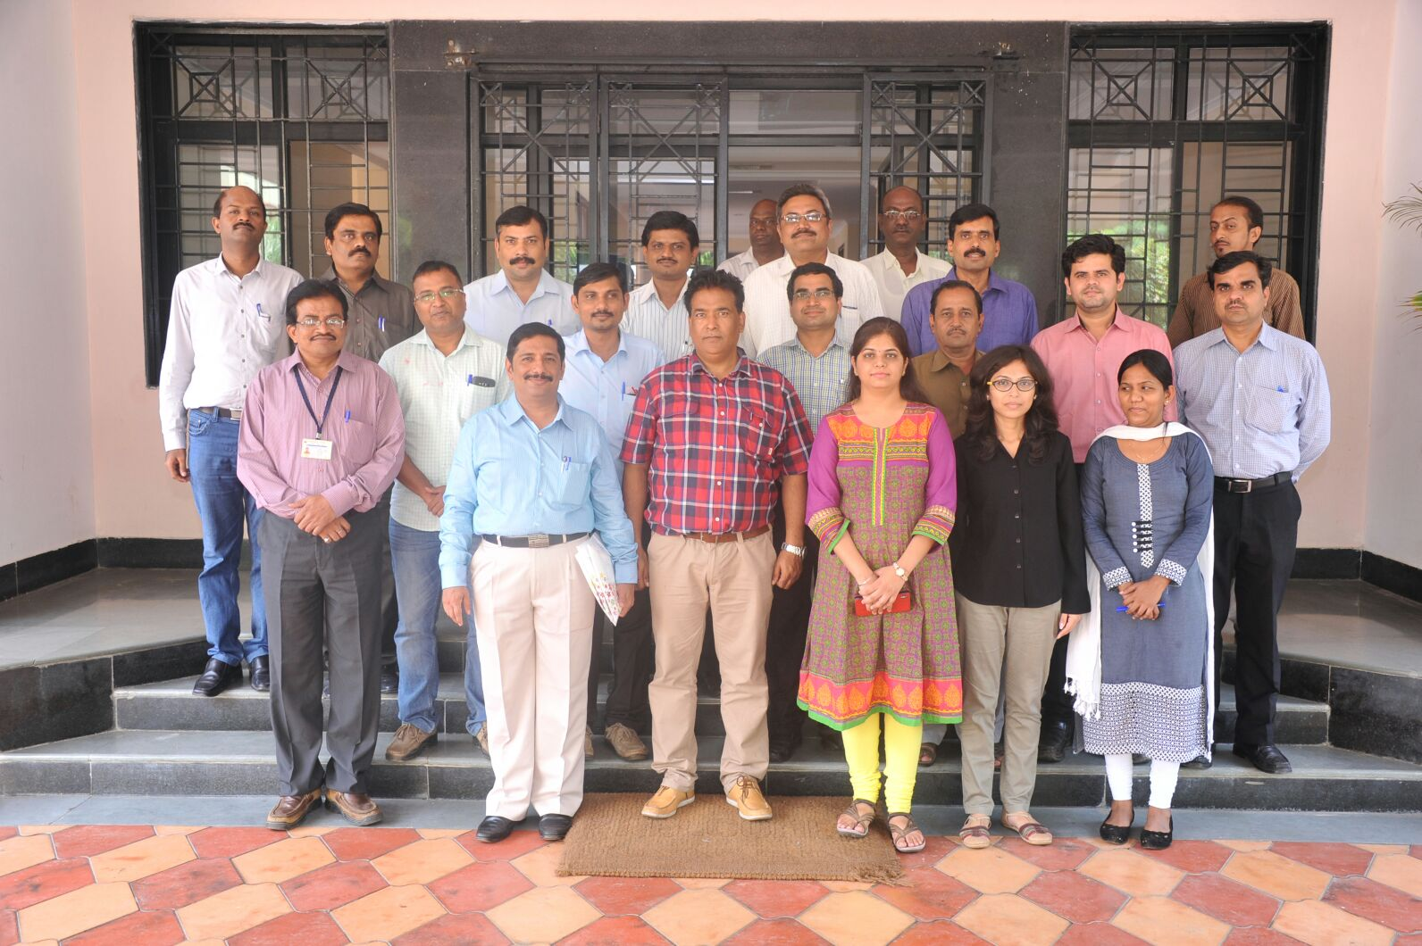
Group photo of Internal Assessor training PHC (14th August 2015)

