Odisha Service Provider Training on National Quality Assurance Standards

27th -29th Jan (BATCH I), 28th- 30th Jan (Batch II) 2015 at Bhubaneswar

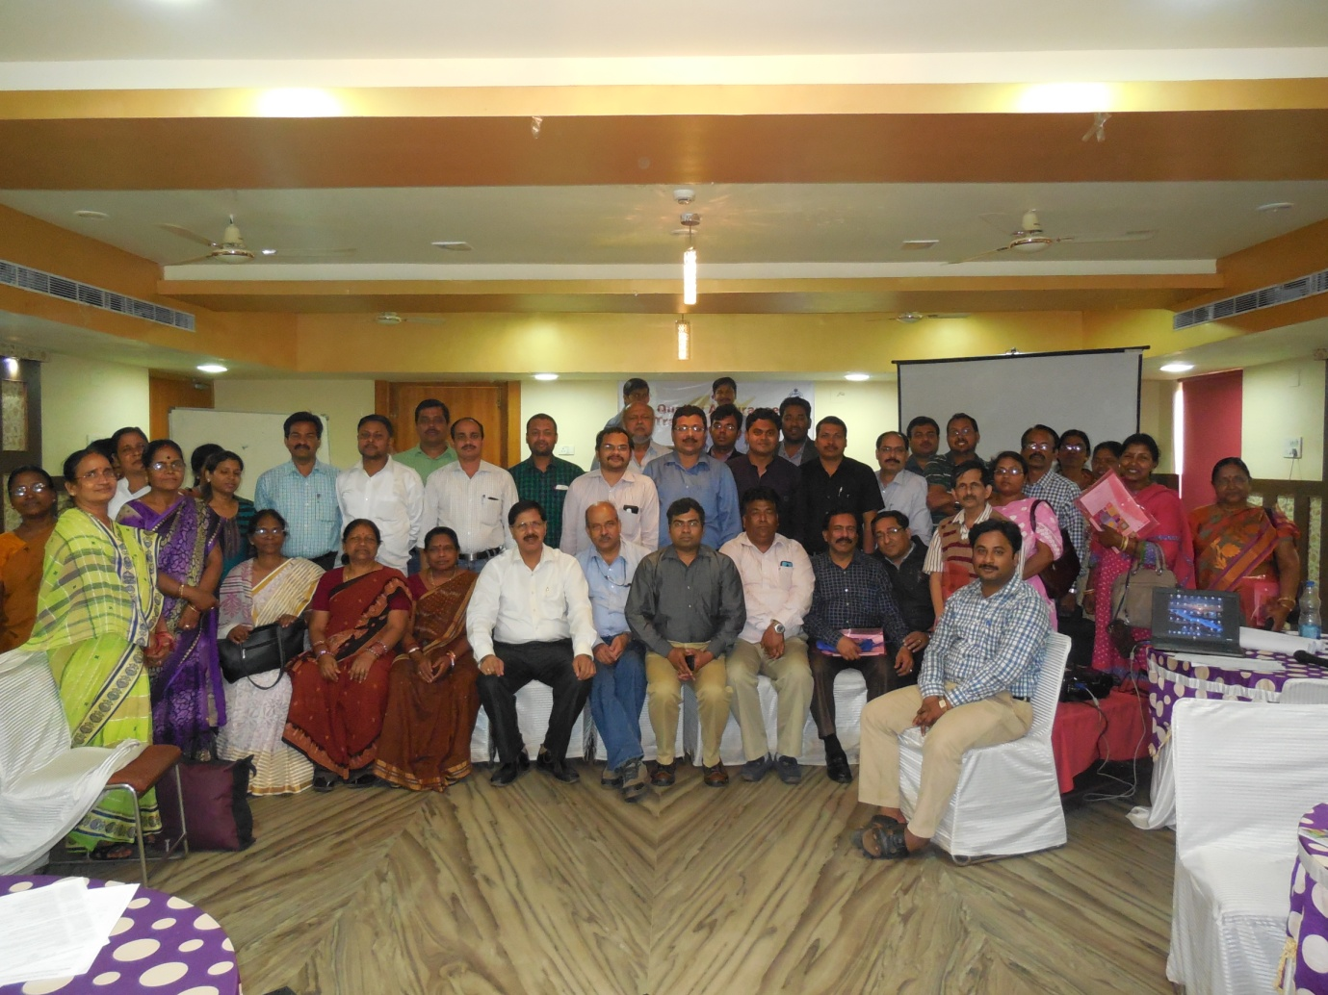

Conducted by:
National Health System Resource Centre in collaboration with NHM, QA Cell, Odisha.

TRAINING REPORT: ODISHA SERVICE PROVIDER TRAINING ON NATIONAL QUALITY ASSURANCE STANDARDS

TRAINING COORDINATOR: Dr Jagjeet Singh (Consultant, NHSRC, New Delhi)
Dr. Manoranjan Mohapatra (Consultant QA, NHM Odisha)

DATE OF TRAINING: 27th January 2015 to 29th January 2015 (Batch I), 28th January 2015 to 30th January 2015 (Batch II)

PLACE OF TRAINING: Hotel Bari International, Bhubaneswar, Odisha

PARTICIPANTS OF TRAINING: Total no. –76. (List attached in Annexure I)

COURSE OVERVIEW: The course schedule (Attached in Annexure II) outlines the day
to day contents and learning methods.
OBJECTIVES OF TRAINING:
The specific objectives of the Training programme were: -
- “To understand basic concepts of quality assurance, standards and how to implement them in their respective facilities”.
- “To improve the quality of services of Service Providers (doctors, nurses & paramedical staff)

BACKGROUND

‘Quality’ is the core & most important aspect of services being rendered at any health facility. National Quality Assurance standards have been developed to create an inbuilt and sustainable quality system for public health facilities which not only delivers good quality but is so perceived by the clients. To comply these standards, MoHFW, GoI has launched operational Guidelines as well as Assessor’s Guidebook for District hospitals, CHC (FRU) and PHC (24X7).

For implementation and certification under National Quality Assurance Standards (NQAS), 4 types of trainings courses were designed i.e. One day Awareness training, two days Internal Assessor Training, three day Service provider training and five day External Assessor training.
The target audience for three day service provider is Facility in charges, doctors, nurses, hospital mangers, programme managers & other Paramedical staffs.

Main aim of training is to understand basic concepts of quality assurance, standards & how to implement them in their facilities & to improve the quality of services from service providers (doctors, nurses & paramedical staff).

eXECUTIVE sERVICE

First fully fledged Service Providers Training was conducted by NHSRC in collaboration with NHM, QA cell, Odisha from 27th Jan, 2015 to 29th Jan, 2015 (Batch I) & 28th Jan, 2015 to 30th Jan, 2015 (Batch II) at Hotel Bari International, Bhubaneswar, Odisha.
The aim of training was to strengthen service provider’s knowledge of basic concepts of Quality assurance, standards and how to implement them in their facilities. Participants were from diverse background including Medical officers, Paediatrician, Gynaecologist, Staff nurse, Hospital Managers etc.
The participants were given-
- A copy of Operational Guideline for National Quality Assurance in public health facilities.
- A copy of Assessor’s guidebook for District Hospital.(Volume I & Volume II)
- A folder with scribbling pad, pen and a sheet of Agenda.
- Hard copy of Exercises and material wherever required during training.

The programme had 22 Sessions, spread over a period of three days for both Batch 1 & 2 respectively.
Feedback from the participants was taken and the report contains analysis and suggestions given by the participants. ,
Training was started with welcome speech from Dr. Srikant Mohapatra (Consultant QA, NHM Odisha) & introduction from all the participants followed by presentation from Dr. Parminder Gautam (Senior Consultant- QI, NHRSC). Training concluded with a good note by fruitful speech by Joint Secretary NHM, Odisha & takes a note of District Specific issues along with vote of thanks to trainer & trainee
The overall rating of the programme in feedback has been good with a overall score of 3.86 for Batch 1 & 3.88 for Batch 2 on a 5 point scale.
DAYWISE SUMMARY OF THE PRESENTATIONS

BATCH 1
DAY 1- 27/01/15

In the first presentation of the training Dr. Parminder Gautam , Senior Consultant, QI, NHSRC gave in detail about the ‘‘Principles and steps in Implementation of Quality Assurance Programme’’. He discussed about four basic Principles of Quality Assurance viz.
- Quality Assurance is oriented toward meeting the needs and expectations of the patients.
- Quality Assurance focuses on the system & processes.
- Quality Assurance uses data to analyze service delivery process.
- Quality Assurance encourages a team approach to problem solving and quality Improvement.
He also discusses about Critical steps of Quality Assurance which is as follows:
- Setting up Quality Standards, Measurable Elements and Check- lists.
- Quality Assessment.
- Identification of Gaps & areas of improvement.
- Action planning.
- Follow-up Assessment.
Speaker explained about the PDCA cycle and shared examples regarding its implementation. Dr. Parminder gave a holistic view of quality management system and various terms related to it. He also emphasize on Donabedian model which classifies Quality of Care (QOC) in terms of three aspects – Structure, Process & outcome. He emphasized on India needs a Pro- Public Health quality model which should be give flexibility to the states to customize, should be sustainable and scalable, have low cost of implementation etc.

This was followed by the session on “Overview of National Quality Assurance Standards and Measurement System” by Dr. Deepika Sharma, Consultant, NHSRC. She explained national quality assurance program and eight key features of QA program namely –
1. Unified organizational framework
2. Quality assurance standards
3. Continual assessment and scoring
4. Key performance indicators
5. Training and Capacity building
6. Inbuilt quality improvement model
7. Certification at state and national level
8. Incentives and sustenance.
The next presenter for the day was Dr. Sushant Agarwal & Dr. Jagjeet Singh, Consultant, NHSRC who has taken Group Exercise (Formation of QI team). In this session participants were given a snapshot of composition of Quality Team at District Hospital, & recommended subcommittee under District Quality Team & their respective Terms of Reference. Based on the member of subcommittee participants have to select himself their respective subcommittee & accordingly four imaginary District Hospital has been named viz. Qualitypur, Qualitygunj, Qualitybaad & Qualitynagar.
Dr. Sushant Agarwal, Consultant, NHSRC took the next session on “Key Performance Indicators”. Participants were explained about all the 30 indicators mentioned in the operational guidelines and were given exercises to calculate each indicator. This session was participative as it engaged all the participants in doing the calculations for solving the exercises.
The next presenter for the day was Dr. Deepika Sharma, Consultant, NHSRC who has taken “Internal Assessment” & “Exercises on assessment & Gap Analysis” explained method for assessing the public health facility based on NQAS. Dr. Deepika explicitly explained the methods of assessment via several pictorial representations. Participants were also explained about the scoring patterns and the method to obtain the cumulative hospital score card. A brief introduction of eighteen checklists was given. Based on the Internal Assessment, Exercises were given & participants were taken keen interest for doing gap analysis. Participants were shown pictures from the public health hospitals and were asked to identify the gaps.

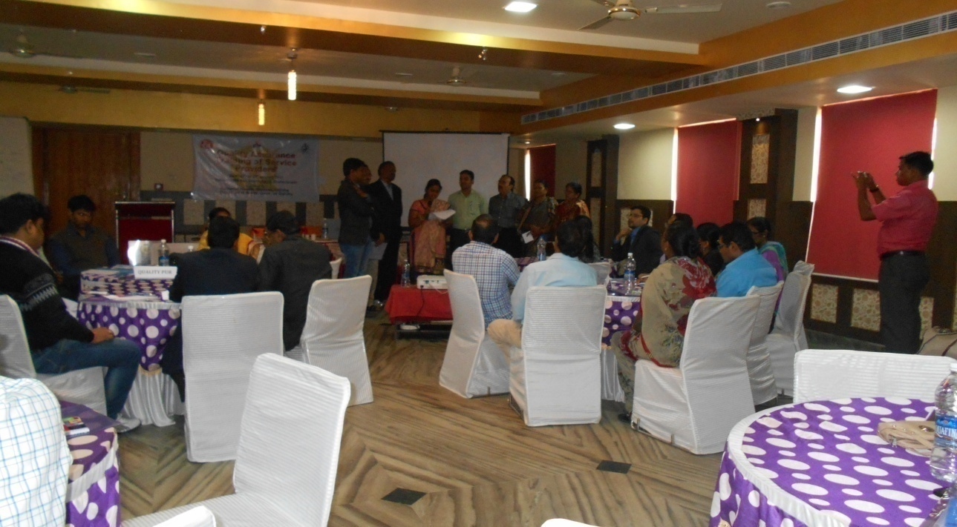

Group Exercise: Exercises on Assessment & Gap Analysis

The concluding session for the day was taken by Dr. Parminder Gautam, Senior Consultant, NHSRC on “Prioritization & Action Planning for Improvement.”In this session participants were explained about prioritization of gap based on severity of impact on patient care i.e. high, medium & low & time bound action planning for the traversing gaps.
DAY 2- 28/01/15
Day 2 was initiated with a brief recap of all the sessions of Day 1 by Dr. Nikhil Prakash.
First technical session on day 2 was taken by Dr. Deepika Sharma on “Hospital Infection Control”. She explained hand hygiene & also demonstrated steps of hand washing. Participants were explained about the Personal protection, instrument processing & environmental control. Dr. Deepika also explained about the categories of Biomedical Waste & standardized color coded collection and their respective treatment method.
The next presenter for the day was Ms. Surbhi Sharma, Consultant, NHSRC who has taken “Clean Hospital – Waste & Facility Management”. She has given emphasis on 5S process to improving organization & cleanliness & Standard method of cleaning. Ms. Surbhi also explained about three bucket system & disinfectants used for environmental cleaning in hospitals. Also explained about the safety, security & BMW management.
The next speaker for the day was Dr. Nikhil Prakash, Senior Consultant, NHSRC who has taken “Patient Safety”. He has given emphasis on Physical Safety of the infrastructure which includes seismic safety & electrical establishment. Dr. Nikhil also explained about the planned infrastructure as per prevalent norms for delivery of assured services. Also discussed about the fire safety. Participants were shown various pictures from the different public health hospitals concerning patient safety for better understanding.
Dr. Parminder Gautam, Senior Consultant NHSRC who took the next session on “Clinical Audits & Exercises on Clinical Audit.” During the session participants were given a detailed explanation about Medical Audit, Death Audit, Prescription Audit & Infection Control Audit. Based on four imaginary Quality districts hospital viz. Qualitypur, Qualitygunj, Qualitybaad & Qualitynagar, participants were given check list to fill their respective findings & present the same. It engaged all the participants in doing the exercises.
The next speaker for the day was Dr. Deepika Sharma, Consultant, NHSRC who gave a very informative lecture on “Tools for Quality Improvement.” She has given explanation about the fish bone diagram, Pareto analysis, control charts, run charts, pick charts.
The next important topic of Public health was taken by Dr. Renu Srivastava, Senior Consultant, RMNCHA, MoHFW on “Quality Assurance in Newborn & Child Health Services”. Dr. Renu Srivastava shared the global estimate of the cause of neonatal and child deaths. Discussions were done on how to prevent and manage the preliminary causes of the neonatal & child deaths. Focus was done on seven steps of quality improvement which mainly included Getting started, Standards of care, Assessment, Improvement, Monitoring, Documentation and Scaling up.
Dr. Srivastava discussed about the importance of breast feeding and good practices to decrease neonatal deaths. She explained about the day to day instances in public hospitals affecting neonatal health. She discussed about child health interventions including essential newborn care, immunizations, beast feeding & diarrheal disease.

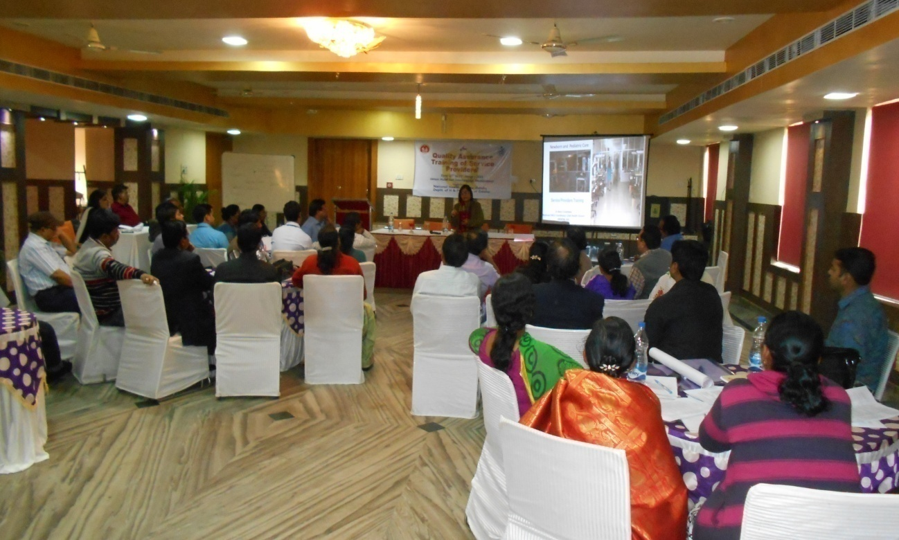
Dr. Renu Srivastava: presenting Quality Assurance in Newborn & Child Health Services

Next Session for the day was taken by Dr. Nikhil Prakash, Senior Consultant NHSRC who took the session on “Documentation for Quality Assurance – Standard Operating Procedure (SOPs)” & “Exercise on Drafting & Review of Standard Operating Procedure (SOPs)”. He explained how to write SOPs for different department of public health facilities. He explained the bullet headings under which SOPs may be written. As participants were divided in four groups, & each group has provided a flip chart & they have to draft SOPs & present in a group. Participants were taken keen interest in drafting of SOPs.

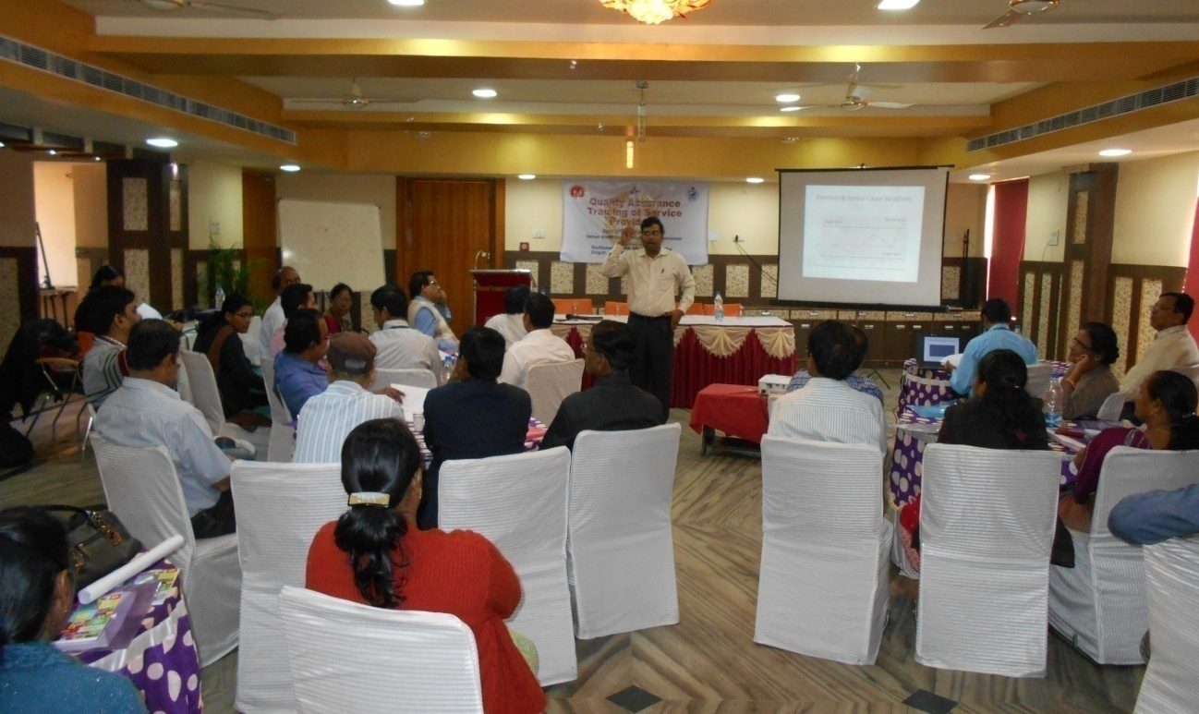

Dr. Nikhil Prakash: presenting Documentation for Quality Assurance – Standard Operating Procedure (SOPs)

Final Session for the day was taken by Dr. Deepika Sharma, Consultant NHSRC who took the session on “Quality Assurance in Laboratories”. Participants were explained about the Pre-analytical, Analytical & Post-Analytical method of testing. Also given emphasis on Calibration of measuring & monitoring equipments & Biosafety level 1 & 2. Explained about the Internal & External Quality Control.

DAY 3- 29/01/15
Day 3 began with recap of the sessions on Day 2 taken by Nikhil Prakash followed by discussion on group Exercise on Drafting & Review of Standard Operating Procedure (SOPs).
First session of the day was taken by Dr. Parminder Gautam on “Free Drugs & Inventory Management.” He has given detail explanation about forecasting & indenting of drugs, procurement of drugs & various Inventory Management techniques. He has also given emphasis on management of expiry & near expiry drugs.
Dr. Nikhil Prakash, Senior Consultant NHSRC took the next session on “Patient Rights & Satisfaction” which explain about availability & accessibility, Privacy & confidentiality, Active participation of the patients & their relatives. Also given emphasis on free services under JSSK. Participants were shown numerous pictures from the different public health hospitals which are handful for the delegates to improve their respective health facility more user friendly.
Next session of the day was taken by Dr. Nikhil Prakash, Senior Consultant NHSRC on “Quality Assurance in Maternal Health Services”. Dr. Nikhil had shared the cause of the maternal deaths & discussions were done on how to prevent and manage the preliminary causes of the maternal deaths including hypertension, haemorrhage and sepsis etc. Also given emphasis on identification and management of moderate & severe anaemia & counselling of pregnant women.
Ms. Surbhi Sharma Consultant NHSRC took the next session on “Group Work on Quality Team Meeting”. Participants were divided into four groups & each group has been provided with agenda points concerning Internal Assessment, PSS, KPI, Time bound action plan, CAPA & paper cuttings. Based on provided agenda, each group has performed Quality team meeting & discussed their agenda points & finally specific work has been allotted to each team member which was supposed to complete in a stipulated time frame.
Final technical Session for the day was taken by Dr. Nikhil Prakash, Senior Consultant NHSRC who took the session on “Road Map for Quality Assurance”. He has given detail explanation for implementing Quality Management System at District Hospitals based on NQAS.
Training concluded with a good note by fruitful speech by Joint Secretary NHM, Odisha & takes a note of District Specific issues along with vote of thanks to trainer & trainee

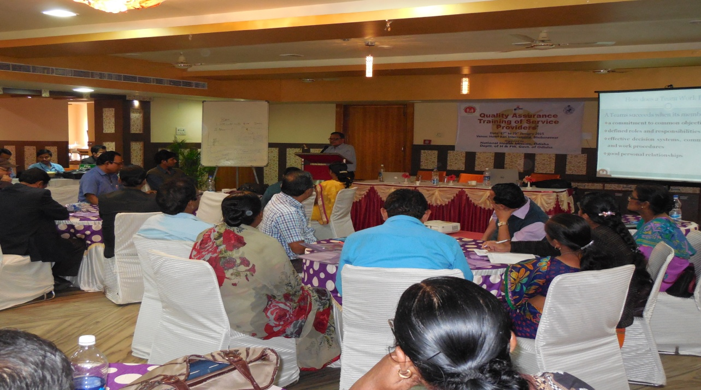

Speech by Joint Secretary, NHM, Bhubaneswar, Odisha

BATCH 2
DAY 1- 28/01/15

In the first presentation of the training Dr. Parminder Gautam , Senior Consultant, QI, NHSRC gave in detail about the ‘‘Principles and steps in Implementation of Quality Assurance Programme’’. He discussed about four basic Principles of Quality Assurance viz.
- Quality Assurance is oriented toward meeting the needs and expectations of the patients.
- Quality Assurance focuses on the system & processes.
- Quality Assurance uses data to analyze service delivery process.
- Quality Assurance encourages a team approach to problem solving and quality Improvement.
He also discusses about Critical steps of Quality Assurance which is as follows:
- Setting up Quality Standards, Measurable Elements and Check- lists.
- Quality Assessment.
- Identification of Gaps & areas of improvement.
- Action planning.
- Follow-up Assessment.
Speaker explained about the PDCA cycle and shared examples regarding it implementation. Dr. Parminder gave a holistic view of quality management system and various terms related to it. He also emphasize on Donabedian model which classifies Quality of Care (QOC) in terms of three aspects – Structure, Process & outcome. He emphasized on India needs a Pro- Public Health quality model which should be give flexibility to the states to customize, should be sustainable and scalable, have low cost of implementation etc.

This was followed by the session on “Overview of National Quality Assurance Standards and Measurement System” by Dr. Deepika Sharma, Consultant, NHSRC. She explained national quality assurance program and eight key features of QA program namely –
1. Unified organizational framework
2. Quality assurance standards
3. Continual assessment and scoring
4. Key performance indicators
5. Training and Capacity building
6. Inbuilt quality improvement model
7. Certification at state and national level
8. Incentives and sustenance.
The next presenter for the day was Dr. Sushant Agarwal Consultant, NHSRC who has taken Group Exercise (Formation of QI team). In this session participants were given a snapshot of composition of Quality Team at District Hospital, & recommended subcommittee under District Quality Team & their respective Terms of Reference. Based on the member of subcommittee participants have to select himself their respective subcommittee & accordingly four imaginary District Hospital has been named viz. Qualitypur, Qualitygunj, Qualitybaad & Qualitynagar.
Dr. Nikhil Prakash Senior Consultant NHSRC took the next session on “Patient Rights & Satisfaction” which explain about availability & accessibility, Privacy & confidentiality, Active participation of the patients & their relatives. Also given emphasis on free services under JSSK. Participants were shown numerous pictures from the different public health hospitals which are handful for the delegates to improve their respective health facility more user friendly.
Ms. Richa Sharma Consultant NHSRC took the next session on “Key Performance Indicators”. Participants were explained about all the 30 indicators mentioned in the operational guidelines and were given exercises to calculate each indicator. This session was participative as it engaged all the participants in doing the calculations for solving the exercises.
The next presenter for the day was Dr. Sushant Agarwal, Consultant, NHSRC who has taken “Internal Assessment” & “Exercises on assessment & Gap Analysis” explained method for assessing the public health facility based on NQAS & Dr. Sushant explicitly explained the methods of assessment via several pictorial representations. Participants were also explained about the scoring patterns and the method to obtain the cumulative hospital score card. A brief introduction of eighteen checklists was given. Based on the Internal Assessment, Exercises were given & participants were taken keen interest for doing gap analysis. Participants were shown pictures from the public health hospitals and were asked to identify the gaps.
The concluding session for the day was taken by Dr. Parminder Gautam, Senior Consultant, NHSRC on “Prioritization & Action Planning for Improvement.”In this session participants were explained about prioritization of gap based on severity of impact on patient care i.e. high, medium & low & time bound action planning for the traversing gaps.

DAY 2- 29/01/15
Day 2 was initiated with a brief recap of all the sessions of Day 1 by Dr. Parminder Gautam.
First technical session on day 2 was taken by Dr. Deepika Sharma on “Hospital Infection Control”. She explained hand hygiene & also demonstrated steps of hand washing. Participants were explained about the Personal protection, instrument processing & environmental control. Dr. Deepika also explained about the categories of Biomedical Waste & standardized color coded collection and their respective treatment method.
The next presenter for the day was Dr. Sushant Agarwal, Consultant, NHSRC who has taken “Clean Hospital – Waste & Facility Management”. He has given emphasis on 5S process to improving organization & cleanliness & Standard method of cleaning. Dr. Sushant also explained about three bucket system & disinfectants used for environmental cleaning in hospitals. Also explained about the safety, security & BMW management.
The next speaker for the day was Dr. Deepika Sharma, Senior Consultant, NHSRC who has taken “Patient Safety”. She has given emphasis on Physical Safety of the infrastructure which includes seismic safety & electrical establishment. Dr. Deepika also explained about the planned infrastructure as per prevalent norms for delivery of assured services. Also discussed about the fire safety. Participants were shown various pictures from the different public health hospitals concerning patient safety for better understanding.
Dr. Parminder Gautam, Senior Consultant NHSRC who took the next session on “Clinical Audits & Exercises on Clinical Audit.” During the session participants were given a detailed explanation about Medical Audit, Death Audit, Prescription Audit & Infection Control Audit. Based on four imaginary Quality districts hospital viz. Qualitypur, Qualitygunj, Qualitybaad & Qualitynagar, participants were given check list to fill their respective findings & present the same. It engaged all the participants in doing the exercises.
The next speaker for the day was Dr. Deepika Sharma, Consultant, NHSRC who gave a very informative lecture on “Tools for Quality Improvement.” She has given explanation about the fish bone diagram, Pareto analysis, control charts, run charts, pick charts
Next session for the day was taken by Dr. Parminder Gautam, Senior Consultant NHSRC who took the session on “Documentation for Quality Assurance – Standard Operating Procedure (SOPs)” & “Exercise on Drafting & Review of Standard Operating Procedure (SOPs)”. He explained how to write SOPs for different department of public health facilities. He explained the bullet headings under which SOPs may be written. As participants were divided in four groups, & each group has provided a flip chart & they have to draft SOPs & present in a group. Participants were taken keen interest in drafting of SOPs.
Final Session for the day was taken by Ms. Richa Sharma, Consultant NHSRC who took the session on “Quality Assurance in Laboratories”. Participants were explained about the Pre-analytical, Analytical & Post-Analytical method of testing. Also given emphasis on Calibration of measuring & monitoring equipments & Biosafety level 1 & 2. Explained about the Internal & External Quality Control.

DAY 3- 30/01/15
Day 3 began with recap of the sessions on Day 2 taken by Dr. Parminder Gautam followed by discussion on group Exercise on Drafting & Review of Standard Operating Procedure (SOPs).
First session of the day was taken by Dr. Parminder Gautam on “Free Drugs & Inventory Management.” He has given detail explanation about forecasting & indenting of drugs, procurement of drugs & various Inventory Management techniques. He has also given emphasis on management of expiry & near expiry drugs.
Next session of the day was taken by Dr. Nikhil Prakash, Senior Consultant NHSRC on “Quality Assurance in Maternal Health Services”. Dr. Nikhil had shared the cause of the maternal deaths & discussions were done on how to prevent and manage the preliminary causes of the maternal deaths including hypertension, haemorrhage and sepsis etc. Also given emphasis on identification and management of moderate & severe anaemia & counselling of pregnant women.
Dr. Jagjeet Singh Consultant NHSRC took the next session on “Group Work on Quality Team Meeting”. Participants were divided into four groups & each group has been provided with agenda points concerning with Internal Assessment, PSS, KPI, Time bound action plan, CAPA & paper cuttings. Based on provided agenda, each group has performed Quality team meeting & discussed their agenda points & finally specific work has been allotted to each team member which was supposed to complete in a stipulated time frame.
Final technical Session for the day was taken by Dr. Nikhil Prakash, Senior Consultant NHSRC who took the session on “Road Map for Quality Assurance”. He has given detail explanation for implementing Quality Management System at District Hospitals based on NQAS.
Training concluded with a good note by fruitful speech by Joint Secretary NHM, Odisha & takes a note of District Specific issues along with vote of thanks to trainer & trainee.

PARTICIPANT FEEDBACK
Following examination feedback was taken from participants. Evaluation of participant feedback is taken on 5 point scale. Analysis of Participant feedback is attached in Annexure IV. Overall Average scoring was of 3.86 for Batch 1 & 3.88 for Batch 2 respectively out of 5.
MOST LIKED SESSIONS WERE:
 | Batch - 1
Name of Session & Presenter |  | Score
Free Drugs & Inventory Management presented by Dr. Parminder Gautam |  | 4.21
Principles & steps in Implementation of Quality Assurance Programme presented by Dr. Parminder Gautam |  | 4.09
Prioritization & Action Planning for Improvement presented by Dr. Parminder Gautam |  | 4.06
Hospital Infection Control presented by Dr. Deepika Sharma |  | 4.0

 | Batch - 2
Name of Session & Presenter |  | Score
Prioritization & Action Planning for Improvement presented by Dr. Parminder Gautam |  | 4.31
Principles & steps in Implementation of Quality Assurance Programme presented by Dr. Parminder Gautam |  | 4.3
Free Drugs & Inventory Management presented by Dr. Parminder Gautam |  | 4.13
Documentation for Quality Assurance – Standard Operating Procedure (SOPs) presented by Dr. Parminder Gautam |  | 4.08

SUGGESTIONS FROM BATCH 1 TO IMPROVE THE TRAINING
- Pharmacists, Laboratory Technician, Pathologists may participate in Service Provider Training.
- Field visits to a nearby Hospital may also improve the training protocols.
- Orientation training for housekeeping & Grade IV staffs may be provided.
- Sig sigma topic may be included.
- Some topics may be included for safety of Doctors.
- Emphasis may be given on practical aspects rather than theoretical.
- Following topics may be included: Emergency services, Immunization services, Diet & nutrition & Kangaroo Mother Care counseling.
SUGGESTIONS FROM BATCH 2 TO IMPROVE THE TRAINING
- NRC related topics may be included.
- Management of Sick new born baby topic may be included.
- Process mapping topic may be included.
- Soft skills topic may be included.
- Antenatal care & Nursing care topic may be included.
VALEDICTORY
At last Joint Secretary, NHM Odisha acknowledges & appreciated the contribution of NHSRC – QI Division for conducting the training & thanked all the participants for the overwhelming participation and sincerity towards the training.

Batch 1
Annexure I
Sr. No | Name & Designation | Phone Number
1 | Dr Chhayakanta Gowda,  Pediatric Specialist  DHH Koraput | 09937160652
2 | Dr Amar Kumar Das  OBG Specialist  DHH Koraput | 09437119050
3 | Dr Kambhupani Naik  OBG Specialist  DHH Kalahandi | 09437433571
4 | Dr Palam Pradhan  Pediatric Specialist  DHH Kalahandi | 09437092335
5 | Dr Chinmayee Swain  Hospital Manager  DHH Kalahandi | 09439980004
6 | Ms Sabitri Nayak  Nursing Sister  DHH Angul | 09937035821
7 | Ms Sasmita Biswal  Staff Nurse  DHH Balasore | 09437803667
8 | Ms Satyashama Behera  Staff Nurse  DHH Keonjhar | 09438032242
9 | Ms Temerin Sanga  Staff Nurse  DHH Koraput | 09437784620
10 | Mr. Devasis Mandal  Hospital Manager  DHH Keonjhar | 09439987009
11 | Ms Rosalia Barla  Assistant Matron  DHH Puri | 09937088750
12 | Dr B.P. Chatray  OBG Specialist  DHH Puri | 09437222718
13 | Mr Sachin Kumar Sahoo  Hospital Manager  DHH Puri | 09439994067
14 | Dr Uthittunanjan Kumar  Pediatric Specialist  DHH Puri | 09437281832
15 | Dr U.R.Pati  OBG Specialist  DHH Angul | 09438803081
16 | Mr. Lalit Mohan Sahu  Hospital Manager  DHH Koraput | 09439972974
17 | Dr M.A. Rashid  OBG Specialist  DHH Keonjhar | 09437680571
18 | Ms Saumyasree Pradhan  Hospital Manager  DHH Jajpur | 09439992262
19 | Dr Sunil Kumar  OBG Specialist  DHH Balangir | 09437243054
20 | Ms Rojalia Sorery  Assistant Matron  DHH Bhawanipatna | 09439422886
21 | Dr D. Brmjanj  Hospital Manager  DHH Balangir | 09439287163
22 | Dr S.B. Mishra  Hospital Manager  DHH Rayagada | 09439983499
23 | Ms Hemlata Raut  Assistant Matron  DHH Balangir | 09861121316
24 | Dr Shriram Mohanty  Hospital Manager  DHH Balasore | 09479952004
25 | Ms Rajkishori Kerketta  Staff Nurse  DHH Rayagada | 08895671394
26 | Dr Hemanta Kumar Mishra  Pediatric Specialist  DHH Keonjhar | 09437793648
27 | Dr S.K.Tiady  Pediatric Specialist  DHH Balangir | 09437150147
28 | Dr. A.K.Patra  OBG Specialist  DHH Balasore | 09438009094
29 | Dr G.V.Rond  Pediatric Specialist  DHH Rayagada | 09437234020
30 | Dr M.R  Hospital Manager  CHB | 09429991156
31 | Dr Bijaya Panda  OBG Specialist (HOD)  Capital Hospital, Bhubaneswar | 09437090760
32 | Ms Santi Lata Jena  Staff Nurse  Capital Hospital, Bhubaneswar | 09040136373
33 | Dr Mritunjay Sahu  Pediatrics Specialist (HOD)  Capital Hospital, Bhubaneswar | 09337662488
34 | Dr Subhendu Mahesh  Assistant Surgeon  DHH Balasore | 09437294656
35 | Dr Prafulla Kumar Padhi  OBG Specialist  Rayagada | 09437298817

Batch 2
Annexure I
Sr. No | Name & Designation | Phone Number
1 | Dr Satyaranjan Mallick  Pediatric Specialist  DHH Kandhamal | 09937185357
2 | Dr Deepak Kumar Nayak  Hospital Manager  DHH Bhadrak | 09439986822
3 | Mr. Bharat Bhusan  Hospital Manager  DHH Nayagarh | 09439991602
4 | Ms Subasini Devi  Staff Nurse  DHH Nayagarh | 09938634123
5 | Mr Kumar Abhishek  Hospital Manager  DHH Nabarangpur | 09439990206
6 | Dr Dinabandhu Panda  Pediatric Specialist  RGH, Rourkela | 09437366145
7 | Ms Mary Kerketta  Assistant Matron  RGH, Rourkela | 09938572312
8 | Dr Sanjeev Pandey  Hospital Manager  DHH Sundargarh | 09938616136
9 | Dr Sanjeev Ranjan Mohapatra  Hospital Manager  RGH, Rourkela | 09437344445
10 | Dr T.K. Das  OBG Specialist  RGH, Rourkela | 09861304943
11 | Dr Saumya Kanta Patro  Hospital Manager  DHH Kendrapara | 09439996008
12 | Ms Sukantilata Maharaj  Assistant Matron  DHH Nabrangpur | 09437264362
13 | Dr Rukmani Devi  OBG Specvialist  DHH Kendrapara | 09437228028
14 | Ms Chulamani Hembram  Staff Nurse  DHH Paralakhemundi | 09438431484
15 | Mr. Shaktimayee Samal  Hospital Manager  DHH Jagatsinghpur | 09439991453
16 | Ms Hemalata Sahay  Staff Nurse  DHH Jagatsinghpur | 09861062788
17 | Dr Biswajit Panda  Pediatric Specialist  DHH Sambalpur | 09439986128
18 | Dr Sudeep Dutta  Hospital Manager  DHH Sambalpur | 09439986008
19 | Dr Pramod Kumar Panda  Pediatric Specialist  DHH Paralekhemundi | 09437645251
20 | Dr Kiran Kumar Rath  OBG Specialist  DHH Bhadrak | Not given
21 | Dr Binod Bihari Panda  Pediatric Specialist  DHH Bhadrak | 09438759305
22 | Mr. Satarupa Mishra  Hospital Manager  DHH Dhenkanal | 09439981100
23 | Dr Bibhudatta Nayak  Medical Officer (SNCU)  DHH Sundargarh | 09437586227
24 | Dr Santosh Kumar Swain  Pediatric Specialist  DHH Kendrapara | 09437318991
25 | Dr R. Mahapatra  Medical Officer  DHH Sundargarh | 09861643838
26 | Ms Sebastina Bolang  Assistant Matron  DHH Sundargarh | 09938166199
27 | Ms Nalini Pattnaik  Staff Nurse  DHH Kendrapara | 09040388454
28 | Dr C.K. Parida  Pediatric Specialist  DHH Dhenkanal | 09861475099
29 | Dr Biswajit Das  OBG Specialist  DHH Kandhamal | 08895331662
30 | Dr S.K. Sahu  Hospital Manager  DHH Paralekhemundi | 09439990207
31 | Dr Uma Shankar Dalal  OBG Specialist  DHH Sambalpur | 09437332599
32 | Dr Anupama Mahan  OBG Specialist  DHH Malkangiri | 09437236769
33 | Dr Leena Kar  Hospital Manager  City Hospital, Behrampur | 09439985017
34 | Ms Mariam Lakra  Staff Nurse  City Hospital, Behrampur | 09439058708
35 | Ms Elisaba Kundulna  Staff Nurse  DHH Sambalpur | 09437737026
36 | Dr Saroj Kumar Jena  Senior OBG Specialist  DHH Jagatsinghpur | 09437062397
37 | Dr B.K. Patnaik  OBG Specialist  DHH Dhenkanal | 09861052207
38 | Ms Pramila Bala Pani  Staff Nurse (OBG In charge)  DHH Dhenkanal | 09778427014
39 | Dr D.R. Satapathy  Pediatric Specialist  DHH Nabrangpur | 09437378164
40 | Mr. Arun Kumar Patro  Hospital Manager  DHH Kandhamal | 09439990208
41 | Mr. Manu Ranjan Mahapatra  Hospital Manager  DHH Mayurbanj | 09439995514

Annexure II
Service Provider Training on National Quality Assurance Standards
27th- 29th January 2015, Orissa.
Batch 1

Day-1
Time | Topic | Resource Person
9:00AM-9:30 AM | Registration
09:30AM -10:00AM | Inaugural Address MD NHM
10:00 AM -11:00 AM | Principles and steps in Implementation of Quality Assurance Programme | Dr. ParminderGautam
11:00 AM - 11:15 AM | Tea
11:15 AM-12:00NOON | Overview of National Quality Assurance Standards and Measurement System | Dr. Deepika Sharma
12:00 NOON -1:00 PM | Group exercise (Formation of QI team) | Dr. Jagjeet Singh
1:00 PM -1.45 PM | Lunch
1:45 PM -2:30 PM | Key Performance Indicators (KPI) – Measurement & Analysis | Dr. SushantAgarwal
2:30 PM -3:15 PM | Quality Assurance in Laboratories | Dr. Deepika Sharma
3:15 PM-3:30 PM | Tea
3:30 PM -4:00 PM | Internal Assessment | Dr. Deepika Sharma
4:00 PM- 4:45 PM | Exercises on Assessment & Gap Analysis | Dr. Deepika Sharma
4:45 PM – 5:30 PM | Prioritization & Action Planning for Improvement | Dr. ParminderGautam

Day-2
9:00 AM -9:30 AM | Recap
9:30 AM - 10:15 AM | Hospital Infection Control | Dr. Deepika Sharma
10:15 AM -10:30 AM | Tea
10:30 AM -11:15 AM | Clean Hospital – Waste & Facility Management | Ms. Surbhi Sharma
11:15 AM - 12:00 NOON | Patient Safety | Dr. Nikhil Prakash
12:00 NOON- 12:45 PM | Clinical Audits (Medical, Death, Prescription and Infection Control Audits) | Dr. ParminderGautam
12:45 PM – 1.30 PM | Lunch
1:30 PM -2:15 PM | Exercises on Clinical Audit | Dr. Parminder Gautam
2:15 PM -3.15 PM | Hospital Infection Control | Dr. Deepika Sharma
3:15 PM -3:30 PM | Tea
3.30.4.30 | Quality Assurance In Newborn and Child Health Services | Dr. Renu Srivastava
4.30-5.00 | Documentation for Quality Assurance – Standard Operating Procedure (SOPs) | Dr. Nikhil Prakash
5.00-5.30 | Exercise on Drafting & Review of Standard Operating Procedure (SOPs) | Dr. Nikhil Prakash

Day-3
Time | Topic | Resource Person
9:00 AM -9:30 AM | Recap
09:30 AM -10:15 AM | Free Drugs & Inventory Management | Dr. ParminderGautam
10:15 AM -11:00 AM | Patient Rights & Satisfaction – Measuring & Improving | Dr. Nikhil Prakash
11:00 AM - 11:15 AM | Tea
11:15 AM-12:00 NOON | Quality Assurance in Maternal Health Services | Dr. Nikhil Prakash
12:00 NOON - 1:15 PM | Group Work on Quality Team meeting | Ms. Surbhi Sharma
1:15 PM -2.00 PM | Lunch
2:00 PM -3:15 PM | Road Map for Quality Assurance | Dr. Nikhil Prakash
3:15 PM -4:15 PM | State Specific issues
4:15 PM-4:30 PM | Tea
4:30 PM -5:00 PM | Feedback & Valedictory

Service Provider Training on National Quality Assurance Standards
28th- 30th January 2015, Orissa.
Batch 2

Day-1
Time | Topic | Resource Person
9:00 AM -9:30 AM | Registration
09:30 AM -10:00 AM | Inaugural Address MD NHM
10:00 AM -11:00 AM | Principles and steps in Implementation of Quality Assurance Programme | Dr. Parminder Gautam
11:00 AM - 11:15 AM | Tea
11:15 AM-12:00 NOON | Overview of National Quality Assurance Standards and Measurement System | Dr. Deepika Sharma
12:00 NOON - 1:00 PM | Group exercise (Formation of QI team) | Dr. Sushant Agarwal
1:00 PM -1.45 PM | Lunch
1:45 PM -2:30 PM | Patient Rights & Satisfaction – Measuring & Improving | Dr. Nikhil Prakash
2:30 PM -3:15 PM | Key Performance Indicators (KPI) – Measurement & Analysis | Ms. Richa Sharma
3:15 PM-3:30 PM | Tea
3:30 PM -4:00 PM | Internal Assessment | Dr. Sushant Agarwal
4:00 PM- 4:45 PM | Exercises on Assessment & Gap Analysis | Dr. Sushant Agarwal
4:45 PM – 5:30 PM | Prioritization & Action Planning for Improvement | Dr. Parminder Gautam

Day-2
9:00 AM -9:15 AM | Recap
9:15 AM - 10:15 AM | Hospital Infection Control | Ms. Surbhi Sharma
10:15 AM -10:30 AM | Tea
10:30 AM -11:15 AM | Clean Hospital – Waste & Facility Management | Dr. SushantAgarwal
11:15 AM - 12:00 NOON | Patient Safety | Dr. Nikhil Prakash
12:00 NOON- 12:45 PM | Clinical Audits (Medical, Death, Prescription and Infection Control Audits) | Dr. Parminder Gautam
12:45 PM – 1.30 PM | Lunch
1:30 PM -2:15 PM | Exercises on Clinical Audit | Ms. Richa Sharma
2:15 PM -3.15 PM | Quality Assurance in Laboratories | Ms. Richa Sharma
3:15 PM -3:30 PM | Tea
3:30 PM -4:15 PM | Documentation for Quality Assurance – Standard Operating Procedure (SOPs) | Dr. ParminderGautam
4:15 PM to 4:45 PM | Exercise on Drafting & Review of Standard Operating Procedure (SOPs) | Dr. Nikhil Prakash

Day-3
Time | Topic | Resource Person
9:00 AM -9:30 AM | Recap
09:30 AM -10:15 AM | Free Drugs & Inventory Management | Dr. Parminder Gautam
10:15 AM -11:00 AM | Quality Assurance in Maternal Health Services | Dr. Nikhil Prakash
11:00 AM - 11:15 AM | Tea
11:15 AM-12:00 NOON | Group Work on Quality Team meeting | Dr. Jagjeet Singh
1:15 PM -2.00 PM | Lunch
2:00 PM -3:15 PM | Road Map for Quality Assurance | Dr. Nikhil Prakash
3:15 PM -4:15 PM | State Specific issues
4:15 PM-4:30 PM | Tea
4:30 PM -5:00 PM | Feedback & Valedictory

Annexure IV
Odisha Service Provider Training Participants’ Feedback Evaluation
27th – 29th January 2015, Batch 1
DAY -1
Topic | Resource Person |  | Average
Principles and steps in Implementation of Quality Assurance Programme | Dr. Parminder Gautam |  | 4.09
Overview of National Quality Assurance Standards and Measurement System | Dr. Deepika Sharma |  | 3.64
Group exercise (Formation of QI team) | Dr. Jagjeet Singh |  | 3.67
Key Performance Indicators (KPI) – Measurement & Analysis | Dr. SushantAgarwal |  | 3.61
Quality Assurance in Laboratories | Dr. Deepika Sharma |  | 3.67
Internal Assessment | Dr. Deepika Sharma |  | 3.63
Exercises on Assessment & Gap Analysis | Dr. Deepika Sharma |  | 3.69
Prioritization & Action Planning for Improvement | Dr. Parminder Gautam |  | 4.06

Day-2
Hospital Infection Control | Dr. Deepika Sharma | 4
Clean Hospital – Waste & Facility Management | Ms. Surbhi Sharma | 3.51
Patient Safety | Dr. Nikhil Prakash | 3.75
Clinical Audits (Medical, Death, Prescription and Infection Control Audits) | Dr. ParminderGautam | 3.94
Exercises on Clinical Audit | Dr. Parminder Gautam | 3.85
Quality Assurance In Newborn and Child Health Services | Dr. Renu Srivastava | 3.88
Documentation for Quality Assurance – Standard Operating Procedure (SOPs) | Dr. Nikhil Prakash | 3.79
Exercise on Drafting & Review of Standard Operating Procedure (SOPs) | Dr. Nikhil Prakash | 3.9

Day-3
Topic | Resource Person |  |  | Average
Free Drugs & Inventory Management | Dr. ParminderGautam |  | 4.21
Patient Rights & Satisfaction – Measuring & Improving | Dr. Nikhil Prakash |  | 3.88
Quality Assurance in Maternal Health Services | Dr. Nikhil Prakash |  | 3.82
Group Work on Quality Team meeting | Ms. Surbhi Sharma |  | 3.94
Road Map for Quality Assurance | Dr. Nikhil Prakash |  | 3.94

Odisha Service Provider Training Participants’ Feedback Evaluation
28th – 30th January 2015, Batch 2
DAY – 1
Topic | Resource Person |  | Average
Principles and steps in Implementation of Quality Assurance Programme | Dr. Parminder Gautam |  | 4.3
Overview of National Quality Assurance Standards and Measurement System | Dr. Deepika Sharma |  | 3.75
Group exercise (Formation of QI team) | Dr. Sushant Agarwal |  | 3.8
Patient Rights & Satisfaction – Measuring & Improving | Dr. Nikhil Prakash |  | 3.8
Key Performance Indicators (KPI) – Measurement & Analysis | Ms. Richa Sharma |  | 3.64
Internal Assessment | Dr. Sushant Agarwal |  | 3.81
Exercises on Assessment & Gap Analysis | Dr. Sushant Agarwal |  | 3.80
Prioritization & Action Planning for Improvement | Dr. Parminder Gautam |  | 4.31

Day-2
Hospital Infection control | Ms. Surbhi Sharma |  |  | 3.79
Clean Hospital – Waste & Facility Management | Dr. Sushant Agarwal |  |  | 3.77
Patient Safety | Dr. Nikhil Prakash |  |  | 3.73
Clinical Audits (Medical, Death, Prescription and Infection Control Audits) | Dr. ParminderGautam |  |  | 3.92
Exercises on Clinical Audit | Ms. Richa Sharma |  |  | 3.74
Documentation for Quality Assurance – Standard Operating Procedure (SOPs) | Dr. Parminder Gautam |  |  | 4.08
Quality Assurance in Laboratories | Ms. Richa Sharma |  |  | 3.83
Exercise on Drafting & Review of Standard Operating Procedure (SOPs) | Dr. Nikhil Prakash |  |  | 3.9

Day-3
Topic | Resource Person | Average
Free Drugs & Inventory Management | Dr. Parminder Gautam | 4.13
Quality Assurance in Maternal Health Services | Dr. Nikhil Prakash | 3.84
Group Work on Quality Team meeting | Dr. Jagjeet Singh | 3.71
Road Map for Quality Assurance | Dr. Nikhil Prakash | 3.81

