Internal Assessor Training on National Quality Assurance Standards

16th to 17th August 2016, Delhi

Conducted by

National Health System Resource Centre in collaboration with National Health Mission Delhi

TRAINING REPORT
INTERNAL ASSESSOR TRAINING ON NATIONAL QUALITY ASSURANCE STANDARDS

TRAINING COORDINATOR Mr. Ramesh Pandey (Nodal officer for QA Delhi State)
Ms. Vinny Arora (Consultant, QI, NHSRC, New Delhi)

DATE OF TRAINING 16th to 17th August 2016

PLACE OF TRAINING 6th Floor, Conference Room, B Wing, Vikas Bhawan – II,
DSHM, Civil Lines, Delhi.

PARTICIPANTS OF TRAINING Total no.33 (List attached in Annexure I)

COURSE SCHEDULE The course schedule (Attached in Annexure II) outlines
the day to day contents and learning methods.

Contents

Overview 2
Objective of Training 2
Session Brief 3
Training Feedback 5
Annexure - I 6
List of Participants 6
Annexure - II 8
Training Agenda 8
Photo Gallery 9

Overview
2-days Internal Assessor training was conducted in state of Delhi by National Health System Resource centre in collaboration with National Health Mission (NHM) Delhi from 16th to 17th August, 2016.
Main objective of the training was to provide an overview of National Quality Assurance Standards as well as to prepare the state participants as internal assessors for the NQAS program. To fulfil the main objective the state has nominated 33 participants for the training which include Specialist, Medical Officers, Nursing Staff, Engineers etc.
Training started with an inaugural key note by state quality nodal officer, he discussed about importance of the Quality in Healthcare system. 2 day training was spread in to 10 Topics & 2 exercises for hands on experience about various methodologies of the assessment and identifying standards.
Training was followed by Post training evaluation, which is attempted by 31 participants. Post training evaluation contain open book exam with Question paper having 42 multiple-choice Questions. Maximum Marks for Question paper is 40. Passing marks for exam was 60%. Out of 31 participants 24 has passed the exam successfully.
Training program have inbuilt training course evaluation system, where training feedback form is provided to each participant in the beginning of the session. Feedback of participants has been analyzed on 5 point scale. Overall score for training program was 4.1 on a Five-point scale.

Objective of Training
- To acquaint the trainees with National Quality Assurance standards, measurable elements, departmental checklists and scoring system along with scoring methodology.
- To develop skills and acumen to carry out assessment of hospitals.

Session Brief

Topic | Session Brief
Day -1 (16 -08-2016)
Overview of National Quality Assurance Program  Dr. Nikhil Prakash | This session covers the concepts, dimensions and approaches towards Quality, it outlines about development of National Quality Assurance Program and also brief about its 8 areas of concern along with its Key features. Session also describes about the proposed organization structure required at state and district level for effective implementation of program.
Measurement System for Quality Assurance, Standards and Assessment Protocol  Ms. Vinny Arora | This session elaborate the measurement system and the differentiation of the system at UPHC & DH level. It also gives an overview of 8 Area of Concerns and its Standards. A detailed discussion about 18 checklists of District Hospital Level is done during the session. This session also entails about scoring & methodology used in the system.
Standards for Service Provision , Patient Rights & Inputs  Dr. Nikhil Prakash & Ms. Richa Sharma | Session cover an elaborative discussion about first 3 area of concern i.e. Service Provision, Patient rights & Input. It includes thorough understanding about availability of services & discussion on patient rights. It includes availability of infrastructure, human resource and their training, competencies & also availability of consumables & drugs. Patient Rights & Inputs were covered by Ms. Richa Sharma.
Case study Labour Room  Ms. Vinny Arora | Case Study of Labour room is given to participants for better understanding of scoring system as well as hands on experience about assessment. Individually all participants had worked upon case study followed by formulation of score card for Area of Concern A, B & C. Followed by thorough detailed discussion about all the checkpoints.
Standards for General Clinical Services  Ms. Richa Sharma | Session include importance of clinical services as well as discussion on 9 standards of Clinical services which includes assessment of Quality of registration, admission, consultation services, assessment & reassessment of in patients, their care during transfer & referral. It also include discussion about nursing care, drug administration, patient record maintenance and discharge process etc.
Standards for Specific Clinical services & RMCH+A Services  Dr. Mrinalini Mani | Session include discussion about Assessment of quality of specific clinical services like Emergency, ICU/SNCU, OT, anaesthetic services, diagnostic services, blood bank as well as end of life care. It also include discussion on RMNCHA services which include Antenatal, intra-natal & Postnatal care as well as family planning & ARSH services along with standards for Quality of National Health Programs. Dr. Mani explained very well about the standards in concurrence with the Delhi state scenario for conducting assessments objectively.
Day -2 (17-08-2016)
Standards for Infection Control  Ms. Richa Sharma | Session includes detailed discussion about 6 standards. It includes elaborative details on how to assess the infection control practices at public health care facilities. Layout of Operation Theatre, discussion of New Bio Medical Waste Management rules forms the part of the session.
Key Performance Indicators  Ms. Richa Sharma | Session include discussion on 30 KPIs. It also include how to calculate & reporting mechanism of KPI at facility, district & state level
Gap Analysis Exercise  Ms. Vinny Arora | Gap Analysis format were given to the participants, later on Slides were shown to them to enable them to find the gap, then prioritize and prepare an action action plan in order to perform the gap analysis activity after assessment in their facilities.
Standards for Support Services  Ms. Vinny Arora | Session Include importance of support services in public healthcare facilities as well as detailed discussion on 12 standards of Support services. It also include detailed discussion on Maintenance of equipments, calibration, inventory management, dietary services, Laundry services, Security services, Community participation, financial management, contract management & Statutory requirement etc.
Standards for Quality Management  Dr. Sapna Bathla | Session include discussion on 8 standards of Quality Management system. It also include how to assess Quality policy, objective, SOP, PSS, process mapping etc. Quality Tools were discussed during the session.
Roadmap for Quality Assurance  Ms. Vinny Arora | Session include compilation of all standards & step need to take for assessment as well as guideline for implementation after gap finding. It also include guidance about activities that can be started at facility along with assessment process.
Post Training Evaluation  NHSRC team | At last Post training Evaluation of participants has been conducted. Post training evolution contain 42 Multiple choice Questions. Participants are allowed to use their notes & assessment guidebook for answering question paper.

Training Feedback

INTERNAL ASSESSOR TRAINING , DELHI (FEEDBACK EVALUATION)
16th to 17th August 2016, Delhi
SESSION | FACULTY | AVERAGE
Overview of National Quality Assurance Program | Dr.Nikhil Prakash | 3.92
Measurement system for Quality Assurance and Assessment Protocol | Ms. Vinny Arora | 4.15
Standards for Service Provision , Patient Rights & Inputs | Dr.Nikhil Prakash | 4.00
Labour Room Exercise | Ms. Vinny Arora | 4.08
Standards for General Clinical Srervices | Ms. Richa Sharma | 4.12
Standards for Specific Clinical Services & RMNCH+A services | Dr. Mrinalini Mani | 3.88
Standards for Support Services | Ms. Vinny Arora | 4.50
Standards for Infection Control | Ms. Richa Sharma | 4.54
Standards for Quality Management | Dr. Sapna Bathla | 3.96
Exercise on Gap Identification | Ms. Vinny Arora | 4.35
Key performance Indicators | Ms. Richa Sharma | 4.00
Roadmap for Quality Assurance | Ms. Vinny Arora | 4.12
 | AVERAGE | 4.13

Annexure - I

List of Participants
Internal Assessor Training , Delhi
16th - 17th August 2016
S.No. | Name | Designation | Institute
1 | Prof. R K Grover | Director | Delhi State Cancer Institute
2 | Dr. Sangeeta Behara | Senior Medical Officer | Guru Teg Bahadur Hospital
3 | Ms. Promila Aggrawal | S/N | Guru Teg Bahadur Hospital
4 | Dr. Prachi Punder | SMO Gynae | NCTMH
5 | Dr. Sangeeta Bhasin | CMO | Lok Nayak Hospital
6 | Dr. Amit Gupta | MO | Lok Nayak Hospital
7 | Dr Karnika Saigal | Asst. Professor Micro | Chacha Nehru Bal Chikitsalaya
8 | Dr. Sapna Bathla | Head of Office and HOD Anaesthesia | Chacha Nehru Bal Chikitsalaya
9 | Dr. Reena Sankhla | Specialist Pathology | Deep Chand Bandhu Hospital
10 | Ms. Suman Lata | Staff Nurse | Bhagwan Mahavir Hospital
11 | Dr. Taruna Tanwar | Pathologist | Jag Pravesh Chandra Hospital
12 | Dr. Natasha Singh Gulati | Specialist (Pathology) | Janakpuri Super Speciality Hospital
13 | Dr. Sumita Kulshrestha | Spl. Anaesthesia | Babu Jagjivan Ram Memorial Hospital
14 | Dr. Rajkumar Aggrawal | MO Paeds | Babu Jagjivan Ram Memorial Hospital
15 | Mr. Manish Kumar | Staff Nurse | Babu Jagjivan Ram Memorial Hospital
16 | Dr. Aldrin A | Neurologist | IHBAS
17 | Mr. Subhash Chand Gupta | Staff Nurse | IHBAS
18 | Dr. Rajender Kumar | Specialist Anaesthesiology | Dr. Baba Saheb Ambedkar Hospital
19 | Dr Shalini Dewan Duggal | Specialist Microbiology | Dr. Baba Saheb Ambedkar Hospital
20 | Dr. Sabrina Barua | Specialist Microbiology | Lal Bahadur Shastri Hospital
21 | Mr. Roshan Lal | Staff Nurse | Acharya Shree Bhikshu Hospital
22 | Ms. Sudesh Sagar | Staff Nurse | Dr. Baba Saheb Ambedkar Hospital
23 | Mr. Arvind Mishra | Commutization Officer | DSHM
24 | Mr. Sachin Kumar Goyal | Staff Nurse | Acharya Shree Bhikshu Hospital
25 | Ms. Rekha Jain | Nursing Sister | Guru Teg Bahadur Hospital
26 | Ms. Usha Luthra | Nursing Sister | Deep Chand Bandhu Hospital
27 | Ms. TIJO JOSE | Staff Nurse | Dr. Hedgewar Arogya Sansthan
28 | Ms. Pushpa Ming | DNS | Lok Nayak Hospital
29 | Ms. Babita Rani | Staff Nurse | Jag Pravesh Chandra Hospital
30 | Ms. Ruby | Staff Nurse | Dr. N C Joshi Hospital
31 | Mr. Kulvir Singh | Executive Engineer | Delhi State Cancer Institute
32 | Dr. Anurag Agrawal | Asst. Proff Paediatrician | Maulana Azad Medical College
33 | Dr. Raghvendera Singh | Specialist Paediatrician | Lok Nayak Hospital

Annexure - II

Training Agenda
Time | Topic | Resource Person
Day-01 ( 16th August 2016)
09:00 am - 09:30 am | Registration
09:30 am - 10.00 am | Inaugural Address MD NHM
10.00 am - 11:00 am | Overview of National Quality Assurance Programme | Dr. Nikhil Prakash
11:00 am -11.15 am | Tea
11:15 am - 12:15 pm | Measurement System for Quality Assurance, Standards and Assessment Protocol | Ms. Vinny Arora
12:15 pm – 01:15 pm | Standards for Service Provision , Patient Rights & Inputs | Dr. Nikhil Prakash
01:15 pm – 02:00 pm | Lunch
02:00 pm - 02:45 pm | Labour Room - Exercise | Ms. Vinny Arora
02:45 pm – 03:30 pm. | Standards for General Clinical Services | Ms. Richa Sharma
03:30 pm – 03.40 pm | Tea
03:40 p.m. – 04:45 p.m. | Standards for Specific Clinical & RMNCHA Services | Dr. Mrinalini Mani
04:45 p.m. – 05:45 p.m. | Group Activity: Identifying Standards | NHSRC Team
Day-02 ( 17th August 2016)
09:00 a.m. - 09:30 a.m. | Recap
09:30 a.m. - 10:30 a.m. | Standards for Support Services | Ms. Vinny Arora
10:30 a.m. - 10:45 a.m. | Tea
10:45 a.m. – 11:45 a.m. | Standards for Infection Control | Ms. Richa Sharma
11:45 a.m. – 12:30 pm. | Standards for Quality Management | Mr. Ramesh Pandey
12:30 p.m. – 01:15 p.m. | Exercise on Gap Identification | Ms. Vinny Arora
01:15 p.m. – 02:00 p.m. | Lunch
02:00 p.m. – 03:00 p.m. | Key Performance Indicators | Ms. Richa Sharma
03:00 pm. – 03:45 p.m. | Roadmap for Quality Assurance | Ms. Vinny Arora
03:45 p.m. – 05:00 p.m. | Post Training Evaluation & Feedback  (Tea during the session) | NHSRC Team

Photo Gallery

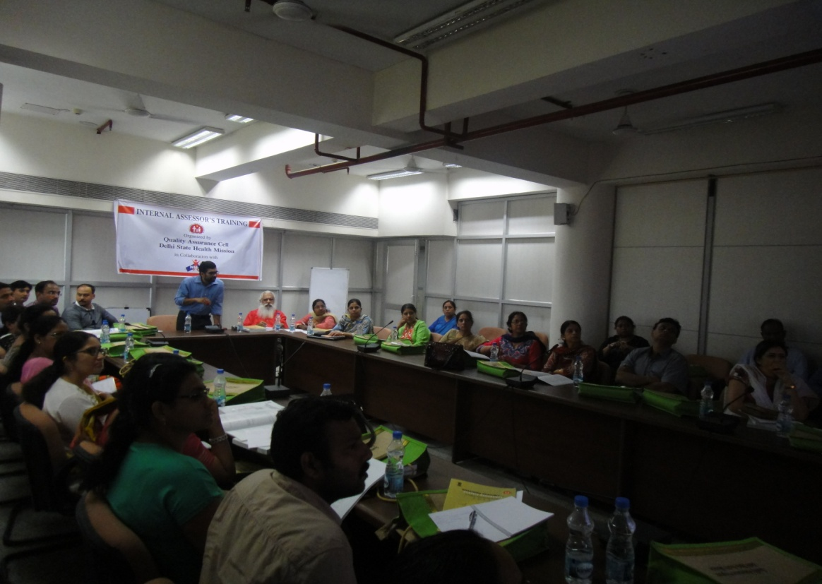
Ms. Vinny Arora briefing about Support Services
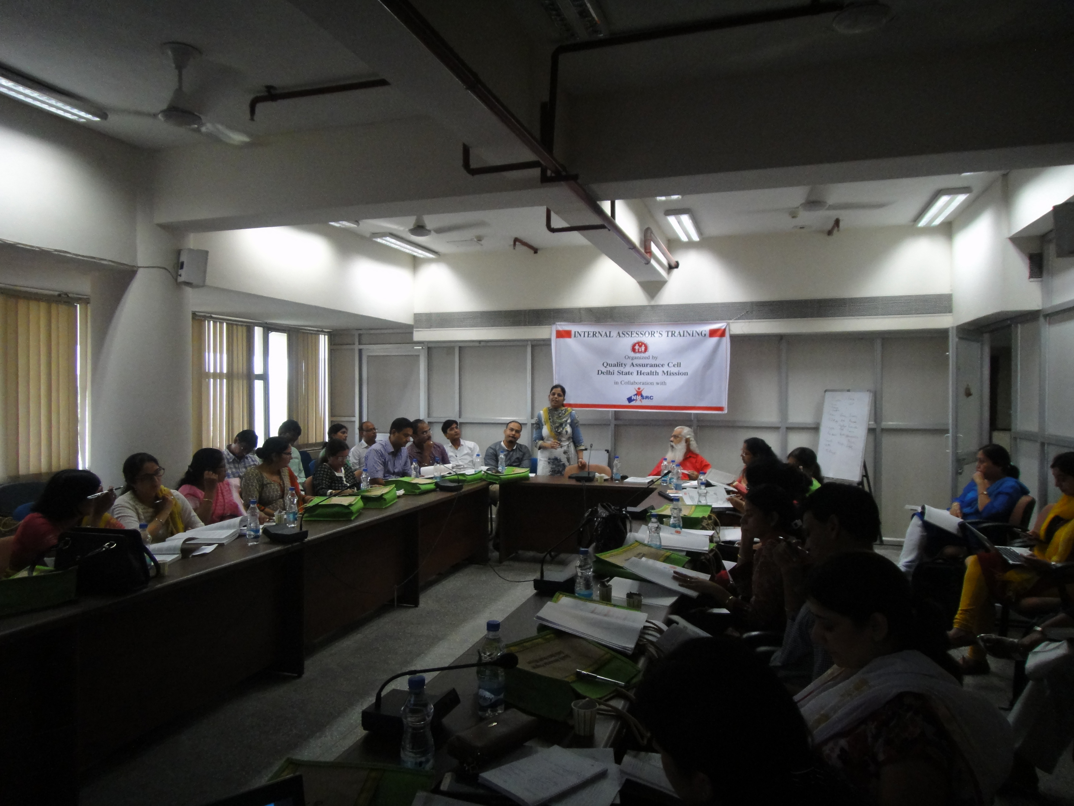
Dr. Nikhil Prakash briefing about National Quality Assurance Programme

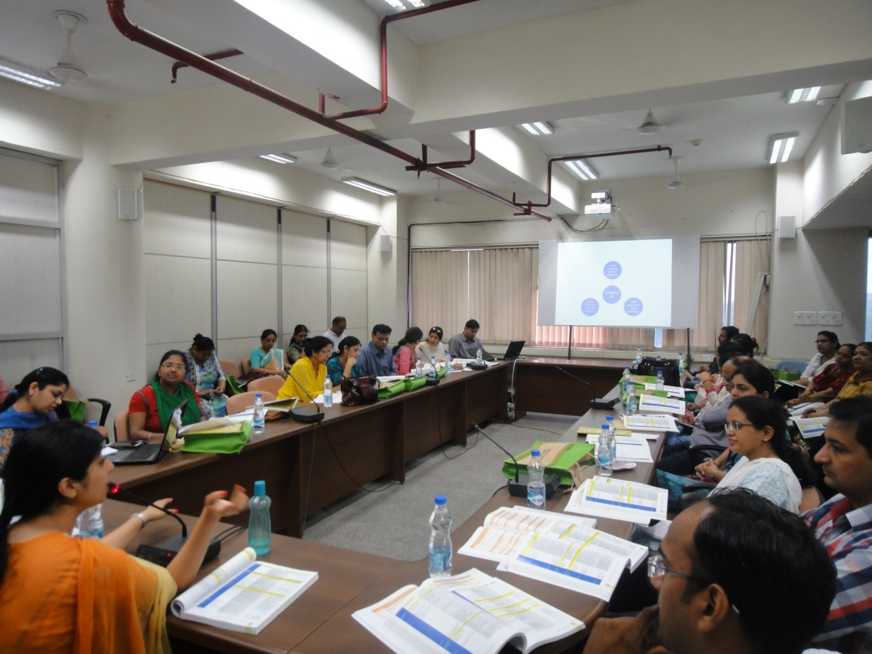
Ms. Richa Sharma briefing about Infection Control Standard

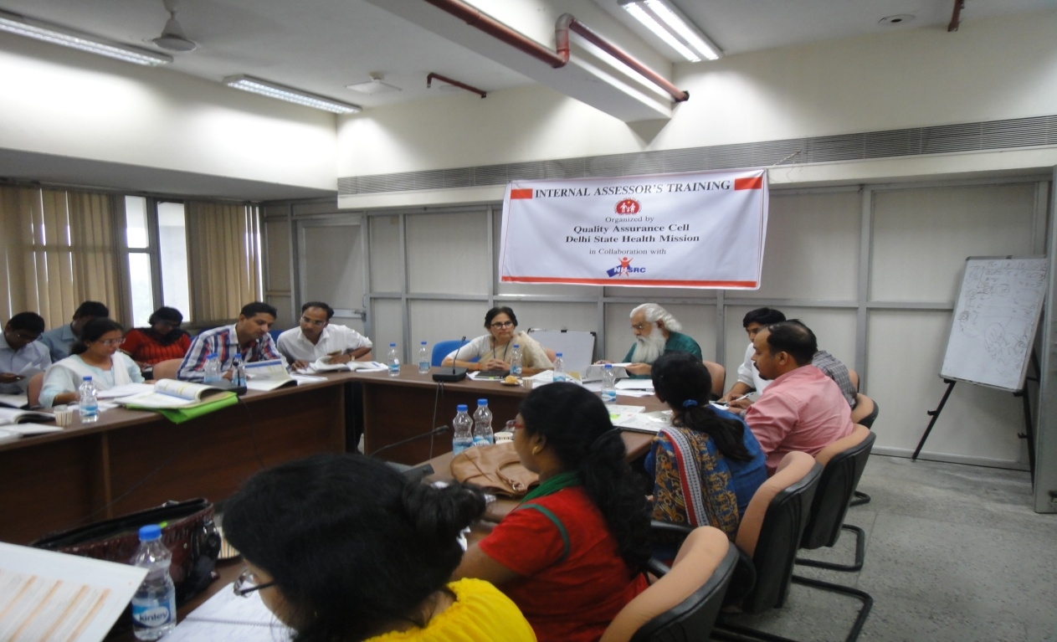
Dr. Monika Rana motivating participants for conducting assessments in their hospitals.

