Internal Assessor Training on National Quality Assurance Program

25th to 26th May 2016, Uttarakhand

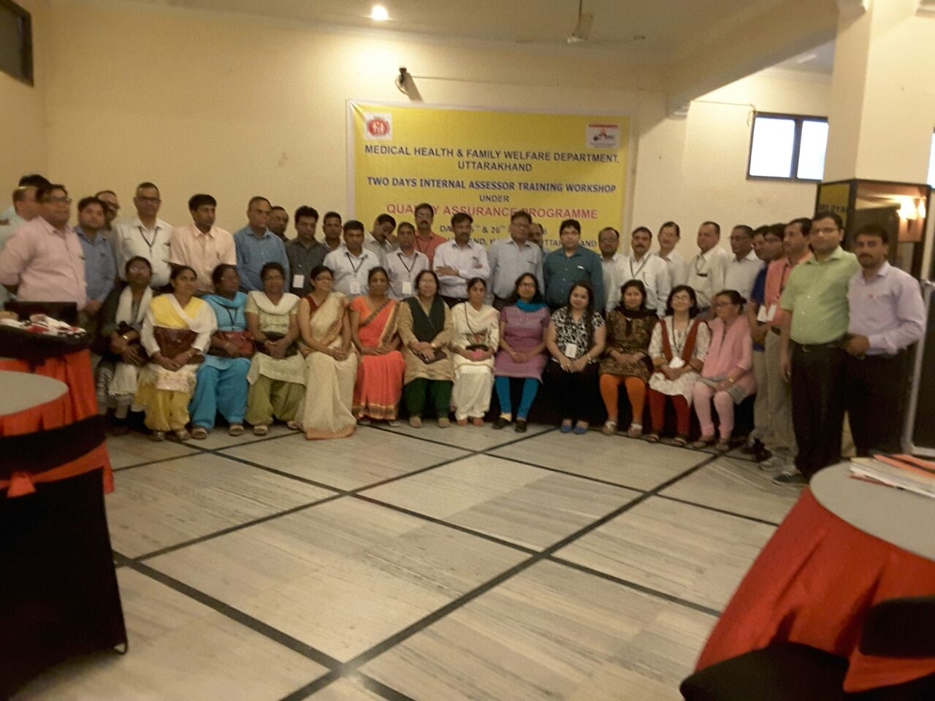

Conducted by

National Health System Resource Centre in collaboration with Medical Health & Family Welfare Department, Uttarakhand

TRAINING REPORT
INTERNAL ASSESSOR TRAINING ON NATIONAL QUALITY ASSURANCE PROGRAM

TRAINING COORDINATOR
Dr.Abhay Kumar (State Consultant, Quality Assurance, Uttarakhand)
Dr. Arvind Srivastava (State Consultant, Quality Assurance, Uttarakhand)
Dr. Sushant Agrawal (Consultant, QI, NHSRC, New Delhi)

DATE OF TRAINING
25th to 26th May 2016

PLACE OF TRAINING
HOTEL LEGRAND,HARIDWAR , Uttarakhand

PARTICIPANTS OF TRAINING
Total no. 47 (List attached in Annexure I)
COURSE SCHEDULE
The course schedule (Attached in Annexure II) outlines the day to day contents and learning methods.

Contents
OBJECTIVES OF TRAINING 4
BACKGROUND 5
EXECUTIVE SUMMARY 6
DAYWISE SUMMARY OF THE PRESENTATIONS 7
Day 1 7
Day 2 8
PARTICIPANT FEEDBACK 10
Most liked sessions were 10
Most useful topics 10
Suggestion to improve the training:- 10
Annexure I 11
List of Participants 11
Annexure II 13
AGENDA 13
Photo Gallery 14

OBJECTIVES OF TRAINING
- The objective of ‘’Internal Assessor Training’’ Programme is to impart knowledge and skill of conducting internal assessment of Health Facilities against the predefined norms of National Quality Assurance Programme at fixed interval preferably quarterly covering all critical departments. An action plan would be prepared on observed non conformities for corrective/improvements activities.
- The course intends building the participants’ capacity to evaluate evidences to arrive at a conclusion with reference to various check-points, which are given in the Assessors’ Guide Book for Quality Assurance in District Hospital, 2013.
- To equip assessors with knowledge of key concepts, tools and methodologies of National quality assurance standards.
- Provide skill to assessors to independently assess different area of concern, measurable elements & checklist
- To develop skills and acumen to carry out internal evaluation as well as assessment of hospitals.
- To set up pool of Internal Assessors for state of Uttarakhand.

BACKGROUND

Under National Health Mission, to improve the quality of Health care services at public hospitals, Ministry of Health & Family welfare, Govt. of India, has launched National Quality Assurance Standards. To comply these standards, Govt. has launched operational Guidelines as well as Assessor’s Guidebook for District hospitals, CHC (FRU) and PHC (24X7).
For implementation and certification under National Quality Assurance Standards (NQAS), 4 types of trainings courses were designed i.e. one day Awareness training, two days Internal Assessor Training, three day Service provider training and five day External Assessor training.
Two day internal assessor training is mandated for assessors who will periodically assessed their facilities covering all critical departments and action plan would be prepared on observed non conformities.
Main aim of training is to provide complete understanding of standards, their sub components, & scoring methodology to aspiring Internal Assessors.
There is fixed curriculum for the training extended up to period of two days, followed by written evaluation of aspiring Internal Assessor. In evaluation, if trainer would be able to score minimum 60 % of marks, than he/she will be awarded with Internal Assessor Certification for NQAS & eligible as an empanelled Internal Assessor for the State.

EXECUTIVE SUMMARY
It was 2nd Internal Assessor training conducted by NHSRC in collaboration with Medical Health and Family Welfare Department, Uttarakhand from 25th to 26th May, 2016 at Hotel Legrand, Haridwar , Uttarakhand
The aim of training was to strengthen assessor’s knowledge of key concepts, tools, and methodologies for assessment of National Quality assurance Standards. Course curriculum for training was prepared by the NHSRC and was duly syndicated with state. Participants were from diverse background including Joint Director, Chief Medical Superintendent, Gynaecologist, Regional Consultant QA, Hospital Quality Manager, Medical officers, Nursing in charges, Nursing sisters and pharmacists from 8 districts of Garhwal region of Uttarakhand. Officials from Dehradun, Pauri, Haridwar, Chamoli, Tehri, Roorkee, Uttarkashi and Rudraprayag were called by state for this training. Three participants from State of Rajasthan also attended this training. The participants were given-
- A copy of Operational Guideline for National Quality Assurance in Public Health Care to all participants
- A copy of Assessor’s guidebook for District Hospital.(Volume1 & Volume 2) to all participants
- A bag with writing pad, pen.
- Course instruction for IA-Training.
- Hard copy of guideline, exercises and material wherever required during training.

The programme had 14 sessions, spread over a period of two days along with group exercises.
Feedback from the participants was taken and the report contains analysis and suggestions given by the participants. The overall rating of the programme in feedback has been good with an overall score of 4.10 on a 5 point scale.

DAYWISE SUMMARY OF THE PRESENTATIONS

Day 1
In the first presentation of the training Dr. Sushant Agarwal, Consultant, NHSRC explained “Key Concepts and Principles of Quality Assurance in Public Health Facilities”. He had explained following things in his session
- Definition of Quality
- Perspectives of the Quality
- Key Concept of Quality
- Principles of Quality Management
- National Quality Assurance Standard for Healthcare Facilities
- How Hazardous is healthcare

This session also covered about “Overview of National Quality Assurance Program and standards”. He has explained national quality assurance standard programme, checklist information, key features of the programme, snapshot of all eight areas of concerns and the standards concerning them. He also explained about measurement system of NQAS and the relationship between the areas of concern -Standard -measurable element –Checkpoint and approaches for assessment. Dr.Sushant also provided snapshot of all eight areas of concerns and the standards concerning them. Participants were explained about the scoring patterns and the method to obtain the cumulative hospital score card. A brief introduction of eighteen checklists was also provided. This helped the participants to acquaint themselves with the newly introduced National Quality Assurance standards.
The next presenter for the day was Dr Namit Singh Tomar, Consultant QI NHSRC he explained about the Area of concern ‘’Service Provision, Patient Rights and Inputs’’. During the session participants were given a detailed explanation about all the standards of Area of Concern service provision which include curative service, RMNCH+A services, Support Services, National Health Program, diagnostic services & services as per community needs. Participants were given details about the availability of services at facility as per state norms /IPHS.
In his presentation he explained about the patient rights which explain about accessibility of services along with their availability & services provided in dignified manner for its acceptance by clients (patients). He continued his presentation with “Area of Concern C –Inputs” and explained about infrastructure availability & adequacy, physical safety, fire safety, HR availability & their training requirement & availability of equipment & instruments.
Next session of the day was started by Dr. Sushant Agrawal, Consultant QI, NHSRC with the session of Area of Concern D - Support Services. Participants were given a snapshot of all 12 standards and the concerning measurable elements.
Post lunch session was presented by Dr. Namit Singh Tomar with an exercise ‘’Identifying Standards’’. He had distributes small papers with a hint to identify standards from the list of standards and measurable elements from NQAS. This exercise acts as a breather for all participants and they actively participated.
Next session was started by Dr. Arvind Srivastava, Consultant QA, Uttarakhand and discussed about Area of Concern E Clinical services. This session only includes standards E1 to E9 i.e General Clinical services standards. He explained about admission, consultation & discharge processes of hospital, other than that it include standards for clinical assessment & reassessment, continuity of care, nursing processes, identification of high risk & vulnerable patients, use of STGs, drug administration& record maintenance. Participants were encouraged to discuss day to day challenges faced by them in improving the quality of clinical services.
Last session for the day was presented by Dr.Sushant Agrawal with an exercise called ‘Labour Room Exercise”’. In this exercise one sheet of paper was distributed to all participants, which was about the observation of assessment done by assessor. All participants were instructed to fill the checklist of Labour Room from area of concern A to C.
Based upon the score generated by the participants Dr.Sushant explained how this scoring can be done in excel sheet. He also explained about the methodology of Hospital wise scoring, Department wise scoring and Area of concern wise scoring.

Day 2
Day 2 was initiated with a brief recap of all the sessions of Day 1 by Dr. Sushant. Participants were encouraged to talk about their understanding from day-1.
First session of the day was about Area of concern E “Specific Clinical Services” which was taken by Dr. Namit Singh Tomar and he covered Specific clinical services from E10 to E-16 like ICU, Accident and Emergency department of the Hospital. Dr. Tomar also explained best practices and quality standards as per NQAS for both of these departments.
Next session of the day was started by Dr Arvind Srivastava with the session of Area of concern- Clinical services- RMNCH+A Services. Dr. Srivastava explained standards related to RMNCH+A services and explained about the Quality of ANC services, labour room protocol etc. during this session.
Session was followed by Dr. Namit Singh Tomar presentation on Area of Concern F - Infection Control. All the six standards related to infection control namely infection control program, Hand Hygiene practices, use of Personal protective equipment, processing of equipment and instruments ,Physical layout and environmental control of the patient care areas & Bio medical waste management were explained. He demonstrated six steps of Hand washing and discussed practical issues related to infection control during his session. Followed by this one Video about ‘’Infection control practices’’ was shown by him.
Post lunch session was started by Dr. Sushant Agarwal and he discussed about “Key Performance Indicators” in which he explained about all 30 KPIs, data required for KPI, how to calculate it. In between training to engage participants he has some quiz’s related to calculations of indicators. It was played very well by all participants.
This was followed by session on Area of concern G -Quality Management” which was taken by Dr Abhay Kumar, during the session participants were given a holistic view about PDCA cycle. Dr. Kumar had divided the PDCA cycle among all the eight standards for better understanding. “Plan” included standards on organizational framework, Quality policy and objectives & -SOP’s, “Do” included process approach ,Patient and employee satisfaction, ”Check” include patient and employee satisfaction, Internal and external QA programs and “Act”- Tools and methods of Quality improvement.
Next session of this training was ‘’Introduction of Swachhta Abhiyan and KAYAKALP’’ Scheme of GOI, which was discussed by Dr Sushant Agrawal. He first discussed about the Swachhta Guideline and its importance in Public health facilities. Followed by this he also explained about GOI Scheme of ‘’KAYAKALP’’. He said for FY-2016-17, State is supposed to take all District Hospital, SDH, CHCs and PHCs under this scheme; best district hospital will get Rs. 50 Lakhs, followed by 2nd prize of 20 lakhs and consolation award of Rs. 3 lakhs for facilities scored more than 70%. State can propose budget under this scheme for its implementation under PIP.
Last session of the day was taken by Dr.Namit Singh Tomar, and he discussed about the ‘’overview of Urban PHC Quality Standards’’.
After completion of session, participants were given question paper with 42 multiple choice questions. 3 set of question paper were prepared for evaluation (A,B and C). Feedback forms were also distributed to all participants.

PARTICIPANT FEEDBACK
Evaluation of participant feedback is taken on 5 point scale. Overall Average scoring was of 4.30 out of 5.

Most liked sessions were
Name of the Topic | Trainer | Feedback score
Key Performance Indicator | Dr.Sushant Agrawal | 4.35
Standard, Measurement System and Assessment Protocol | Dr.Sushant Agrawal | 4.33
Overview of Quality Assurance Program | Dr.Sushant Agrawal | 4.30
Standard for Infection Control | Dr. Namit Singh Tomar | 4.22
Standard for Specific Clinical services | Dr. Namit Singh Tomar | 4.18
Standard for Support Services | Dr. Sushant Agrawal | 4.18

Most useful topics
- Hospital Infection control
- Quality Management System
- Exercise Labour Room
- Key Performance Indicators

Suggestion to improve the training:-
- More interaction with participants
- More Group exercise
- More training days
- More video clips

Annexure I

List of Participants
ATTENDENCE SHEET - INTERNAL ASSESSOR TRAINING UNDER QUALITY ASSURANCE
S.NO. | NAME OF PARTICIPANT | DESIGNATION | DISTRICT | MOBILE NO
1 | DR.RAMBABU JAISWAL | STATE NODAL OFFICER | NHM JAIPUR | 9414339018
2 | DR.ARVIND KUMAR | DISTRICT CONSULTANT | NHM JAIPUR | 9460071368
3 | SHASHANK PATHAK | STATE PLANNING CONSULTANT-NUHM | NHM JAIPUR | 9983131538
4 | DR.ARVIND PRAKASH SRIVASTAVA | STATE CONSULTANT-QA | DEHRADUN | 9555798055
5 | DR.ABHAY KUMAR | STATE CONSULTANT-PH | DEHRADUN | 9690927895
6 | DR.M.K.PANDEY | SR.PATHOLOGIST | DEHRADUN | 9760804760
7 | B.P.BHATT | PHARMACIST | DEHRADUN | 9997407772
8 | PARAMITA PAYAL MOHAPATRA | QUALITY MANAGER | DEHRADUN | 8881865175
9 | ATUL DWIVEDI | STATE CONSULTANT-DOCUMENTATION | DEHRADUN | 8826516101
10 | DR.MEGHNA ASWAL | MEDICAL SUPERINTENDENT | DEHRADUN | 9412923114
11 | DR.PARMARTH JOSHI | SURGEON | DEHRADUN | 7895179383
12 | DR.PRADEEP CHAUHAN | SR.ANESTHESIOLOGIST | PAURI | 9412004630
13 | DR.VED PRAKASH MAURYA | SURGEON | HARIDWAR | 9410369437
14 | DR.BINDHESH KR.SHUKLA | CMS | CHAMOLI | 9452514444
15 | RAMESH CHANDRA NEGI | PHARMACIST | CHAMOLI | 9412119135
16 | MANJU TRIPATHI | SISTER | HARIDWAR | 7579048714
17 | MEENAKSHI RANDHAWA | SISITER INCHARGE | HARIDWAR | 9760624946
18 | KRISHNA RAWAT | SISTER INCHARGE | DEHRADUN | 9458900997
19 | DR.SUNIL KUMAR VERMA | SR.ANESTHESIOLOGIST | DEHRADUN | 9412369248
20 | MISS BENIDITA BECK | ASST NURSING SUPERINTENDENT | HARIDWAR | 9412409792
21 | DR.D.K.CHAKARPANI | ACMO | DEHRADUN | 9412020556
22 | DR.S.K.PANDEY | MEDICAL SUPERINTENDENT | DEHRADUN | 9411143986
23 | BALBIR SINGH | QUALITY MANAGER | PAURI | 9634562236
24 | DR.U.S.KANDWAL | PMS | PAURI | 9412403065
25 | DR.KALPANA GUPTA | CHIEF MEDICAL SUPERINTENDENT | PAURI | 9412933991
26 | DR.P.R.PANDEY | GYNAECOLOGIST | PAURI | 9412108816
27 | IRIN MASIH | SISTER INCHARGE | HARIDWAR | 9927805587
28 | DR.BHAWANI PAL | CHIEF MEDICAL SUPERINTENDENT | HARIDWAR | 9412079366
29 | TARUN BHARDWAJ | HOSPITAL MANAGER | HARIDWAR | 9411070470
30 | DR.MEENAKSHI UNIYAL | SPH | TEHRI | 9410312966
31 | DR.RITA BHAMOLA | GYNAECOLOGIST | TEHRI | 9411536600
32 | DR. VAGISH CHANDRAKALA | MEDICAL SUPERINTENDENT | TEHRI | 9456119032
33 | USHA SRIVASTAVA | ASISTANT NURSING SUPERINTENDANT | ROORKEE | 9259517764
34 | MOHAN SINGH ASWAL | PHARMACIST | PAURI | 9045657576
35 | DR.RAVINDRA THAPLIYAL | PRINCIPAL SUPERINTENDENT | UTTARKASHI | 9412971448
36 | KANISHK KALA | QUALITY MANAGER | UTTARKASHI | 9759563503
37 | KUSHLA SHAH | PHARMACIST | UTTARKASHI | 9412938814
38 | S.M.DANGWAL | CHIEF PHARMACIST | DEHRADOON | 9411553517
39 | H.M.GAIROLA | CHIEF PHARMACIST | HARIDWAR | 8057891259
40 | SANTOSH BHASKAR | REGIONAL QUALITY CONSULTANT | PAURI-GARHWAL | 7310801531
41 | P.D.RATURI | PHARMACIST | TEHRI | 9411399095
42 | DR.VIJAY SINGH | PAEDIATRICIAN | RUDRAPRAYAG | 9411352973
43 | B.P.JAMLOKI | CHIEF PHARMACIST | RUDRAPRAYAG | 9412109634
44 | TULSA CHAUDHARI | NURSING SISTER | TEHRI | 9412076291
45 | DR.MEETA SRIVASTAVA | PAEDIATRICIAN | HARIDWAR | 9411388535
46 | DR.AMIT KUMAR | REGIONAL QUALITY CONSULTANT | GARHWAL | 7310801585
47 | SHRADDHA | CARDIAC TECHNICIAN | HARIDWAR | 9639626271

Annexure II
AGENDA
Internal Assessor’s Training on National Quality Assurance Standards

Time | Topic | Resource Person
Day-01 ( 25th May 2016)
09:00 am - 09:30 am | Registration
09:30 am - 10.00 am | Inaugural Address | State representative
10.00 am - 10:45 am | Overview of National Quality Assurance Programme | Dr. Sushant Agrawal
10:45 a.m. -11.00 a.m. | Tea
11:00 am – 11:45 am | Measurement System, Standards and Assessment Protocols | Dr. Sushant Agrawal
11:45 am - 12:30 pm | Standards for Service Provision , Patient Rights & Inputs | Dr. Namit Singh Tomar
12:30 pm-1.15 pm | Standards for Support Services | Dr. Sushant Agrawal
1:15 pm - 2:00 pm | Lunch
2.00 pm-2:45 pm | Group Activity- Identifying Standards | Dr. Namit Singh Tomar
2.45 pm – 3.30 pm | Standards for General Clinical Services (E1 to E9) | Dr. Arvind Srivastava
3:30 p.m. – 4:15 p.m. | Standards for Specific Clinical Services(E10 to E16)  (Tea to be served in between the session) | Dr. Namit Singh Tomar
4:15 p.m. – 5.00 p.m. | Exercise Labour Room- | Dr. Abhay Kumar
Day-02 ( 26th May 2016)
09:00 a.m. - 09:15 a.m. | Recap
09:15 a.m. - 10:00 a.m. | Standards for RMNCH+A(E17-E23) | Dr. Arvind Srivastava
10:00 a.m. - 10:45 a.m. | Standards for Infection Control  (Tea during the session) | Dr. Namit Singh Tomar
10:45 a.m. - 11:30 a.m. | Key Performance Indicators | Dr. Sushant Agrawal
11:30 p.m. - 01:00p.m. | Standards for QMS | Dr. Abhay Kumar
01:00 p.m. – 01:45 p.m. | Lunch
01:45 p.m. - 02:15 p.m. | Kayakalp Overview | Dr.Sushant Agrawal
02:15 Pm – 02:45 pm | Overview of Urban PHCs Standards | Dr. Namit Singh Tomar
02:45 p.m. - 03:45 p.m. | Post Training Evaluation & Feedback  (Tea during the evaluation) | NHSRC Team
03:45 p.m. - 04:15 p.m. | Roadmap for Quality Assurance | Dr. Abhay Kumar  Dr. Arvind Srivastava

Photo Gallery

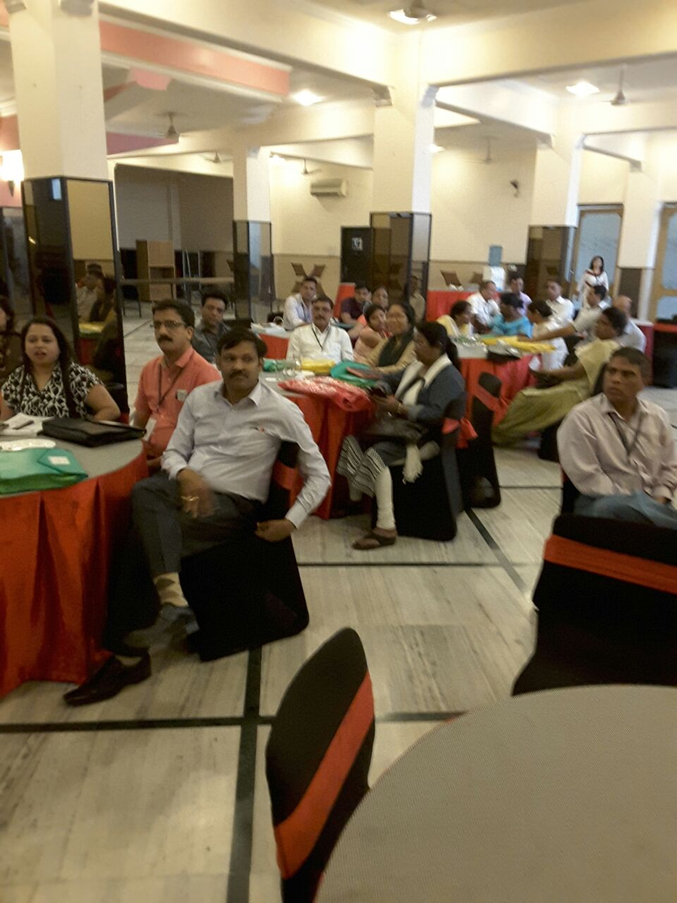

Participants attending training

