**Madhya Pradesh Internal Assessor Training on National Quality Assurance Standards**

**25th to 26th March 2015, Bhopal Madhya Pradesh**

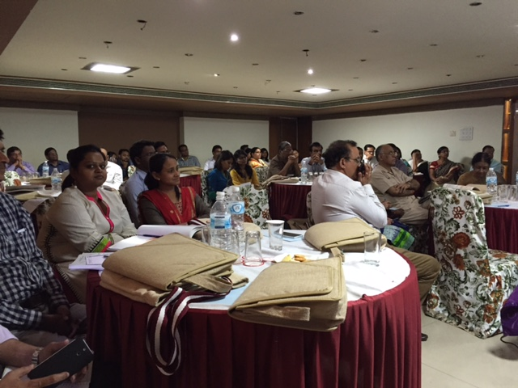

**Conducted by:**

**National Health System Resource Centre in collaboration with NHM Kerala.**

**TRAINING COORDINATOR:** Dr Sushant Kumar Agrawal (Consultant, NHSRC, New Delhi)

Dr. Vivek Mishra Consultant,NHM, Madhya Pradesh

**DATE OF TRAINING:** 25th to 26th March 2015

**PLACE OF TRAINING**: Hotel Amar Villas, Bhopal, Madhya Pradesh

**PARTICIPANTS OF TRAINING:** Total no. 39–. (*List attached in Annexure I*)

**COURSE OVERVIEW:** The course schedule (Attached in A*nnexure II*)

**OBJECTIVES OF TRAINING:**

The specific objectives of the Training programme were: -

1. To set up pool of Internal Assessors for state of MP.
2. To equip assessors with knowledge of key concepts, tools and methodologies of National quality assurance standards.
3. Provide skill to assessors to independently assess different area of concern, measurable elements & checklist
4. To develop skills and acumen to carry out internal evaluation as well as assessment of hospitals.

**BACKGROUND**

Under National Health Mission, to improve the quality of Health care services at public hospitals, Ministry of Health & Family welfare, Govt. of India, has launched National Quality Assurance Standards. To comply these standards, Govt. has launched operational Guidelines as well as Assessor’s Guidebook for District hospitals, CHC (FRU) and PHC (24X7).

For implementation and certification under National Quality Assurance Standards (NQAS), 4 types of trainings courses were designed i.e. one day Awareness training, two days Internal Assessor Training, three day Service provider training and five day External Assessor training.

Two day internal assessor training is mandated for assessors who will periodically assessed their facilities covering all critical departments and action plan would be prepared on observed non conformities.

Main aim of training is to provide complete understanding of standards, their sub components, & scoring methodology to aspiring Internal Assessors.

There is fixed curriculum for the training extended up to period of three days, followed by written evaluation of aspiring Internal Assessor. In evaluation, if trainer would be able to score minimum 70 % of marks, than he/she will be awarded with Internal Assessor Certification for NQAS & eligible as an empanelled Internal Assessor for the State.

**eXECUTIVE sERVICE**

1st Internal Assessor training was conducted by NHSRC in collaboration with NHM, MP from 25th March, 2015 to 26th March, 2015 at Hotel Amar Villas, Bhopal..

The aim of training was to strengthen assessor’s knowledge of key concepts, tools, and methodologies for assessment of National Quality assurance Standards. Course curriculum for training was prepared by the NHSRC and was duly syndicated with state. Participants were from diverse background including Directors, Civil Surgeons, Medical officers, District Program coordinators, Quality Assurance Consultant, Consultants of Technical support partners like MP TAST.

The participants were given-

1. A copy of Operational Guideline for National Quality Assurance in public health care.
2. A copy of Assessor’s guidebook for District Hospital.(Volume1 & Volume 2)
3. A Bag with writing pad and pen.
4. Hard copy of Exercises and material wherever required during training.
5. Dynamic Training tools like Group discussions; Interactions, group work, individual work etc. has been used to facilitate focused learning and keep the interest of the audience alive.

The programme had 13 Sessions, spread over a period of two day..

Feedback from the participants was taken and the report contains analysis and suggestions given by the participants.

Training was started with welcome speech from Dr. B.N.Chauhan (Director, NHM) followed by presentation from Dr. Nikhil Prakash (Senior Consultant- QI, NHRSC).

The overall rating of the programme in feedback has been good with a overall score of ….. on a 5 point scale.

**DAYWISE SUMMERY OF THE PRESENTATIONS**

**Day 1**

In the first presentation of the training **Dr. Nikhil Prakash, Senior Consultant, QI, NHSRC gave an Overview of National Quality Assurance Program**. He discussed about the existing models of quality like NABH, ISO, IPHS etc and there implication on public health. He emphasized on need of Pro- Public Health quality model which give flexibility to the states to customize, sustainable and scalable, low cost of implementation. He introduced national quality assurance program and briefly explained eight key features of QA program namely –

1. Unified organizational framework

2. Quality assurance standards

3. Continual assessment and scoring

4. Assessment Methodology

5. Training and Capacity building

6. Inbuilt quality improvement model

7. Certification at state and national level

8. Incentives and sustenance

Dr. Nikhil also explained Key concepts and definitions in quality, where introduction of terminologies of quality including quality control, quality assurance, quality improvement and certification and accreditation was given. He explained about the PDCA cycle and shared examples regarding it implementation. Holistic view of quality management system and various terms related to it was also defined by Dr.Nikhil.

Next presenter Dr.Sushant Agrawal Consultant, NHSRC explained the relationship between the **area of concern -Standard -measurable element –Checkpoint** and approachesfor assessment .Participants were explained about the scoring patterns and the method to obtain the cumulative hospital score card. A brief introduction of eighteen checklists was also provided.

The next presenter for the day was **Dr. Nikhil Prakash who gave an overview of National Quality Assurance standards**. In this session participants were given a snapshot of all eight areas of concerns and the standards concerning them. This helped the participants to acquaint themselves with the newly introduced National Quality Assurance standards.

Dr. Nikhil Prakash continued his presentation **on Area of Concern A & B “Assessment of Service Provision & Patient Rights** “. During the session participants were given a detailed explanation about all the standards of Area of Concern service provision which include curative service, RMNCHA services, Support Services, National Health Program, diagnostic services & services as per community needs. Participants were given details about the availability of services at facility as per state norms /IPHS.

2nd part of presentation was about patient rights which explain about accessibility of services along with their availability & services provided in dignified manner for its acceptance by clients( patients).

Post lunch Dr.Nikhil Prakash continued his presentation with “**Area of Concern C –Inputs**” and explained about infrastructure availability & adequacy, physical safety, fire safety, HR availability & their training requirement & availability of equipments & instruments.

This was followed by a group exercise conducted by Dr.Sushant **called “Finding the key word “**which acted as a breather for all the participants. Participants were distributed key words and were instructed to find the area of concern concerning the key word. Then the participants were supposed to form a group with similar area of concern and select a team leader who explains about the importance of the area of concern & also identify the checklist where they would find their checkpoints.

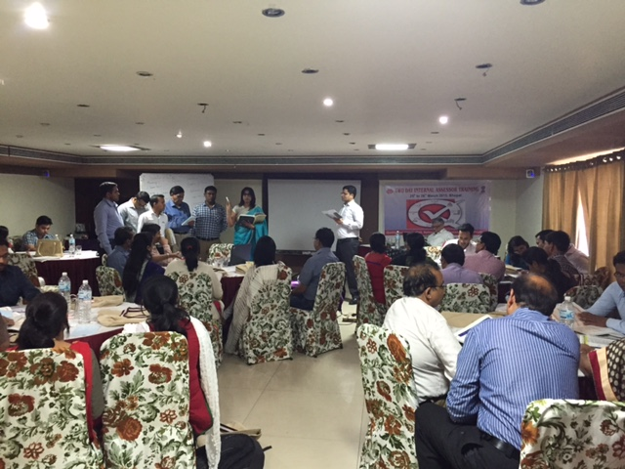

Participation in Group activity

Dr. Sushant continued the session of **Area of Concern D - Support Services.** Participants were given a snapshot of 12 standards and the concerning measurable elements. Dr. Sushant related real life situations faced by staff working in support services of the hospital and encouraged the participants to share their comments.

The last session of the day was about **Area of concern E “Clinical Services**” which was taken by Dr. Arun K Dutta. Clinical services include standards E1 to E23 which was further divided into General Clinical process (E1-E9), Specific clinical processes (E10-E16) and RMNCHA & NHP from (E17-E23). This session includes standards E1 to E9 explained about admission, consultation &discharge processes of hospital, other than that it include standards for clinical assessment & reassessment, continuity of care, nursing processes, identification of high risk & vulnerable patients, use of STGs, drug administration& record maintenance. Participants were encouraged to discuss day to day challenges faced by them in improving the quality of clinical services.

Followed by this Dr O.P Kansal from BD, presented safe injection practices in Healthcare organization. He shown video about the complication may arise due to unsafe use of syringe and also demonstrate various type of syringe made by BD for preventing infection due to syringe use.

**Day2**

Day 2 was initiated with a brief recap of all the sessions of Day 1 by Dr. Farid of MPTAST.

First session of Day 2 was started by Dr.A.K.Dtta and he continued his session from Area of Concern E 10 to E 23 and covered assessment of ICU, Emergency, Laboratory, Blood Bank facilities, Anesthetic, OT and End of life care services.

Session was followed by Dr.Nikhil Prakash Presentation on **Area of Concern F - Infection Control.**  All the six standards related to infection control namely infection control program, Hand Hygiene practices, use of Personal protective equipments, processing of equipment and instruments ,Physical layout and environmental control of the patient care areas & Bio medical waste management were explained.

Next session of the day was taken by **Dr A.K.Dutta** on Area of Concern E-17-23 and covered RMNCH+A Services and National Health Program. He shared the various component of RMNCH+A services and importance of 5*5 Matrix. As session was dedicated on **Reproductive, maternal, neonatal, child and adolescent health there was detail discussion on** antenatal care services, Intra-natal care, and Post-natal care.

Post Lunch session was started by Dr.Sushant Agrawal with an exercise called ‘’Labour Room Exercise”’. In this exercise one sheet of paper was distributed to all participants, which was about the observation of assessment done by assessor. All participants were instructed to fill the checklist of Labour Room from area of concern A to C.

Based upon the score generated by the participants Dr.Sushant explained how this scoring can be done in excel sheet. He also explained about the methodology of Hospital wise scoring, Department wise scoring and Area of concern wise scoring.

This was followed by session on **Area of concern G -Quality Management”** which was taken **by Dr. Sushant Agrawal,** during the session participants were given a holistic view about PDCA cycle. Dr.Sushant had divided the PDCA cycle among all the eight standards for better understanding. “Plan” included standards on organizational framework, Quality policy and objectives & -SOP’s, “Do” included process approach ,Patient and employee satisfaction, ”Check” include patient and employee satisfaction, Internal and external QA programs and “Act”- Tools and methods of Quality improvement.

After this session Mission Director National Health Mission, MP Mr.Faiz Ahmad Kidwai arrived to review the status of training. He explained participants about the importance of this training and also instructed to conduct assessment with realistic assessment schedule.

After this session Dr.Nikhil Prakash presented **on “Key Performance Indicators”.** Participants were explained about all the 30 indicators mentioned in the operational guidelines and were given examples to calculate each indicator. This session was very participative as it engaged all the participants in solving the examples.

Last presentation of the Day was about Exercise on Gap Analysis and action planning, which was conducted by Dr.Sushant Agrawal. Here were participants were distributed format for gap analysis. Dr. Sushant shown 8 photographs related to many gaps assessed in a district Hospital. Participants were instructed to find the gap and name corresponding standards, measurable elements. They were also instructed to categorized gaps into structure, process and outcome. They also instructed to categorized these gap based upon the severity also.

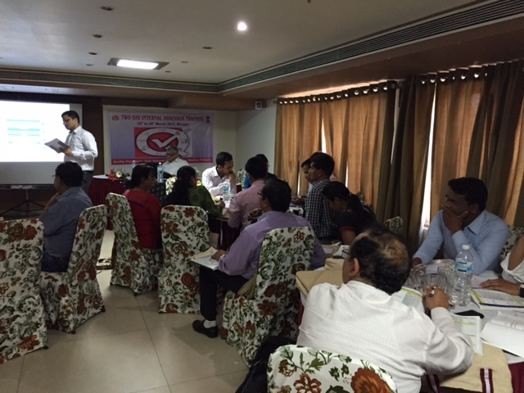

After completion of session, participants were given question paper with 42 multiple choice questions. 3 set of question paper were prepared for evaluation (A,B and C).

**PARTICIPANT FEEDBACK**

Following examination feedback was taken from participants. Evaluation of participant feedback is taken on 5 point scale. Analysis of Participant feedback is attached in *Annexure IV.* Overall Average scoring was of …… out of 5.

**MOST LIKED SESSIONS WERE**:

|  |  |
| --- | --- |
| Name of Session & Presenter | Score |
|  |  |
|  |  |
|  |  |
|  |  |

**SUGGESTIONS TO IMPROVE THE TRAINING**

***Annexure I***

|  |  |  |
| --- | --- | --- |
| **Sr. No** | **Name of Participants** | **Designation** |
|
|  | Saket Sharma | RMNCH+A Coordinator |
|  | Mirza Tausuf Bang | RMNCH+A Coordinator |
|  | Dr.Ambrish Mishra | RMNCH+A Coordinator |
|  | Dr.A.K.Khare | Civil Surgeon Rewa |
|  | Dr.Ram Kumar | PGMO DH, Singhrauli |
|  | Dr.Reha Ahmad Quereshi | Consultant UNDPA |
|  | Dr.R.K.Verma | Child Specialist |
|  | Dr.Smita Agrawal | MO, Rewa |
|  | Mr.Somnath | NSPL |
|  | Dr.Aswini Nigam | MP TAST |
|  | Shubhra Patawar | Medica Synergie Consultant |
|  | Mahendra Bhushan Upadhyaye | MP TAST |
|  | Saroj Kumhar | Staff Nurse |
|  | Dr.Rajesh Sriwastava | Civil Surgeon |
|  | Dr.Amar Singh | SMO |
|  | Dr.Jyoti Patore | MP TAST |
|  | Dr.O.P Kansal | Tech Advisor, B D India |
|  | Dr.Yorgmic Velmic | DGO |
|  | Dr.Amit Ajnay | Radiologist |
|  | Dr.Shradha Dakesha | MS Gynae |
|  | Dr.Y S Kaurav | MO, Misrod |
|  | Dr.Vivek Mishra | NHM |
|  | Dr.B.N.Chauhan | Director NHM |
|  | Dr.Panha Shulka | DD NHM |
|  | Ms Juhi | QA Consultant |
|  | Shahnad kumar |  |
|  | Dr.B.K.Agrawal | Civil Surgeon |
|  | Dr.K.K.Thakur | Director |
|  | Dr.Bhushan | Dy Director |
|  | Dr.Amit Chaudhary | MO |
|  | Dr.A.K.Chauhan | Civil Surgeon |
|  | Dr.Prabhakar Tiwari | Deputy Director NHM |
|  | Dr.Pankaj | MO |
|  | Ankita Saxena | Consultant |
|  | Jitendra Sharma | Consultant NHM |
|  | Dr.Babita Khare | MO Gynae |
|  | Dr.A.K.Srivastava | MO |
|  | Dr.A.K.Sinha | Civil Surgeon |
|  | Dr.Aboli Gore | DTL(Health)  MP TAST |

***Annexure II***

|  |  |  |
| --- | --- | --- |
| **Time** | **Topic** | **Resource Person** |
| 9:00AM-9:30 AM | **Registration** |  |
| 09:30AM -10:00 AM | **Inaugural Address Director NHM** |  |
| 10:00-11:00 AM | **Overview of National Quality Assurance Program** | **Dr. Nikhil Prakash** |
| 11:00-11:15AM | Tea | |
| 11.15-12:00 | **Measurement System for Quality Assurance & Assessment Protocol** | **Dr.Sushant Agrawal** |
| 12.00PM-1:00PM | **Standards for Service Provision , Patient Rights& Inputs** | **Dr. Nikhil Prakash** |
| 1.00 PM -1.45 PM | **Lunch** | |
| 1.45 PM -2.45 PM | **Group Activity** | **Mr. Sushant Agrawal** |
| 2.45PM -3:30 PM | **Standards for Support Services** | **Mr. Sushant Agarwal** |
| 3:30-3:45 | **Tea** | |
| 3.45 PM -4:30 PM | **Standards for General and Clinical** | **Dr. A.K.Dutta** |
| 4:30 PM 5:30 | **Standards for Safe Injection Practices** | **BD** |
| **Day-2** | | |
| 9:00 AM -9:30 AM | **Recap** |  |
| 9.30 AM - 10.15 AM | **Standards for Specific Clinical Services** | **Dr. A.K.Dutta** |
| 10:15 AM-11:00 AM | **Standard for Infection Control** | **Dr.Nikhil Prakash** |
| 11.00 AM-11:15 AM | **Tea** | |
| 11.15 AM -12.15 PM | **Standards for RMNCH+A** | **Dr.A.K.Dutta** |
| 12.15PM - 1.00 PM | **Standard for Quality Management** | **Dr. Sushant Agrawal** |
| 1.00 PM -1.45 PM | **Lunch** | |
| 1.45 PM -2.30 PM | **Exercise Gap analysis & Action Planning** | **Dr.Sushant Agrawal** |
| 2:30 PM-2:45PM | **Address By MD -NHM** | |
| 2:45 PM-3:30 PM | **Key Performance Indicator** | **Dr.Sushant Agrawal** |
| 3.30 PM -4.15 PM | **Roadmap for Quality Assurance** | **Dr.Nikhil Prakash** |
| 4.15 PM -4.30 PM | **Tea** | |
| 4.30 PM -5:30 PM | **Post Training Evaluation** |  |
| 5.30 PM - 5.45 PM | **Feedback & Valedictory** |  |

***Annexure iii***

|  |  |
| --- | --- |
| **Internal Assessor Training, Bhopal Participant Feedback Evaluation** | |
| **Topic** | **Average** |
| **Day 1 (25/3/2015)** | |
| Overview of National Quality Assurance Program Dr. Nikhil Prakash |  |
| Measurement System for Quality Assurance and Assessment Protocols  Dr. Sushant Agrawal |  |
| Standards for Service Provision, Patient Rights and Inputs Dr. Nikhil Prakash |  |
| Group Activity  Dr.Sushant Agrawal |  |
| Standards for Support Services  Dr.Sushant Agrawal |  |
| Standards for General Clinical Services  Dr.A.K.Dutta |  |
| **Average** |  |
| **Day 2 (26/03/2015)** | |
| Standards for Specific Clinical Services  Dr. A.K.Dutta |  |
| Standards for Infection Control  Dr.Nikhil Prakash |  |
| Standards for RMNCH+A  Dr. A.K.Dutta |  |
| Standards for Quality Management Dr. Sushant Agrawal |  |
| Exercise Gap Analysis and Action Planning  Dr.Sushant Agrawal |  |
| Exercise Labour Room  Dr.Sushant Agrawal |  |
| Key Performance Indicator  Dr.Nikhil Prakash |  |
| Road Map and Action Planning |  |
| **Average** |  |
| **Overall Average** |  |