Jharkhand Internal Assessor Training on National Quality Assurance Standards

12th-13th January 2015

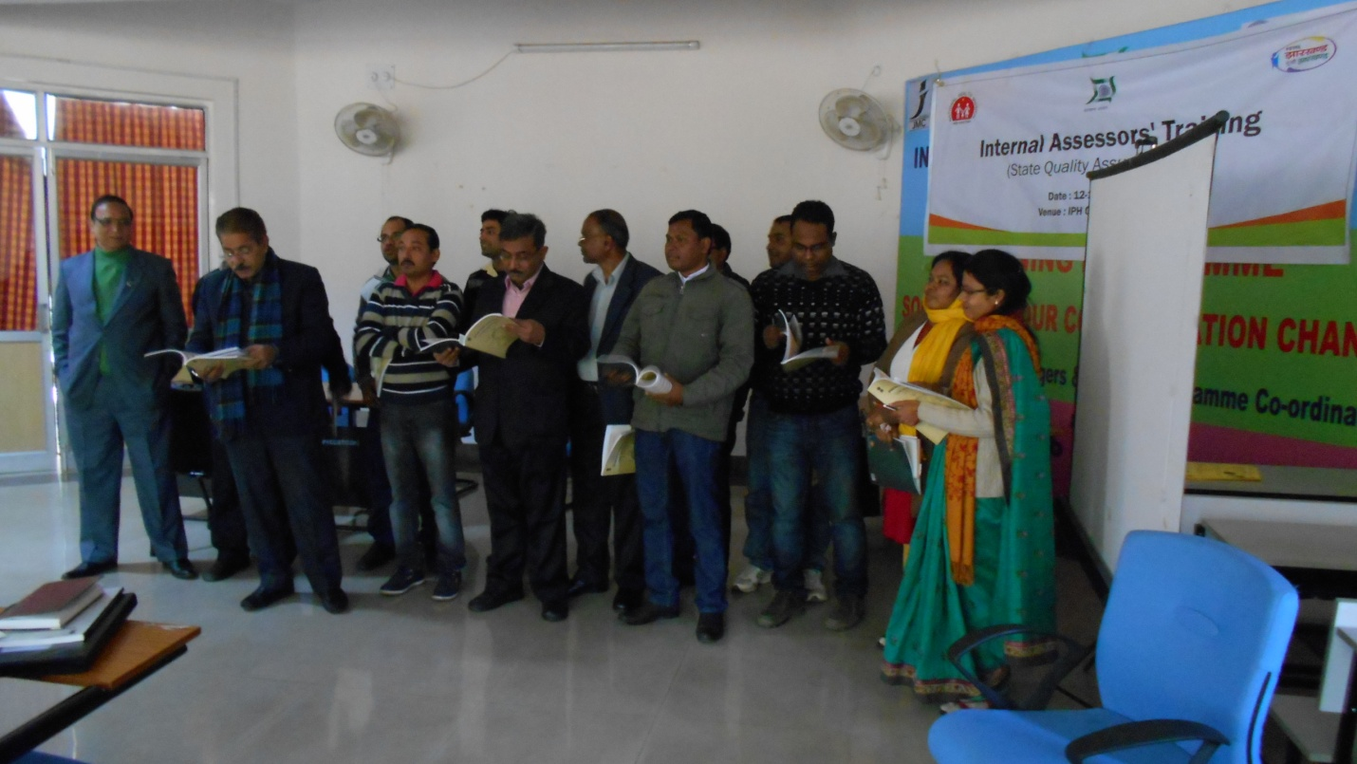

Conducted by:
National Health System Resource Centre in collaboration with NHM, Jharkhand

TRAINING COORDINATOR: Mr. Jagjeet Singh (Consultant, NHSRC, New Delhi)
Mr. Kedar Nath Verma (Consultant QA, NHM, Jharkhand)

DATE OF TRAINING: 12th – 13th January 2015

PLACE OF TRAINING: Institute of Public Health (IPH) Ranchi

PARTICIPANTS OF TRAINING: Total no. 37 (List attached in Annexure I)

COURSE OVERVIEW: The course schedule (Attached in Annexure II)
OBJECTIVES OF TRAINING:
The specific objectives of the Training programme were: -
- To set up pool of Internal Assessors for state of Jharkhand.
- To equip assessors with knowledge of key concepts, tools and methodologies of National quality assurance standards.
- Provide skill to assessors to independently assess different area of concern, measurable elements & checklist
- To develop skills and acumen to carry out internal evaluation as well as assessment of hospitals.

BACKGROUND

Under National Health Mission, to improve the quality of Health care services at public hospitals, Ministry of Health & Family welfare, Govt. of India, has launched National Quality Assurance Standards. To comply these standards, Govt. has launched operational Guidelines as well as Assessor’s Guidebook for District hospitals, CHC (FRU) and PHC (24X7).
For implementation and certification under National Quality Assurance Standards (NQAS), 4 types of trainings courses were designed i.e. one day Awareness training, two days Internal Assessor Training, three day Service provider training and five day External Assessor training.
Two day internal assessor training is mandated for assessors who will periodically assessed their facilities covering all critical departments and action plan would be prepared on observed non conformities.
Main aim of training is to provide complete understanding of standards, their sub components, & scoring methodology to aspiring Internal Assessors.
There is fixed curriculum for the training extended up to period of two days, followed by written evaluation of aspiring Internal Assessor. In evaluation, if trainer would be able to score minimum 60 % of marks, than he/she will be awarded with Internal Assessor Certification for NQAS & eligible as an empanelled Internal Assessor for the State.
eXECUTIVE sERVICE
1st Internal Assessor training was conducted by NHSRC in collaboration with NHM, Jharkhand from 12th January to 13th January 2015 at Institute of Public Health (IPH) Ranchi, Jharkhand.
The aim of training was to strengthen assessor’s knowledge of key concepts, tools, and methodologies for assessment of National Quality assurance Standards. Course curriculum for training was prepared by the NHSRC and was duly syndicated with state. Participants were from diverse background including Deputy Superintendents, Medical Officer’s and Hospital Managers from 24 districts of Jharkhand.
The participants were given-
- A copy of Operational Guideline for National Quality Assurance in public health care.
- A copy of Assessor’s guidebook for District Hospital.(Volume1 & Volume 2)
- A Bag with writing pad and pen.
- Instruction’s for Participant about ‘’Internal Assessor’s Training.
- Hard copy of Exercises and material wherever required during training.

Dynamic Training tools like Group discussions; Interactions, individual work etc. has been used to facilitate focused learning and keep the interest of the audience alive.
The programme had 13 Sessions, spread over a period of two day.
Feedback from the participants was taken and the report contains analysis and suggestions given by the participants.
Training was started with welcome speech from Dr. Tunul Hemrom [Deputy Director (QA), NHM, Jharkhand] followed by presentation from Dr. J N Srivastava (Advisor- QI, NHRSC).
The overall rating of the programme in feedback was excellent with an overall score of 3.17 on a 4 point scale.
DAYWISE SUMMARY OF THE PRESENTATIONS

Day 1
In the first presentation of the training Dr. J N Srivastava, (Advisor, QI, NHSRC) gave an Overview of National Quality Assurance Program. He started with his session with the concepts of Quality and explained various definition and dimension of Quality. He also discussed about the existing models of quality like NABH, ISO, IPHS etc and there implication on public health. He emphasized on need of Pro- Public Health quality model which give flexibility to the states to customize, sustainable and scalable, low cost of implementation. He introduced national quality assurance program and briefly explained eight key features of QA program namely –
1. Unified organizational framework
2. Quality assurance standards
3. Continual assessment and scoring
4. Assessment Methodology
5. Training and Capacity building
6. Inbuilt quality improvement model
7. Certification at state and national level
8. Incentives and sustenance
The next session started by Dr. Deepika Sharma (Consultant, QI, NHSRC). She explained about measurement system of NQAS and the relationship between the areas of concern – Standard - measurable element - Checkpoint and approaches for assessment. Participants were explained about the scoring patterns and the method to obtain the cumulative hospital score card. This helped the participants to acquaint themselves with the newly introduced National Quality Assurance standards.
The next session started by Dr. Nikhil Prakash (Senior Consultant, QI, NHSRC), he explained about the 1st area of concern ‘’Service Provision’’. During the session participants were given a detailed explanation about all the standards of Area of Concern service provision which include curative service, RMNCH+A services, Support Services, National Health Program, diagnostic services & services as per community needs. Participants were given details about the availability of services at facility as per state norms /IPHS.
Dr. Nikhil continued his presentation with Area of Concern B & C “Assessment of Patient Rights & Inputs “. In his presentation he explained about the patient rights which explain about accessibility of services along with their availability & services provided in dignified manner for its acceptance by clients (patients). He continued his presentation with “Area of Concern C –Inputs” and explained about infrastructure availability & adequacy, physical safety, fire safety, HR availability & their training requirement & availability of equipments & instruments.
Followed by this session Dr. Jagjeet Singh (Consultant, QI, NHSRC) distributed case study on labour room as an exercise for participants. In this exercise one sheet of paper was distributed to all participants, which was about the observation of assessment done by assessor. All participants were instructed to fill the checklist of Labour Room from area of concern A to C. This exercise worked as a breather for the participants.
Based upon the score generated by the participants Dr. Nikhil & Dr. Jagjeet explained how this scoring can be done in excel sheet. He also explained about the methodology of Hospital wise scoring, Department wise scoring and Area of concern wise scoring.
Followed by this, Dr. Deepika Sharma (Consultant, QI, NHSRC) presented on Area of Concern D- Support services. Participants were given a snapshot of 12 standards and the concerning measurable elements. Ms Surbhi related real life situations faced by staff working in support services of the hospital and encouraged the participants to share their comments.
The last session of the day was started by Dr. J N Srivastava (Advisor, QI, NHSRC) and discussed about Area of Concern E Clinical services. This session only includes standards E1 to E9 i.e General Clinical services standards. He explained about admission, consultation & discharge processes of hospital, other than that it include standards for clinical assessment & reassessment, continuity of care, nursing processes, identification of high risk & vulnerable patients, use of STGs, drug administration & record maintenance. Participants were encouraged to discuss day to day challenges faced by them in improving the quality of clinical services.

Day-2
Day 2 was initiated with a brief recap of all the sessions of Day 1 by Dr. Nikhil. Participants were encouraged to talk about their understanding from day-1.
First session of the day was started by Dr. Nikhil Prakash (Senior Consultant, QI, NHSRC) about Area of concern E “Clinical Services” (Specific & RMNCHA). They covered Specific clinical services like ICU, Accident and Emergency department of the Hospital. Dr. Nikhil also explained best practices and quality standards as per NQAS for both of these departments.
Dr. Nikhil explained standards related to laboratory and blood banks. He explained about the pre- analytic, analytic and post analytic standards for lab services. He continued his presentation with standards for RMNCH+A services and explained about the Quality of ANC services, labour room protocol etc during this session.
Session was followed by Dr. Deepika Sharma Presentation on Area of Concern F - Infection Control. All the six standards related to infection control namely infection control program, Hand Hygiene practices, use of Personal protective equipments, processing of equipment and instruments ,Physical layout and environmental control of the patient care areas & Bio medical waste management were explained. He demonstrated six steps of Hand washing and discussed practical issues related to infection control during his session.
After this session Dr. Jagjeet Singh (Consultant, QI, NHSRC) presented on “Key Performance Indicators”. Participants were explained about all the 30 indicators mentioned in the operational guidelines and were given examples to calculate each indicator. This session was very participative as it engaged all the participants for exercise.
Next session was started by Dr. Deepika Sharma (Consultant, QI, NHSRC) about presentation on Area of Concern G ‘’Quality Management System. During the session participants were given a holistic view about PDCA cycle. All eight standards of quality management i.e. G1 to G 8 were discussed.
Last session of the day was taken by Dr. Deepika Sharma on “Road Map for Quality Assurance”.
After completion participants were given question paper with 42 multiple choice questions. 3 set of question paper were prepared for evaluation.
PARTICIPANT FEEDBACK
Following examination feedback was taken from participants. Evaluation of participant feedback is taken on 4 point scale. Analysis of Participant feedback is attached in Annexure III. Overall Average scoring was 3.17 of out of 4.
MOST LIKED SESSIONS WERE:
Name of Session & Presenter | Score
STANDARDS FOR GENERAL CLINICAL SERVICES  DR J N Srivastava | 3.27
STANDARDS FOR SPECIFIC CLINICAL SERVICES  DR. NIKHIL PRAKASH | 3.23
STANDARDS FOR INFECTION CONTROL  DR. DEEPIKA SHARMA | 3.23
ROAD MAP FOR QUALITY ASSURANCE  DR. NIKHIL PRAKASH | 3.22
STANDARD FOR SERVICE PROVISION, PATIENT RIGHTS & INPUTS  DR. NIKHIL PRAKASH | 3.12

SUGGESTIONS TO IMPROVE THE TRAINING
- Real time case study would be more meaningful.
- More training days.

Annexure I

List of Participants for IA-Training Jharkhand
S.No. | Name of Participant |  | Name of Facility | Designation
1 | Md. Shahnawaz |  |  | HM
2 | Dr. Sahir Pall |  | DH, East Singhbhum | District Surveillance Officer
3 | Dr. Manish Kumar Sinha |  | DH, Pakur | DRCHO (Nominated)
4 | Ms. Jaya Reshma Xaxa |  | DH, Latehar | DPM
5 | Mr. Sudip Kumar Kisku |  |  | HM
6 | Dr. Lakhan Soren |  | DH, Dumka | MO
7 | Dr. Capt.Shesh Narayan Jha |  | DH, Lohardaga | ACMO
8 | Mr. Atindra Upadhyay |  | DH, Ramgarh | HM
9 | Ms. Mamta Sahu |  |  | Junior Nursing Tutor
10 | Ms. Madhumita Prabha |  |  | RCQA
11 | Ms. Kanan Bala Tirky |  |  | DPM
12 | Ms. Sinny Ravi |  |  | Junior Nursing Tutor
13 | Ms. Shanti Lata Purti |  |  | Nursing Tutor
14 | Mr. Kedar Nath Gupta |  | DH, Ranchi | Quality Consultant
15 | Mr. Murshid |  |  | HM
16 | Ms. Niral Kujur |  | DH, Ranchi | Nursing Tutor
17 | Ms. Chandmani Purty |  |  | Sister Tutor
18 | Md. Azmat Azeem |  |  | District Epidemiologist
19 | Mr. Jiren.S. Kandulna |  |  | HM
20 | Mr. Chandra Sekhar Mahato |  |  | HM
21 | Dr. Bandevi Jha |  |  | MO
22 | Dr. Ram Prasad |  |  | District Leprosy Officer
23 | Dr. Sudhir Prasad |  |  | DRCHO
24 | Antara Jha |  |  | HM
25 | Dr. P.P. Pandey |  | DH, Sahibganj | District TB Officer
26 | Dr. R.C.Sahay |  |  | ACMO
27 | Mr. Ravi Shankar Saurav |  |  |  | HM
28 | Mr. Mukesh Kumar | DH, Godda |  |  | HM
29 | Ms. Subhashini Chandrika |  |  |  | HM
30 | Dr. Maheshwar Prasad |  |  |  | DRCHO
31 | Dr. Binod Oraon | DH, Simdega |  |  | DS
32 | Mr. Suneet Kumar Srivastava |  |  |  | HM
33 | Mr. Nishant Kumar Kunal | DH, Chatra |  |  | HM
34 | Dr. Nand Kishore Rajak | DH, Garhwa |  |  | DRCHO
35 | Dr. Rajkumar Beck | DH, Gumla |  |  | DS
36 | Mr. Niraj Kumar Bhagat |  |  |  | DPM
37 | Dr. Subodh Kumar | DH, Jamtara |  |  | MO

Annexure II
Internal Assessor’s Training on National Quality Assurance Standards Jharkhand.
Time | Topic | Resource Person
10:00AM-10:30 AM | Registration
10:30AM -11:00 AM | Inaugural Address MD NHM
11: 00AM -11:15 AM | Tea
11.15-12.00 AM | Overview of National Quality Assurance Program | Dr. J N Srivastava
12.00-12.45 | Measurement System for Quality Assurance & Assessment Protocol | Dr. Deepika Sharma
12.45 PM-1.30 PM | Standards for Service Provision , Patient Rights & Inputs | Dr. Nikhil Prakash
1.30 PM -2.15 PM | Lunch
2.15 PM -3.15 PM | Case Study 1 | Dr. Jagjeet Singh
3.15PM -4.00 PM | Standards for Clinical Services | Dr. J N Srivastava
4.00-4.15 | Tea
4.15 PM -4.45 PM | Standards for Clinical Services (Specific & RMNCHA) | Dr. Nikhil Prakash
4.45-5.30 | Group Activity- Identifying Standards | Dr. Deepika Sharma
Day-2
9.30 AM -9.40 AM | Recap
9.40 AM - 10.45 AM | Standards for Support Services | Dr. Deepika Sharma
10.45 AM -11.00 AM | Tea
11.00 AM -11.45 PM | Standards for Infection Control | Dr. Deepika Sharma
11.45PM - 12.30 PM | Standards for Quality Management | Dr. Deepika Sharma
12.30PM - 1.15 PM | Key Performance Indicators | Dr. Jagjeet Singh
1.15 PM -2.00 PM | Lunch
2.00 PM -2.45 PM | Exercise Gap analysis & Action Planning | Dr. Jagjeet Singh
2.45 PM -3.30 PM | Roadmap for Quality Assurance | Dr. Nikhil Prakash
3.30 PM -3.45PM | Tea
3.45 PM -4.45 PM | Post Training Evaluation
4.45 PM - 5.15PM | Feedback & Valedictory

Annexure-III
Internal Assessor Training, Jharkhand Participant Feedback Evaluation

Topic | Average
Overview of National Quality Assurance Program Dr. J N Srivastava | 3.00
Measurement System for Quality Assurance & Assessment Protocol  Dr. Deepika Sharma | 3.09
Standards for Service Provision, Patient Rights and Inputs  Dr. Nikhil Prakash | 3.12
Case Studies  Dr. Jagjeet Singh | 2.96
Standards for General Clinical Services  Dr. J N Srivastava | 3.27
Standards for Specific Clinical Services  Dr. Nikhil Prakash | 3.23
Standards for RMNCH+A  Dr. Nikhil Prakash | 3.12
Standards for Support Services  Dr. Deepika Sharma | 3.12
Standards for Infection Control  Dr. Deepika Sharma | 3.23
Standards for Quality Management  Dr. Deepika Sharma | 3.08
Key Performance Indicators  Dr. Jagjeet Singh | 3.00
Exercise Gap Analysis and Action Planning  Dr. Jagjeet Singh | 3.09
Road Map for Quality Assurance  Dr. Nikhil Prakash | 3.22
Overall Average | 3.17

