Training Report on External Assessor Training

Conducted for Gujarat

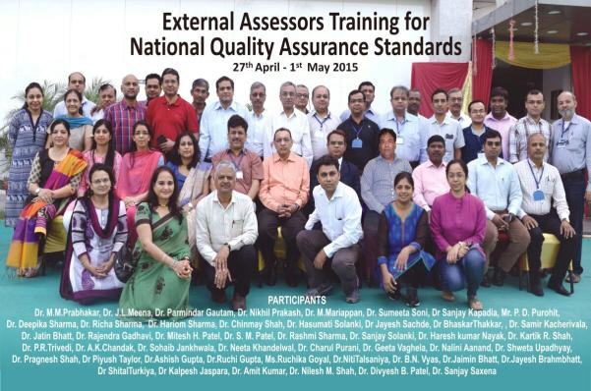

By

National Health Systems Resource Centre

Technical Support Institution with National Health Mission

Ministry of Health & Family Welfare

Government Of India

INDEX

Contents
I.INTRODUCTION 3
II.Aim and Objectives of TRAINING 4
III. PREPARATION 4
IV. Methodology for Implementation of Workshop 4
V. INAUGRAL ADDRESS 7
VI. SUMMARY OF PRESENTATIONS 8
VII.VALEDICTORY 17
IX. PARTICIPANT FEEDBACK. 17
X. SUGGESTIONS BY THE PARTICIPANTS. 17
Annexure-I-Training Schedule 19
Annexure II. Feedback of participants 22
Annexure III-List of participants 27
Abbreviations. 28

INTRODUCTION

The Ministry Of Health and Family Welfare has rolled out 'Operational Guidelines for Quality Assurance in Public Health Facilities' which suggests institutional framework for then quality assurance in states and districts. This system requires assessment of health facilities internally by the facilities and the district teams followed by external assessment by the state and centre .

National Health Systems Resource Centre (NHSRC) has taken the task to create a pool of assessors for which both Internal Assessor Trainings (2days ) and External Assessor Trainings (5days) are being conducted. An Internal Assessor is certified to conduct assessments at the state and district level while an External Assessor is certified to conduct assessments at National Level.

A five day external assessor training was conducted in Gujarat from 27th April-1st May at Govt. Spine Institute ,BJ Medical College,Gandhinagar,Gujarat. The workshop was facilitated by Dr J.L Meena, State Nodal Officer for Quality Assurance ,Government of Gujarat

The Training Process was designed with a view to enable the Trainees for the Assessment of the Healthcare Facilities against the checklists contained in the Assessor guidebooks (Two Volumes).

This report therefore provides information about how the five-day workshop was conducted, and highlights lessons learnt and the way forward for improving the quality in public health hospitals in India.

The training was participatory in nature. A set of Operational guidelines along with two assessor guidebooks was shared with the participants and used as a basis for facilitation of the training. The Sessions were divided into five days and consisted of elaborate sessions describing Standards, Measurable Elements, Check points and all Areas of Concern as mentioned in the Operational Guidelines.

Feedback from the participants was taken and the report consist of analysis of the feedback and suggestions given by the participants.

A written evaluation was undertaken at the end of the training and as per the procedure the participants scoring minimum 70 % shall be empanelled as external assessor. There were total 41 participants including two representatives from each state which encompassed Professors, Associate Professors, RMO, Civil Surgeons, District Quality Assurance Officers and Paramedics. In addition to this there were three participants from Haryana including Executive Director HSHRC and two consultants.
.

Aim and Objectives of TRAINING
The aim of the five day training was to strengthen the knowledge, skills and
assessment capacities on Operational Guidelines for Quality Improvement. The
specific objectives are as follows-
- To equip participants with knowledge of key concepts, tools and
methodologies of quality improvement.
- To develop skills and acumen to carry out Assessment as per the National
Accreditation System proposed under Quality Assurance Programme .

III. PREPARATION

The course curriculum was prepared by the QI division of NHSRC. The training was divided into five days and consisted of elaborate sessions describing Standards, Measurable Elements, Check points and all Areas of Concern as mentioned in the Operational Guidelines . A Field visit was arranged at Distict Hospital SOLA and PHC Usarval in district Ahmedabad giving the participants a platform for conducting assessment based on the shared checklists in assessor guidebooks. Training also consisted of many exercises which led to healthy brainstorming of the participants. In addition to this many participants were given many exercises , therby making the training more participatory.
The following materials were distributed:
- A Bag with writing pad ,pen & Pen drive
- Operational Guidelines for Quality Assurance in Public Health Facilities.
- Assessors Guidebook for Quality Assurance in District Hospital Volume I
- Assessors Guidebook for Quality Assurance in District Hospital Volume II
- CD consisting of all presentations made during the training programme

IV. Methodology for Implementation of Workshop

Methods.
A mix of methods was used for the External Assessor Training workshop. They are as follows-
- Power point presentation. Ref Pic 3
- Brainstorming
- Case study. Ref Pic 2
- Group work and Group Presentation. Ref Pic1
- Questions and Answers
- Practical Experiences from Field Visit. Ref Pic 4
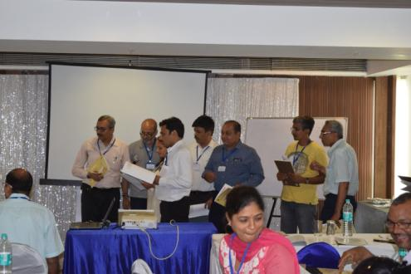
Pic.1 Group Presentation by Participants

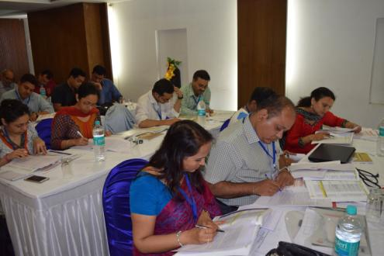
Pic. 2 Participants participating in case Study.

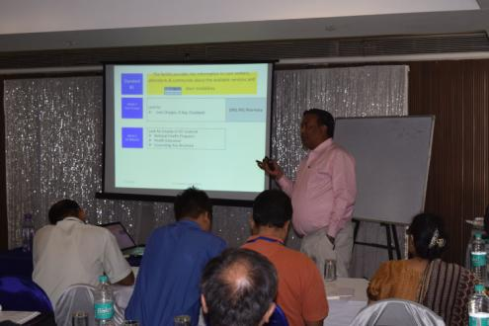
Pic 3. Class room Teaching by using Presentations

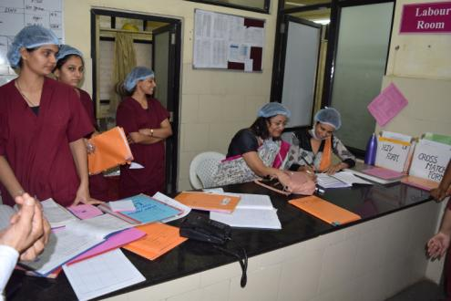
Pic 4. Participants Interviewing nursing staff in Labor room during field visit at DH Sola ,Ahmedabad.
Participants
The final number of participants was 41. List of participants is attached in Annexure III.

V. INAUGRAL ADDRESS

Dr. M.M Prabhakar, Civil Surgeon, Government Spine Institute, BJ Medical College gave the inaugural address and spoke about quality in the public health system and why do we need it. He emphasized on the importance of establishing a group of empanelled assessor’s at the state level. He explained that how workshop had a broader goal of impacting the quality situation in Public health hospitals in India.
The inauguration was followed by an introductory session by Dr. J.L Meena, State Quality Assurance Officer . He explained about the current achievements in the field of quality in Gujarat.(Pic 5)
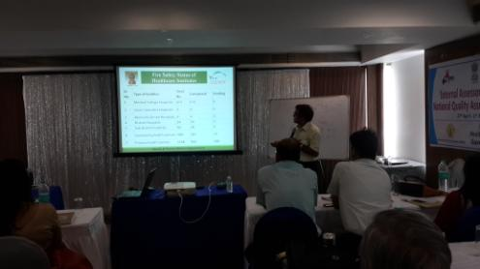
Pic 5. Dr.J.L Meena giving the introductory session .

VI. SUMMARY OF PRESENTATIONS

The course schedule outlines the day to day contents and learning methods. Details have been provided in Annexure 1. The presentations were supported with brainstorming, group work and group presentations .

DAY 1- 27th April 2015

In the first presentation of the training Dr. Parminder Gautam, QI, NHSRC gave an Overview of National Quality Assurance Program . He discussed about the Donabedian’s Model of Quality of care which involved three major aspects namely Structure, Process and Outcome . He gave an overview of the National Quality Assurance Systems which included all eight areas of concerns. For each area of concern he explained the importance, rational, reference, measures, outcome and total weightage as compared to all eight areas of concerns. He tried to acquaint the participants with the nomenclature used in the National Quality Assuarnce System.
This was followed by the session on Key concepts and definitions in quality by Dr. Nikhil Prakash, Senior Consultant, NHSRC , where introduction of terminologies of quality including quality control, quality assurance, quality improvement and certification and accreditation was given . Speaker explained about the PDCA cycle and shared examples regarding it implementation. Dr. Nikhil gave a holistic view of quality management system and various terms related to it.
Dr. Deepika Sharma, Consultant, NHSRC presented on Measurement System for Quality Assurance . She explained the relationship between the area of concern -Standard -measurable element –Checkpoint and approaches for assessment .Participants were explained about the scoring patterns and the method to obtain the cumulative hospital score card. A brief introduction of all the eighteen checklist in NQAS was given.
The next presenter for the day was Dr. Nikhil Prakash , Senior Consultant, NHSRC who gave a presentation on Overview Of National Quality Assurance Standards . In this session participants were given a snapshot of all eight area of concerns and the standards concerning them . This helped the participants to acquaint themselves with the newly introduced national quality assurance standards.
This was followed by a group exercise called “ Finding the key word ” which channelised all the participants. Participants were distributed key words and were instructed to find the area of concern concerning the key word. Then the participants were supposed to form a group with similar area of concern and select a team leader who explained about the importance of the area of concern.(Pic 6)
The concluding session for Day 1 was “Assessment of Area of Concern ‘A’ – Service Provision” by Dr. Nikhil Prakash . He explained in detail about the Area if concern A by giving detailed explanation about all the standards, measurable elements and checkpoints covered under the Area of concern A. He also made the presentation very interesting by adding few live photographs of hospitals and asked the patients to find the gaps.

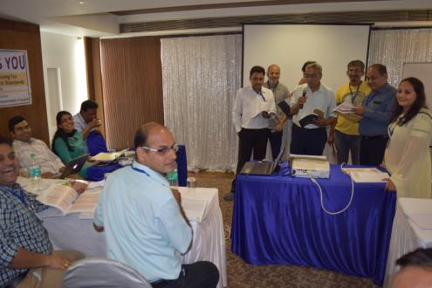
Pic 6. Dr. B.N Vyas from Distt Bhavnagar presenting on Area of concern Support Services during group exercise.

Day-2: 28th April 2015.
Day 2 was initiated with a brief recap of all the sessions of Day 1 by Dr. Parminder Gautam.
First session of Day 2 was presented by Dr. Parminder Gautam on “Assessment of Area of Concern ‘B’- Patient Rights ”(Pic7). During the session participants were given a detailed explanation about all the standards in Area of Concern B. Presenter explicitly explained the methods of assessment via pictoral representations .Participants were shown pictures from the public health hospitals and were asked to identify the gaps.
Session on patient rights was followed by an exercise “ Assessing the complaints” to make the training more participative. The exercise was related to identification of standards on Patient Rights from a complaint. Ten groups of five participants each were formed and each group was given one complaint. Participants were asked to find related standard and measurable elements from Area of Concern B after analysis of the complaint.
This session was followed by the presentation on “Area of Concern C –Inputs” by Dr.Nikhil Prakash who explained about all the six major standards ie C1 to C 6 and methods of assessment for these standards. Participants were provided in depth knowledge about the standards concerning area of concern “ Inputs” . The session was of participative nature.
Dr. Deepika Sharma explained about Area Of Concern D Support Services . Participants were given a snapshot of standards D1 till D12 and the concerning measurable elements. Dr. Deepika related real life situations faced by staff working in support services of the hospital and encouraged the participants to share their comments.
To engage the participants more this session was followed by an Exercise on Area of Concern D in which participants were a given a Case Study on SNCU and were asked to score the SNCU checklist on the basis of information provided in the case study. This helped the participants to have an assessor’s perspective of a situation.
Participants were taught about Area of concern E “ Clinical Services” by Dr. Arun Kumar Dutta, Short term consultant, NHSRC . Clinical services included standards E1 till E22 which was further divided into General Clinical process (E1-E9), Specific clinical processes(E10-E16) and RMNCHA & NHP from (E17-E22). Dr. Dutta covered both General Clinical( E1-E9)and Specific Clinical Services(E10-E16) while RMNCHA & NHP from (E17-E22) was covered by Dr. Himanshu Bhushan on Day 3. This session was very informative for the participants as it explained about the checkpoints of assessment of the clinical processes of a hospital which directly affect the patient. Participants were encouraged to discuss day to day challenges faced by them in improving the quality of clinical services .
This was followed by an Exercise On Area Of Concern E . Participants were given a case study and were asked to score the checklist for emergency department and identify compliance and non compliance from the standards. The scores were discussed by the whole team,
This was followed by session on Area of Concern F “Assessment of Infection Control Practices” by Dr. Deepika Sharma. (Pic 8) All the five standards related to infection control namely Standard F1 covering the infection control program, standards F2 explaining the Hand Hygiene practices, Standard F3 explaining the use of Personal protective equipments, Standard F4 explaining the procedures for processing of equipment and instruments and Standard F5 explaining about the infection control in Physical layout and environmental control of the patient care areas were explained.

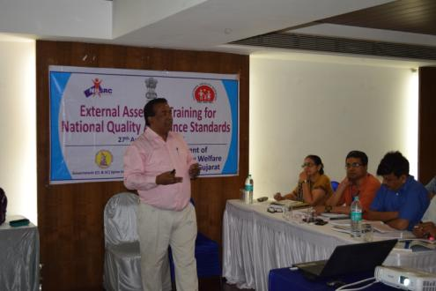
Pic 7. Dr. Parminder Gautam explaining about Area of Concern B Patient rights

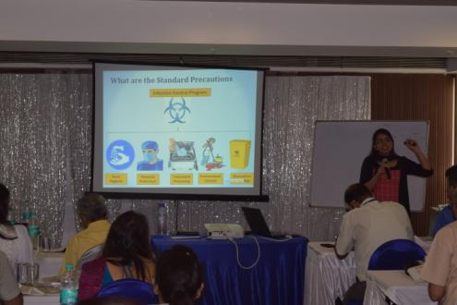
Pic 8. Dr. Deepika Sharma Presenting on Infection Control

Day-3: 29th April 2015
Day 3 began with recap of the sessions taken on Day 2 by Dr Parminder Gautam.

First session of the day was taken on Assessment of Laboratory and Blood Bank Services by Dr. Sumeeta Soni, Associate Professor, Department of Biochemistry, BJ Medical College, Gujarat.(Pic 10) This session was mainly focussed on the day to day quality practices that should be followed in laboratory. Dr. Sumeeta also shared some of the live pictures from her recent study conducted in Dibrugarh to the participants .She explained about the standards/checkpoints related to laboratory and blood bank which cut across all the area of concerns.
This was followed by a session on RMNCHA services by Dr. Himanshu Bhushan, Advisor, Public Health Administration, NHSRC.(Pic 9). He interacted with the audience on current status of RMNCHA . He discussed the standards related to MCH services namely E17 related to antenatal care guidelines, E18 related to for Intra-natal care as per guidelines and E19 related to Post-natal care as per guidelines . Applicability of these standards in hospital departments and how to assess them was explained thoroughly.He emphasised on the use of Partograph in labor room and explained how to read and plot the graph. Participants really enjoyed his lecture and discussed about their queries.
Dr. Bhushan’s session was followed by an Exercise on Assessment which proved to be very useful. In the exercise participants were shown few photographs from the public health hospitals and were asked to frame the gap assessment, identify the related standard and measurable elements. This exercise helped the participants to be more acquainted with the standards.
This was followed by session on Area of concern G “Quality Management” by Dr. Parminder Gautam. During the session participants were given a holistic view aboutPDCA cycle. All eight standards of quality management ie G1 to G 8 were discussed. Dr. Gautam divided the PDCA cycle among all the eight standards for better understanding . “Plan” included standards G1-organisational framework, G7-Quality policy and obejectives,G4-SOP’s, “Do” included G5-process approach, G2-Patient and employee satisfaction,”Check” included G6-patient and employee satisfaction,G7-Internal and external QA programs and G8-Tools and methods of QI.
Participants were given an introduction regarding national quality assurance system for Primary health Care Centre (PHC ) by Dr. Deepika Sharma. She gave a brief session on all the six checklist under the NQAS for PHC namely OPD, Labor room, IPD, lab, general admin and NHP.

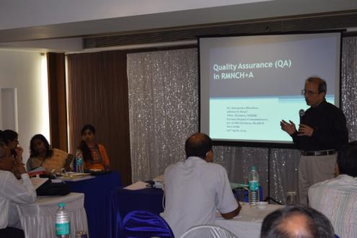
Pic 9. Dr. Himanshu Bhushan discussing about RMNCHA

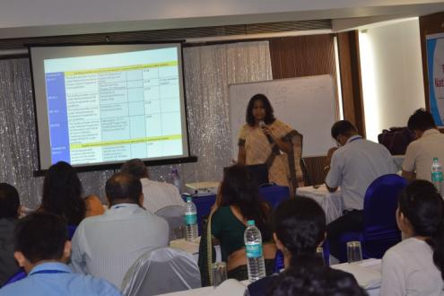
Pic 10.. Dr. Sumeeta Soni presenting on Laboratory and Bloodbank services

Day 4 30th April 2015
Field Visit.
Field Visit was conducted in District Hospital Sola and PHC Uvarsad .(Pic11,12)
Participants were divided into total 9 teams with approximately 4-5 members per team . Team 1 to Team 7 was sent to District Hospital Sola and Team 8 to Team 9 was sent to PHC Uvarsad.
Each team was given one checklist of their respective department for assessment.
All the teams were supposed to conduct assessment and then prepare a presentation enumerating the gaps.(Pic13).
This field visit gave a great exposure to the participants , giving them an opportunity for practical application .
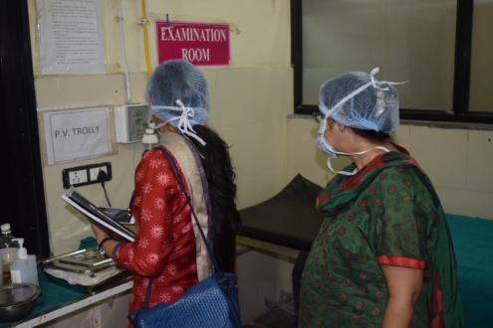
Pic 11. Participants during visit to DH Sola trying to capture the gaps in Emergency Dept.

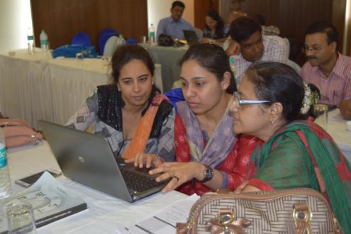
Pic 12. Participants preparing presentations after the field visit enumerating the gaps.

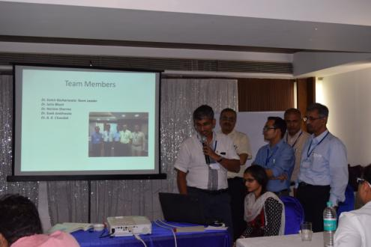
Pic 13.. Participants giving presentation post field visit..
Day 5 1st May 2015
First session of the day was taken by Dr. Nikhil Prakash on “Key Performance Indicators ”. Participants were explained about all the 30 indicators mentioned in the operational guidelines and its importance.
This was followed by a very informative session on “Analysis and Presentation of Scores – Learning from Assessment of 20 District Hospital ” by Dr. M. Mariappan. He showcased the findings of baseline assessments conducted in 20 district hospitals all over India. He shared both positive and negative experiences during the assessments. Participants were given hospital score comparison for all 20 district hospitals in a dashboard format.This session served as a great eye opener for participants.
Concluding session for the whole training was taken by Dr. Nikhil Prakash on “Standard Operating Procedure for External Assessment & Certification” in which he explained about the Do’s and Don’t’s during assessment and the protocol to undergo External Certification.

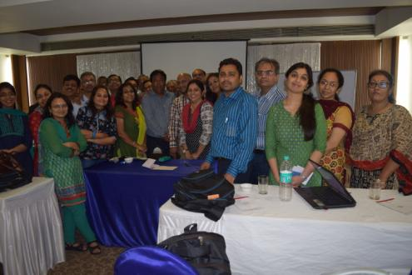
Trainers along with the participants on last day of the training.

Evaluation
Participants underwent an evaluation based on the 5 day training . They were given question paper with 45 multiple choice questions (each participant having a different set). In addition to this participants were also given spotting of the gaps in which they were shown pictures of gaps in public health hospitals and were asked to enumerate the gaps in form of gap statement.

VII. VALEDICTORY
Dr. M.M Prabhakar delivered the Valedictory address. During the course of discussion, he reiterated the Quality Management System in the Identified Hospitals. He thanked all the participants for the overwhelming participation and sincerity towards the training.

IX. PARTICIPANT FEEDBACK.
The evaluation was done on 5 point scale, which is enclosed as Annexure II.

All the participants expressed their profound gratitude to NHSRC for conducting external assessors training. They noted that the training has strengthened their knowledge on quality management systems . They said the training was a huge success as it sought to address key gaps in their knowledge of issues.

They were also very appreciative of the methods used by the facilitators. They said, the participatory approaches used at all levels of the training had invigorated them and enhanced their willingness to acquire knowledge. They therefore pledged their
commitment to utilize the skills and knowledge acquired in assessment of facilities .
All of them were happy with the training programme and acknowledged the fact that this will help them in conducting assessments at facilities in future.
The most useful session found by the participants were-
- Assessment of RMNCHA and family Planning services
- Standards for Primary Health Care
- Assessment of Area of Concern G- Quality Management
- Assessment of Area of Concern F- Infection Contro
- Assessment of Area of Concern E Clinical Services
Certificates of Participation were distributed to all participants.

X. SUGGESTIONS BY THE PARTICIPANTS.

Participants gave some valuable suggestion namely-

- One session should be included for the participants to share their experiences.
- Sessions should be more interactive
- Training module should be sent to participants in advance.
- More exercises and more field visits should be organised.
- Share soft copy /hard copy at least 10 day before the commencement of training, so participants are aware regarding aim/objective/methodology.
- Training course should be of three days
- Pre training evaluation should be conducted
- RMNCHA to be correlated with the training module.
- Technical SOP’s, STG and operational guidelines must be provided for handholding and supportive assessment during training.
- Quality indicators can be used by MCI for evaluation of medical colleges.
- Speaker should not be stationary at one place , keep on moving amongst audience

XI. Message from NHSRC
We thanks Government of Gujarat for this endeavour towards National Quality Assurance System and hope that the state will achieve all milestones in Quality Imrovement.

Annexure-I-Training Schedule

External Assessors training for National Quality Assurance Standards
27th April to 1st May 2015, Ahmedabad
Time | Topic | Resource Person
Day 1
9.30-10.00 | Registration
10.00-10.30 | Inaugural Address & Introduction | Mission Director
10.30-11.00 | Quality Initiatives in the State of Gujarat | Dr. J. L. Meena
11.00-11.30 | Tea
11.30-12.15 | Overview of National Quality Assurance Program | Dr. Parminder Gautam
12.15-1.00 | Key concepts and Definitions in Quality | Dr. Nikhil Prakash
1.00-2.00 | Lunch
2.00-2.45 | Measurement System for Quality Assurance | Dr. Deepika Sharma
2.45-3.45 | Overview of National Quality Assurance Standards | Dr. Nikhil Prakash
3.45-4.15 | Tea
4.15-5.00 | Group Activity on Standards | Facilitator – Dr. Richa Sharma
5.00-5.30 | Assessment of Area of Concern ‘A’ – Service Provision | Dr. Nikhil Prakash
Day 2
9.30 –10.00 | Recap
10.00-10.45 | Assessment of Area of Concern ‘B’- Patient Rights | Dr. Parminder Gautam
10.45-11.00 | Tea
11.00-11.30 | Exercise on Patient Rights | Facilitator – Dr. Nikhil Prakash
11.30-12.15 | Assessment of Area of Concern ‘C’- Input | Dr. Nikhil Prakash
12.15-1.15 | Assessment of Area of Concern ‘D’- Support Services | Dr. Deepika Sharma
1.15-2.00 | Lunch
2.00-2.45 | Exercise on Area of Concern ‘D’ | Facilitator- Dr. Richa Sharma
2.45-3.30 | Assessment of Area of Concern ‘E’- General Clinical Services | Dr. Arun K Dutta
3.30-3.45 | Tea
3.45-4.15 | Exercise on Area of Concern ‘E’ | Facilitator – Dr. Arun K Dutta
4.15-4.45 | Assessment of Area of Concern ‘E’ - ICU, Emergency and OT | Dr. Arun K. Dutta
4.45-5.45 | Assessment of Area of Concern ‘F’- Infection Control | Dr.Deepika Sharma
Day 3
9.30-10.00 | Recap
10.00-11.00 | Assessment of Laboratory and Blood Bank Services | Dr. Sumeeta Soni
11.00-11.15 | Tea
11.15-12.30 | Assessment of RMNCHA Services (E17-E22) | Dr. Himanshu Bhushan
12.30-1.00 | Exercise on the Assessment | Dr. Himanshu Bhushan
1.00-1.45 | Lunch
1.45-2.30 | Assessment of Area of Concern ‘G’- Quality Management | Dr. Parminder Gautam
2.30-3.15 | Exercise of Area of Concern ‘G’- (General Checklist) | Facilitator – Dr. Parminder Gautam
3.00-4.00 | Standards for Primary Health Care | Dr. Deepika Sharma
4.00-4.30 | Tea
4.30-5.15 | Assessment Team formation and Instructions for Field Visit | Dr. Parminder Gautam
Day 4
9.00-1.00 | Field Visit | 1 DH &1 PHC.
1.00-2.00 | Lunch
2.00-3.00 | Analysis & Scoring
3.00-4.00 | Presentation & Discussion
4.00-4.30 | Tea
4.30-5.30 | Presentation & Discussion
Day 5
9.30-10.00 | Recap
10.00-11.00 | Key Performance Indicators under National Quality Assurance Program | Dr. Nikhil Prakash/Dr. Deepika Sharma
11.00-12.00 | Analysis and Presentation of Scores – Learning from Assessment of 20 District Hospitals | Dr. M. Mariappan
12.00-01.00 | Standard Operating Procedure for External Assessment & Certification | Dr. Nikhil Prakash
1.00-2.00 | Lunch
2.00-3.30 | Post Training Evaluation
3.30-4.00 | Feedback & Valedictory

Annexure II. Feedback of participants

External Assessor's Training (27th April-1st May)

DAY 1
S.No | Topic | Speaker | Average Score
1 | Overview of National Quality Assurance Program | Dr. Parminder Gautam | 4.3
2 | Key concepts and Definitions in Quality | Dr. Nikhil Prakash | 4.0
3 | Measurement System for Quality Assurance | Dr.Deepika Sharma | 4.0
4 | Overview of National Quality Assurance Standards | Dr. Nikhil Prakash | 4.1
5 | Group Activity on Standards | Dr.Deepika Sharma | 4.1
6 | Assessment on Area of Concern 'A' | Dr. Nikhil Prakash | 4.0
AVERAGE |  |  | 4.1
DAY 2
1 | Assessment of Area of Concern B Patient Rights | Dr. Parminder Gautam | 4.3
2 | Exercise on Patient Rights | Dr. Nikhil Prakash, NHSRC | 3.9
3 | Assessment of Area of Concern C Input | Dr. Nikhil Prakash, NHSRC | 3.9
4 | Assessment of Area of Concern D Support Services | Dr.Deepika Sharma | 3.9
5 | Exercise on Area of Concern D | Dr.Deepika Sharma | 3.9
6 | Assessment of Area of Concern E Clinical Services | Dr. Arun Kumar Dutta | 3.7
7 | Exercise on Area of Concern E | Facilitator – Dr.ParminderGautam &Dr.Deepika Sharma | 3.8
8 | Assessment of Emergency & ICU Services& newborn health | Dr. Arun Kumar Dutta | 3.5
9 | Assessment of Area of Concern F- Infection Control | Dr. Deepika Sharma | 3.9
AVERAGE |  |  | 3.9
Day 3
1 | Assessment of Lab & Radiology & blood bank Services | Dr.Sumeeta Soni | 3.6
2 | Assessment of RMNCHA and family Planning services | Dr.Himanshu Bhushan | 3.5
3 | Exercise on Assessment | Dr.Parminder Gautam & Dr.Deepika Sharma | 3.7
4 | Assessment of Area of Concern G- Quality Management | Dr. Parminder Gautam, | 4.5
5 | Standards for Primary Health Care | Dr.Deepika Sharma | 4.3
6 | Instructions for Filed visit | Dr. Parminder Gautam, | 4.2
AVERAGE |  |  | 4.0
Day 4
1 | Field Visit | NHSRC | 4.4
2 | Interpretation of Assessment & Reporting | Dr. ParminderGautam, | 4.3
AVERAGE |  |  | 4.3
Day 5
1 | Key Performance Indicators under National Quality Assurance Program | Dr. Nikhil Prakash | 4.00
2 | Analysis and Presentation of Scores-Learnings from Assessment of 20 districts | Dr. M. Mariappan | 4.00
3 | Standard Operating Procedure for External Assessment & Certification | Dr. Nikhil Prakash | 3.94
AVERAGE |  |  | 3.98
Consolidated AVERAGE |  |  | 4.06

Graphical representation Day 1
Graphical representation Day 2

Annexure III-List of participants
Sr. | Name of participants | Designation | Contact No. | E-mail
No
1 | Dr Hariom Sharma | Professor & Head, Biochemistry | 7567951707 | hariom_sharma2000@yahoo.com
2 | Dr Chinmay Shah | Associate Professor Physiology | 9328938008 | cjshah79@yahoo.co.in
3 | Dr Hasumati Solanki | Assistant Professor Microbiology | 9879543002 | hlsolanki@gmail.com
4 | Dr JayeshSachde | Professor Plastic Surgery | 9824018848 | jayeshsachde@yahoo.in
5 | Dr BhaskarThakkar | Associate Professor ,Pathology | 9426370900 | drbhaskar_9@yahoo.com
6 | Dr Sanjay Kapadia | RMO | 9099952626 | sanjaymeet@rediffmail.com
7 | Dr. Samir Kacherivala | Associate Professor, Surgery | 9898930339 | dr_samir_k@yahoo.com
8 | Mr. P. D. Purohit | Occupational Therapist | 9099952632 | manubhaipurohit@gmail.com
9 | Dr Jatin Bhatt | HOD, Surgery | 9428894466 | drjatin@hotmail.com
10 | Dr RajendraGadhavi | Assistant Professor, PSM | 9825068116 | drrgadhavi@yahoo.com
11 | Dr Rashmi Sharma | Associate Professor, PSM | 9825280850 | drrashmi_psm@yahoo.com
12 | Dr Sanjay Solanki | Incharge Central Store | 9426305253 | drsanjay.india76@gmail.com
13 | Dr Mahesh Kapadiya | Civil Surgeon | 9426026266 | sanjaymeet@rediffmail.com
14 | Dr.Hareshkumar R Nayak | District Quality Assurance Medical Officer | 9687679011 | qamo.health.sabarkantha@gmail.com
15 | Dr Kartik R. Shah | District Quality Assurance Medical Officer | 7567893700 | qamopanchmahal@yahoo.com
16 | Dr.P.R.Trivedi | District Quality Assurance Medical Officer | 7567863217 | qamokheda@yahoo.com
17 | Dr.A.K.Chandak | Senior Medical Officer | 9727742509 | ghvyara@gmail.com
18 | Dr.SohaibJankhwala | Microbiologist | 9099004636 | qamopanchmahal@yahoo.com,shoaibdoc4@gmail.com
19 | Dr Neeta Khandelwal | Professor, Microbiology | 9925276950 | neetashokk@gmail.com
20 | Dr CharulPurani | Asst Professor , Pediatrics | 9825612393 | charulpurani@yahoo.com
21 | Dr Geeta Vaghela | Associate Professor, Microbiology | 9925017154 | drgeet_12290@yahoo.co.in
22 | Dr.NaliniAanand | Professor OBG Department | 9824213693 | docnalini.anand@gmail.com
23 | Dr.ShwetaUpadhyay | Asso. Prof IHBT Dept. | 9824336383 | sbu_33@yahoo.co.in
24 | Dr Pragnesh Shah | Associate Professor, Pathology | 9428106604 | drphshah73@yahoo.com
25 | Dr.Ashish Gupta | Haryana |  | qahshrc@gmail.com
26 | Dr.Ruchi Gupta | Haryana |  | qahshrc@gmail.com
27 | Ms.RuchikaGoyal | Haryana | 8288021903 | qahshrc@gmail.com
28 | Dr.NitiTalsaniya | Associate Professor | 9879843918 | nitibenok@gmail.com
29 | Dr. B.N. Vyas | District Quality Assurance Medical Officer | 9727779727 | drbnvyas@gmail.com
30 | Dr.Jaymin Bhatt | Asst Professor IHBT | 9723812300 | jayminbhatt67@gmail.com
31 | Dr.JayeshBrahmbhatt | Prof /head for Dept of burns and plastic surgery | 9898141114 | jaybrahma@gmail.com
32 | Dr ShitalTurkiya | Asso Professor , Radiology | 9913018881 | skaplesh1822@gmail.com
33 | Dr Kalpesh Jaspara | GMERS Gandhinagar | 9825480210 | drkalpeshjaspara@gmail.com
34 | Dr. Jaydeep Gadhavi | Civil Hospital , Gandhinagar | 9904437000
35 | Dr. Amit Kumar |  | 9727721366
36 | Dr. Mitesh . H. patel | Associate Professor | 9825171815 | drmitesh_76@yahoo.co.in
37 | Dr. Nilesh Shah | Associate Professor | 9979091384 | netu_n_shah@yahoo.com
38 | Dr. Diveysh. B Patil | GMC Surat | 9909981893
39 | Dr. Shailesh M Patel | Prof Biochemistry, GMC Surat | 9825191911
40 | Dr Piyush Tailor | Associate Prof. Biochemistry | 9428043531
41 | Dr. Sanjay M Saxena | MO. PHC,Patan | 9435053499

Abbreviations.

NHSRC | National Health Systems Resource Centre
MOHFW | Ministry Of Health and Family Welfare
ED | Executive Director
NQAS | National Quality Assurance System
QI | Quality Improvement
PHC | Primary Health Centre
OPD | Outpatient Department
IPD | Inpateint Department
NHP | National Health Program

