Internal Assessor Training (UPHC) on
National Quality Assurance Program
18th to 19th July 2016, Punjab

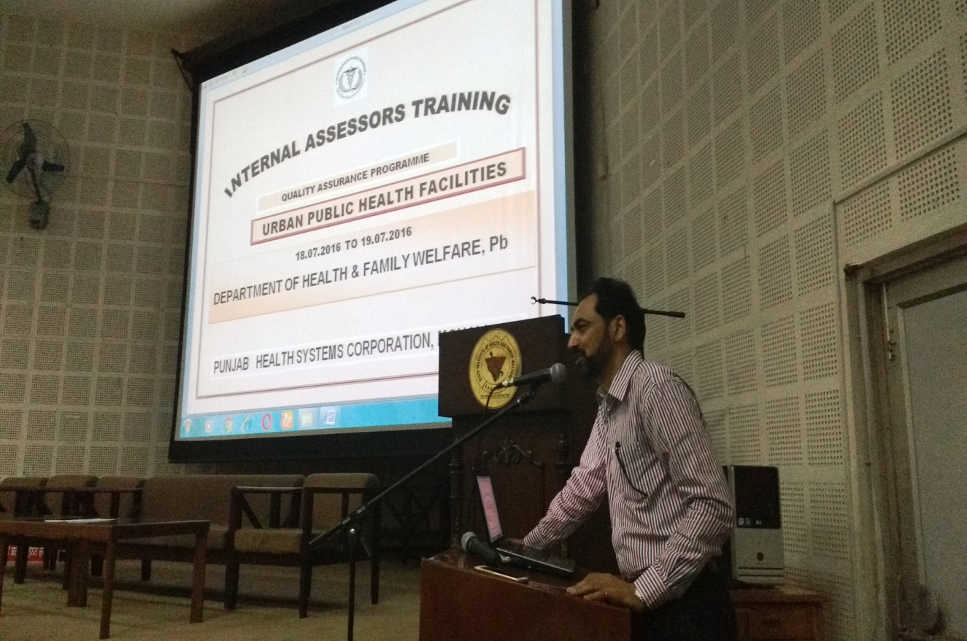

Conducted by
National Health System Resource Centre in collaboration with State Health Systems Resource Centre, Punjab

TRAINING REPORT
INTERNAL ASSESSOR TRAINING FOR UPHC ON NATIONAL QUALITY ASSURANCE PROGRAM

CONTENTS
TRAINING DETAILS..................................................................................................................................1
OBJECTIVES OF TRAINING 2
BACKGROUND 3
EXECUTIVE SUMMARY 4
DAYWISE SUMMARY OF THE PRESENTATIONS 5
Day 1 5
Day2 7
PARTICIPANT’S FEEDBACK 9
Most liked sessions 9
Most useful topics 9
Suggestions to improve the training:- 9
Annexure I 10
Annexure II 16
AGENDA 16
PHOTO GALLERY.....................................................................................................................................17

TRAINING DETAILS

- TRAINING COORDINATORS:
- Dr Parvinder Pal Kaur (AD QA, Punjab)
- Dr Sushant Agrawal (Consultant, QI, NHSRC, New Delhi)

- DATE OF TRAINING: 18th & 19th July, 2016

- PLACE OF TRAINING: Auditorium, Punjab Health Systems Corporation Centre, Phase 6, Mohali

- PARTICIPANTS OF TRAINING: 166 (List attached in Annexure I)

- COURSE SCHEDULE: The course schedule (Attached in Annexure II) outlines the day to day contents and learning methods.

OBJECTIVES OF TRAINING

- The objective of ‘’Internal Assessor Training for Urban PHC’’ Programme is to impart knowledge and skills of conducting internal assessment of Health Facilities against the predefined norms of National Quality Assurance Programme at fixed interval preferably quarterly covering all critical departments. An action plan would be prepared on observed non conformities for corrective/improvement activities.
- The course intends building the participants’ capacity to evaluate evidences to arrive at a conclusion with reference to various check-points, which are given in the Assessors’ Guide Book for Quality Assurance in UPHC, 2016.
- To equip assessors with knowledge of key concepts, tools and methodologies of National Quality Assurance Standards.
- Provide skill to assessors to independently assess different Areas of concern, Measurable Elements & Checklists.
- To develop skills and acumen to carry out internal evaluation as well as assessment of the UPHC’s.
- To set up pool of Internal Assessors for state of Punjab for assessment of Urban PHC.
- To understand basic concept of Quality in Public health facilities.
- To provide skill to identify gaps and fulfils these gaps.
- To develop skills and acumen to implement Quality services in their health facilities.

BACKGROUND

Under National Health Mission, to improve the quality of Health care services at public hospitals, Ministry of Health & Family welfare, Govt. of India, has launched National Quality Assurance Standards. To comply with these standards, Govt. has launched operational Guidelines as well as Assessor’s Guidebook for District hospitals, CHC (FRU) and PHC (24X7) and UPHC’s.
For implementation and certification under National Quality Assurance Standards (NQAS), 4 types of trainings courses were designed which includes one day Awareness training, two days Internal Assessor Training, three days Service provider training and five days External Assessor training.
Two days Internal Assessor training for Urban PHC was newly designed for service provider of Urban PHC, so that they will periodically assess their facilities covering all checklists and action plan would be prepared on observed non conformities for final traversing gaps.
Main aim of training is to provide complete understanding of standards, their sub components, & scoring methodology to aspiring Internal Assessors and its closure for national certifications.
One curriculum was designed for the training extended up to period of two days, followed by written evaluation of aspiring Internal Assessors.
In evaluation, if trainer would be able to score minimum 60 % of marks, then he/she will be awarded with Internal Assessor Certification for NQAS & will be eligible as an empanelled Internal Assessor for the State.

EXECUTIVE SUMMARY

The training was conducted by the team of NHSRC, New Delhi in collaboration with State Health Systems Resource Centre, Mohali at SHSRC, Phase-6, Mohali.
The aim of the training was to strengthen assessor’s knowledge of key concepts, tools, and methodologies for assessment of National Quality Assurance Standards. Course curriculum for training was prepared by the NHSRC and was duly syndicated with state. Participants were from diverse background including Chief Medical Superintendent, Gynaecologists, Regional Consultants QA, Hospital Quality Managers, Medical Officers etc., called from 26 districts of Punjab called by the state for this training. The participants were given:
- A copy of Assessor’s guidebook for Urban Primary Health Centre
- A copy of Biomedical Waste Management Guidelines, 2016
- A folder with writing pad, pen and pencil
- Course instruction for IA-Training
- Feedback form
- Hard copy of guidelines, exercises and material whenever required during the training

The programme had 13 sessions, spread over a period of two days along with group exercises.
Feedback from the participants was taken and the report contains analysis and suggestions given by the participants. The overall rating of the programme in feedback has been good with an overall score of 4.13 on a 5 point scale.

DAYWISE SUMMARY OF THE PRESENTATIONS

Day 1
- In the starting session Mr. Navdeep Gautam, Consultant Policy & Planning, NHM Punjab, gave presentation on “National Urban Health Mission, Punjab”. The overview of Urban Health needs was being explained elaborately in the presentation which has covered the following topics:

- An overview of NUHM
- Reasons for giving special focus to Urban areas
- Different needs of Urban population
- Vulnerability of Urban poor/slum population
- Punjab state demographic profile (NUHM)
- Special focus on MMR & IMR rates

- This is followed by the session presented by Dr. Nikhil Prakash on “Key Concepts and Principles of Quality Assurance, an Overview of National Quality Assurance Program”. He had explained following things in his session:

- Definition of Quality
- Perspectives of the Quality
- Key Concept of Quality
- Principles of Quality Management
- National Quality Assurance Standard for Healthcare Facilities
- How Hazardous is healthcare

This session also covered an “Overview of National Quality Assurance Program and standards”. He had explained NQAS programme, information about the Checklists, key features of the programme, snapshot of all eight Areas of Concerns and the Standards concerning them. He had also explained about measurement system of NQAS and the relationship between the areas of concern, Standards, Measurable Elements, Checkpoints and Approaches for the assessment.

- This was followed by Dr. Sushant Agrawal and he had explained about the scoring patterns and the methods to obtain the cumulative Hospital Score Card. A brief introduction of twelve checklists was also provided. This helped the participants to acquaint themselves with the newly introduced National Quality Assurance standards for UPHC’s.
- The next presenter for the day was Dr Namit Singh Tomar. He had presented the Areas of Concern A & B, “Service Provision & Patient Rights”. During the session, participants were given a detailed explanation about all the standards of Area of Concern Service Provision which include curative services, RMNCH+A services, Support Services, National Health Program, diagnostic services & services as per community needs. Participants were given details about the availability of services at facility as per state norms / IPHS.

He had also explained about the Patient rights which had included the accessibility of services along with their availability & services provision in dignified manner for its acceptance by the clients (patients).

- Post lunch session was presented by Dr. Sushant Agrawal on “Areas of Concern C & D, Inputs & Support Services”. He had covered the “Area of Concern and explained about infrastructure availability & adequacy, physical safety, fire safety, HR availability & their training requirement & availability of equipment & instruments at the facility level. In Support services area of concern, Dr. Sushant had covered Equipment maintenance, Inventory management, Community participation, Reporting and work management.

- An exercise was conducted soon after completing the Areas of concern A. B. C & D by Dr. Namit & Dr. Sushant. All participants were given a case sheet and were instructed to fill the checklist for Maternal Health for the mentioned areas of concern.

Based upon the score generated by the participants they were explained how this scoring can be done in excel sheet. Also, the methodology of Department wise scoring and Area of concern wise scoring were being explained to the participants.

- In the evening session, Dr. Nikhil Prakash had provided a detailed explanation of “Area of Concern E, Clinical Services”. This session had included Standards E1 to E9 i.e. General Clinical services standards. He had also presented a brief introduction of various National Health Programs launched by Government of India.

.

Day2
Day 2 was initiated with a brief recap of all the sessions of Day 1 by Dr. Nikhil Prakash. Participants were encouraged to talk about their understanding from Day-1.

- First session of the day was taken up by Dr. Nikhil Prakash about “Steps for Implementation of QA Program, Area of Concern G i.e. Quality Management”. Dr. Nikhil explained about the key features of Quality team, Quality Policy, Quality objectives and Quality Assurance cycle. The participants were also informed about the logistics and process of conducting of Internal Assessment at the facility level.

- Next session of the day was conducted by Dr. Namit Singh Tomar on “Infection Prevention & BMW Rules 2016 (Area of Concern F)”. All the six Standards related to Infection control, namely, Infection control program, Hand Hygiene practices, Use of Personal protective equipment, Processing of equipments and instruments, Physical layout and environmental control of the patient care areas & Bio medical waste management were explained. He had also demonstrated six steps of Hand washing and discussed practical issues related to infection control during his session. Followed by this, one Video about ‘’Infection control practices’’ was shown by him.

- Next session was taken up by Dr. Sushant Agrawal on “Gap analysis, Action Planning & Patient Satisfaction (Area of Concern G)”. This had included information about Post assessment activities i.e. generating score cards, gap analysis, reporting. Methods of Root cause analysis like fish bone technique, why- why analysis, PICK chart, action planning and prioritization etc. were adequately explained to the participants, with appropriate examples and quick interaction with the participants. The participants were also explained about the process of conducting Patients Satisfaction Surveys at facility level.

- This was followed by an Exercise conducted by Dr. Namit on “Gap analysis and action planning” in which participants were shown different pictures in which they had to identify the gap based on SMART approach and plan an action accordingly. The exercise was an interactive one and had a positive impact on the understanding of the basic concept of gap analysis for the participants.

- Post lunch session was started by Dr. Sushant Agrawal and he discussed about the “Key Performance Indicators ( Area of Concern H)” in which all 30 KPI’s, data required for KPI’s, calculation of KPI’s were discussed. A quiz was organized by Dr. Sushant to engage the participants in calculating KPI’s on their own and provided them with a clear idea of the calculation of Key performance indicators. In between training to engage participants he has some quiz’s related to calculations of indicators.

- The last session was covered by Dr. Palvinder Pal Kaur, Nodal Officer, QI, Punjab on “Prescription Audit” where participants were explained about the importance and process of conducting prescription audit. This was followed by an exercise on conducting the Prescription Audit at facility level.

- At last, the participants were given question papers with 42 multiple choice questions. 3 set of question paper were prepared for evaluation (A, B and C). Feedback forms were also distributed to all participants.

PARTICIPANT’S FEEDBACK

Evaluation of participant’s feedback is taken on a 5-point scale. Overall average scoring was 4.13 out of 5.

Most liked sessions
NAME OF TOPIC & PRESENTER | SCORE
Prescription Audit by Dr. Palvinder Pal Kaur | 4.26
Infection Control & BMW Management by Dr. Namit Singh Tomar | 4.20
Standard for Clinical Services by Dr. Nikhil Prakash | 4.17
Gap Analysis, Action Planning & Prioritization by Dr. Sushant Agrawal | 4.17

Most useful topics
- BMW rules 2016 & Infection Control
- Gap Analysis & Action Planning
- Key Performance Indicators
- Prescription Audit

Suggestions to improve the training:-
- More interaction with the participants
- More Group exercise
- More training days
- More video clips
- TA DA should be provided just after training
- Provision of Retraining after fixed intervals to trace improvements

Annexure I
List of Participants
Sr. No. | NAME | MOBILE NO | E-mail ID | DISTRICT | HOSPITAL
1 | Dr. Suman Lata | 9501870788 | nuhmphcbaltana@gmail.com | Mohali | UPHC Baltana
2 | Dr. Sukhjit Kaur | 9815490373 | uphc1nayagaon@gmail.com | SAS Nagar | UPHC Nayagaon
3 | Dr. Atul Gautam | 9780673844 | atulgautam3863@gmail.com | Mohali | SDH Kharar
4 | Dr. Nitin Sethi | 7677767788 | drcoolsethi@gmail.com | Rupnagar | Ch rupnAGAR
5 | Dr. Aman Preet Kaur | 8146653366 | apreeto73@gmail.com | Mohali | UPHC NEEUDI KHARAR
6 | Dr. jatinder kumar | 9988103062 | drjatinder.nikku277@gmail.com | ludhiana | uphc bhagwan nagar
7 | Dr. Parneet kaur | 9988411300 | parneetsabir@gmail.com | patiala | uphc bishan nagar
8 | Dr. Shaina Goyal | 9876084887 | doc.shaina1310@gmail.com | bathinda | uphc Phul town
9 | dr. harbir | 9872424907 | harbirgrewal2594@yahoo.co.in | ludhiana | uphc durgi
10 | DR. SURINDER PAL KAUR | 8146500383 | surrnder67jaggi@gmail.com | LUDHIANA | UPHC NODEL TOWN
11 | SONIA | 8872094996 | nhmpunjab@gmail.com | chandigarh
12 | DR. SUREDSHO | 9417144550 | akchr@gmail.com | jalandhar | UPHC B. NAGAR
13 | dr. jaginder pal kaur | 9872728222 | drmahi13@rediffmail.com | jalandhar | UPHC KAZI MANDI
14 | Dr. Manreet benipal | 9876504262 | manreetsam86@rediff.com | ludhiana | UPHC Khazana
15 | dr. Rupan Cahudhary | 9876388500 | uphchheharta@gmail.com | Amritsar | UPHC
16 | Dr. amar preet singh | 9888520055 | uphcdhuri@gmail.com | sangrur | UPHC Dhuri
17 | DR PRABHOJOT SINGH | 8146822507 | urbanphcswwam@gmai.com | sangrur | UPHC SWNAM
18 | Dr. Arpit Sharma | 9417094171 | arpit_sr2@yahoo.co.in | fazilkka | civil hospital Fazilka
19 | Dr. Rishma Bhauil | 9855538212 | bhaursdrreshma@ymail.com | patiala | UPHC SULAR
20 | DR. Harleen Kaur | 9876396217 | dr.harleenkaur11@gmail.com | patiala | uphc 2 rajpura
21 | Dr. Varun Mittal | 9988801719 | drvarunmittal17@gmail.com | Mansa | UPHC II
22 | Dr. Salini | 9417321981 | drshaliniheer@gmail.com | Hoshiarpur | UPHC Purhiran
23 | DR. RENU BHATIA | 9463310907 | takraj_62@yahoo.in | HOSHIARPUR | UPHC
24 | Dr. Sanjeev Gupta | 8146892700 | drsanjeevgupta63@gmail.com | Amritsar | UPHC Khazana
25 | Dr. Sandeep | 8699402599 | sandeepsingh119@gmail.com | Ajitgarh | UPHC
26 | Dr. Rahul JINDAL | 9815191915 | jindalrahul1971@yahoo.co.in | barnala | uphc prem nagar
27 | Dr. AILEENA | 9780024850 | sidharaileena@gmail.com | patiala | UPHC J. Nagar
28 | Dr. Robin | 9634045505 | itsmerobin5@yahoo.in | ferozpur | fzr cantt
29 | Dr. hitesh | 8968343780 | hitesh_sharma600.yahoo.com | Khana | Lady hospital
30 | Dr. Balbir singh | 9888602316 | drbalbir.singh@yahoo.com | Amritsar | B.M.S.M.S. Sakatribagh
31 | DR. Gaurav Kaushal | 9530500154 | kaushal444@gmail.com | ropar | uphc roopnagar
32 | Dr. Harish Bhardwaj | 9815289316 |  | jalandhar | uphc aman nagar
33 | Dr. Vandana Saggar | 9041002484 | saggarvandanan@yahoo.com | jalandhar | UPHC Bhargo camp
34 | Dr. Kuldeep Kaur | 8146624208 |  | Amritsar
35 | DR. NEELAM | 9417490621 | uphcgaulmandi@gmail.com | Amritsar | uphc gaual Mandi
36 | DR. GAGAN DEEP SINGH | 7508978403 | dr.gagan0008@gmail.com | Muktsar | uphc Maloat
37 | DR. DALJEET SINGH | 9888338825 | perdeshidedaljeet@yahoo.co.uk | patiala | GMC Patiala
38 | DR. RETA BALA | 7837733005 | drretabalajalandhar@gmail.com | jalandhar | Basti bank khel
39 | DR. NAVJOT KAUR | 8054854715 | sonun241990@gmail.com | Amritsar | UPHC Haripura
40 | Dr. lalita | 9465089372 | lalitaleal27@gmail.com | fatehgarh sahib | uphc mandi gobindgarh
41 | DR. SURAJ BHAN GOEL | 9814444167 | surajgoyal189@gmail.com | BATHIDA | UPHC
42 | DR. ALEXANDAR SINGH | 9417674399 | nakodaaeiya@yahoo.com | jalandhar | UPHC Maqsudan
43 | Dr. KIRAn KUMAR | 8427052800 | drkirankumar27272@gmail.com | Amritsar | UPHC
44 | dr. SURENDER KAUR | 9464257268 | surinderkaurpb@gmail.com | SAS NAGAR | UPHC PH-II, Mohali
45 | Dr. PANKAJ | 985577247 | pdhingra@ipeglobal.com | CHD | DHS
46 | dr. parvinder kaur | 9878445965 |  | SAS NAGAR | UPHC PHASE -1
47 | DR. PREETJOT KAUR | 9878673336 | preet371259@yahoo.co.in | fatehgarh sahib | CIVIL HOSP.
48 | dr. AASHISH SHARMA | 9878750005 | aashish.sharma57@gmail.com | Amritsar | UPHC KAN COLONY
49 | DR. VANITA BHUUAR | 9815749549 | bhullarrujn@gmail.com | firozpur | UPHC FZR CITY -1
50 | DR. GALDY |  |  | PHSC
51 | DR RAMIL BANSAL | 9417954615 | RAMILBANSAL@GMAIL.COM | BATHIDA | UPHC LAL SINGH BAGH
52 | DR BHARTI | 9878697207 | bhartigupta49@gmail.com | BATHIDA | UPHC JANTA NAGAR
53 | DR. PUJA GARG | 9878681004 | puja.garg81@ymail.com | Mohali | CH MOHALI
54 | Mr. GAUTAM |  |  | NRHM
55 | DR. PRABHA PAL | 9920961069 | prabha07pal@gmail.com | mohali | DH
56 | DR. SWETABH | 9619447068 | swtabh.neiem@gmail.com | PHSC | PHSC
57 | dr. gagan preet singh | 9501332211 | drgagaganpreet@gmail.com | Faridkot | UPHC
58 | DR. RAMNI BANSAL | 9814705155 | ramnibansal | sangrur | UPHC SANGRUR
59 | DR. MAGGI | 8872973354 | maggibansal@gmail.com | sangrur | UPHC MALERKOT
60 | DR. GAGAN DEEP DHALIWAL | 9876703617 | lluckydhaliwal@gmail.com | BATHIDA | uphc BEANT NAGAR
61 | DR. MANOJ NAHR | 9463104092 | gurinayatgurn
62 | DR. MANJIT SINGH RATAUL | 8427003395 | rataul72@gmail.com | Amritsar | UPHC mustafabad
63 | DR. AMANDEEP KAUR | 9582835600 | amankaur12349@gmail.com | fazilka | UPHC-II Abohar
64 | DR. AMANDEEP TUAKUR | 9478382593 | uphcrajpura1@gmail.com | Patiala | UPHC RAJPURA
65 | DR. DALBIR SINGH | 8146818886 | dsaulakh8@gmail.com | TARAN TARAN | UPHC SACHIKHAND ROAD
66 | DR. BANPREET SINGH | 9876838787 | zinky21@gmail.com | Amritsar | UPHC JODHANAGAR
67 | DR. PARAMPREET SINGH | 8557883296 | dr.parampreetsingh@yahoo.com | Amritsar | UPHC GOBIND NAGAR
68 | DR. NISHA SHAHI | 9876979762 | nishashahi52@gmail.com | Amritsar | SAD BASANT AVENUE
69 | DR. AMRIT PAL SINGH | 9815622275 | astaramritpal@gmail.com | patiala | SABET HOSP. PATIALA
70 | DR. H S OBEROI | 9814829779 | harjeetoberoi05@gmail.com | Mohali | DH Mohali
71 | DR. RAJIV CHAMBER | 9501991033 | rajiv_chamber@yahoo.com | Patiala | UPHC SAMNA
72 | DR. VISHAL GOYAL | 9915205552 | vishal_goyal2003@yahoo.co.in | sangrur | UPHC Malarhtla
73 | DR. MANAV PRAKASH KAUR | 9779086505 | gill_manav786@yahoo.co.in | SBS NAGAR | UPHC SBS NAGAR
74 | DR. VIKARMJEET JINDAL | 9837497405 | vikramjeet_jindal@yahoo.com | Faridkot | KUTAPURA
75 | DR. NEERAJ MITTAL | 9815109347 |  | GMC PATIALA | GMC Patiala
76 | DR. SUMAN BALI | 9814736863 | drsumanbali54@gmail.com | phsc | PHSC
77 | DR. PARMINDER | 8146201164 | pkdr89@gmail.com | jalandhar | UPHC BASTI DANISHMAN
78 | NARAYAN B | 9771402050 | nbhera@ipeglobal.com | STO RANCHA
79 | DR. KIRANJOT KAUR | 9646704470 | UPHCARYASAMAJ@GMAIL.COM | Patiala | UPHC ARYA SAMAJ
80 | GUNPAN SINGH | 8528662530 | UPHCZIRAKPUR@GMAIL.COM | mohali | UPHC ZIRAKPUR
81 | DR. MANOJ KUMAR | 9988606547 | panjumanoj@gmail.com | MUKTSAR | UPHSC 2 MUKTSAR
82 | Dr. MANDEEP KAUR | 9876157265 | meenu83145@gmail.com | Faridkot | C.D Faridkot
83 | DR. HARINDER KAUR | 9878918408 | drharinder123@gmail.com | LUDHIANA | UPHC MURADPURA
84 | DR. SUDESH BADAN | 7087670337 | suresh.badan@yahoo.com | LUDHIANA | UPHC JANTA NAGAR
85 | Dr. JAWINDER | 8054814999 | drrasput2011@gmail.com | Patiala | UPHC Anand Nagar
86 | DR. NEELU | 9501455887 |  | MOHALI | PHSC
87 | DR. VISHAL GARG |  |  | Mohali | PHSC
88 | DR. KHUSDEEP SINGH | 9988855855 | rkhusdeep@yhaoo.com | kapurthala | UPHC
89 | DR. RAJENDER | 9417485854
90 | Dr. KIRAn KUMAR | 8427052800 | drkirankumar27272@gmail.com | Amritsar | UPHC
91 | Dr. SANJEEV GUPTA | 8146892700 | drsanjeevgupta63@gmail.com | Amritsar | UPHC GATE KHAZANA
92 | DR. JAGEINDER PAL KAUR | 9872728222 | drmahi13@rediffmail.com | jalandhar | UPHC KAZI MANDI
93 | DR. RETA BALA | 7837733005 | ritebalelalendhar@gmail.com | jalandhar | Mo
94 | dr. nisha shahi | 9876979762 | nishashahi52@gmail.com | Amritsar | SAD BASANT AVENUE
95 | DR. MANOJ NAHR | 9463104092 | gurinayatgurn
96 | DR. MANPREET KAUR | 8146653366 | apreet073@gmail.com | mohali | UPHC MUNDI KHARAR
97 | DR. ARPIT SHARMA | 9417094171 | arpit_sr2@yahoo.co.in | FAZILKA | CIVIL HOSPITAL
98 | Dr. MANDEEP KAUR | 9876157265 | meenu83145@gmail.com | Faridkot | C.D Faridkot
99 | DR. HARLEEN KAUR | 9876396217 | dr.harleenkaur11@gmail.com | Patiala | UPHC 2 RAJPURA
100 | DR. PARNEET KAUR | 9988411300 | uphcbishannagar@gmail.com | Patiala | UPHC BISHAN NAGAR
101 | NARAYAN B | 9771402050 | nbhera@ipeglobal.com | STO RANCHA
102 | DR. SHARMILA GUPTA | 7529833503 | UPCAMRITSAR@GMAIL.COM | Amritsar
103 | BALKARAN SINGH | 7529833509 | nuhmsangrur@gmail.com | sangrur | CS Sangrur
104 | DR. SHAINA GOYAL | 9876084887 | doc.shaina1310@GMAIL.COM | BATHIDA | UPHC PHUL TOWN
105 | DR. NAVJOT KAUR | 8054854715 | sonun241990@gmail.com | Amritsar | UPHC Haripura
106 | Dr. PANKAJ | 985577247 | pdhingra@ipeglobal.com | CHD | DHS
107 | DR. AMARPREET SINGH | 9888520055 | uphcdhuri@gmail.com | sangrur | Dhuri
108 | DR. RAJIV CHAMBER | 9501991033 | rajiv_chamber@yahoo.com | Patiala | UPHC SAMNA
109 | DR. VIKARMJEET JINDAL | 9837497405 | vikramjeet_jindal@yahoo.com | Faridkot | KUTAPURA
110 | DR. DALBIR SINGH | 8146818886 | dsaulakh8@gmail.com | TARAN TARAN | UPHC SACHIKHAND ROAD
111 | DR. SUKHJIT KAUR | 9815490373 | uphc1nayagaon@gmail.com | S.A.S Nagar | UPHC NAYAGAON
112 | Dr. AILEENA | 9780024850 | sidharaileena@gmail.com, uphcjhujaenagar@gmail.com | patiala | UPHC J. Nagar
113 | Dr. Robin | 9634045505 | itsmerobin5@yahoo.in | ferozpur | fzr cantt
114 | dr. parvinder kaur | 9878445965 |  | SAS NAGAR | UPHC PHASE -1
115 | GUNPAN SINGH | 8528662530 | UPHCZIRAKPUR@GMAIL.COM | mohali | UPHC ZIRAKPUR
116 | DR. RENU BHATIA | 9463310907 | takraj_62@yahoo.in | HOSHIARPUR | UPHC
117 | DR. AMANDEEP TUAKUR | 9478382593 | uphcrajpura1@gmail.com | Patiala | UPHC RAJPURA
118 | dr. gagan preet singh | 9501332211 | drgagaganpreet@gmail.com | Faridkot | UPHC
119 | dr gaurav KAUSHAL | 9530500154 | kushal444@gmail.com | ROPAR | UPHC ROPAR
120 | DR. VANDANA SAGGAR | 9041002484 | saaggarvandana@yahoo.com | jalandhar | UPHC BHARGO CAMP JALANDHAR
121 | HARSH | 9529833508 | nrhmptl@gmail.com | Patiala | o/o civil surgeon ptl
122 | DR. KIRANJOT KAUR | 9646704470 | UPHCARYASAMAJ@GMAIL.COM | Patiala | UPHC ARYA SAMAJ
123 | DR. RAJENDER SIGHLA | 9915556400 | drsinglasmo@gmail.com | Patiala | DMC PATIALA
124 | dr. SHILPY MEHTA | 9914030219 | sunny2002mehta@gmail.com | fatehgarh sahib | UPHC BALA FTH
125 | DR. SURINDER PAL KAUR | 8146500383 | surrnder67jaggi@gmail.com | LUDHIANA | UPHC NODEL TOWN
126 | DR, AMANDEEP KAUR | 9888939453 | lubana.amandeepkaur@gmail.com | pathankot | CHC GHAROTA
127 | DR. SANDEEP | 869940279 | sandeepsingh119@gmail.com | AJITGARH | UPHC PH-7 MOHALI
128 | DR RAMIL BANSAL | 9417954615 | RAMILBANSAL@GMAIL.COM | BATHIDA | UPHC LAL SINGH BAGH
129 | DR BHARTI | 9878697207 | bhartigupta49@gmail.com | BATHIDA | UPHC JANTA NAGAR
130 | DR. VISHAL GOYAL | 9915205552 | vishalgoyal2003@yahoo.co.in | sangrur | UPHC Malarhtla
131 | DR. MAMOJ KUMAR | 9988606547 | panjumanoj@gmail.com | MUKTSAR | UPHSC 2 MUKTSAR
132 | DR. VANITA BHUUAR | 9815749549 | bhullarrujn@gmail.com | firozpur | UPHC FZR CITY -1
133 | DR. LALITA | 9465089372 | lalitakal27@gmail.com | fatehgarh sahib | UPHC MANDI EUZINDARH
134 | DR. AMANDEEP KAUR | 9582835600 | amankaur12349@gmail.com | fazilka | UPHC-II Abohar
135 | dr. AASHISH SHARMA | 9878750005 | aashish.sharma57@gmail.com | Amritsar | UPHC KAN COLONY
136 | DR. ALEXANDAR SINGH | 9417674399 | nakodaaeiya@yahoo.com | jalandhar | UPHC Maqsudan
137 | DR. NEELAM | 9417490621 | uphcgaulmandi@gmail.com | Amritsar | uphc gaual Mandi
138 | dr. kuldeep kaur | 8146624208 |  | Amritsar | AMRISTAR
139 | DR. MANAV PRAKASH KAUR | 9779086505 | gill_manav786@yahoo.co.in | SBS NAGAR | UPHC SBS NAGAR
140 | DR. HARBIR | 9872424907 | harbirgrewal2594@gmail.com | LUDHIANA | UPHC DUGRI
141 | DR. SUDESH BADAN | 7087670337 | suresh.badan@yahoo.com | LUDHIANA | UPHC JANTA NAGAR
142 | DR. GAGAN DEEP DHALIWAL | 9876703617 | lluckydhaliwal@gmail.com | BATHIDA | uphc BEANT NAGAR
143 | DR. SUREDSHO | 9417144550 | akchr@gmail.com | jalandhar | UPHC B. NAGAR
144 | DR. HARINDER KAUR | 9878918408 | drharinder123@gmail.com | LUDHIANA | UPHC MURADPURA
145 | DR. MANREET BENIPAL | 9876504262 | manreetsanu86@ewdiff.com | LUDHIANA | UPHC MODEL TOWN KHANNA
146 | DR. MAGGI | 8872973354 | maggibansal@gmail.com | sangrur | UPHC MALERKOT
147 | DR. RAHUL JINDAL | 8872973354 | jindalrahul1971@yahoo.co.in | BARNALA | UPHC BARNALA
148 | DR. RUPAM CHAUDHARY | 9876388560 | uphcchheharta@gmail.com | Amritsar | uphc chheharta
149 | dr. SURENDER KAUR | 9464257268 | surinderkaurpb@gmail.com | SAS NAGAR | UPHC PH-II, Mohali
150 | DR PRABHOJOT SINGH | 8146822507 | urbanphcswwam@gmai.com | sangrur | UPHC SWNAM
151 | Dr. JAWINDER | 8054814999 | drrasput2011@gmail.com | Patiala | UPHC Anand Nagar
152 | Malika | 7529833501 | nrhmmohali@gmail.com | mohali | CS office Mohali
153 | DR. MANJIT SINGH RATAUL | 8427003395 | rataul72@gmail.com | Amritsar | UPHC mustafabad
154 | DR. BALBIR SINGH | 9888602315 | drbalbirsingh@yahoo.com | Amritsar | BMS Sakatribagh
155 | SUNIL KUMAR | 7529833504 | nhmotd@GMAIL.COM | BATHIDA | CS office bathinda
156 | DR. SUMAN LATA | 9501870788 | nuhmphcbaltana@gmail.com | MOHALI | UPHC Baltana
157 | DR. PARMINDER | 8146201164 | pkdr89@gmail.com | jalandhar | UPHC BASTI DANISHMAN
158 | DR. RISHMA BHAWNA | 9855538212 | uphcsular@gmail.com | Patiala | UPHC SULAR
159 | DR. SHALINI | 9417321581 | drshaliniheer@gmail.com | HOSHIARPUR | UPHC PURHIRAN
160 | DR. VARUN MITTAL | 9988801719 | drvarunmittal17@gmail.com | MANSA | MANSA
161 | DR. PARAMPREET SINGH | 8557883296 | dr.parampreetsingh@yahoo.com | Amritsar | UPHC GOBIND NAGAR
162 | DR. PRABHA PAL | 9920961069 | prabha07pal@gmail.com | mohali | DH
163 | DR. SWETABH | 9619447068 | swtabh.neiem@gmail.com | PHSC | PHSC
164 | DR. HITESH | 8908343780 | hitesh_sharma600@yahoo.com |  | UPHC KHANNA
165 | DR. SURAJ BHAN GOEL | 9814444167 | surajgoyal189@gmail.com | BATHIDA | UPHC
166 | DR. NEELU | 9501455887 |  | MOHALI | PHSC

Annexure II
AGENDA

INTERNAL ASSESSOR’S TRAINING ON NATIONAL QUALITY ASSURANCE STANDARDS 18TH & 19TH JULY, 2016

Time | Topic | Resource Person
Day-01 ( 18th July 2016)
09:00 am - 09:30 am | Registration
09:30 am - 09:45 am | Inaugural Address
09:45 am - 10:30 am | Overview of National Urban Health Mission | Nodal Officer, Urban Health Punjab, NHM
10:30 am - 11:15 am | Key Concepts of Quality, Overview on National Quality Assurance Program | Dr. Nikhil Prakash
11:15 am.- 11.30 am | Tea
11:30 am - 12:15 pm | Measurement System, Standards and Assessment Protocol | Dr. Sushant Agrawal
12:15 pm- 01.00 pm | Area of Concern A & B (Service Provision and Patient Rights) | Dr. Namit Singh Tomar
01:00 pm - 02:00 pm | Lunch
02:00 pm - 03:00 pm | Area of Concern C & D (Inputs & Support Services) | Dr. Sushant Agrawal
03:00 pm - 04:00 pm | Exercise on Area of Concern A, B, C & D | Dr. Namit Singh Tomar & Dr. Sushant Agrawal
04:00 p.m.- 4:15 p.m. | Tea
4:15 p.m. - 5.15 p.m. | Area of Concern E (Clinical Services) | Dr. Nikhil Prakash
Day-02 ( 19th July 2016)
09:00 a.m. - 09:30 a.m. | Recap
09:30 a.m. - 10:30 a.m. | Steps for Implementation of QA Program (Area of Concern G) | Dr. Nikhil Prakash
10:30 a.m. - 11:00 a.m. | Infection Prevention & BMW Rules 2016 (Area of Concern F) | Dr. Namit Singh Tomar
11:00 a.m. - 11:15 a.m. | Tea
11:15 a.m. - 12:15 p.m. | Gap Analysis, Action Planning & Patient Satisfaction (Area of Concern G) | Dr. Sushant Agrawal
12:15 p.m. - 01:00 p.m. | Exercise on Gap Analysis & Action Planning | Dr. Namit Singh Tomar
01:00 p.m. – 02:00 p.m. | Lunch
02:00 p.m. - 03:00 p.m. | Key Performance Indicators (Area of Concern H) | Dr. Sushant Agrawal
03:00 p.m. – 03:30 p.m. | Prescription Audit | Dr. Palvinder Pal Kaur
03:30 p.m. - 04:30 p.m. | Post Training Evaluation & Feedback
 | (Tea during the evaluation)
PHOTO GALLERY
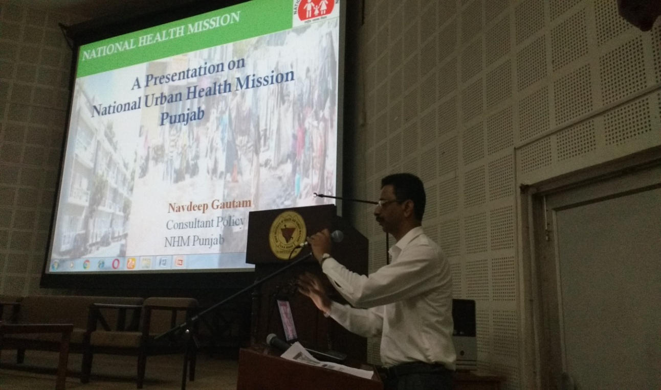
CONSULTANT POLICY PLANNING PRESENTING AN OVERVIEW OF NUHM, PUNJAB

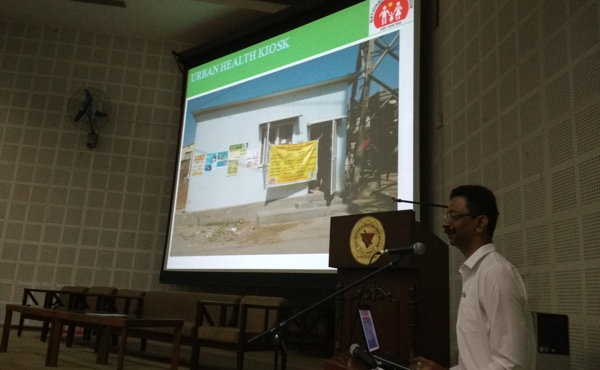
MR. GAUTAM PROVIDING INFORMATION ON URBAN HEALTH KIOSK DEVELOPED IN PUNJAB STATE
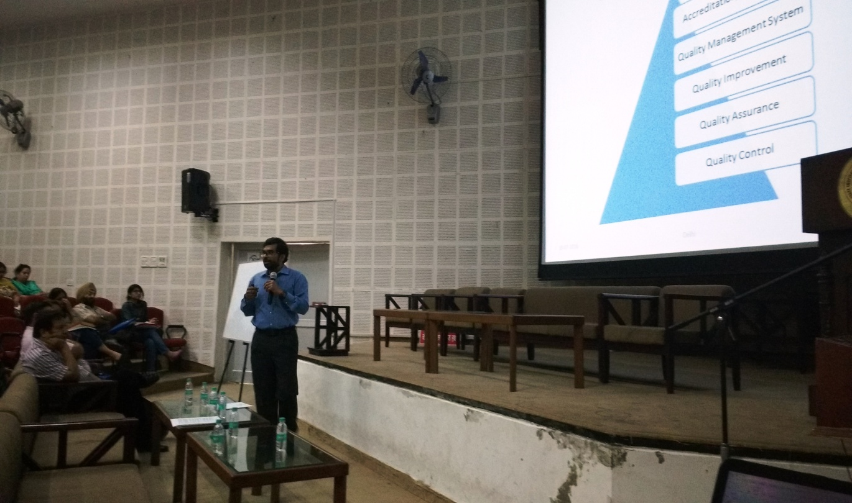
DR. NIKHIL EXPLAINING KEY CONCEPTS OF QUALITY DURING THE SESSION
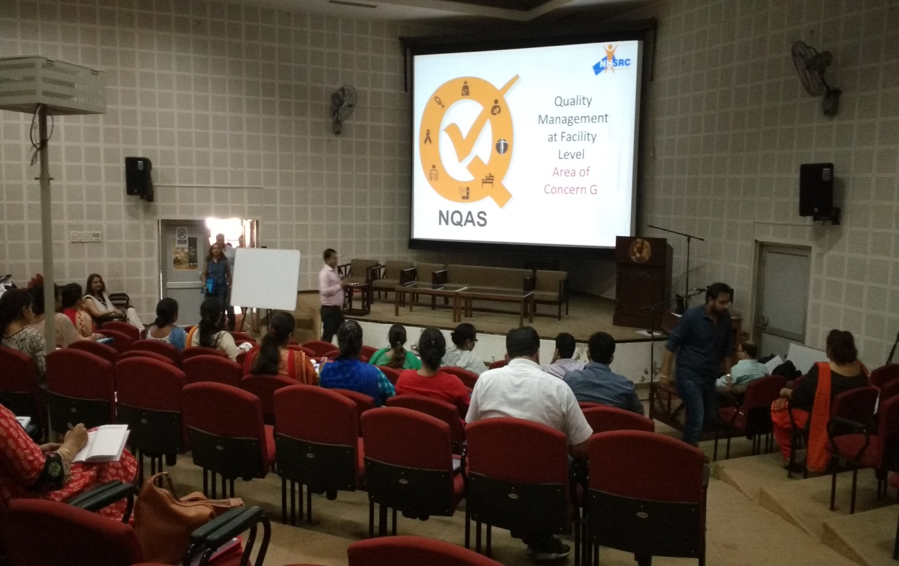
DR. SUSHANT EXPLAINING AREA OF CONCERN G

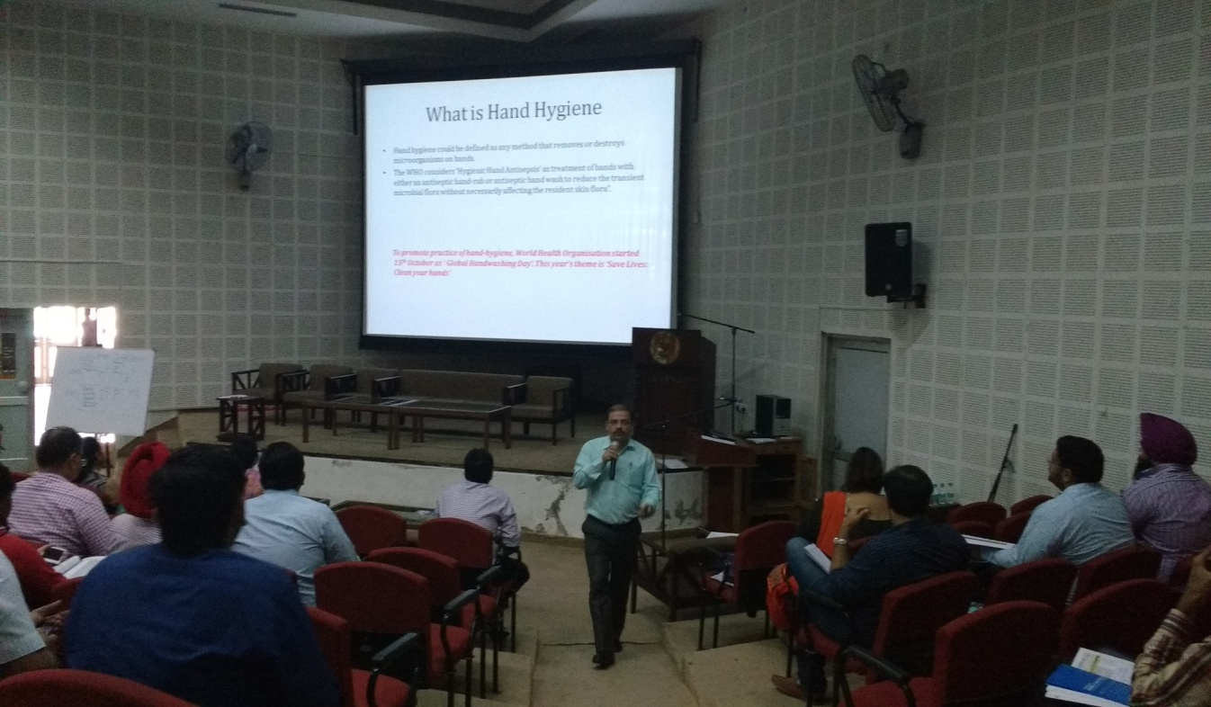
DR. NIKHIL PROVIDING INFORMATION ABOUT HYGIENE & OTHER INFECTION CONTROL PRACTICES

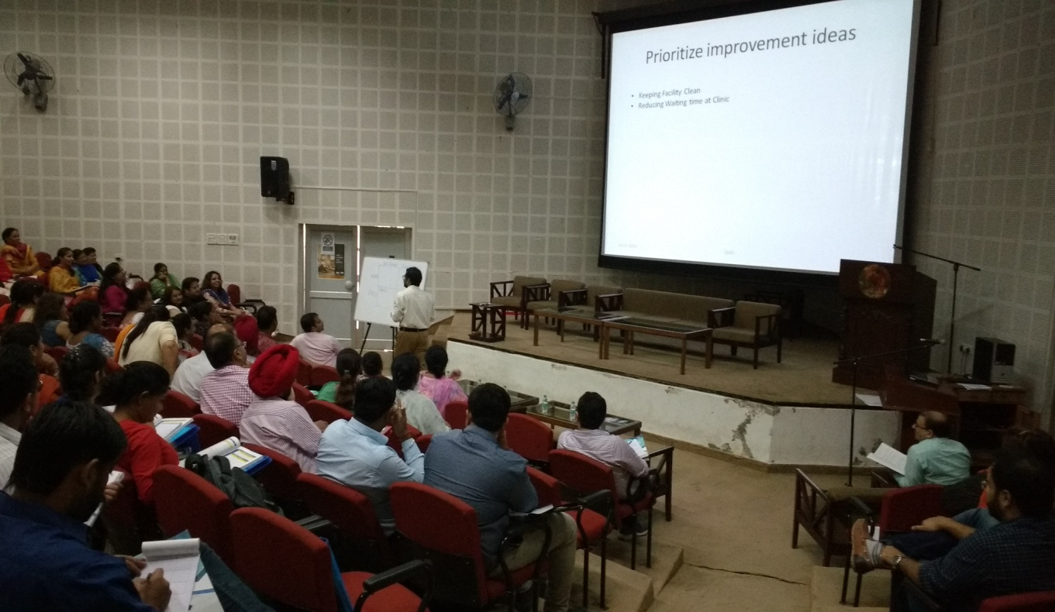
DR. NIKHIL DURING INTERACTIVE SESSION ON PRIORITIZATION OF GAPS

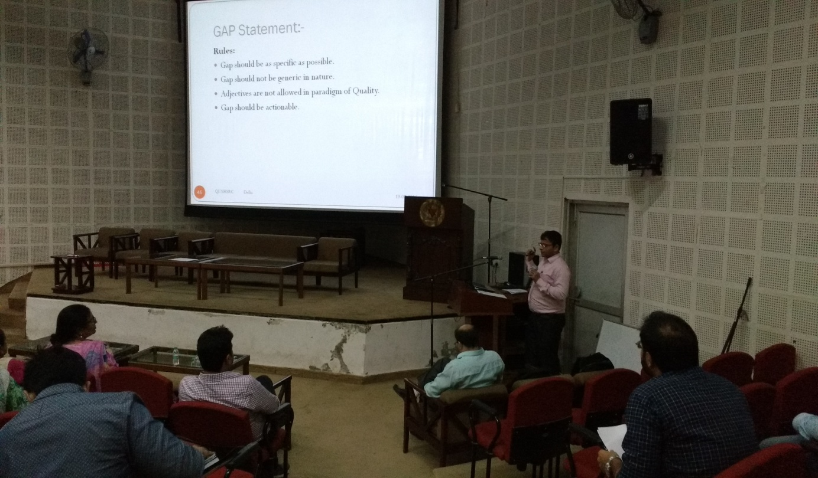
DR. SUSHANT DURING SESSION ON GAP ANALYSIS

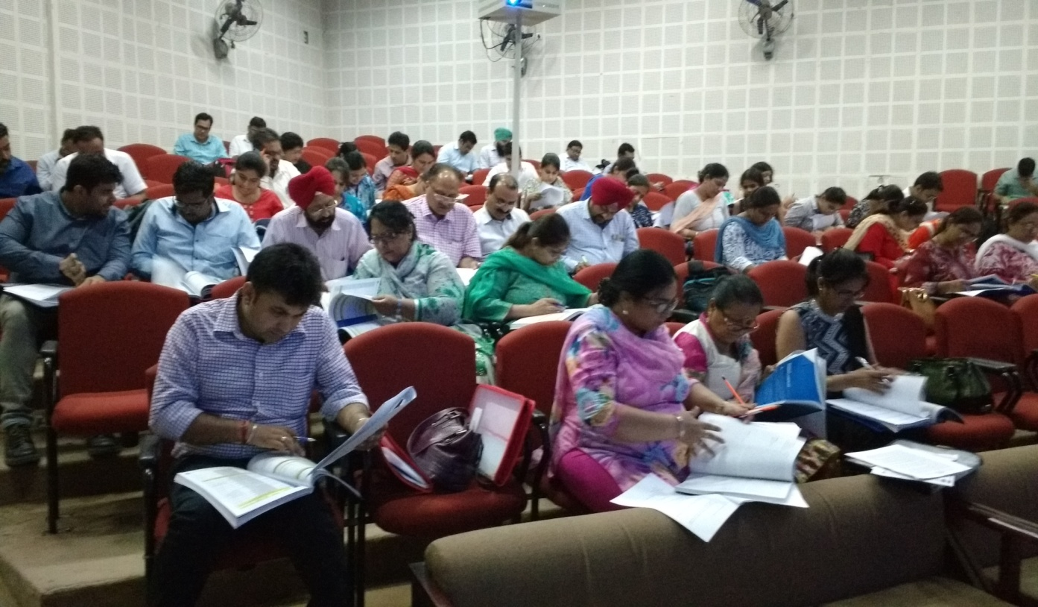
PARTICIPANTS DURING THE FINAL ASSESSMENT EVALUATION EXAM
Dr.Abhay Kumar taking session on ‘’Standards for Support Services’’
Participants attending training

